
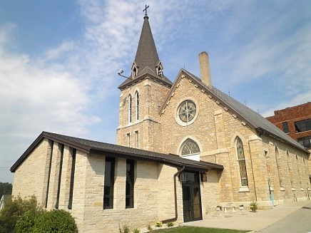
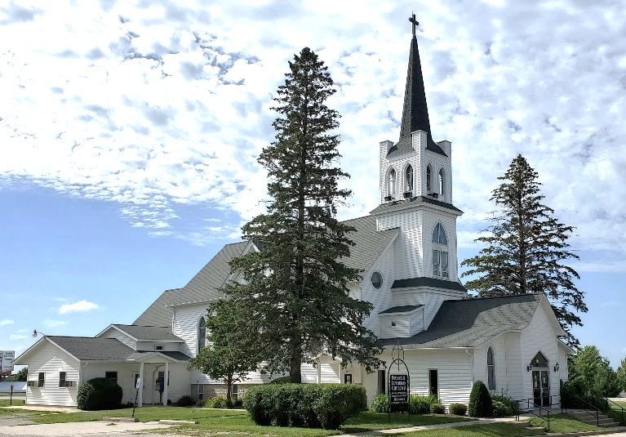
Mailing Address:
P.O. Box 75
Fountain, MN 55935

Church E-mail Address:
flc@mediacombb.net

Church Office Phone:
507.268.4413

Our Facebook Page
www.facebook.com/FountainLutheranChurch/

Our Website
www.fountainlutheranchurch.com

Pastor Kerry’s E-mail Address:
kbeversole@yahoo.com

Pastor Kerry’s Cell Phone:
507.951.3954

Parsonage Phone:
507.467.3017
Mailing Address:
P.O. Box 314
Lanesboro, MN 55949

Church E-mail Address:
bethlehemlc@acegroup.cc

Church Office Phone:
507.467.3344

Our Facebook Page
www.facebook.com/BethlehemLutheranLanesboro/

Our Website
www.staronthehill.com

Pastor Kerry’s E-mail Address:
kbeversole@yahoo.com

Pastor Kerry’s Cell Phone:
507.951.3954

Parsonage Phone:
507.467.3017
Special Summer News Sheet July 2022
Bethlehem and Fountain Lutheran Churches

During May and June, many of us were focused on proms, track & field meets, baseball games, baccalaureate services, the last days of school, commencements, graduation open houses, and the joy they gave us. But we did so under a dark cloud: Russia’s ongoing war in Ukraine and … three mass shootings — one at a supermarket in Buffalo, New York, a second at a church in Laguna Woods, California, and a third at an elementary school in Uvalde, Texas. This extra newsletter contains a news release from the ELCA, a letter from the bishop of our Southeastern Minnesota Synod, an article by Adam Russel Taylor of Sojourners, and an article by Isa Torres retrieved from christianitytoday.com, about this recent wave of gun violence. I commend them for your reading.

Pastor Kerry

ELCA Response to the School Shooting in Uvalde, Texas
5/26/2022
"Peace I leave with you; my peace I give to you. I do not give to you as the world gives. Do not let your hearts be troubled, and do not let them be afraid." (John 14:27)
Gracious God, news of the mass shooting at Robb Elementary School in Uvalde, Texas, has ripped our hearts and torn our souls. We are walking through the valley of the shadow of death. In the depths of pain and anger, we come before you, O God, our rock and our refuge. You are our only comfort. You are our only hope. Merciful God, you know the depth of our suffering. We have only begun to mourn those we have lost.
The Evangelical Lutheran Church in America grieves with the families of the 19 students and two teachers killed [on Tuesday, May 24th’s] mass shooting in Uvalde, Texas. Mass shootings in this country over the past two weeks have deepened the wounds of grief and sorrow. This follows the racially motivated shooting of 10 people in Buffalo, N.Y.; the shooting in Laguna Woods, Calif.; and the 27 other school shootings that have occurred in 2022. Many of the shooters have targeted children and older adults — some of the most vulnerable in our society.
We reaffirm our commitment in calling for greater gun safety, including preventing easy access to assault-style weapons and strengthening our federal system of background checks for all gun sales. As people of faith, we hold on to our belief in caring for our neighbors and striving for justice and peace in all the earth. We ask for continued support for all first responders that arrive at a moment's notice and place their lives in harm's way for the sake of others. We ask for continued support for those providing medical, mental and emotional support as we grieve over this tragedy. We lament for those who have perpetrated violence against others. We thank the leaders of the Southwestern Texas Synod responding to the shooting in Uvalde and for ecumenical and interreligious partners committed to accompanying this community for the long term.
The ELCA social message "Community Violence" (1994) calls on our church to continue partnering with other religious and community groups in anti-violence initiatives that offer vital spiritual and moral resources, and that replaces the fear and violence plaguing our homes, schools, communities and nation with hope and reconciliation. We join with others in pushing to stem the proliferation of guns in our streets, schools, and communities, and to end the culture of violence that pervades our media and society.

Response to Recent Violence

A Letter from Bishop Regina Hassanally, SE MN Synod

May 27, 2022
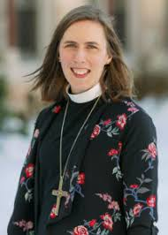
Three mass shootings in ten days.
A grocery store, a church, an elementary school. Places where community is formed and gathered all desecrated by violence.
I am angry, sad, frustrated, and overwhelmed, and I find myself wondering if what our faith offers in the face of such violence is too small.
How does God show up in a moment like this?
I am trying to do what I always do: return to Scripture and scour it for answers.
As I read, I am reminded of the ways God has always been at work in the world. I remember God’s work in Abram, a nomadic leader who was given the promises of blessing and land. I remember God’s work in Exodus. A people enslaved in a foreign land who, through journeys in the wilderness, become the People of God. I remember God’s work through a ragtag group of men and women who became the first followers of Jesus and the first proclaimers of the Good News.
What Scripture tells me is: God at work in the world is God at work through us.
My doubt leads me to fear our faith is not enough for the magnitude of this moment; our collective history teaches me it is.
We are the people who meet at the table of brokenness and walk away from it, having been made whole. We are people drowned in the waters of baptism and raised up in the promises of resurrection life.
We are people called to do justice and love mercy.
We are people who have failed.
And we are people who have been, and will yet be, redeemed.
We are not a people with the luxury of looking toward others to fix the problems we abhor. And we are not a people called to spend more time thinking about ourselves than the world we are called to serve.
We are the people who are called to show up, tell the truth, and point to Christ.
Christ is the only one with the power to transform, the power to take our meager offerings and make it enough to sustain thousands, the power to take our brokenness and make us whole… not for our sake alone but so that all may know the abundance of life Jesus came to give.

Continued on the next page
We start at the table of brokenness. At that table, we are made whole. At that table, all are fed, and every need is met. And from that table, we are sent to proclaim the Good News and to live transformed lives in a way that transforms the world.
I want promises that our neighbors will not be shot in a grocery store and our children will come home from their elementary schools. I want to know the people I love are safe in the places they gather to worship.
When I scour the word of God, I find this truth: God at work in the world is God at work through us.
We are the people to whom the prophet Micah speaks: when the nations live in obedience to God, then we will beat swords into plowshares (Micah 4:3). We are the people called to love and serve our neighbors, knowing they are us and we are them (Mark 12:30-31). We are the people called to embody justice and mercy and kindness for the sake of God’s work in the world (Micah 5:6).
God at work in the world is God at work through us. And we have work to do.
In Christ,

Bishop Regina Hassanally
Southeastern Minnesota Synod, ELCA

Resources from Bishop Hassanally for our Communities of Faith and for us as Individuals
A 60 Day Journey Toward Justice in a Culture of Gun Violence this resource focuses on reflection, education, and action.

Prompts for Prayers of Intercession written for Sunday, May 29 but easily adapted for other dates.

Gun Violence Litany a litany of lament in the aftermath of gun violence.

Also see All Creation Sings, a new worship supplement with resources including a lament for gun violence and lament for racism and a Service after a Violent Event.

Our Numbness to Gun Violence Is a Spiritual Failure
BY Adam russell taylor

Rev. Adam Russell Taylor is president of Sojourners, an organization and magazine whose rallying point is faith in action for social justice. Sojourner’s mission statement says, “We seek to inspire hope and build a movement to transform individuals, communities, the church, and the world”.

JUN 2, 2022
Four days. That’s how long researchers have found that people’s sadness and outrage last after each major gun massacre in America. Perhaps this is our own defense mechanism kicking in or maybe we have become far too desensitized to this time loop of horrific gun violence. But anger that dissipates after four days dishonors the lives that are stolen. Four days isn’t enough time to sufficiently process and grieve. And it’s not nearly enough time to galvanize the political will necessary to overcome political fecklessness, particularly the degree to which the GOP remains captive to fierce advocates for gun rights.
In the case of the 22 deaths in Uvalde, public outrage has focused on the significant failure of law enforcement to stop the shooter for over an hour after the first barrage of shots were fired. Media and politicians seem to be in rare agreement that police should have acted sooner, yet this rare consensus overshadows that a young man was able to purchase two AR-15 style semi-automatic rifles just days after his 18th birthday and use these weapons to take the lives of 19 children and 2 teachers. As Christians, we need to wrestle with this as a political and spiritual failure; we claim to love God and yet far too many of us can’t be bothered to care for more than four days, much less disrupt our lives enough to demand real change.
And as the days have passed since the Uvalde and Buffalo shootings, the killing hasn’t stopped: According to the Gun Violence Archive, there were at least 15 mass shootings— defined as an incident in which four or more people are shot or killed, not including the shooter — over the three-day Memorial Day weekend. The overall national toll of gun violence for those three days is even harder to wrap one’s head around: From 5 p.m. on Friday to 5 a.m. Tuesday, the Gun Violence Archive recorded 209 deaths and 515 injuries from guns. But sadly, the daily toll of gun violence fails to dominate our headlines and captivate our attention, let alone our political priorities.

I strongly encourage you to READ THE REST OF ADAM RUSSELL TAYLOR’S ARTICLE AT https://sojo.net/articles/our-numbness-gun-violence-spiritual-failure.
And visit
https://www.gunviolencearchive.org

The Uvalde School Shooting Sends Me to Matthew 18
Jesus gave specific instructions on caring for the “little ones.” The Texas tragedy suggests the church has gravely fallen short.
ISA TORRES

This article first appeared on ChristianityToday.com on May 27, 2022. Used by permission of Christianity Today, Carol Stream, IL 60188.

I remember being 10. I had just discovered a passion for soccer and watched the entire World Cup for the first time alongside my father and my brother.
I embarked on my first mission trip with my church that year to the sierras of Chihuahua, Mexico, where I was fascinated by the idea of one day doing ministry full-time.
I remember being 18. I had graduated high school a semester earlier and had moved to Alabama for a few months before starting college in the fall. My family was no longer together, and my mother had to work all the time because she was now a single parent of two kids.
I knew I wanted to leave those difficult experiences behind and study college away from home. Today I can tell you that I did not know much more at 18 than I knew at 10.
As a journalist and minister who has found a home in Texas, I’ve reflected on these stages of my life as I’ve mourned the tragedy currently crushing the Latino community—an additional chapter to our often painful history. As we so dreadfully now know, on Tuesday, 19 children, ages 9, 10, and 11, were murdered by one who had reached 18 a little more than a week earlier.
The victims loved their moms, celebrated first Communions, and made honor roll. They were children who, just like me years ago, might have watched their first World Cup with their dads and brothers later this very year.
The person who murdered these children was a man barely on the other side of childhood—one who, as Brennan Manning writes, was “broken on the wheels of living.” We know only the surface of what Salvador Ramos’s life was like: a parent struggling with drug addiction, bullying that targeted his speech impediment, violence that intensified as he grew older.
As we grieve these outrageous deaths, we know that Christ was not indifferent to children. Matthew 18 and 19 reveal that Jesus, the very embodiment of God, loves and sees them.
These passages show that as we mature in Christ, we are expected not only to become more like children—as the disciples learned when they asked who would be the greatest in God’s kingdom—but also to protect and look after them.
While we struggle to seek solutions to an infuriatingly intractable problem, perhaps one area the church should take care to not neglect is the care and stewardship of the youngest and most vulnerable members of our society.
Continued on the next page.

A little child shall lead them
Matthew 18:1–5
At that time the disciples came to Jesus and asked, “Who, then, is the greatest in the kingdom of heaven?”
He called a little child to him, and placed the child among them. And he said: “Truly I tell you, unless you change and become like little children, you will never enter the kingdom of heaven. Therefore, whoever takes the lowly position of this child is the greatest in the kingdom of heaven. And whoever welcomes one such child in my name welcomes me.
Our culture understands greatness not unlike the culture that Jesus was born into. Wealth. Power. Markers of status that people devote their entire lives to seeking. But Jesus has a different model for those who want to make it in his kingdom: children.
To make his point, Jesus beckons to a child and brings him or her into the circle of disciples. He wants them to consider the child’s smallness, fragility, dependence, humanity and to emulate it. In contrast to his own culture, Jesus’ words and actions tell us that children not only are people but are also the most important members of the eternal and holy kingdom of heaven.
But children are not a prop that Jesus wants to use as an object lesson. Our interactions with them are our interactions with God. Welcoming a child, Jesus says, is welcoming God. Shaping a culture that will hurt children, tear them to the ground, ignore their loneliness, and violate their vulnerability suggests something about how we worship the Lord.
A world where mass shootings of children exist starkly reveals our failure to honor and love the stage of human life God sees as the greatest in the kingdom of heaven.

Woe!
Matthew 18:6
If anyone causes one of these little ones—those who believe in me—to stumble, it would be better for them to have a large millstone hung around their neck and to be drowned in the depths of the sea.
Have we adults in the church ever asked ourselves what we do that causes children to sin? In our conversations about the significance that community has on our spiritual lives, how often do we think about the type of company we offer children? What consequences result from a child growing up in a society that glorifies guns?
How are children impacted by parents leaving homes, society’s normalizing violence, or their experiencing poverty? How are kids hurt by leaders who lie to the parents, by authority figures who don’t trust them, and by elected officials who fail to steward their responsibility well?
The consequences of such dysfunction can destroy children for generations. Just as we see in family systems theory, events and behaviors tend to repeat over and over again, from generation to generation. Learned behaviors are transmitted to the next generation almost with no control or say from the previous generation. Mindsets and understandings are transferred almost involuntarily from elders to children. Our actions become just a mirror reflecting what our ancestors did—and will be done all over again by those who come after us.
Continued on the next page.

The one wandering sheep
Matthew 18:10–14
See that you do not despise one of these little ones. For I tell you that their angels in heaven always see the face of my Father in heaven.
What do you think? If a man owns a hundred sheep, and one of them wanders away, will he not leave the ninety-nine on the hills and go to look for the one that wandered off? And if he finds it, truly I tell you, he is happier about that one sheep than about the ninety-nine that did not wander off. In the same way your Father in heaven is not willing that any of these little ones should perish.
Maybe there are some who grew up without the experiences of being an outcast, a reject. Maybe. But I think most of us remember and understand what it feels like to be alone. What it is like to be pushed away. These verses reveal that Jesus will leave everything behind when looking for the ones who have wandered off.
Our call to imitate Christ clearly commands us to do the same. Perhaps these verses have been said to refer to us when we step away from our faith or simply when we do something we know we should not do.
But to me, these words reveal the heart of Christ for children like Salvador Ramos or Eric Harris and Dylan Klebold. Those lonely, forsaken, and rejected children are out there, and Christ has a heart for them.
Our society takes children, beats them senseless, and then throws them out when they are no longer needed. Is Christ not calling us to go after those who have wandered off because our society has pushed them away?
Too many children grow up in our society neglected or abused by their parents, with few adults equipped to healthily deal with their anger and pain, who take their isolation and search for community and significance in the dark.
For Christians, our task then is to bring these children home. We are not to do this because we ourselves are their saviors or because through us they can experience a new life. And home does not mean our society or our culture or this nation that one day will pass. Our home is Christ’s kingdom.

Jesus loves the little children
Matthew 19:13-15
Then people brought little children to Jesus for him to place his hands on them and pray for them. But the disciples rebuked them.
Jesus said, “Let the little children come to me, and do not hinder them, for the kingdom of heaven belongs to such as these.” When he had placed his hands on them, he went on from there.
Mark Madrigal had two cousins shot and wounded in Uvalde and knew a number of the kids who died.
“As a community, we’re together and looking out for everyone’s kids no matter what,” he said.
Continued on the next page.
His attitude reflects the posture that Jesus calls us to. When it comes to children, he doesn’t limit his instructions to family members. The absence of specificity suggests a responsibility to all, including the lonely, the angry, the repressed, the traumatized, the bitter, the unchurched, the church haters, the sad.
While this latest wretched shooting suggests that we have significant work to do, an enveloping posture toward children is something I’ve witnessed firsthand. Growing up in a single-parent home, I received guidance and care from church members, my youth pastor and his leadership team, and several other pastors—helping my faith grow even during a period of intense difficulty. Children who have only one parent or a family member yet also have others committed to walk with them faithfully. Life can be harsh. We need a few who will tenderly and lovingly walk alongside us.
Our nation now carries even more broken children. How will we Christians in the wider church embody our love of God in how we love all the little ones in our communities?

Isa Torres is a minister, writer, and reporter, who lives in North Texas.

Copy and paste the link below into your web browser to view the original article.
www.christianitytoday.com/ct/2022/may-web-only/uvalde-texas-school-shooting-children-jesus-matthew-18.html?utm_source=Today+in+Christian+History+Newsletter&utm_medium=Newsletter&utm_term=264066&utm_content=9613&utm_campaign=email



NONPROFIT ORGANIZATION
STD MAIL
US POSTAGE PAID
LANESBORO, MN
PERMIT NO. 16

Summer Newsletter EXTRA

July 2022
Rev. Kerry Eversole
P.O. Box 314
Lanesboro, MN 55949

ADDRESS SERVICE REQUESTED



SUNDAYS at 9:00 am
www.facebook.com/BethlehemLutheranLanesboro/
www.facebook.com/FountainLutheranChurch/
via

