Fountain Lutheran Church
Established 1904

Rev. Kerry B. Eversole, Pastor
Deacon Cindy Cordes-Eversole, Associate in Ministry

Mailing Address: P.O. Box 75, Fountain, MN 55935
Physical Address: 314 Main Street, Fountain, Minn.

Church Office Phone: 507.268.4413
E-mail Address: flc@mediacombb.net
Web Page: www.fountainlutheranchurch.com
On Facebook at: www.facebook.com/FountainLutheranChurch/

Parsonage Phone: 507.467.3017
Pastor Kerry’s Cell Phone: 507.951.3954

Our Global Partner Congregation: Issuna Lutheran Church, Tanzania
Fountain Lutheran Church
Fountain, Minnesota

Third Sunday of Advent

December 11, 2022


Welcome to worship at Fountain Lutheran Church
and our celebration of Christ’s coming!

Jesus is our fountain of living water! For with you is the fountain of life; in your light we see light. Psalm 36:9

COVID-19 Practices — Out of love for God and Neighbor

1) Use hand sanitizer upon entry. Wash your hands and use hand sanitizer often while in the facility.
2) Members and visitors who are vaccinated and boosted are not required to wear a mask.
3) Members and visitors are free to wear a mask if they wish to do so.
4) Unvaccinated and not boosted members and visitors must wear a mask.
5) There are no physical distancing requirements, but you are welcome to keep a distance from others in the sanctuary as you are able.
6) All are welcome to enjoy coffee fellowship in the narthex or downstairs in the dining room following worship.

Worship Book and Hymns. This morning’s service is printed in the bulletin. The hymns can be found in Evangelical Lutheran Worship (ELW), “the red book”, which are in the pews. Hymns in ELW are indicated by a large bold number in each page’s left or right margin.

Abbreviations. Throughout this worship folder hymns are signified by the pound symbol (#), Deacon: refers to the presiding minister, Reader: denotes an assisting minister, and People: and/or bold text indicates the congregation.

Offering. Later in our service, we will be receiving an offering. The offering is an opportunity to worship God with our money. We know that the money you give to Fountain Lutheran Church represents your lives — your time, talents, and hard work. We recognize that and we appreciate your generosity. Your support not only helps all of us to fulfill God’s call on our lives, but it also makes an impact, and we thank you! Lastly, our visitors are not expected to give. After all, you are our guests! We’re glad you’re here and we want you to feel welcomed!

Mistakes do not happen in our worship service;
only unexpected events which are opportunities for joy!

An signifies that you may stand, as you are comfortably able.

Gathering

MUSIC AS WE COME TOGETHER Sherry Hareldson

WELCOME AND INTRODUCTION TO THE DAY

BLESSING THE CHRISTMAS DECORATIONS

Deacon Cindy: Gracious God, we offer to you these banners and paraments, these garlands and wreaths, these candles, lights, and ornaments that adorn our worship space, all of which have been inspired by our love for you. We especially praise you for these Christmas trees. They are a sign of your everlasting, evergreen presence. They are a sign of the reign of heaven, sheltering the creatures of the earth under their open arms. And they are a sign of the cross, shining with the light of your grace and mercy. May everyone who stands in all this beauty and light eagerly welcome the true Light which never fades, whose coming we anticipate once again this season. We ask this through Jesus Christ, our Savior and Lord.

People: Amen.

LIGHTING THE ADVENT WREATH Hope for Those Who Are Watching

Responsive Litany

Reader: Advent is a time to awaken our senses to God’s mighty acts.

People: We stand in awe of your words and deeds, O Lord. Repeat them in our day!

Reader: Grant us the vision to behold your promises and your work.

People: We stand in awe of your words and deeds, O Lord. Repeat them in our day!

Reader: Make us vessels of your compassion and mercy.

People: We stand in awe of your words and deeds, O Lord. Repeat them in our day!

Reader: For all of us eagerly looking for your glory in our midst:

People: Grant that we might have the peace of Christ as we wait, the love of Christ as we act, and the grace of Christ as we speak.

Continued on the next page.
Candle Lighting

Reader: This morning we light three candles. The first candle represents those who find themselves waiting patiently and hopefully for God’s activity. The second candle stands for anyone feeling weak and weary by the circumstances of life. God promises to renew your strength and increase your power. The third candle signifies our listening for God’s still, soft voice and embracing God’s movement as we anticipate our Savior’s certain coming.

GREETING

Deacon Cindy: The grace of our Lord Jesus Christ, the love of God, and the communion of the Holy Spirit be with you all.

People: And also with you.

PRAYER OF THE DAY

Deacon Cindy: Let us pray together.

Stir up the wills of all who look to you, Lord God,

All: and strengthen our faith in your coming, that, transformed by grace, we may walk in your way; through Jesus Christ, our Savior and Lord, who lives and reigns with you and the Holy Spirit, one God, now and forever. Amen.

SONG OF THE DAY Awake! Awake, and Greet the New Morn ELW # 242

Stanzas 1, 3 and 4

OFFERING Music by Sherry Hareldson

PRAYERS OF GOD’S PEOPLE

LORD’S PRAYER

All: Our Father, who art in heaven, hallowed be thy name, thy kingdom come, thy will be done, on earth as it is in heaven. Give us this day our daily bread; and forgive us our trespasses, as we forgive those who trespass against us; and lead us not into temptation, but deliver us from evil. For thine is the kingdom, and the power, and the glory, forever and ever. Amen.

Christmas Program

Directed by Geri Ann Hanson, Renae Reinhardt, and Mary Schwarz

OPENING SONG I Love to Tell the Story ELW # 661

INTRODUCTION

SUNDAY SCHOOL PODCAST

TIC TOC DANCE to Go Tell It on the Mountain

CLOSING SONG Go Tell It on the Mountain ELW # 290

Sending

ANNOUNCEMENTS

BLESSING

Deacon Cindy: God the eternal Word,
who dwells with us in Jesus,
and who holds us in the grace of the Holy Spirit,
☩ bless you now and forever.

People: Amen.

DISMISSAL

Deacon Cindy: Go in peace. Christ is near.

People: Thanks be to God.

SENDING MUSIC Sherry Hareldson

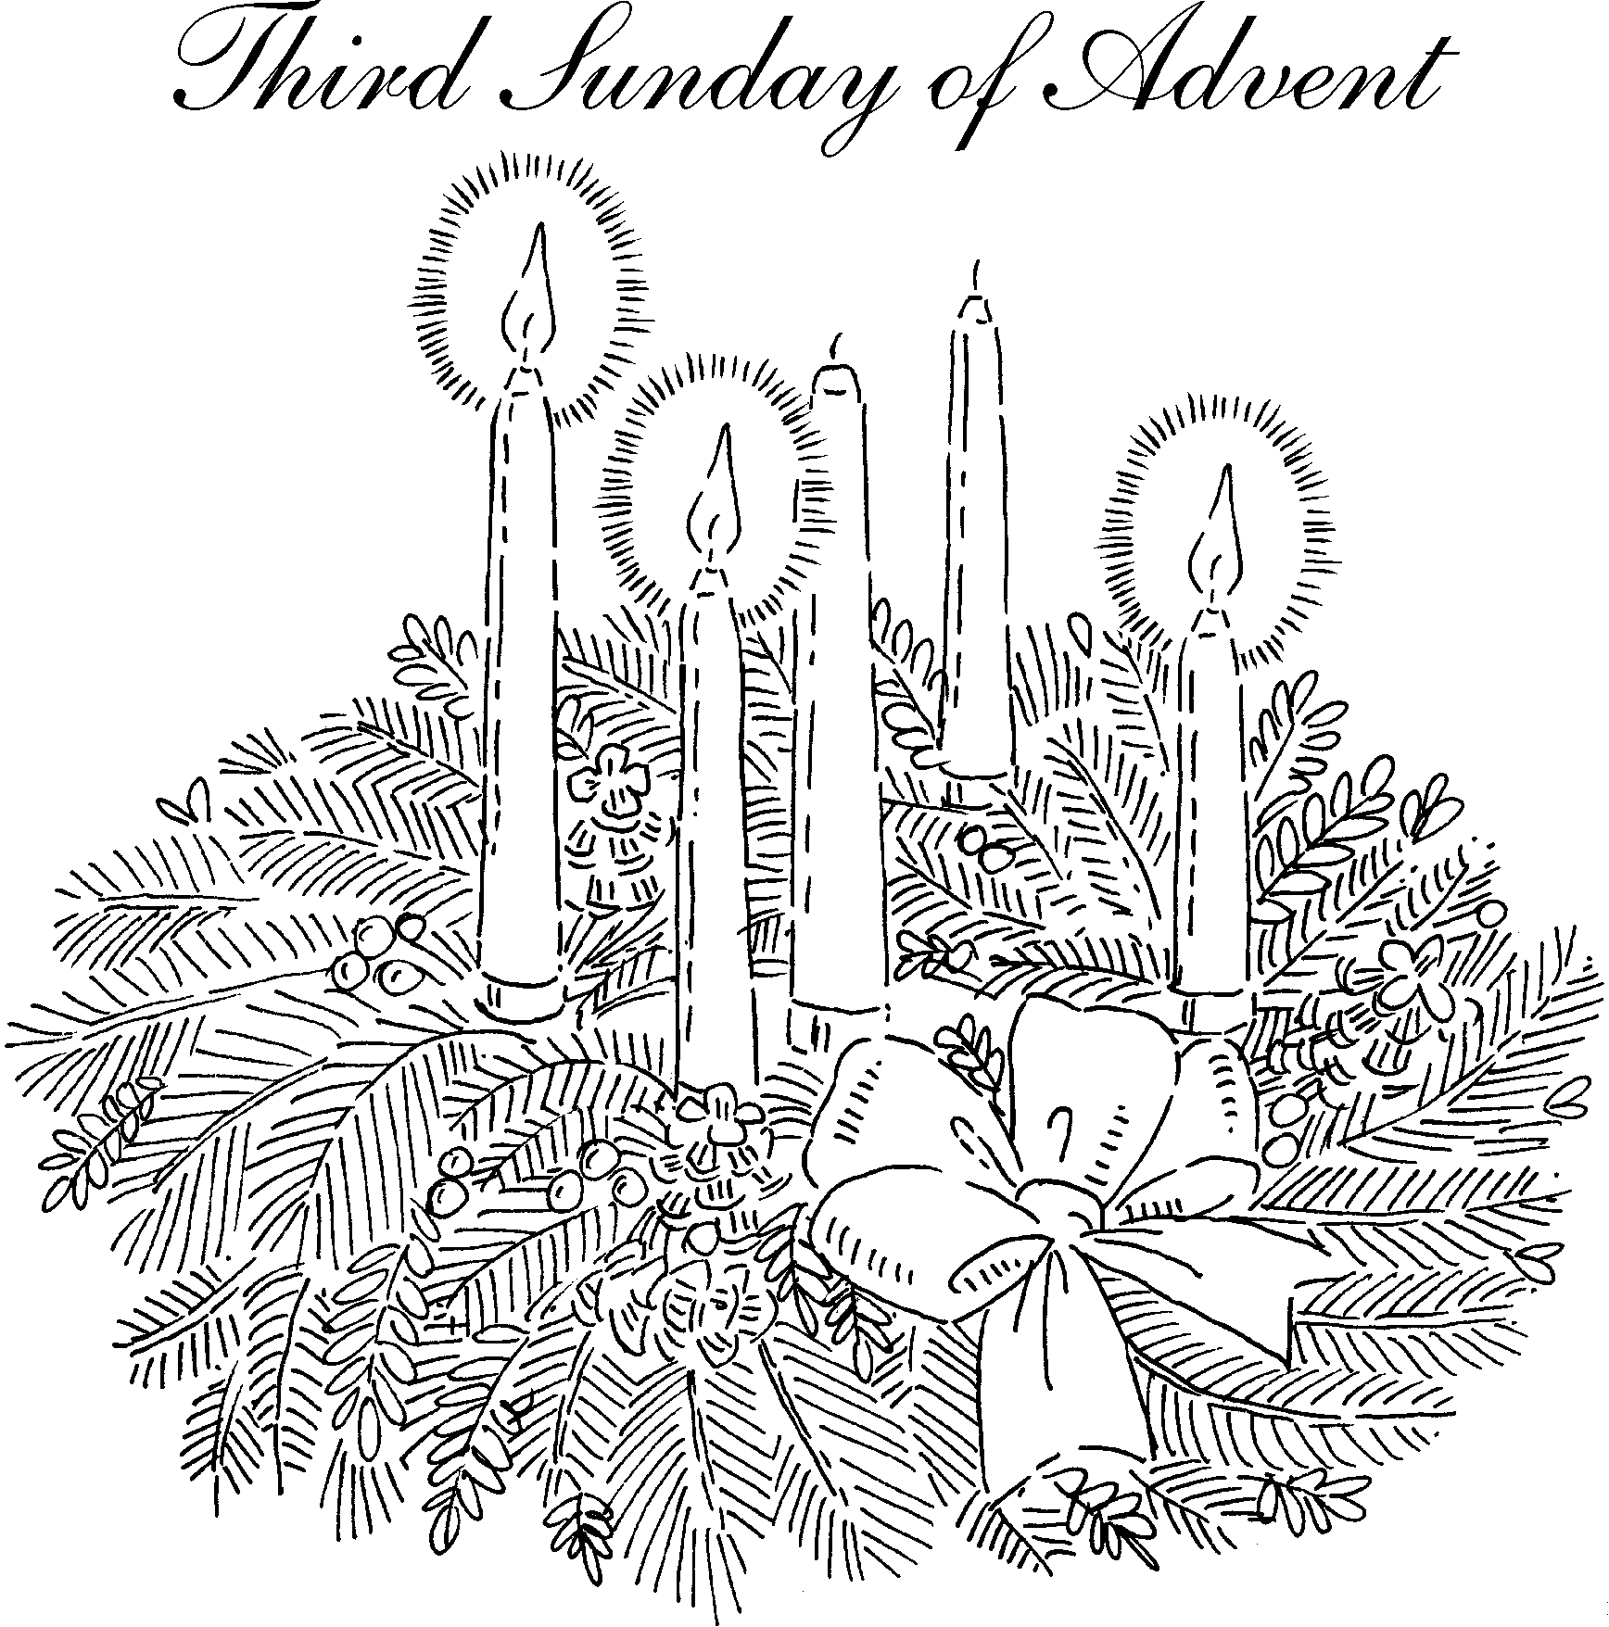
Introduction to the Day

A note of joyful expectation marks the readings for Advent 3. Isaiah announces that the desert shall rejoice and blossom, and Jesus points to the unexpected and transforming signs of God’s reign. We wait with patience for the coming of the Lord, even as we rejoice at his presence among us this day: in word, song, and drams, in church and in our homes, in silent reflection, and in works of justice and love. We pray that God would open our eyes and ears to the wonders of Christ’s advent among us.

Prayer of the Day

Stir up the wills of all who look to you, Lord God, and strengthen our faith in your coming, that, transformed by grace, we may walk in your way; through Jesus Christ, our Savior and Lord, who lives and reigns with you and the Holy Spirit, one God, now and forever. Amen.

Readings and Psalms

Isaiah 35:1-10 The desert blooms as God’s people return from exile
Psalm 146:5-10 The Lord lifts up those who are bowed down. (v. 8)
or Luke 1:46b-55 My spirit rejoices in God my Savior (v. 47)
James 5:7-19 Patience until the coming of the Lord;
Matthew 11:2-11 The forerunner of Christ.



Jesus spoke to the crowds about John: “What did you go out into the wilderness to look at? A reed shaken by the wind? What then did you go out to see? Someone dressed in soft robes? Look, those who wear soft robes are in royal palaces. What then did you go out to see? A prophet? Yes, I tell you, and more than a prophet. This is the one about whom it is written, ‘See, I am sending my messenger ahead of you, who will prepare your way before you.’ Truly I tell you, among those born of women no one has arisen greater than John the Baptist; yet the least in the kingdom of heaven is greater than he.”
Matthew 11:7-11

Today’s Assistants and Ministers

Greeters & Ushers ……………………………………..…....….………… Chuck & Deb Jeffers
Organist / Pianist ……………………..…………..……..………...……..…… Sherry Hareldson
Presiding Minister …………………………...…..…………… Deacon Cindy Cordes-Eversole
Altar Care & Communion Preparation …………………………......…... Chuck & Deb Jeffers
Custodians ………………………….….…….………...….…..…….. Dave & Geri Ann Hanson

This Week in Our Congregation

Today, December 11 — Third Sunday of Advent

Everyone is invited to enjoy refreshments downstairs in the dining room following
the service
Church council meeting after fellowship

Tuesday, December 13

Men’s breakfast at Home Sweet Home, Lanesboro 7:00 AM
Pastor Kerry at Root River Conference Monthly Gathering 9:30 AM
Root Prairie Lutheran Church, rural Fountain

Wednesday, December 14

Pastor Kerry and Deacon Cindy at Bethlehem Church Council meeting 6:30 PM

Next Sunday, December 18 — Fourth Sunday of Advent

Worship, NO Communion 9:00 AM
NO Sunday School until January 8, 2023. See you next year!

Prayer Requests

In Our Community. For our church members and friends living with chronic illness and other diseases, who are homebound, residing in care facilities, and hospitalized. See the newsletter for our members living in area nursing homes. And let us not forget those sick and dying of COVID-19, those entrusted with the authority of government, justice, and law enforcement, as well as our fallen and wounded soldiers and those still serving.

In Our Synod. Bishop Regina Hassanally invites the congregations of our synod to commit to praying this week for the following communities of faith: Immanuel Lutheran Church, Wykoff; Faith Lutheran Church, Janesville; Zumbro Lutheran Church, Rochester; Wanamingo Lutheran Church, Wanamingo; Sepuka Lutheran Church, Tanzania; and Gambella Lutheran Parish, South Sudan.

Community activities

Celebrate Christmas with the Luren Singers, today, 3:00 p.m., at Decorah Lutheran Church, Decorah, IA. Free will offering. All are welcome.

Good Earth Village is sponsoring Beer and Carols, Thursday, December 15, from 7:00 to 8:30 p.m. at the Chatfield Center for the Arts in Chatfield.
Acknowledgments

Graphics, worship texts, service music, readings, and PowerPoint® Slides are from sundaysandseasons.com © 2022 Augsburg Fortress. Used by permission under Augsburg Fortress Liturgies Annual License SAS005401.

Permission to project liturgy and music content under copyright to or administered by Augsburg Fortress provided under Augsburg Fortress Liturgies Annual License SAS005401.

Lighting the Advent Wreath written by Rev. Rich Davis, Senior Pastor, First Presbyterian Church, River Forest, IL. A date was not identified.


Christmas Celebrations

Saturday, December 24, Christmas Eve, 5:00 p.m.
Service of Carols, Communion, and Candlelight
Or watch a service live streamed from our sister congregation, Bethlehem Lutheran, at 5:00 p.m.

Sunday, December 25, Christmas Day
NO IN-PERSON SERVICE AT FOUNTAIN
in-person at and live-streamed from Bethlehem at 9:00 a.m.

Sunday, January 1, First Sunday of Christmas
NO IN-PERSON SERVICE AT FOUNTAIN
Lessons and Carols for Christmas
in-person at and live-streamed from Bethlehem at 9:00 a.m.

You can watch services live on our Facebook page
www.facebook.com/FountainLutheranChurch/
Families and individuals are cordially invited to provide poinsettias or other flowers to decorate our sanctuary during the Christmas Season.

Please tell us if the plant is given “in honor of” or “in memory of” a loved one, or even in celebration of a birthday, baptism, anniversary, etc., so this information can be included in our Christmas bulletins.

Please complete the form below and leave it on the table in the narthex. Better yet, send it to Deb Jeffers or Pastor Kerry via email or text message no later than Sunday,
December 18.

Please bring your plant or flowers to the church by Friday, December 23.

I am giving a plant or other flowers:

Your Name _______________________________________________________________

___ In memory of __________________________________________________________

___ In honor of ____________________________________________________________

___ In celebration of ________________________________________________________

Families and individuals are cordially invited to provide poinsettias or other flowers to decorate our sanctuary during the Christmas Season.

Please tell us if the plant is given “in honor of” or “in memory of” a loved one, or even in celebration of a birthday, baptism, anniversary, etc., so this information can be included in our Christmas bulletins.

Please complete the form below and leave it on the table in the narthex. Better yet, send it to Deb Jeffers or Pastor Kerry via email or text message no later than Sunday,
December 18.

Please bring your plant or flowers to the church by Friday, December 23.

I am giving a plant or other flowers:

Your Name _______________________________________________________________

___ In memory of __________________________________________________________

___ In honor of ____________________________________________________________

___ In celebration of ________________________________________________________

