
Church Mailing Address:
P.O. Box 75
Fountain, MN 55935

Church E-mail Address:
flc@mediacombb.net

Church Office Phone:
507.268.4413

Church Facebook Page
www.facebook.com/FountainLutheranChurch/

Church Website
www.fountainlutheranchurch.com

Pastor Kerry’s E-mail Address:
kbeversole@yahoo.com

Pastor Kerry’s Cell Phone:
507.951.3954

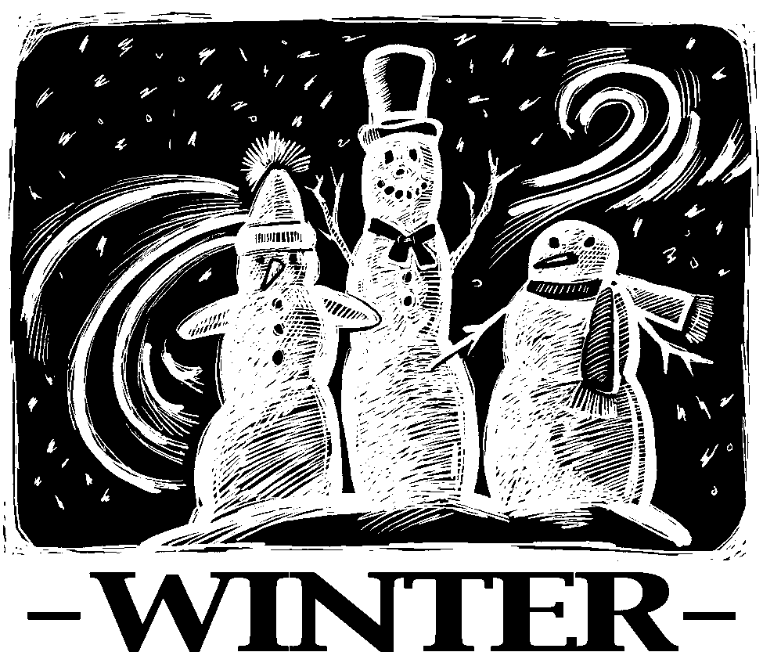Parsonage Phone:
507.467.3017



December Advent & Christmas Worship

Sunday, December 4, 9:00 am

Second Sunday of Advent
with Holy Communion

Sunday, December 11, 9:00 am

Sunday School Christmas Program

Saturday, December 24, 5:00 pm
Christmas Eve
Service of Carols, Communion, and Candlelight

Sunday, December 25

Christmas Day

NO SERVICE AT FOUNTAIN

Worship in-person at Bethlehem at 9:00 am
or online on our Facebook page

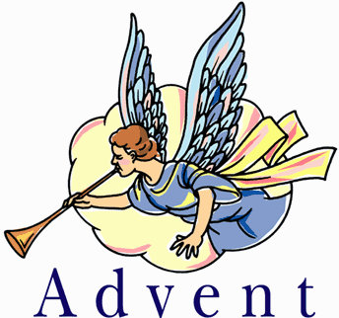Pastor Kerry and Deacon Cindy will be presenting midweek Advent devotions on Wednesday, December 7, December 14, and December 21.
Please note that these brief services will be ONLINE ONLY. THEY WILL NOT BE IN-PERSON GATHERINGS. Instead, they will be posted on our Facebook page sometime each Wednesday.
The theme for these brief devotional services is Prepare the Royal Highway.
Highways, pathways, gates, and journeys figure prominently in the imagery of Advent. We hear the voice shouting, “Prepare the way of the Lord! Make straight the path!” We witness the unexpected detours for Elizabeth and Zechariah, Mary and Joseph. Like them, we make a way in our hearts and lives for our God.
Join us on Fountain’s Facebook page to prepare to celebrate the birth of Jesus, Emmanuel, God with us. The web address is: www.facebook.com/FountainLutheranChurch/
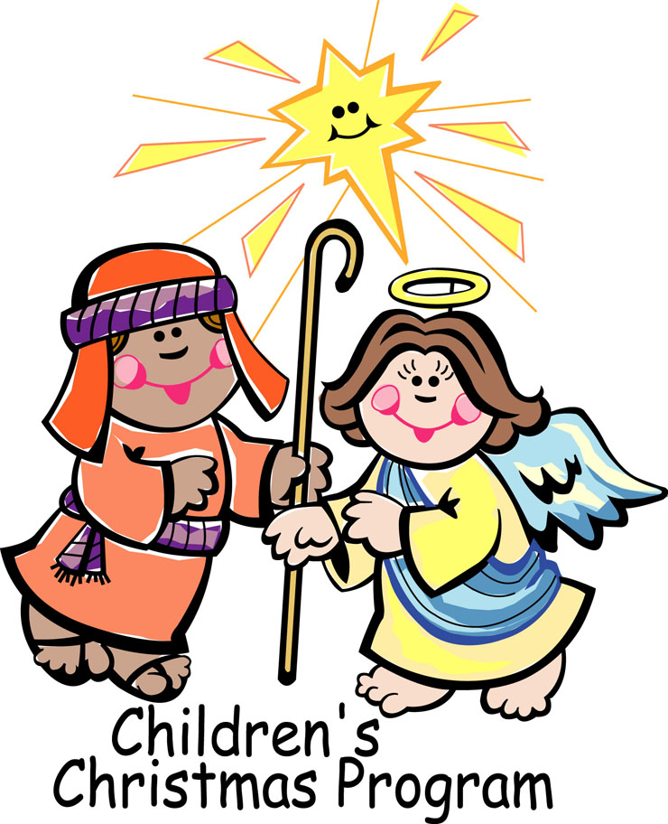Our Sunday School kids, under the direction of Mary Schwarz, Renae Reinhardt, and Geri Ann Hanson will present a Christmas program on Sunday, December 11 at the church at 9:00 a.m. during our usual weekly worship service. The title is A Christmas Podcast and will include a TikTok dance to Go Tell it on the Mountain.
Everyone — parents, siblings, grandparents, friends, parishioners young and old — are invited to attend!
Refreshments will be served after the service.
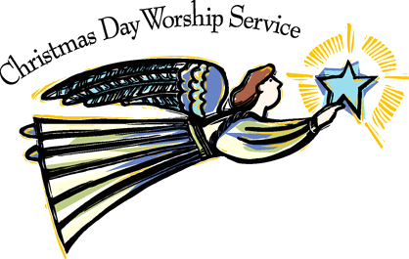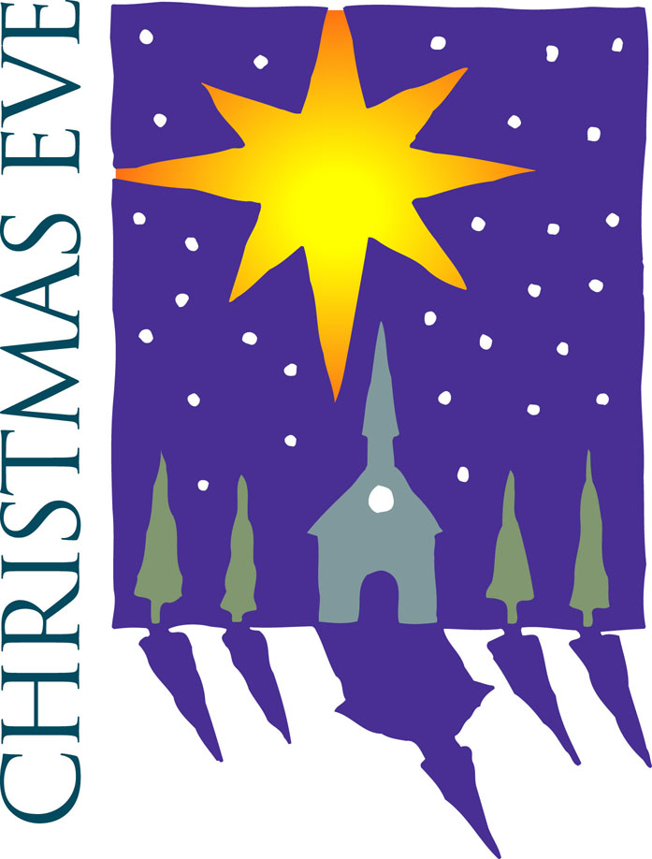Join us for a service of Carols, Communion, and Candlelight on Saturday, December 24, at 5:00 p.m. The service will include Luke’s and John’s Christmas story, carols, Holy Communion, and a candlelight singing of Silent Night, Holy Night.
NO SERVICE AT FOUNTAIN
ON CHRISTMAS DAY
SUNDAY, DECEMBER 25
You are more than welcome to attend worship at our sister congregation, Bethlehem Lutheran in Lanesboro, at 9:00 a.m.
Or, as usual, you can view the live stream of the service on Fountain’s Facebook page: www.facebook.com/FountainLutheranChurch/
Schedule of Services for December
Sunday, December 4
Second Sunday of Advent
with Holy Communion

Wednesday, December 7
Midweek Advent Devotion
Look for it on our Facebook page

Sunday, December 11
Third Sunday of Advent
Sunday School
Christmas Program

Wednesday, December 14
Midweek Advent Devotion
Look for it on our Facebook page

Sunday, December 18
Fourth Sunday of Advent

Wednesday, December 21
Midweek Advent Devotion
Look for it on our Facebook page

Saturday, December 24
Christmas Eve
Carols, Communion, and Candlelight Service
5:00 pm

Sunday, December 25
Christmas Day
NO SERVICE AT FOUNTAIN
In-person at Bethlehem at 9:00 am or online on Fountain’s Facebook page

Chuck and Deb Jeffers oversee the paraments, banners, and Communion preparation for December.

Sunday, December 4
Second Sunday of Advent
The parament color is Blue

Sunday, December 11
Third Sunday of Advent
The parament color is Blue

Sunday, December 19
Fourth Sunday of Advent
The parament color is Blue

Saturday, December 24
Christmas Eve
The parament color is White

Sunday, December 25
Christmas Day
The parament color is White

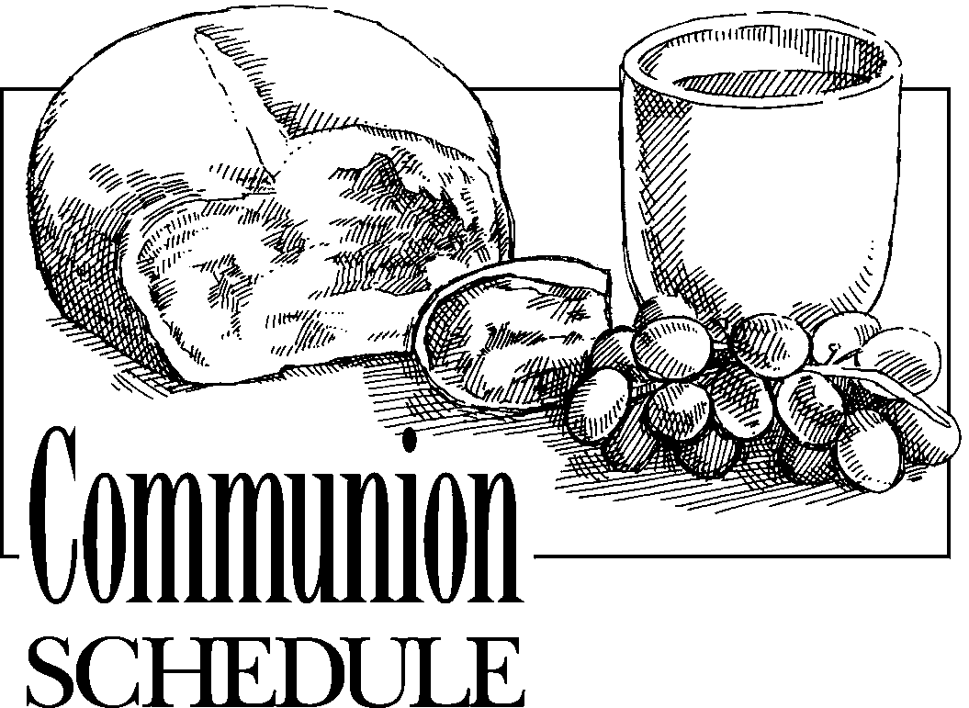

Sunday, December 4
In procession

Christmas Eve, December 24
In procession
Chuck and Deb Jeffers are the ushers for December.

Commemoration of Saint Nick
Tuesday, December 6
Nicholas, Bishop of Myra, died around 342
Though Nicholas is one of the church's most beloved saints, little is known about his life. In the fourth century, he was a bishop in what is now Turkey. Legends that surround Nicholas tell of his love for God and neighbor, especially the poor. One famous story tells of Nicholas secretly giving bags of gold to the three daughters of a father who was going to sell them into prostitution because he could not provide dowries for them. Nicholas has become a symbol of anonymous gift-giving, and is associated with Santa Claus of American culture, and Father Christmas of English folklore.

From sundaysandseasons.com
© 2022 Augsburg Fortress. Used by permission under Augsburg Fortress Liturgies Annual License SAS005401.
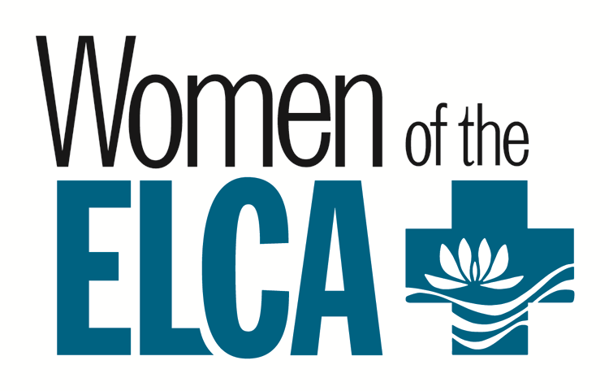Advent Devotional
The December Gather magazine Bible study is not the next installment of a multi-month study. Rather, it’s a devotional for the season of Advent, written by the Rev. Dr. Becca Ehrlich and titled “Good things come in small packages: Moving from wanting to waiting at Advent”.
“Small packages” is clearly a reference to Messiah Jesus whose birth the church will celebrate at Christmas. But it may also refer to Becca’s offering of brief writing for each of the four weeks of Advent.
Week 1: The “More” Myth; Luke 12:13-21.
Week 2: The Appearance Illusion; 1 Samuel 16:1-13.
Week 3: The Still, Small Voice; 1 Kings 19:11-13.
Week 4: The Best Thing Came in a Small Package; Luke 2:1-20.
You don’t have to subscribe to Gather to enjoy this Advent devotional. Just type www.gathermagazine.org into your web browser, then click on “DOWNLOAD THE ADVENT DEVOTIONAL PDF”.

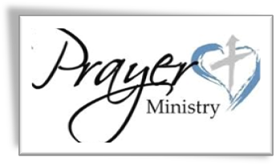Our 9th Grade Confirmand this school year

Caroline Himli-Seelbinder.

Our 10th Graders who affirmed their baptism on Sunday, November 6

Fox Andersen, Lena Andersen, and Mara Schwarz.

Those Living in Care Centers

MaryAnn Hamann, Larry Hunt, and Duaine Bacon at Chosen Valley Care Center, Chatfield; Mervin Heidtke at Gundersen Harmony Care Center, Harmony.

Those Living with Chronic Illness and other Diseases including Cancer

David Drury and Bob Redalen.

Our Homebound Members

Mary Dohrmann, Merv & Carol Heidke.

Those Whom You Can Name

Please contact Pastor Kerry or Deacon Cindy and let them know about your loved one or friend.

of Dave Gudmundson’s dad, Gordon
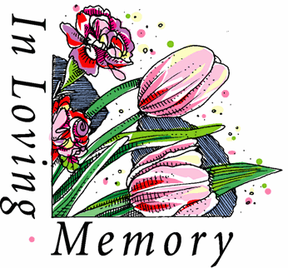Gordon Lester Gudmundson, age 99, died peacefully on Saturday, November 19, 2022, in Youngtown, Arizona.
Gordon Gudmundson was born June 17, 1923. He married Selvina Erickson in 1952, and had one child, Dave. They were later divorced. In 1981, he married Lucille Siefert and they enjoyed their retirement in Sun City, Arizona. Lucille passed away in 2019 and Gordy continued to live in Arizona.
Gordy served in the Army for a short period of time until coming home to work on the family farm in Highland. After service and the farm, Gordy was a can milk hauler for the Preston Creamery where he met his first wife, Sally. After that, he operated Gudmundson Livestock in Chatfield until 1966. Gordy was a cattle buyer for Zumbrota Sales Barn, Lanesboro Sales Barn, and Lewiston Sales Barn.
Continued the next page.
Gordon Gudmundson obituary continued
He held many positions in the Fountain Community on the Fountain Fire Department, Fountain Lutheran Church Council, and Fountain City Council. Gordy fully retired in 2012. He and Lucille lived their final years in Arizona. He enjoyed cooking, playing cards, dancing, and going to casinos.
Gordy is survived by his son, Dave (Kathy) of Fountain, Minnesota; and two granddaughters, Lisa (Bryan) Ostby of Fountain, Minnesota, and Sara (Brian) Schroeder of Preston, Minnesota; five great-grandchildren, Terron, Rylan and Taylor Ostby, and Hayden and Elydie Schroeder; one sister-ln-law, Evelyn Gudmundson; and many nieces and nephews.
Gordy was preceded in death by his parents, Maria and Sigvart Gudmundson; three brothers, Siebert, LeRoy, and Delyle, and two sisters, Myranda and Vivian.
A private family memorial service will be held on Friday, December 9, at 2:00 p.m., at Fountain Lutheran Church with burial following at the Minnesota State Veterans Cemetery in Preston.

of Chuck Jeffer’s brother, Bill
William “Bill” Lloyd Jeffers, age 80, of Rushford, Minnesota passed away surrounded by family at home after a 3-year battle with cancer on November 22, 2022. William was born on July 8, 1942 to parents Lloyd and Aletha (Young) Jeffers in Preston, Minnesota.
Bill was raised on a farm near Peterson and graduated from Peterson High School in 1960. He enlisted in the Army Reserves and served from October 1964 to October 1970. On November 26, 1969, he was united in marriage to Carol (Eickhoff) Utley. He welcomed three little girls, Star, Alecia, and Sandi, into his life with that union. Bill and Carol adopted a son, Reid, in 1973 and their family became complete.
Throughout his lifetime, he had been a logger, dairy & hog farmer, and worked for the State of Minnesota Highway Maintenance Department, attending his grandchildren’s activities, watching sports of all kinds, and spending time with family and friends. He also enjoyed listening to classic country music. Bill and Carol were fortunate to enjoy part of their retirement in Arizona for 8 years.
Bill is survived by his wife, Carol Jeffers; children, Star, Alecia (Lowell), and Reid (Kristi); 10 grandchildren; 17 great-grandchildren; and siblings, John, Tom, Judy, and Chuck Jeffers. He was preceded in death by his parents, Lloyd and Aletha; daughter, Sandi Utley; infant granddaughter; parents-in-law, Eddie and Edna Eickhoff; and brothers, James Garvalia and Richard Jeffers.
A memorial service for Bill was held at 11:00 a.m. on Saturday, November 26, 2022 at Rushford Lutheran Church with Pastor Steve Chellew officiating. Burial will be held at a later date at the Minnesota State Veterans Cemetery in Preston, Minnesota.
Thanks be to God for

Fountain Lutheran Church
P.O. Box 75
Fountain, MN 55935-0075

ADDRESS SERVICE REQUESTED

FOUNTAIN MESSENGER


via

SUNDAYS at 9:00 am
www.facebook.com/FountainLutheranChurch/

