Fountain Lutheran Church
Established 1904

Rev. Kerry B. Eversole, Pastor
Deacon Cindy Cordes-Eversole, Associate in Ministry

Mailing Address: P.O. Box 75, Fountain, MN 55935
Physical Address: 314 Main Street, Fountain, Minn.

Church Office Phone: 507.268.4413
E-mail Address: flc@mediacombb.net
Website: www.fountainlutheranchurch.com
Facebook Page: www.facebook.com/FountainLutheranChurch/

Parsonage Phone: 507.467.3017
Pastor Kerry’s Cell Phone: 507.951.3954

Our Global Partner Congregation: Issuna Lutheran Church, Tanzania
Fountain Lutheran Church
Fountain, Minnesota

Second Sunday after Epiphany

January 15, 2023



John was standing with two of his disciples, and as he watched Jesus walk by, he exclaimed, “Look, here is the Lamb of God!” The two disciples heard him say this, and they followed Jesus. When Jesus turned and saw them following, he said to them, “What are you looking for?” They said to him, “Rabbi”, “where are you staying?” He said to them, “Come and see.” John 1:35-39
Welcome to worship at Fountain Lutheran Church
and our celebration of God’s Light arising upon us!
Isaiah 60:1-3; John 1:1-5

COVID-19 Practices — Out of love for God and Neighbor

1) Use hand sanitizer upon entry. Wash your hands and use hand sanitizer often while in the facility.
2) Members and visitors who are vaccinated and boosted are not required to wear a mask.
3) Members and visitors are free to wear a mask if they wish to do so.
4) Unvaccinated and not boosted members and visitors must wear a mask.
5) There are no physical distancing requirements, but you are welcome to keep a distance from others in the sanctuary as you are able.
6) All are welcome to enjoy coffee fellowship in the narthex or downstairs in the dining room following worship.

Worship Book and Hymns. This morning’s service is printed in this bulletin. All of the hymns can be found in Evangelical Lutheran Worship (ELW), “the red book” in the pews. Hymns in ELW are indicated by a large bold number in each page’s left or right margin.

Abbreviations. Hymns are signified throughout this worship folder by the pound symbol (#); P: refers to the presiding minister or preacher; A: denotes an assisting minister; and C: and/or bold text indicates the congregation.

Offering. Later in our service, we will be receiving an offering. The offering is an opportunity to worship God with our money. We know that the money you give to Fountain Lutheran Church represents your lives — your time, talents, and hard work. We recognize that and we appreciate your generosity. Your support not only helps all of us to fulfill God’s call on our lives, but it also makes an impact, and we thank you! Lastly, our visitors are not expected to give. After all, you are our guests! We’re glad you’re here and we want you to feel welcomed!

Mistakes do not happen in our worship service;
only unexpected events which are opportunities for joy!

An asterisk () signifies that you may stand, as you are comfortably able.


Gathering

The Holy Spirit calls us together as the people of God.

Introduction to the day. Last Sunday, we celebrated the Baptism of Our Lord. Today’s gospel opens with further reflection on Jesus’s baptism. He is the Lamb of God who takes away the sin of the world and the one anointed by the Spirit. In the liturgy we come and see Christ revealed among us in word and sacrament. We go forth to invite others to come and worship the Holy One and to receive the gifts of grace and peace made known among us.

PRELUDE

RINGING OF THE BELL

OPENING HYMN Christ Be Our Light ELW # 715

GREETING ELW p. 203

P: The grace of our Lord Jesus Christ, the love of God, and the communion of the Holy Spirit be with you all.

C: And also with you.

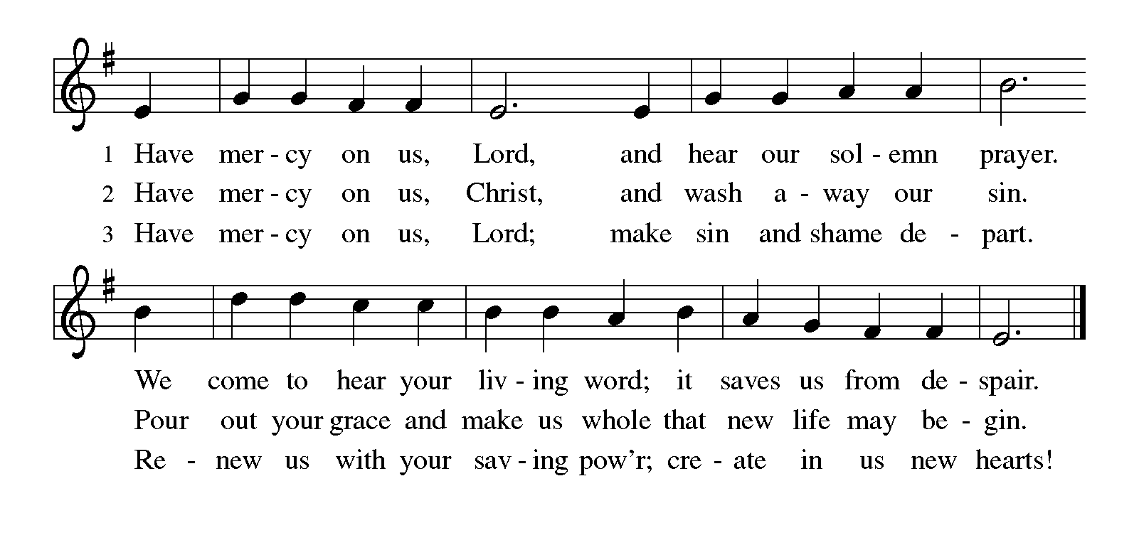KYRIE ELW p. 203

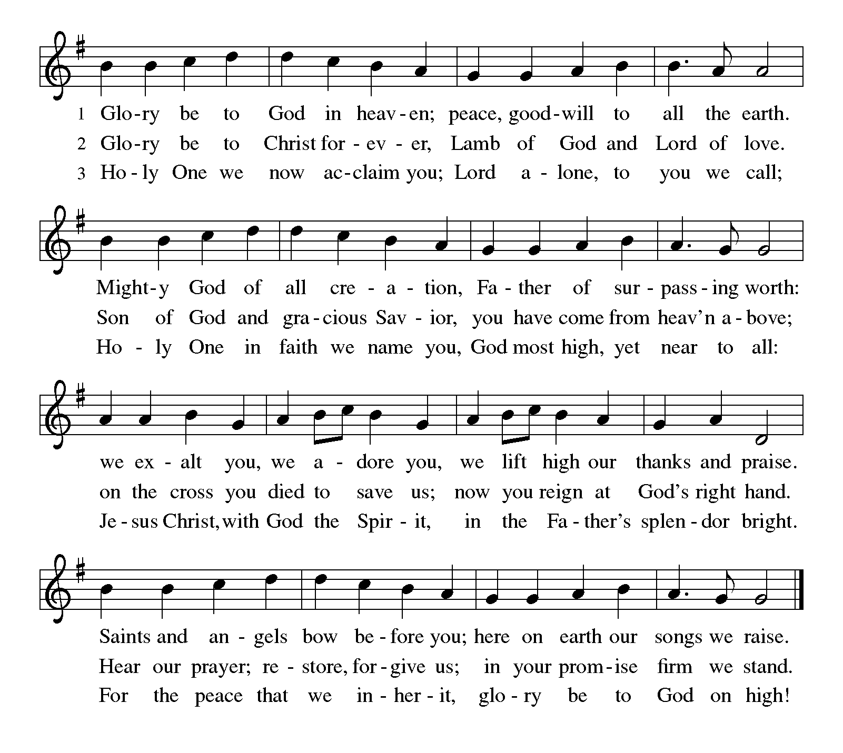CANTICLE OF PRAISE Glory to God ELW p. 204

PRAYER OF THE DAY

P: Holy God, our strength and our redeemer, by your Spirit hold us forever, that through your grace we may worship you and faithfully serve you, follow you and joyfully find you, through Jesus Christ, our Savior and Lord.

C: Amen.

Word

God speaks to us in scripture reading, preaching, and song.

FIRST READING Isaiah 49:1-7

Here the servant, identified as Israel, speaks for herself and describes her honored mission. Called before her birth like Jeremiah and John the Baptist, the servant is not only to restore Israel. The servant’s ultimate assignment is to bring news of God’s victory to the ends of the earth. God in faithfulness has chosen Israel for this task.

¹Listen to me, O coastlands,
pay attention, you peoples from far away!
The Lord called me before I was born,
while I was in my mother’s womb he named me.
²He made my mouth like a sharp sword,
in the shadow of his hand he hid me;
he made me a polished arrow,
in his quiver he hid me away.
³And he said to me, “You are my servant,
Israel, in whom I will be glorified.”
⁴But I said, “I have labored in vain,
I have spent my strength for nothing and vanity;
yet surely my cause is with the Lord,
and my reward with my God.”
⁵And now the Lord says,
who formed me in the womb to be his servant,
to bring Jacob back to him,
and that Israel might be gathered to him,
for I am honored in the sight of the Lord,
and my God has become my strength—
⁶he says,
“It is too light a thing that you should be my servant
to raise up the tribes of Jacob
and to restore the survivors of Israel;
I will give you as a light to the nations,
that my salvation may reach to the end of the earth.”
⁷Thus says the Lord,
the Redeemer of Israel and his Holy One,
to one deeply despised, abhorred by the nations,

Continued on the next page
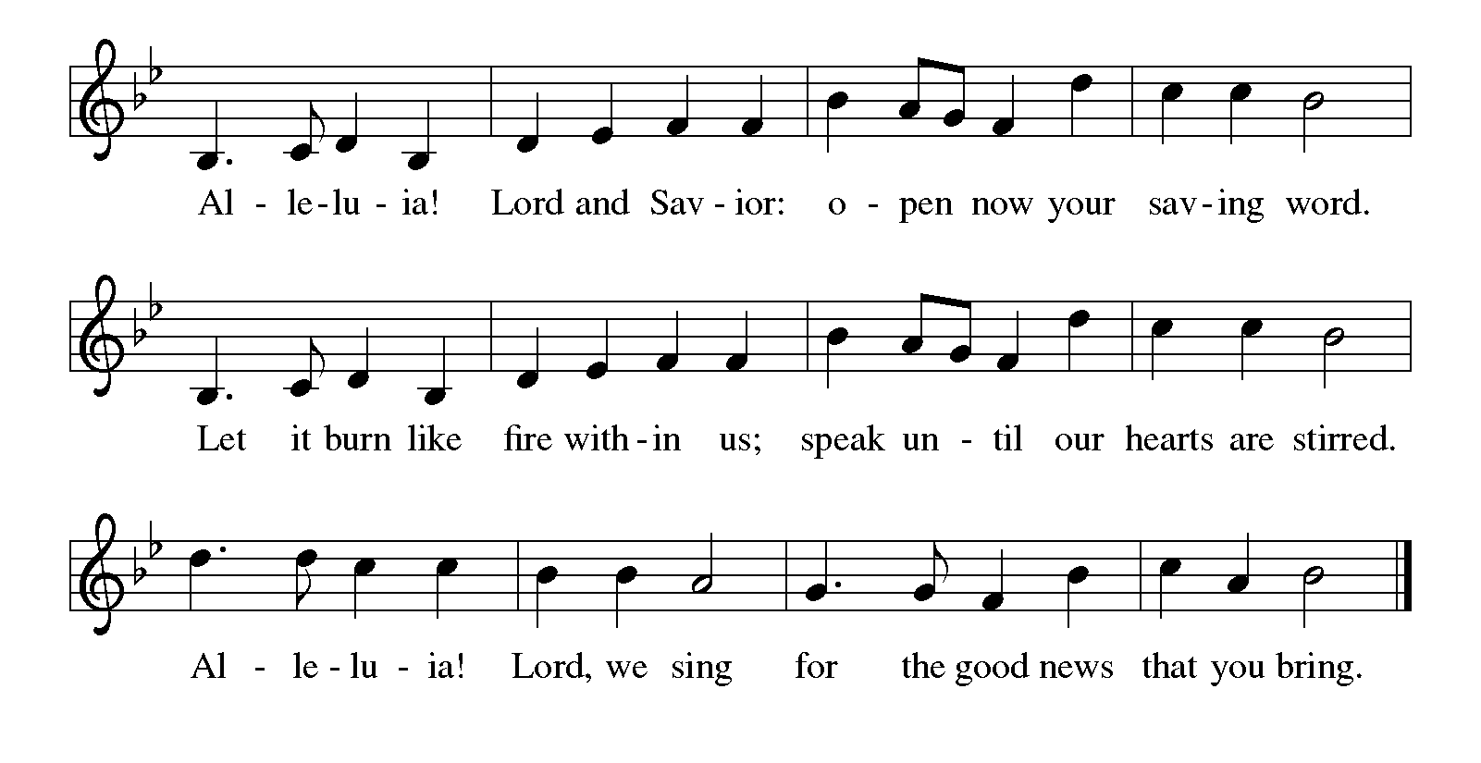the slave of rulers,
“Kings shall see and stand up,
princes, and they shall prostrate themselves,
because of the Lord, who is faithful,
the Holy One of Israel, who has chosen you.”

A: The word of the Lord.

C: Thanks be to God.

SECOND READING 1 Corinthians 1:1-9

Although God’s church in Corinth is a fractious congregation beset with many conflicts, Paul opens this letter by spotlighting the multiple ways God has enriched and sustained its life as part of the divine call into the fellowship of our Lord Jesus Christ.

¹Paul, called to be an apostle of Christ Jesus by the will of God, and our brother Sosthenes,
²To the church of God that is in Corinth, to those who are sanctified in Christ Jesus, called to be saints, together with all those who in every place call on the name of our Lord Jesus Christ, both their Lord and ours:
³Grace to you and peace from God our Father and the Lord Jesus Christ.
⁴I give thanks to my God always for you because of the grace of God that has been given you in Christ Jesus, ⁵for in every way you have been enriched in him, in speech and knowledge of every kind—⁶just as the testimony of Christ has been strengthened among you—⁷so that you are not lacking in any spiritual gift as you wait for the revealing of our Lord Jesus Christ. ⁸He will also strengthen you to the end, so that you may be blameless on the day of our Lord Jesus Christ. ⁹God is faithful; by him you were called into the fellowship of his Son, Jesus Christ our Lord.

A: The word of the Lord.

C: Thanks be to God.

GOSPEL ACCLAMATION Alleluia ELW p. 205

Printed on the next page

GOSPEL John 1:29-42

P: Announcement of the Gospel.

C: Glory to you, O Lord.

John the Baptist’s witness to Jesus initiates a chain of testimony as his disciples begin to share with others what they have found.

²⁹[John the Baptist] saw Jesus coming toward him and declared, “Here is the Lamb of God who takes away the sin of the world! ³⁰This is he of whom I said, ‘After me comes a man who ranks ahead of me because he was before me.’ ³¹I myself did not know him; but I came baptizing with water for this reason, that he might be revealed to Israel.” ³²And John testified, “I saw the Spirit descending from heaven like a dove, and it remained on him. ³³I myself did not know him, but the one who sent me to baptize with water said to me, ‘He on whom you see the Spirit descend and remain is the one who baptizes with the Holy Spirit.’ ³⁴And I myself have seen and have testified that this is the Son of God.”
³⁵The next day John again was standing with two of his disciples, ³⁶and as he watched Jesus walk by, he exclaimed, “Look, here is the Lamb of God!” ³⁷The two disciples heard him say this, and they followed Jesus. ³⁸When Jesus turned and saw them following, he said to them, “What are you looking for?” They said to him, “Rabbi” (which translated means Teacher), “where are you staying?” ³⁹He said to them, “Come and see.” They came and saw where he

Continued on the next page
was staying, and they remained with him that day. It was about four o’clock in the afternoon. ⁴⁰One of the two who heard John speak and followed him was Andrew, Simon Peter’s brother. ⁴¹He first found his brother Simon and said to him, “We have found the Messiah” (which is translated Anointed). ⁴²He brought Simon to Jesus, who looked at him and said, “You are Simon son of John. You are to be called Cephas” (which is translated Peter).

P: Affirmation of the Gospel.

C: Praise to you, O Christ.

SERMON

HYMN OF THE DAY This Little Light of Mine ELW # 677

Responding to the Word — the Light and the Lamb of God

OFFERING Music by Sherry Hareldson

At this point in our service, we worship God with our money. The ushers will pass plates down the pews to receive your gifts of cash and checks made out to Fountain Lutheran Church. You can even give online at secure.myvanco.com/ YM2F/. Your gifts support the worship, faith formation, administration, and other ministries of Fountain Lutheran as well as the mission of the Southeastern Minnesota Synod, and the whole Evangelical Lutheran Church in America. God bless your giving and your generosity. And thank you!

OFFERING SONG Lamb of God ELW # 336

PRAYERS OF INTERCESSION

Each petition ends with these words and response:

P: Merciful God,

C: receive our prayer.

Concluding petition and response:

P: We bring to you our needs and hopes, O God, trusting your wisdom and power revealed in Christ crucified.

C: Amen.

LORD’S PRAYER Traditional Wording ELW p. 208

P: Gathered into one by the Holy Spirit, let us pray as Jesus taught us.

All: Our Father, who art in heaven, hallowed be thy name, thy kingdom come, thy will be done, on earth as it is in heaven. Give us this day our daily bread; and forgive us our trespasses, as we forgive those who trespass against us; and lead us not into temptation, but deliver us from evil. For thine is the kingdom, and the power, and the glory, forever and ever. Amen.

Sending

God blesses us and sends us in mission to the world.

ANNOUNCEMENTS

BLESSING

P: The God who faithfully brings forth justice
and breaks the oppressor’s rod
☩ bless, strengthen, and uphold you,
today and always.

C: Amen.

DEPARTING HYMN Rise, Shine, You People ELW # 665

DISMISSAL

P: Go in peace. Follow the way of Jesus.

C: Thanks be to God.

RINGING OF THE BELL

POSTLUDE

Commemoration

Monday, January 16
Martin Luther King Jr., renewer of society, martyr (1929–1968)

The third Monday of January has for some time been a civil holiday honoring Dr. King. In the Christian church, most commemorations are held on the date of the person's death, but many churches hold commemorations near his birth date of January 15, in conjunction with the holiday honoring him. An alternate date for the commemoration would be his death date, April 4.

Martin Luther King Jr. is remembered as an American prophet of justice among races and nations, a Christian whose faith undergirded his advocacy of vigorous yet nonviolent action for racial equality. A pastor of churches in Montgomery, Alabama, and Atlanta, Georgia, his witness was taken to the streets in such other places as Birmingham, Alabama, where he was arrested and jailed while protesting against segregation. He preached nonviolence and demanded that love be returned for hate. Awarded the Nobel Peace Prize in 1964, he was killed by an assassin on April 4, 1968.
One way to remember King is by singing “We shall overcome” in the hymnbook This Far by Faith, # 213, or “Holy God, you raise up prophets” also in This Far by Faith, # 299.

Today’s Assistants and Ministers

Greeters & Ushers …………………………....….………… Dave Gudmundson & Jim Schott
Organist-Pianist ……………………..….……………….………...……..…… Sherry Hareldson
Presiding Minister ……………………………………....…..…………… Pastor Kerry Eversole
Altar Care & Communion Preparation ……..……......…... Lisa Ostby & Kathy Gudmundson
Custodians ………………………….….…….………...….…..…….. Dave & Geri Ann Hanson

This Week in Our Congregation

Today, January 15 — Second Sunday after Epiphany

Sunday School after the children’s message
Refreshments in the narthex or downstairs for everyone after worship

Tuesday, January 17

Men’s breakfast at Home Sweet Home, Lanesboro 7:00 AM

Next Sunday, January 22 — Third Sunday after Epiphany

Worship with Holy Communion 9:00 AM
Sunday School after the children’s message
Pastor Kerry and Deacon Cindy at Bethlehem’s Annual Meeting of the Congregation

News and Notes

Note to church groups, committees, and ministry teams: Written reports for the 2022 Annual Report should be submitted by email, regular mail, or dropped off at the church office by next Sunday, January 22, 2023!

The Church Council is seeking leaders and representatives for 2023. Two (2) people, each to serve a three-year term, are needed to fill approaching vacancies on the church council. In addition, voting members to forthcoming annual meetings are also needed: Root River Conference Assembly, Good Earth Village, and the Southeastern Minnesota Synod Assembly. Please prayerfully consider accepting one of these important leadership roles in our congregation. Contact council president Ken Hollerman at 507-421-7435 or Pastor Kerry at 507-951-3954.

Notice of Congregational Meeting. In accordance with the constitution and bylaws of Bethlehem Lutheran Church of Lanesboro, Minnesota, official notice is hereby given of the annual meeting of the congregation on Sunday, January 29, 2023 immediately following the 9:00 a.m. worship service. The meeting will take place downstairs in the Dining Room/Fellowship Hall. The purpose of this meeting is to present the mission and ministries carried out in 2022, elect leaders, adopt a spending plan for 2023, and conduct any other business that may properly come before the congregation.

Online registration is open and print & mail forms are available for Summer 2023 at Good Earth Village Bible Camp! Use code EARLY23 to save 10% on registration fees, excludes preschool play day. For a limited time, each camper registered can receive a free summer theme t-shirt. One t-shirt per camper if registered for multiple camps. Siblings each receive a 25% discount with code SIBLING23, excludes Intergen Family Camp. Discounts cannot be combined. Go to www.goodearthvillage.org to register or call (507) 346-2494 or email info@goodearthvillage.org.

Prayer Requests

In Our Community. For our church members and friends living with chronic illness and other diseases, who are homebound, residing in care facilities, and hospitalized. See the newsletter for our members living in area nursing homes. And let us not forget those sick and dying of COVID-19, those entrusted with the authority of government, justice, and law enforcement, as well as our fallen and wounded soldiers and those still serving.

In Our Synod. Bishop Regina Hassanally invites the people and congregations of our Southeastern Minnesota Synod to make a commitment to pray this week for the following faith communities: First Lutheran Church, Albert Lea; Henrytown Lutheran Church, Canton; Ascension Lutheran Church, Albert Lea; Grace Lutheran Church, Fairmont; Kinampanda Lutheran Church, Tanzania; Mazoezi Mughamo Lutheran Church, Tanzania; and Espiritu de Vida Lutheran Church, Colombia.

Acknowledgments

Graphics, worship texts, service music, readings, and PowerPoint® Slides are from sundaysandseasons.com © 2023 Augsburg Fortress. Used by permission under Augsburg Fortress Liturgies Annual License SAS005401.

Permission to project liturgy and music content under copyright to or administered by Augsburg Fortress provided under Augsburg Fortress Liturgies Annual License SAS005401.



