Fountain Lutheran Church
Established 1904

Rev. Kerry B. Eversole, Pastor
Deacon Cindy Cordes-Eversole, Associate in Ministry

Mailing Address: P.O. Box 75, Fountain, MN 55935
Physical Address: 314 Main Street, Fountain, Minn.

Church Office Phone: 507.268.4413
E-mail Address: flc@mediacombb.net
Website: www.fountainlutheranchurch.com
Facebook Page: www.facebook.com/FountainLutheranChurch/

Parsonage Phone: 507.467.3017
Pastor Kerry’s Cell Phone: 507.951.3954

Our Global Partner Congregation: Issuna Lutheran Church, Tanzania
Fountain Lutheran Church
Fountain, Minnesota

Second Sunday in Lent

March 5, 2023


For God so loved the world that he gave his only Son, so that everyone who believes in him may not perish but may have eternal life. Indeed, God did not send the Son into the world to condemn the world, but in order that the world might be saved through him. John 3:16-17
Welcome to worship at Fountain Lutheran Church
and the season of Lent!
Lent is the forty-day period before Easter. It’s a time for reflection, penitence, and preparation for new life.

COVID-19 Practices — Out of love for God and Neighbor

1) Use hand sanitizer upon entry. Wash your hands and use hand sanitizer often while in the facility.
2) Members and visitors who are vaccinated and boosted are not required to wear a mask.
3) Members and visitors are free to wear a mask if they wish to do so.
4) Unvaccinated and not boosted members and visitors must wear a mask.
5) There are no physical distancing requirements, but you are welcome to keep a distance from others in the sanctuary as you are able.
6) All are welcome to enjoy coffee fellowship in the narthex or downstairs in the dining room following worship.

Worship Book and Hymns. This morning’s service is printed in this bulletin. Portions can also be found with all the hymns in Evangelical Lutheran Worship (ELW), “the red book” in the pews. Hymns in ELW are indicated by a large bold number in each page’s left or right margin.

Abbreviations. Hymns are signified throughout this worship folder by the pound symbol (#); P: refers to the presiding minister or preacher; A: denotes an assisting minister; and C: and/or bold text indicates the congregation.

Offering. Later in our service, we will be receiving an offering. The offering is an opportunity to worship God with our money. We know that the money you give to Fountain Lutheran Church represents your lives — your time, talents, and hard work. We recognize that and we appreciate your generosity. Your support not only helps all of us to fulfill God’s call on our lives, but it also makes an impact, and we thank you! Lastly, our visitors are not expected to give. After all, you are our guests! We’re glad you’re here and we want you to feel welcome!

Mistakes do not happen in our worship service;
only unexpected events which are opportunities for joy!

An asterisk () signifies that you may stand, as you are comfortably able.

Gathering

The Holy Spirit calls us together as the people of God.

Introduction to the Season. On Ash Wednesday, we began the season of Lent and our annual baptismal journey with Jesus to his death on the cross and his glorious resurrection. The forty days of Lent are like no other. It is our opportune time to return to the God who rescues; to receive the gifts of God’s grace; to believe with the heart and confess with the mouth the wonder of God’s love in Jesus.

Introduction to the Day. In today’s gospel, Jesus tells Nicodemus that he must be born of water and Spirit. At the font we are a given a new birth as children of God. As God made a covenant with Abraham, in baptism God promises to raise us up with Christ to new life. From worship we are sent forth to proclaim God’s love for all the world.

PRELUDE

RINGING OF THE BELL, WELCOME, AND INTRODUCTION TO THE DAY

THANKSGIVING FOR BAPTISM

All may make the sign of the cross, the sign marked at baptism, as the presiding minister begins.

P: In the name of the Father, and of the ☩ Son, and of the Holy Spirit.

C: Amen.

P: Joined to Christ in the waters of baptism, we are clothed with God's mercy and forgiveness. Let us give thanks for the gift of baptism.

We give you thanks, O God, for in the beginning your Spirit moved over the waters and by your Word you created the world, calling forth life in which you took delight.

Through the waters of the flood you delivered Noah and his family. Through the sea you led your people Israel from slavery into freedom.
At the river your Son was baptized by John and anointed with the Holy Spirit.

By water and your Word you claim us as daughters and sons,
making us heirs of your promise and servants of all.

We praise you for the gift of water that sustains life,
and above all we praise you for the gift of new life in Jesus Christ.

Continued on the next page.
P: Shower us with your Spirit, and renew our lives with your forgiveness, grace, and love.

To you be given honor and praise through Jesus Christ our Lord in the unity of the Holy Spirit, now and forever.

C: Amen.

OPENING HYMN We Are Baptized in Christ Jesus ELW # 451

GREETING

P: The grace of our Lord Jesus Christ, the love of God, and the communion of the Holy Spirit be with you all.

C: And also with you.

PRAYER OF THE DAY

P: O God, our leader and guide, in the waters of baptism you bring us to new birth to live as your children. Strengthen our faith in your promises, that by your Spirit we may lift up your life to all the world through your Son, Jesus Christ, our Savior and Lord, who lives and reigns with you and the Holy Spirit, one God, now and forever.

C: Amen.

God’s Lenten Word

God speaks to us in scripture reading, preaching, and song.

FIRST READING Genesis 12:1-4a

God’s call of Abram and Sarai has a clear purpose—that through them all the families of the earth would gain a blessing. As they set out on their journey, they are accompanied by promises of land, nation, and a great reputation.

¹The Lord said to Abram, “Go from your country and your kindred and your father’s house to the land that I will show you. ²I will make of you a great nation, and I will bless you, and make your name great, so that you will be a blessing. ³I will bless those who bless you, and the one who curses you I will curse; and in you all the families of the earth shall be blessed.”
^{4a}So Abram went, as the Lord had told him; and Lot went with him.

A: The word of the Lord.

C: Thanks be to God.
SECOND READING Romans 4:1-5, 13-17

In the person and example of Abraham we discover that a right relationship with God does not involve earning a reward from God but entails trusting God’s promises. Abraham is the forebear and model for both Jews and Gentiles, because we too trust that ours is a God who gives life to the dead.

¹What then are we to say was gained by Abraham, our ancestor according to the flesh? ²For if Abraham was justified by works, he has something to boast about, but not before God. ³For what does the scripture say? “Abraham believed God, and it was reckoned to him as righteousness.” ⁴Now to one who works, wages are not reckoned as a gift but as something due. ⁵But to one who without works trusts him who justifies the ungodly, such faith is reckoned as righteousness.
¹³For the promise that he would inherit the world did not come to Abraham or to his descendants through the law but through the righteousness of faith. ¹⁴If it is the adherents of the law who are to be the heirs, faith is null and the promise is void. ¹⁵For the law brings wrath; but where there is no law, neither is there violation.
¹⁶For this reason it depends on faith, in order that the promise may rest on grace and be guaranteed to all his descendants, not only to the adherents of the law but also to those who share the faith of Abraham (for he is the father of all of us, ¹⁷as it is written, “I have made you the father of many nations”)—in the presence of the God in whom he believed, who gives life to the dead and calls into existence the things that do not exist.

A: The word of the Lord.

C: Thanks be to God.

LENTEN ACCLAMATION Return to the Lord ELW p. 151

Based on Joel 2:13
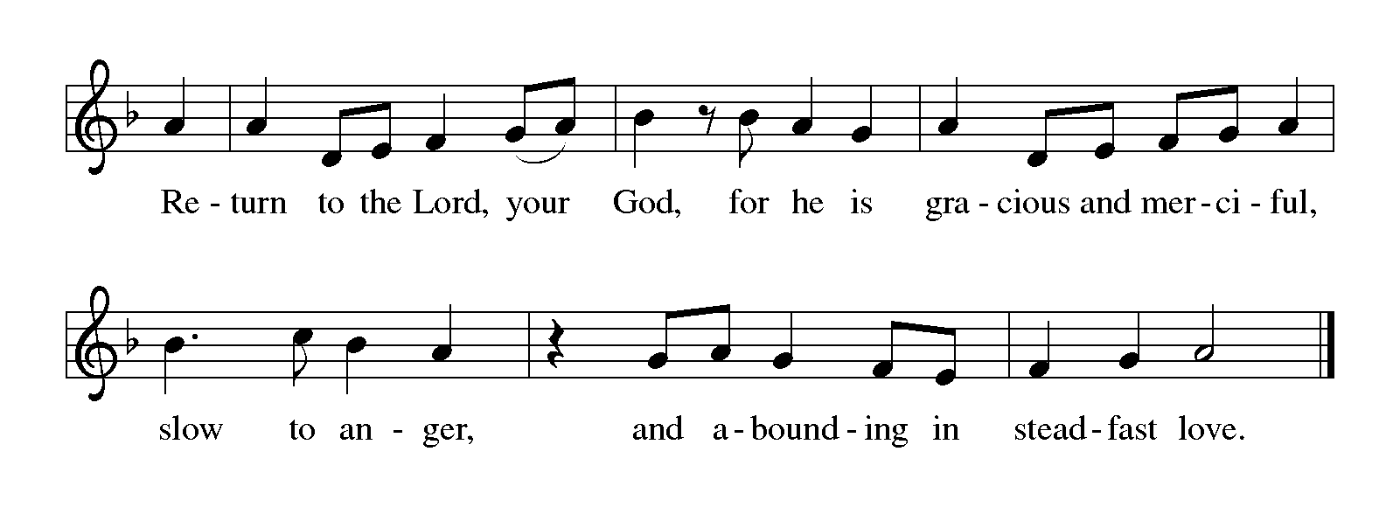
GOSPEL John 3:1-17

P: Announcement of the Gospel.

C: Glory to you, O Lord.

An inquisitive Pharisee visits Jesus by night to learn from the teacher his fellow religious leaders reject. Jesus speaks to him about life in the Spirit and the kingdom of God.

¹Now there was a Pharisee named Nicodemus, a leader of the Jews. ²He came to Jesus by night and said to him, “Rabbi, we know that you are a teacher who has come from God; for no one can do these signs that you do apart from the presence of God.” ³Jesus answered him, “Very truly, I tell you, no one can see the kingdom of God without being born from above.” ⁴Nicodemus said to him, “How can anyone be born after having grown old? Can one enter a second time into the mother’s womb and be born?” ⁵Jesus answered, “Very truly, I tell you, no one can enter the kingdom of God without being born of water and Spirit. ⁶What is born of the flesh is flesh, and what is born of the Spirit is spirit. ⁷Do not be astonished that I said to you, ‘You must be born from above.’ ⁸The wind blows where it chooses, and you hear the sound of it, but you do not know where it comes from or where it goes. So it is with everyone who is born of the Spirit.” ⁹Nicodemus said to him, “How can these things be?” ¹⁰Jesus answered him, “Are you a teacher of Israel, and yet you do not understand these things?
¹¹“Very truly, I tell you, we speak of what we know and testify to what we have seen; yet you do not receive our testimony. ¹²If I have told you about earthly things and you do not believe, how can you believe if I tell you about heavenly things? ¹³No one has ascended into heaven except the one who descended
from heaven, the Son of Man. ¹⁴And just as Moses lifted up the serpent in the wilderness, so must the Son of Man be lifted up, ¹⁵that whoever believes in him may have eternal life.
¹⁶“For God so loved the world that he gave his only Son, so that everyone who believes in him may not perish but may have eternal life.
¹⁷“Indeed, God did not send the Son into the world to condemn the world, but in order that the world might be saved through him.”

P: Affirmation of the Gospel.

C: Praise to you, O Christ.

SERMON

HYMN OF THE DAY Baptized in Water ELW # 456

PRAYERS OF INTERCESSION

Each petition ends with these words and response:

P: Merciful God,

C: receive our prayer.

Concluding petition and response:

P: We lift our prayers to you, O God, trusting in your steadfast love and your promise to renew your whole creation; through Jesus Christ our Savior.

C: Amen.

God’s Lenten Word in the Holy Meal

God feeds us with the presence of Jesus Christ.

WORLD DAY OF PRAYER SUMMARY

OFFERING AND MUSIC

OFFERING SONG Take My Life, That I May Be ELW # 685

Stanzas 1, 4, 5 and 6

OFFERING PRAYER

P: God of good gifts, receive these and all our offerings as we present them in faithful service for the sake of your gospel. Prepare our hearts to receive you in this meal as you pour out your very presence through Christ Jesus, the wellspring of eternal life.

C: Amen.

GREAT THANKSGIVING

Dialogue ELW p. 206

P: The Lord be with you.

C: And also with you.

P: Lift up your hearts.

C: We lift them to the Lord.

P: Let us give thanks to the Lord our God.

C: It is right to give our thanks and praise.

Preface

P: It is indeed right, our duty and our joy, that we should at all times and in all places give thanks and praise to you, almighty and merciful God, through our Savior Jesus Christ. You call your people to cleanse their hearts and prepare with joy for the paschal feast, that, renewed in the gift of baptism, we may come to the fullness of your grace. And so, with all the choirs of angels, with the church on earth and the hosts of heaven, we praise your name and join their unending hymn:

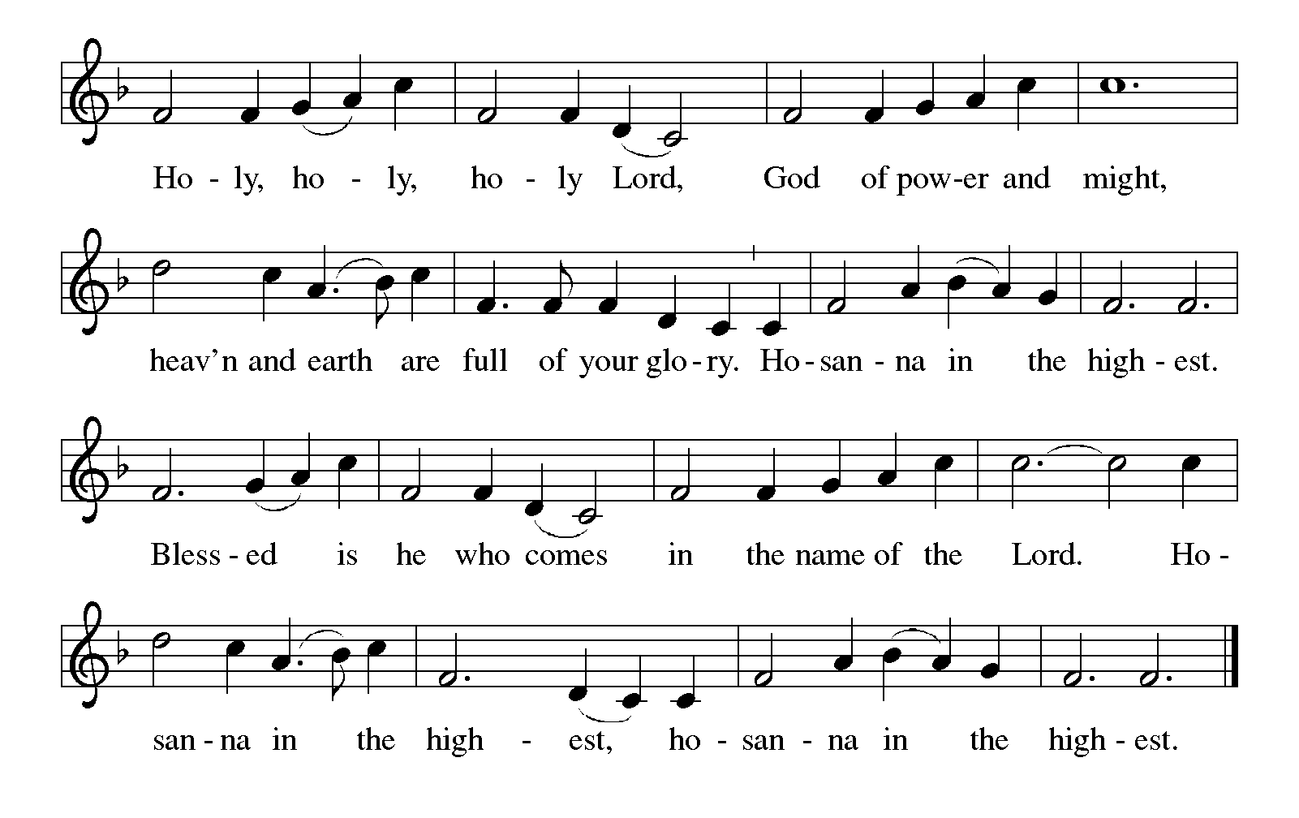Holy, Holy, Holy (the angels’ song) ELW p. 207

Thanksgiving at the Table

P: Blessed are you, O God of the universe. Your mercy is everlasting and your faithfulness endures from age to age.

Praise to you for creating the heavens and the earth.
Praise to you for saving the earth from the waters of the flood.
Praise to you for bringing the Israelites safely through the sea.

Continued on the next page.

P: Praise to you for leading your people through the wilderness to the land of
milk and honey.
Praise to you for the words and deeds of Jesus, your anointed one.
Praise to you for the death and resurrection of Christ.
Praise to you for your Spirit poured out on all nations.

In the night in which he was betrayed, our Lord Jesus took bread, and gave thanks; broke it, and gave it to his disciples, saying: Take and eat; this is my body, given for you. Do this for the remembrance of me.

Again, after supper, he took the cup, gave thanks, and gave it for all to drink, saying: This cup is the new covenant in my blood, shed for you and for all people for the forgiveness of sin. Do this for the remembrance of me.

With this bread and cup we remember our Lord's passover from death to life as we proclaim the mystery of faith:

C: Christ has died. Christ is risen. Christ will come again.

P: O God of resurrection and new life: Pour out your Holy Spirit on us and on these gifts of bread and wine. Bless this feast. Grace our table with your presence.

C: Come, Holy Spirit.

P: Reveal yourself to us in the breaking of the bread. Raise us up as the body of Christ for the world. Breathe new life into us. Send us forth, burning with justice, peace, and love.

C: Come, Holy Spirit.

P: With your holy ones of all times and places, with the earth and all its creatures, with sun and moon and stars, we praise you, O God, blessed and holy Trinity, now and forever.

C: Amen.

Lord’s Prayer Traditional Wording ELW p. 208

P: Lord, remember us in your kingdom and teach us to pray.

All: Our Father, who art in heaven, hallowed be thy name, thy kingdom come, thy will be done, on earth as it is in heaven. Give us this day our daily bread; and forgive us our trespasses, as we forgive those who trespass against us; and lead us not into temptation, but deliver us from evil. For thine is the kingdom, and the power, and the glory, forever and ever. Amen.
INVITATION TO COMMUNION

P: Come and receive Jesus, our strength in the wilderness.

COMMUNION

What We Believe

Who May Receive. We welcome all baptized Christians to the Lord's Table. In our parish baptized children who have entered the 5th grade are instructed in this sacrament and receive their First Communion; younger children come to the altar and receive a blessing. If your baptized child has received such instruction, or if you want your baptized child to receive Communion, then he or she is welcome to partake.

Proper Preparation. In his Small Catechism, Martin Luther asks, "When is a person rightly prepared to receive this sacrament?" He answers, "Fasting and other outward preparations serve a good purpose. However, that person is well prepared and worthy who believes these words, given and shed for you for the remission of sins. But anyone who does not believe these words, or doubts them, is neither prepared nor worthy, for the words for you require simply a believing heart.”

Real Presence. We believe that the bread and wine truly are the body and blood of Christ given and shed for the forgiveness of sins.

Distribution

Holy Communion will be served in procession, one side of the sanctuary at a time; please keep some distance from the person in front of you. The ushers will direct you when to make your way to the front of the church using the center aisle. You will receive the elements near the chancel. Please extend your hands, palms up, if you will be receiving the bread. Gluten-free wafers are also available; please ask for one. Proceed to your right or to your left to receive the wine. White grape juice is also available in the center ring of each tray for those who prefer an alcohol-free element. You may say “Amen” after receiving each element. If you will not be receiving Communion, keep your hands folded for a blessing. Place your empty cup in the basket and then return to your seat by the side aisle.

Music During Communion Sherry Hareldson

PRAYER AFTER COMMUNION

P: Embodied God, at your table, we have tasted the goodness of Jesus. With the eyes of our hearts open to your promise, empower us to see the needs of our neighbors and touch them with your love.

C: Amen.

Sending

God blesses us and sends us in mission to the world.

ANNOUNCEMENTS

BLESSING

P: God, the giver of love,
☩ Christ, the resurrection and the life,
and the Holy Spirit of rebirth
bless you in this Lenten journey.

C: Amen.

DEPARTING HYMN Lift High the Cross ELW # 660

Stanzas 1, 2 and 3

DISMISSAL

P: Go in peace. Serve in love.

C: Thanks be to God.

RINGING OF THE BELL

POSTLUDE



Commemorations

Tuesday, March 7

Perpetua and Felicity and companions, martyrs at Carthage, died 202

In the year 202 the emperor Septimius Severus forbade conversions to Christianity. Perpetua, a noblewoman, Felicity, a slave, and other companions were all catechumens at Carthage in North Africa. They were imprisoned and sentenced to death. Perpetua's father, who was not a Christian, visited her in prison and begged her to lay aside her Christian convictions in order to spare her life and spare the family from scorn. Perpetua responded and told her father, "We know that we are not placed in our own power but in that of God."

During the weeks of Lent, we do not have anyone preparing for baptism (catechumens), but we can pray for those in the global church as they approach their own death and rebirth in the waters of baptism at the Easter Vigil, and are clothed with the new life of Christ.

Friday, March 10

Harriet Tubman, died 1913; Sojourner Truth, died 1883; renewers of society

Harriet Tubman was born into slavery in Maryland and remained a slave until about age 30 when, fearing she would be sold and moved farther south, she escaped with the help of the Underground Railroad. After that, she helped about 300 others to escape until slavery was abolished. After the Civil War, her home in Auburn, New York, became a center for women's rights and served the aged and poor.

Sojourner Truth, too, was born a slave, in New York state. Her birth name was Isabella. After slavery was abolished in New York in 1827, she was freed and while working as a housekeeper, became deeply involved in Christianity. A number of years later, she discerned a call to become a preacher. Taking the name Sojourner Truth, she set out on an evangelistic journey, where people found her testimony to be deeply moving. In later life, she also became a popular speaker against slavery and for women's rights.

Today’s Assistants and Ministers

Greeters & Ushers ……………………………...….………… Dave & Debbie Long and family
Organist-Pianist ……………………..….………….……………...……..…… Sherry Hareldson
Presiding Minister …………………………………………..…………… Pastor Kerry Eversole
Altar Care & Communion Preparation ……..……….....…... Dave & Debbie Long and family
Custodians ………………………….….…….………...….…..…….. Dave & Geri Ann Hanson

This Week in Our Congregation

Today, March 5 — Second Sunday in Lent

Sunday School after the children’s message
Refreshments in the narthex or downstairs in the dining room for everyone after worship
Good Earth Village Annual Meeting in the Log Lodge 2:30 PM

Tuesday, March 7

Men’s breakfast at Home Sweet Home, Lanesboro 7:00 AM

Wednesday, March 8

Midweek Lenten Worship at Bethlehem Light Supper 6:00 PM
Service and live stream 7:00 PM

Thursday, March 9

Deacon Cindy at Park Lane Estates, Preston, for Bible study/chapel 9:30 AM

Saturday, March 11 — Set your clocks ahead 1 hour before retiring

Next Sunday, March 12 — Third Sunday in Lent

Worship 9:00 AM
Sunday School after the children’s message

News and Notes

Good Earth Village Annual Meeting, today, at 2:30 p.m., in the Log Lodge. Geri Ann Hanson is Fountain’s voting member but we are entitled to 3 more. Contact Geri Ann if you would like to attend. Welcome, registration and refreshments at 2:00 p.m. Meeting at 2:30 p.m.

Come to Bethlehem for Lenten supper at 6 pm, followed by the Amazing Grace Lenten series based on the beloved song that celebrates its 250th anniversary this year! Service is at 7 pm. Or view the live stream at 7 pm. In this week’s service, we hear Jesus tell of the great love of a father who lavished amazing grace upon his wasteful Son, a picture of our Heavenly Father’s lavish compassion toward us through his Son. Jesus. We were lost but now are found. See the insert for a detailed description of the series and each week’s Bible figure focus.

Daylight Saving Time Begins, next Sunday, March 12. Spring ahead! Set your clocks ahead one hour Saturday night, March 11.

Prayer Requests

In Our Community. For our church members and friends living with chronic illness and other diseases, who are homebound, residing in care facilities, and hospitalized. See the newsletter for our members living in area nursing homes. And let us not forget those sick and dying of COVID-19, those entrusted with the authority of government, justice, and law enforcement, as well as our fallen and wounded soldiers and those still serving.

Continued on the next page.
In Our Synod. Bishop Regina Hassanally invites the people and congregations of our Southeastern Minnesota Synod to make a commitment to pray this week for the following faith communities: Hosanna Lutheran Church, Rochester; Trinity Fellowship ELCA, Rushford; Minneola Lutheran Church, Goodhue; Kisiriri Lutheran Church, Tanzania; Mang’onyi Lutheran Church, Tanzania; Principe de Paz Lutheran Church, Colombia; and Lutheran School of Theology (IELCO), Bogotá.

Community Activities

Red Cross Blood Drive, Wednesday, March 8, from 12 noon to 6 pm, in the Lanesboro Community Center. You can schedule an appointment at www.redcross.org or by calling Kathryn Wade (507-272-6864) or Gwen Harmon (507-272-3136). Bring your donor card or a photo ID. You must be at least 16 years old. Youths under the age of 18 need a signed parental consent form, which will be available at the Community Center.

Grief and Loss Program, Tuesday, March 21, at 2:30 p.m. The Lanesboro Study Club is sponsoring a talk about dealing with grief and loss. The program will be held in the Fellowship Hall at Bethlehem Lutheran Church in Lanesboro on Tuesday, March 21, at 2:30 p.m. The speaker will be the Rev. Kal Rissman. Rev. Rissman is a Lutheran minister, currently serving two congregations in Alexandria, Indiana. He has also served many years as an addiction counselor, among other things. If you or someone you know is dealing with grief and loss, Rev. Rissman will give you some helpful options for understanding and dealing with your grief and loss. Members of Fountain and anyone in the community are welcome to attend.

Mayo Clinic Hospice is seeking compassionate and caring volunteers to support the hospice philosophy of care and mission. The role of a Mayo Clinic Hospice Volunteer is very dynamic and will utilize your interests, hobbies, passions, and skills. Volunteers assist with administrative tasks, provide supportive companionship to patients, and grief support. We also welcome registered pet therapy teams. If you are interested or would like to learn more about all the exciting and diverse volunteer opportunities Mayo Clinic Hospice has to offer, please contact Amy Stelpflug or Pam Roe, Volunteer Coordinators at mchospicevolteam@mayo.edu or 507-284-4002. Please visit https://volunteer.mayoclinic.org/ for more information and to submit an application.

Acknowledgments

Graphics, worship texts, service music, readings, and PowerPoint® Slides are from sundaysandseasons.com © 2023 Augsburg Fortress. Used by permission under Augsburg Fortress Liturgies Annual License SAS005401.

Permission to project liturgy and music content under copyright to or administered by Augsburg Fortress provided under Augsburg Fortress Liturgies Annual License SAS005401.

