Fountain Lutheran Church
Established 1904

Rev. Kerry B. Eversole, Pastor
Deacon Cindy Cordes-Eversole, Associate in Ministry

Mailing Address: P.O. Box 75, Fountain, MN 55935
Physical Address: 314 Main Street, Fountain, Minn.

Church Office Phone: 507.268.4413
E-mail Address: flc@mediacombb.net
Website: www.fountainlutheranchurch.com
Facebook Page: www.facebook.com/FountainLutheranChurch/

Parsonage Phone: 507.467.3017
Pastor Kerry’s Cell Phone: 507.951.3954

Our Global Partner Congregation: Issuna Lutheran Church, Tanzania
Fountain Lutheran Church
Fountain, Minnesota

Fourth Sunday in Lent

March 19, 2023


Jesus said to his disciples, “As long as I am in the world, I am the light of the world.” When he had said this, he spat on the ground and made mud with the saliva and spread the mud on the [blind] man’s eyes, saying to him, “Go, wash in the pool of Siloam” (which means Sent). Then he went and washed and came back able to see.” John 9:5-7
Welcome to worship at Fountain Lutheran Church
and the season of Lent!
Lent is the forty-day period before Easter. It’s a time for reflection, penitence, and preparation for new life.

COVID-19 Practices — Out of love for God and Neighbor

1) Use hand sanitizer upon entry. Wash your hands and use hand sanitizer often while in the facility.
2) Members and visitors who are vaccinated and boosted are not required to wear a mask.
3) Members and visitors are free to wear a mask if they wish to do so.
4) Unvaccinated and not boosted members and visitors must wear a mask.
5) There are no physical distancing requirements, but you are welcome to keep a distance from others in the sanctuary as you are able.
6) All are welcome to enjoy coffee fellowship in the narthex or downstairs in the dining room following worship.

Worship Book and Hymns. This morning’s service is printed in this bulletin. Portions can also be found with all the hymns in Evangelical Lutheran Worship (ELW), “the red book” in the pews. Hymns in ELW are indicated by a large bold number in each page’s left or right margin.

Abbreviations. Hymns are signified throughout this worship folder by the pound symbol (#); P: refers to the presiding minister or preacher; A: denotes an assisting minister; and C: and/or bold text indicates the congregation.

Offering. Later in our service, we will be receiving an offering. The offering is an opportunity to worship God with our money. We know that the money you give to Fountain Lutheran Church represents your lives — your time, talents, and hard work. We recognize that and we appreciate your generosity. Your support not only helps all of us to fulfill God’s call on our lives, but it also makes an impact, and we thank you! Lastly, our visitors are not expected to give. After all, you are our guests! We’re glad you’re here and we want you to feel welcome!

Mistakes do not happen in our worship service;
only unexpected events which are opportunities for joy!

An asterisk () signifies that you may stand, as you are comfortably able.

Gathering

The Holy Spirit calls us together as the people of God.

Introduction to the Season. On Ash Wednesday, we began the season of Lent and our annual baptismal journey with Jesus to his death on the cross and his glorious resurrection. The forty days of Lent are like no other. It is our opportune time to return to the God who rescues; to receive the gifts of God’s grace; to believe with the heart and confess with the mouth the wonder of God’s love in Jesus.

Introduction to the Day. Baptism is sometimes called enlightenment. The gospel for this Sunday is the story of the man born blind healed by Christ. “I was blind, now I see,” declares the man. In baptism, God opens our eyes to see the truth of who we are: God’s beloved children. As David was anointed king of Israel, in baptism God anoints our head with oil, and calls us to bear witness to the light of Christ in our daily lives.

PRELUDE There is a Balm in Gilead Jan Meyer

traditional spiritual arr. by R. Wilson

RINGING OF THE BELL, WELCOME, AND INTRODUCTION TO THE DAY

OPENING HYMN Praise the One who Breaks the Darkness ELW # 843

GREETING

P: The grace of our Lord Jesus Christ, the love of God, and the communion of the Holy Spirit be with you all.

C: And also with you.

PRAYER OF THE DAY

P: Bend your ear to our prayers, Lord Christ, and come among us. By your gracious life and death for us, bring light into the darkness of our hearts, and anoint us with your Spirit, for you live and reign with the Father and the Holy Spirit, one God, now and forever.

C: Amen.

God’s Lenten Word

God speaks to us in scripture reading, preaching, and song.

FIRST READING 1 Samuel 16:1-13

Continued on the next page.
Samuel anointed David even though he was the eighth-oldest son of Jesse and did not match his brothers in height or other physical characteristics. With the anointing came endowment with the Spirit of the Lord, designating David as the Lord’s chosen successor to Saul.

¹The Lord said to Samuel, “How long will you grieve over Saul? I have rejected him from being king over Israel. Fill your horn with oil and set out; I will send you to Jesse the Bethlehemite, for I have provided for myself a king among his sons.” ²Samuel said, “How can I go? If Saul hears of it, he will kill me.” And the Lord said, “Take a heifer with you, and say, ‘I have come to sacrifice to the Lord.’ ³Invite Jesse to the sacrifice, and I will show you what you shall do; and you shall anoint for me the one whom I name to you.” ⁴Samuel did what the Lord commanded, and came to Bethlehem. The elders of the city came to meet him trembling, and said, “Do you come peaceably?” ⁵He said, “Peaceably; I have come to sacrifice to the Lord; sanctify yourselves and come with me to the sacrifice.” And he sanctified Jesse and his sons and invited them to the sacrifice.
⁶When they came, he looked on Eliab and thought, “Surely the Lord’s anointed is now before the Lord.” ⁷But the Lord said to Samuel, “Do not look on his appearance or on the height of his stature, because I have rejected him; for the Lord does not see as mortals see; they look on the outward appearance, but the Lord looks on the heart.” ⁸Then Jesse called Abinadab, and made him pass before Samuel. He said, “Neither has the Lord chosen this one.” ⁹Then Jesse made Shammah pass by. And he said, “Neither has the Lord chosen this one.” ¹⁰Jesse made seven of his sons pass before Samuel, and Samuel said to Jesse, “The Lord has not chosen any of these.” ¹¹Samuel said to Jesse, “Are all your sons here?” And he said, “There remains yet the youngest, but he is keeping the sheep.” And Samuel said to Jesse, “Send and bring him; for we will not sit down until he comes here.” ¹²He sent and brought him in. Now he was ruddy, and had beautiful eyes, and was handsome. The Lord said, “Rise and anoint him; for this is the one.” ¹³Then Samuel took the horn of oil, and anointed him in the presence of his brothers; and the spirit of the Lord came mightily upon David from that day forward. Samuel then set out and went to Ramah.

A: The word of the Lord.

C: Thanks be to God.

SECOND READING Psalm 23 Read responsively

Continued on the next page.

¹The Lord is my shepherd; I shall not be in want.

²The Lord makes me lie down in green pastures and leads me beside still waters.

³You restore my soul, O Lord, and guide me along right pathways for your name’s sake.

⁴Though I walk through the valley of the shadow of death, I shall fear no evil; for you are with me; your rod and your staff, they comfort me.

⁵You prepare a table before me in the presence of my enemies; you anoint my head with oil, and my cup is running over.

⁶Surely goodness and mercy shall follow me all the days of my life, and I will dwell in the house of the Lord forever.

LENTEN ACCLAMATION Return to the Lord ELW p. 151

Based on Joel 2:13
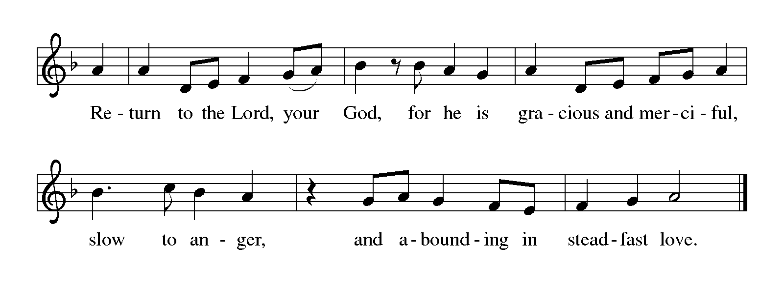

GOSPEL John 9:1-41

P: Announcement of the Gospel.

C: Glory to you, O Lord.

Jesus heals a man born blind, provoking a hostile reaction that he regards as spiritual blindness to the things of God.

Due to the length of the reading, it is not printed in the bulletin, and you may be seated.

P: Affirmation of the Gospel.

C: Praise to you, O Christ.

SERMON

HYMN OF THE DAY Amazing Grace, How Sweet the Sound ELW # 779

THANKSGIVING FOR BAPTISM

All may make the sign of the cross, the sign marked at baptism, as the presiding minister begins.

P: Blessed be the holy Trinity, ☩ one God, the fountain of living water,
the rock who gave us birth, our light and our salvation.

C: Amen.

P: Joined to Christ in the waters of baptism, we are clothed with God's mercy and forgiveness. Let us give thanks for the gift of baptism.

We give you thanks, O God, for in the beginning your Spirit moved over the waters and by your Word you created the world, calling forth life in which you took delight.

Through the waters of the flood you delivered Noah and his family. Through the sea you led your people Israel from slavery into freedom.
At the river your Son was baptized by John and anointed with the Holy Spirit.

By water and your Word you claim us as daughters and sons,
making us heirs of your promise and servants of all.

We praise you for the gift of water that sustains life,
and above all we praise you for the gift of new life in Jesus Christ.

Shower us with your Spirit, and renew our lives with your forgiveness, grace, and love.

To you be given honor and praise through Jesus Christ our Lord in the unity of the Holy Spirit, now and forever.

C: Amen.

BAPTISM HYMN I Heard the Voice of Jesus Say ELW # 611

Stanzas 2 and 3

PRAYERS OF INTERCESSION

Each petition ends with these words and response:

P: Merciful God,

C: receive our prayer.

Concluding petition and response:

P: We lift our prayers to you, O God, trusting in your steadfast love and your promise to renew your whole creation; through Jesus Christ our Savior.

C: Amen.

God’s Lenten Word in the Holy Meal

God feeds us with the presence of Jesus Christ.

OFFERING AND MUSIC He Touched Me Jan Meyer

by Wm. Gaither

OFFERING SONG I Want to Walk as a Child of the Light ELW # 815

Stanzas 1 and 2

OFFERING PRAYER

P: God of good gifts, receive these and all our offerings as we present them in faithful service for the sake of your gospel. Prepare our hearts to receive you in this meal as you pour out your very presence through Christ Jesus, the wellspring of eternal life.

C: Amen.

GREAT THANKSGIVING

Dialogue ELW p. 206

P: The Lord be with you.

C: And also with you.

P: Lift up your hearts.

C: We lift them to the Lord.

P: Let us give thanks to the Lord our God.

C: It is right to give our thanks and praise.

Preface

P: It is indeed right, our duty and our joy, that we should at all times and in all places give thanks and praise to you, almighty and merciful God, through our Savior Jesus Christ. You call your people to cleanse their hearts and prepare with joy for the paschal feast, that, renewed in the gift of baptism, we may come to the fullness of your grace. And so, with all the choirs of angels, with the church on earth and the hosts of heaven, we praise your name and join their unending hymn:

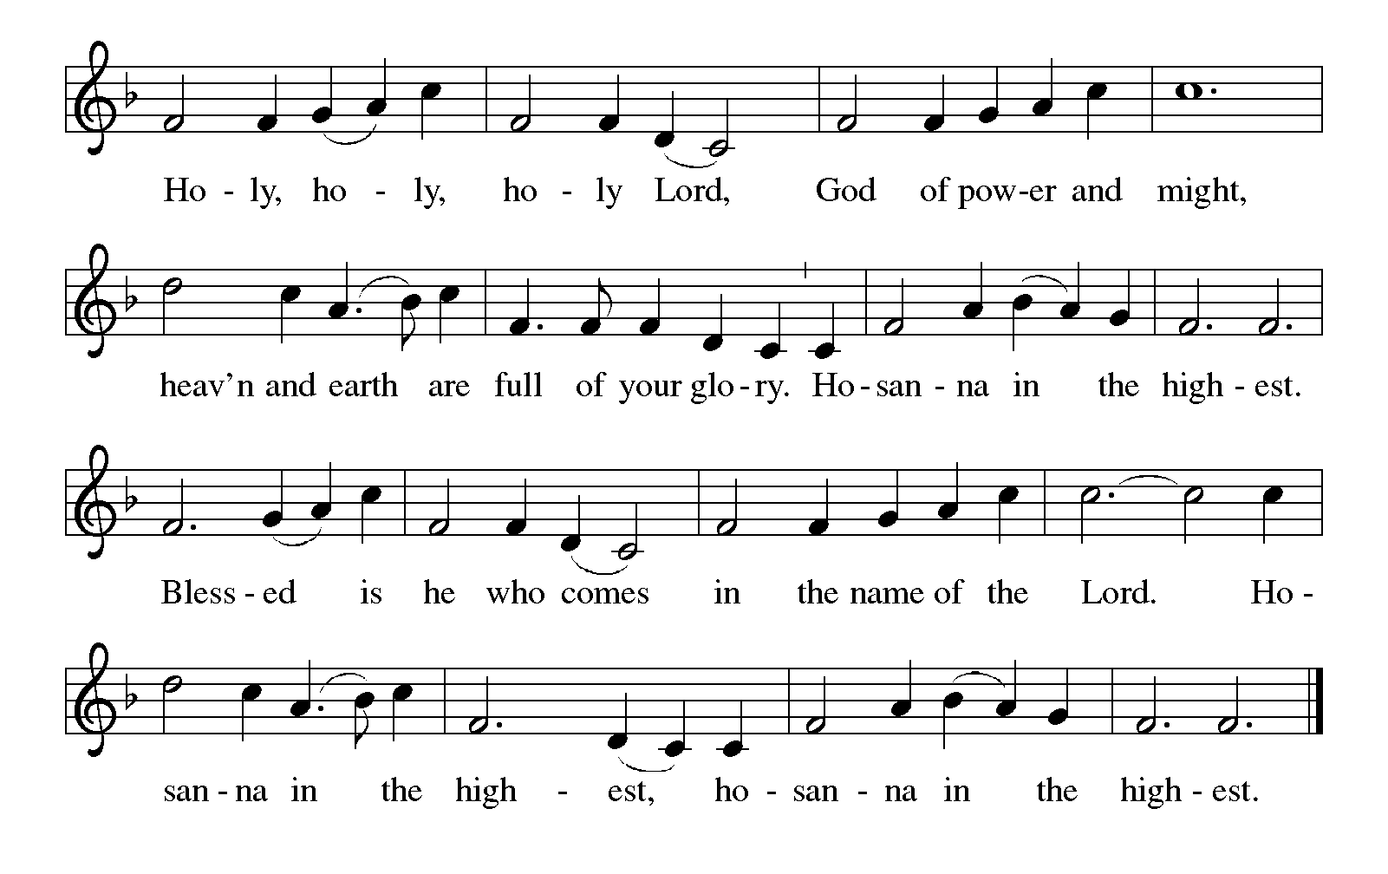Holy, Holy, Holy (the angels’ song) ELW p. 207

Thanksgiving at the Table

P: Holy, mighty, and merciful Lord, heaven and earth are full of your glory. In great love you sent to us Jesus, your Son, who reached out to heal the sick and suffering, who preached good news to the poor, and who, on the cross, opened his arms to all.

In the night in which he was betrayed, our Lord Jesus took bread, and gave thanks; broke it, and gave it to his disciples, saying:

Continued on the next page.
P: Take and eat; this is my body, given for you. Do this for the remembrance of me.

Again, after supper, he took the cup, gave thanks, and gave it for all to drink, saying: This cup is the new covenant in my blood, shed for you and for all people for the forgiveness of sin. Do this for the remembrance of me.

Remembering, therefore, his death, resurrection, and ascension,
we await his coming in glory.

Pour out upon us the Spirit of your love, O Lord, and unite the wills of all who share this heavenly food, the body and blood of Jesus Christ, our Lord; to whom, with you and the Holy Spirit, be all honor and glory, now and forever.

C: Amen.

Lord’s Prayer Traditional Wording ELW p. 208

P: Lord, remember us in your kingdom and teach us to pray.

All: Our Father, who art in heaven, hallowed be thy name, thy kingdom come, thy will be done, on earth as it is in heaven. Give us this day our daily bread; and forgive us our trespasses, as we forgive those who trespass against us; and lead us not into temptation, but deliver us from evil. For thine is the kingdom, and the power, and the glory, forever and ever. Amen.

INVITATION TO COMMUNION

P: Come and receive Jesus, our strength in the wilderness.

COMMUNION

What We Believe

Who May Receive. We welcome all baptized Christians to the Lord's Table. In our parish baptized children who have entered the 5th grade are instructed in this sacrament and receive their First Communion; younger children come to the altar and receive a blessing. If your baptized child has received such instruction, or if you want your baptized child to receive Communion, then he or she is welcome to partake.

Proper Preparation. In his Small Catechism, Martin Luther asks, "When is a person rightly prepared to receive this sacrament?" He answers, "Fasting and other outward preparations serve a good purpose. However, that person is well prepared

Continued on the next page.
and worthy who believes these words, given and shed for you for the remission of sins. But anyone who does not believe these words, or doubts them, is neither prepared nor worthy, for the words for you require simply a believing heart.”

Real Presence. We believe that the bread and wine truly are the body and blood of Christ given and shed for the forgiveness of sins.

Distribution

Holy Communion will be served in procession, one side of the sanctuary at a time; please keep some distance from the person in front of you. The ushers will direct you when to make your way to the front of the church using the center aisle. You will receive the elements near the chancel. Please extend your hands, palms up, if you will be receiving the bread. Gluten-free wafers are also available; please ask for one. Proceed to your right or to your left to receive the wine. White grape juice is also available in the center ring of each tray for those who prefer an alcohol-free element. You may say “Amen” after receiving each element. If you will not be receiving Communion, keep your hands folded for a blessing. Place your empty cup in the basket and then return to your seat by the side aisle.

Music During Communion Jan Meyer

The Lord's My Shepherd traditional from the Scottish Psalter

My Shepherd Will Supply My Need trad. Am. melody arr. by Fred Bock

PRAYER AFTER COMMUNION

P: Embodied God, at your table, we have tasted the goodness of Jesus. With the eyes of our hearts open to your promise, empower us to see the needs of our neighbors and touch them with your love.

C: Amen.

Sending

God blesses us and sends us in mission to the world.

ANNOUNCEMENTS

BLESSING

P: God, the giver of love,
☩ Christ, the resurrection and the life,
and the Holy Spirit of rebirth
bless you in this Lenten journey.

C: Amen.
DEPARTING HYMN Be Thou My Vision ELW # 793

DISMISSAL

P: Go in peace. Serve in love.

C: Thanks be to God.

RINGING OF THE BELL

POSTLUDE I Stand Amazed Jan Meyer

by Charles H. Gabriel



Commemorations

Today, Sunday, March 19, 2023

Joseph, Guardian of Jesus

Though the Bible tells us little about the husband of Jesus’ mother Mary, we know that he was a carpenter or builder by trade. He is also shown as being devoted both to God and to Mary and Jesus. It is assumed that he died before Jesus became an adult.

Wednesday, March 22, 2023

Jonathan Edwards, teacher, missionary to American Indians, died 1758

A Puritan minister in Connecticut, Edwards is remembered as being a great preacher. Though his most famous sermon talks at length about hell, he was more concerned with God's love. He served both as missionary to the Housatonic people in Massachusetts, and as president of the future Princeton University.

Today’s Assistants and Ministers

Greeters & Ushers ……………………………...….………… Dave & Debbie Long and family
Organist ……………………..….………….………………….…………...……..…… Jan Meyer
Presiding Minister …………………………………………..…………… Pastor Kerry Eversole
Altar Care & Communion Preparation ……..……….....…... Dave & Debbie Long and family
Custodians ………………………….….…….………...….…..…….. Dave & Geri Ann Hanson

This Week in Our Congregation

Today, March 19 — Fourth Sunday in Lent

Refreshments in the narthex or downstairs in the dining room for everyone after worship

Tuesday, March 21

Men’s breakfast at Home Sweet Home, Lanesboro 7:00 AM
Talk on Grief and Loss by Rev. Kal Rissman, Bethlehem Fellowship Hall 2:30 PM

Wednesday, March 22

Midweek Lenten Worship at Bethlehem Light Supper 6:00 PM
Service and live stream 7:00 PM

Thursday, March 23

Pastor Kerry at Park Lane Estates, Preston, for Bible study/chapel 9:30 AM
Deacon Cindy at Good Shepherd Lutheran Home, Rushford, for chapel 1:30 PM

Next Sunday, March 26 — Fifth Sunday in Lent

Worship 9:00 AM

News and Notes

Come to Bethlehem for Lenten supper at 6 pm, followed by the Amazing Grace Lenten series based on the beloved song that celebrates its 250th anniversary this year! Service is at 7 pm. Or view the live stream at 7 pm. In this week’s service, we listen to Jesus teach a woman at a well of his amazing grace poured out for us abundantly, which satisfies our thirsting souls for all eternity. Taste and see that the Lord is good. See the insert for a detailed description of the series and each week’s Bible figure focus.

2023 Root River Conference WELCA Spring Gathering, Saturday, April 15, North Prairie Lutheran Church, rural Lanesboro. Registration and Coffee fellowship 8 am. Program 9 am. Lunch 12:30 pm and wrap up. $10 registration fee includes coffee, program, and lunch.

Prayer Requests

In Our Community. For our church members and friends living with chronic illness and other diseases, who are homebound, residing in care facilities, and hospitalized. See the newsletter for our members living in area nursing homes. And let us not forget those sick and dying of COVID-19, those entrusted with the authority of government, justice, and law enforcement, as well as our fallen and wounded soldiers and those still serving.

In Our Synod. Bishop Regina Hassanally invites the people and congregations of our Southeastern Minnesota Synod to make a commitment to pray this week for the following faith communities: St. John Lutheran Church, Kasson; St. John Lutheran Church, Waseca; Chatfield Lutheran Church, Chatfield; Kisimba Lutheran Church, Tanzania; Mkiwa Lutheran Church, Tanzania; and Kijota Hull High School, Tanzania.

Community Activities

LHS presents HIGH SCHOOL MUSICAL at the Lanesboro Community Center, today, at 2 pm. Students: $3.00; Adults $5.00. Tickets are available at the door. Today is the last performance!

Grief and Loss Program, Tuesday, March 21, at 2:30 p.m., in the Bethlehem Lutheran Church Fellowship Hall. The guest presenter is the Rev. Kal Rissman. Rev. Rissman is a Lutheran minister, currently serving two congregations in Alexandria, Indiana. He has also served many years as an addiction counselor. All are welcome to attend.

Acknowledgments

Graphics, worship texts, service music, readings, and PowerPoint® Slides are from sundaysandseasons.com © 2023 Augsburg Fortress. Used by permission under Augsburg Fortress Liturgies Annual License SAS005401.

Permission to project liturgy and music content under copyright to or administered by Augsburg Fortress provided under Augsburg Fortress Liturgies Annual License SAS005401.

