Fountain Lutheran Church
Established 1904

Rev. Kerry B. Eversole, Pastor
Deacon Cindy Cordes-Eversole, Associate in Ministry

Mailing Address: P.O. Box 75, Fountain, MN 55935
Physical Address: 314 Main Street, Fountain, Minn.

Church Office Phone: 507.268.4413
E-mail Address: flc@mediacombb.net
Website: www.fountainlutheranchurch.com
Facebook Page: www.facebook.com/FountainLutheranChurch/

Parsonage Phone: 507.467.3017
Pastor Kerry’s Cell Phone: 507.951.3954

Our Global Partner Congregation: Issuna Lutheran Church, Tanzania
Fountain Lutheran Church
Fountain, Minnesota

Maundy Thursday

April 6, 2023

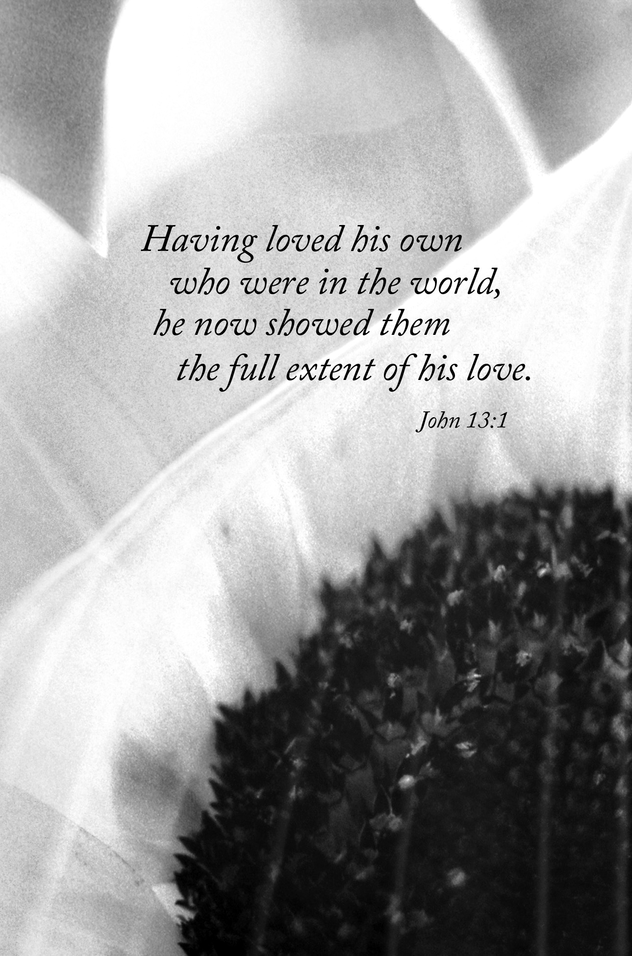
Welcome to worship at Fountain Lutheran Church
and our celebration of the Great Three Days!

COVID-19 Practices — Out of love for God and Neighbor

1) Use hand sanitizer upon entry. Wash your hands and use hand sanitizer often while in the facility.
2) Members and visitors who are vaccinated and boosted are not required to wear a mask.
3) Members and visitors are free to wear a mask if they wish to do so.
4) Unvaccinated and not boosted members and visitors must wear a mask.
5) There are no physical distancing requirements, but you are welcome to keep a distance from others in the sanctuary as you are able.

About the next three days. With nightfall our Lenten observance changes emphasis as we gather with Christians around the world to celebrate the Great Three Days—the Triduum—the ancient observance of the mystery of our faith: Christ has died. Christ is risen. Christ will come again. The Great Three Days are really one liturgy extending from Thursday evening through Easter evening, the liturgical day being reckoned from sundown to sundown.

Introduction to Maundy Thursday. This first liturgy of the Great Three Days focuses on three significant actions. First, the confession of sins and announcement of forgiveness brings to a conclusion the Lenten discipline of repentance that began on Ash Wednesday. Second, the church hears Jesus’s command (in Latin, mandatum, from which this day receives its name) to love one another (John 13:34). This love is clearly demonstrated by Jesus washing the feet of his disciples. We are called to follow his example as we humbly care for one another, especially the poor and the unloved. And third, we celebrate our meal of deliverance, taking our place at the supper Jesus shared with his disciples on this night and remembering the sacrifice of his life. In this holy meal we are called to offer ourselves in love for the life of the world. The Maundy Thursday liturgy has no ending; it continues with the worship of Good Friday and concludes with the Resurrection of our Lord.

Worship Book and Hymns. This evening’s service is printed in this bulletin. Parts of the liturgy are from Maundy Thursday on pages 258–261 and from Holy Communion Setting Four on pages 147-155 in the front section of Evangelical Lutheran Worship (ELW), “the red book” in the pews. All the hymns can also be found in ELW and are identified by a large bold number in the left or right margin of each page.

Other Worship Resources. Worship texts, prayers, service music, and readings are from Sundays and Seasons.com. © 2023 Augsburg Fortress. All rights reserved. Reprinted by permission under Augsburg Fortress Liturgies Annual License SAS005401.

Abbreviations. Throughout this worship folder, hymns are signified by the pound symbol (#), P: refers to the presiding minister or preacher, A: denotes an assisting minister, and C: and/or bold text indicates the congregation.
Gathering

PRELUDE

CONFESSION AND FORGIVENESS ELW p. 258

Invitation to Confession

Silence for reflection and self-examination.

The Confession ELW p. 258

P: Most merciful God,

All: we confess that we are captive to sin and cannot free ourselves. We have sinned against you in thought, word, and deed, by what we have done and by what we have left undone. We have not loved you with our whole heart; we have not loved our neighbors as ourselves. For the sake of your Son, Jesus Christ, have mercy on us. Forgive us, renew us, and lead us, so that we may delight in your will and walk in your ways, to the glory of your holy name. Amen.

The Absolution ELW p. 259

P: In the mercy of almighty God, Jesus Christ was given to die for us, and for his sake God forgives us all our sins. As a called and ordained minister of the church of Christ and by his authority, I therefore declare to you the entire forgiveness of all your sins, in the name of the Father, and of the ☩ Son, and of the Holy Spirit.

C: Amen.

Laying On of Hands

Those who wish to receive individual pronouncement of forgiveness may come forward and kneel before the altar. The pastor will lay both hands on each person's head and address each one in turn, “In obedience to the command of our Lord Jesus Christ, I forgive you all your sins.” Each person may respond “Amen.”

Hymns

Softly and Tenderly Jesus Is Calling ELW # 608 szz. 1, 2 & 3

O Christ, Our Hope ELW # 604 szz. 1, 2 & 4

GREETING ELW p. 259

P: The grace of our Lord Jesus Christ, the love of God, and the communion of the Holy Spirit be with you all.

C: And also with you.

PRAYER OF THE DAY

P: Holy God, source of all love, on the night of his betrayal, Jesus gave us a new commandment, to love one another as he loves us, and he washed the feet of his disciples showing us the dignity of service, and he shared a meal of bread and wine establishing a new covenant for all people. Grant that by the power of your Holy Spirit this commandment and these signs of our life in faith may speak again to our hearts, feed our spirits, and refresh our bodies, through your Son, Jesus Christ, our Savior and Lord, who lives and reigns with you and the Holy Spirit, one God, now and forever.

C: Amen.

Hearing God’s Word of Love

FIRST READING Exodus 12:1-14

Israel remembered its deliverance from slavery in Egypt by celebrating the festival of Passover. This festival featured the Passover lamb, whose blood was used as a sign to protect God's people from the threat of death. The early church described the Lord's Supper using imagery from the Passover, especially in portraying Jesus as the lamb who delivers God's people from sin and death.

The Lord said to Moses and Aaron in the land of Egypt: ²This month shall mark for you the beginning of months; it shall be the first month of the year for you. ³Tell the whole congregation of Israel that on the tenth of this month they are to take a lamb for each family, a lamb for each household. ⁴If a household is too small for a whole lamb, it shall join its closest neighbor in obtaining one; the lamb shall be divided in proportion to the number of people who eat of it. ⁵Your lamb shall be without blemish, a year-old male; you may take it from the sheep or from the goats. ⁶You shall keep it until the fourteenth day of this month; then the whole assembled congregation of Israel shall slaughter it at twilight. ⁷They shall take some of the blood and put it on the two doorposts and the lintel of the houses in which they eat it. ⁸They shall eat the lamb that same night; they shall eat it roasted over the fire with unleavened bread and bitter herbs. ⁹Do not eat any of it raw or boiled in water, but roasted over the

Continued on the next page.
fire, with its head, legs, and inner organs. ¹⁰You shall let none of it remain until the morning; anything that remains until the morning you shall burn. ¹¹This is how you shall eat it: your loins girded, your sandals on your feet, and your staff in your hand; and you shall eat it hurriedly. It is the passover of the Lord. ¹²For I will pass through the land of Egypt that night, and I will strike down every firstborn in the land of Egypt, both human beings and animals; on all the gods of Egypt I will execute judgments: I am the Lord. ¹³The blood shall be a sign for you on the houses where you live: when I see the blood, I will pass over you, and no plague shall destroy you when I strike the land of Egypt. ¹⁴This day shall be a day of remembrance for you. You shall celebrate it as a festival to the Lord; throughout your generations you shall observe it as a perpetual ordinance.

A: The word of the Lord.

C: Thanks be to God.

PSALM 116:1-2, 12-19a

I love the Lord, because he has heard my voice, and my supplications.

²Because he inclined his ear to me, therefore I will call on him as long as I live.

¹²What shall I return to the Lord for all his bounty to me?

¹³I will lift up the cup of salvation and call upon the name of the Lord.

¹⁴I will pay my vows to the Lord in the presence of all his people.

¹⁵Precious in the sight of the Lord is the death of his faithful ones.

¹⁶O Lord, I am your servant; I am your servant, the child of your serving girl. You have loosed my bonds.

¹⁷I will offer you a thanksgiving sacrifice and call on the name of the Lord.

¹⁸I will pay my vows to the Lord in the presence of all his people,

¹⁹in the courts of the house of the Lord, in your midst, O Jerusalem.

SECOND READING 1 Corinthians 11:23-26

In the bread and cup of the Lord’s Supper, we experience intimate fellowship with Jesus Christ and with one another, because it involves his body given for us and the new covenant in his blood. Faithful participation in this meal is a living proclamation of Christ’s death until he comes in the future.

Continued on the next page.

For I received from the Lord what I also handed on to you, that the Lord Jesus on the night when he was betrayed took a loaf of bread, ²⁴and when he had given thanks, he broke it and said, “This is my body that is for you. Do this in remembrance of me.” ²⁵In the same way he took the cup also, after supper, saying, “This cup is the new covenant in my blood. Do this, as often as you drink it, in remembrance of me.” ²⁶For as often as you eat this bread and drink the cup, you proclaim the Lord's death until he comes.

A: The word of the Lord.

C: Thanks be to God.

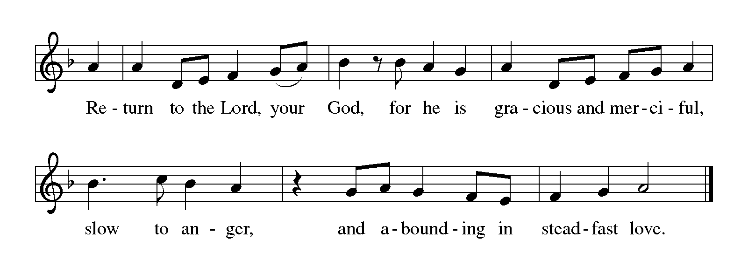LENTEN ACCLAMATION Return to the Lord ELW p. 151

GOSPEL John 13:1-17, 31b-35

P: Announcement of the Gospel.

C: Glory to you, O Lord.

The story of the Last Supper in John’s gospel recalls a remarkable event not mentioned elsewhere: Jesus performs the duty of a slave, washing the feet of his disciples and urging them to do the same for one another.

Now before the festival of the Passover, Jesus knew that his hour had come to depart from this world and go to the Father. Having loved his own who were in the world, he loved them to the end. ²The devil had already put it into the heart of Judas son of Simon Iscariot to betray him. And during supper ³Jesus, knowing that the Father had given all things into his hands, and that he had come from God and was going to God, ⁴got up from the table, took off his outer robe, and tied a towel around himself. ⁵Then he poured water into a

Continued on the next page.
basin and began to wash the disciples' feet and to wipe them with the towel that was tied around him. ⁶He came to Simon Peter, who said to him, “Lord, are you going to wash my feet?” ⁷Jesus answered, “You do not know now what I am doing, but later you will understand.” ⁸Peter said to him, “You will never wash my feet.” Jesus answered, “Unless I wash you, you have no share with me.” ⁹Simon Peter said to him, “Lord, not my feet only but also my hands and my head!” ¹⁰Jesus said to him, “One who has bathed does not need to wash, except for the feet, but is entirely clean. And you are clean, though not all of you.” ¹¹For he knew who was to betray him; for this reason he said, “Not all of you are clean.”
¹²After he had washed their feet, had put on his robe, and had returned to the table, he said to them, “Do you know what I have done to you? ¹³You call me Teacher and Lord and you are right, for that is what I am. ¹⁴So if I, your Lord and Teacher, have washed your feet, you also ought to wash one another's feet. ¹⁵For I have set you an example, that you also should do as I have done to you. ¹⁶Very truly, I tell you, servants are not greater than their master, nor are messengers greater than the one who sent them. ¹⁷If you know these things, you are blessed if you do them.”
^{31b}“Now the Son of Man has been glorified, and God has been glorified in him. ³²If God has been glorified in him, God will also glorify him in himself and will glorify him at once. ³³Little children, I am with you only a little longer. You will look for me; and as I said to the Jews so now I say to you, ‘Where I am going, you cannot come.’ ³⁴I give you a new commandment, that you love one another. Just as I have loved you, you also should love one another. ³⁵By this everyone will know that you are my disciples, if you have love for one another.”

P: Affirmation of the Gospel.

C: Praise to you, O Christ.

SERMON

HYMN OF THE DAY Where Charity and Love Prevail ELW # 359

PRAYERS OF INTERCESSION

Each petition ends with these words and response:

A: Merciful God,

C: receive our prayer.

Continued on the next page.

Concluding petition and response:

P: We lift our prayers to you, O God, trusting in your steadfast love and your promise to renew your whole creation; through Jesus Christ our Savior.

C: Amen.

Receiving God’s Word of Love in the
Sacrament of Holy Communion

OFFERING

OFFERING SONG Take My Life, That I May Be ELW # 685

Stanzas 1, 4, 5 & 6

OFFERING PRAYER

A: God of good gifts, receive these and all our offerings as we present them in faithful service for the sake of your gospel. Prepare our hearts to receive you in this meal as you pour out your very presence through Christ Jesus, the wellspring of eternal life.

C: Amen.

GREAT THANKSGIVING

Dialogue

P: The Lord be with you.

C: And also with you.

P: Lift up your hearts.

C: We lift them to the Lord.

P: Let us give thanks to the Lord our God.

C: It is right to give our thanks and praise.

Eucharistic Prayer

P: We give you thanks, Father, through Jesus Christ, your beloved Son, whom you sent in this end of the ages to save and redeem us and to proclaim to us your will.

Continued on the next page.

P: He is your Word, inseparable from you, through whom you created all things, and in whom you take delight. He is your Word, sent from heaven to a virgin's womb. He there took on our nature and our lot and was shown forth as your Son, born of the Holy Spirit and of the virgin Mary. He, our Lord Jesus, fulfilled all your will and won for you a holy people; he stretched out his hands in suffering in order to free from suffering those who trust you.

He is the one who, handed over to a death he freely accepted, in order to destroy death, to break the bonds of the evil one, to crush hell underfoot, to give light to the righteous, to establish his covenant, and to show forth the resurrection, taking bread and giving thanks to you, said: Take and eat; this is my body, given for you. Do this for the remembrance of me.

In the same way he took the cup, gave thanks, and gave it for all to drink, saying: This cup is the new covenant in my blood, shed for you and for all people for the forgiveness of sin. Do this for the remembrance of me.

Remembering, then, his death and resurrection, we take this bread and cup, giving you thanks that you have made us worthy to stand before you and to serve you as your priestly people.

Send your Spirit upon these gifts of your church; gather into one all who share this bread and wine; fill us with your Holy Spirit to establish our faith in truth, that we may praise and glorify you through your Son Jesus Christ; through whom all glory and honor are yours, almighty Father, with the Holy Spirit, in your holy church, both now and forever.

C: Amen.

Lord's Prayer Traditional Wording

All: Our Father, who art in heaven, hallowed be thy name, thy kingdom come, thy will be done, on earth as it is in heaven. Give us this day our daily bread; and forgive us our trespasses, as we forgive those who trespass against us; and lead us not into temptation, but deliver us from evil. For thine is the kingdom, and the power, and the glory, forever and ever. Amen.

INVITATION TO COMMUNION

P: Come and receive Jesus, our strength in the wilderness.

COMMUNION HYMN Lamb of God (Agnus Dei) ELW p. 154

Printed on the next page.
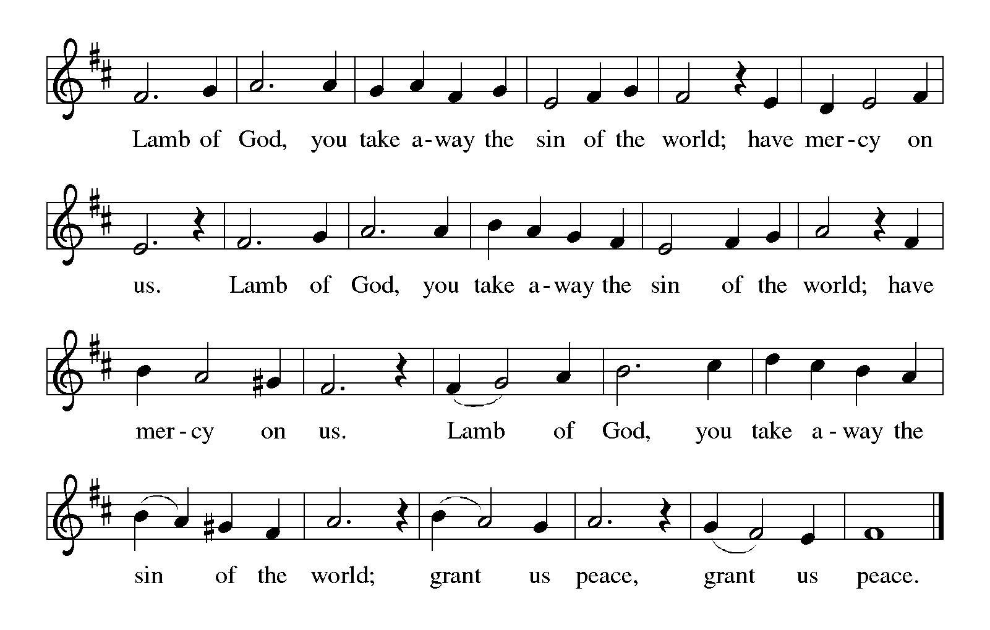

COMMUNION

What We Believe

Who May Receive. We welcome all baptized Christians to the Lord's Table. In our church baptized children who have entered the 5th grade are instructed in this sacrament and receive their First Communion; younger children come and receive a blessing. If your baptized child has received such instruction, or if you want your baptized child to receive Communion, then he or she is welcome to partake.

Proper Preparation. In his Small Catechism, Martin Luther asks, “When is a person rightly prepared to receive this sacrament?” He answers, “Fasting and other outward preparations serve a good purpose. However, that person is well prepared and worthy who believes these words, given and shed for you for the remission of sins. But anyone who does not believe these words, or doubts them, is neither prepared nor worthy, for the words for you require simply a believing heart.”

Real Presence. We believe that the bread and wine truly are the body and blood of Christ given and shed for the forgiveness of sins.

Continued on the next page.

Distribution

Holy Communion will be served at the altar rail. The ushers will direct you to the chancel by way of the side aisles. Proceed to the altar rail when space is available. Please kneel, as you are comfortably able. Extend your hands, palms up, if you will be receiving the bread and wine. Gluten-free wafers are available; please ask for one. White Grape juice is also available in the center ring of each tray of wine for those who prefer an alcohol-free element. You may say "Amen" after receiving each element. If you will not be receiving Communion, then keep your hands folded for a blessing. After receiving Communion, you are free to return to your seat using the center aisle.

Music During Communion Sherry Hareldson

PRAYER AFTER COMMUNION

P: Lord Jesus, in a wonderful sacrament you strengthen us with the saving power of your suffering, death, and resurrection. May this sacrament of your body and blood so work in us that the fruits of your redemption will show forth in the way we live, for you live and reign with the Father and the Holy Spirit, one God, now and forever.

C: Amen.

Stripping of the Altar

Stripping of the altar is symbolic of Christ being stripped of his power and glory at the hands of his captors. You are encouraged to watch the dramatic action of the altar being stripped while listening to the words of Psalm 88.

There is no benediction, departing hymn, or postlude.

You are encouraged to remain for as long as you wish for prayer and meditation.

Please leave the church in silence.

Today’s Assistants and Ministers

Greeters & Ushers ……………...………… Paul & Julie Gade and Ken & Gloria Hollermann
Organist / Pianist ………………………….………………….………….…… Sherry Hareldson
Presiding Minister ……………………………….……….....…………… Pastor Kerry Eversole
Altar Care ……..……………………......…... Paul & Julie Gade and Ken & Gloria Hollerman
Custodians ………………………….….…….………...….…..…….. Dave & Geri Ann Hanson
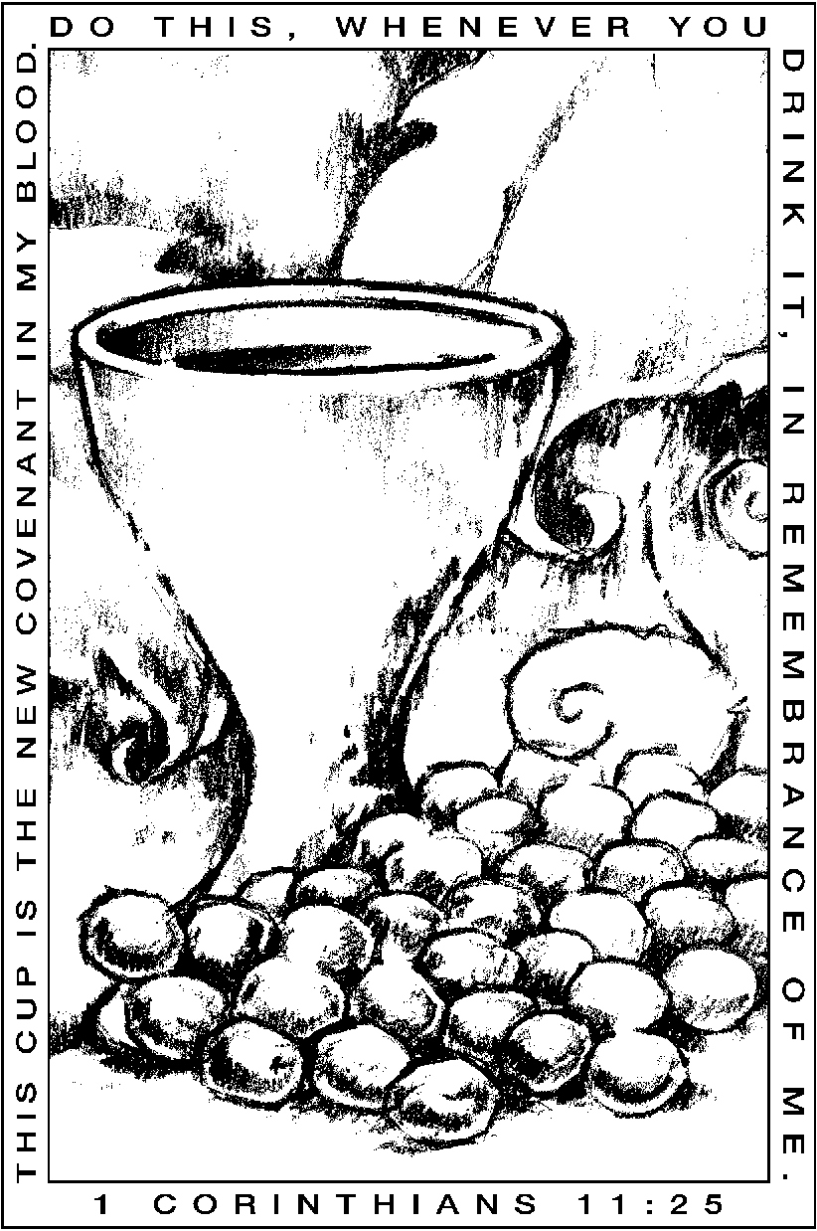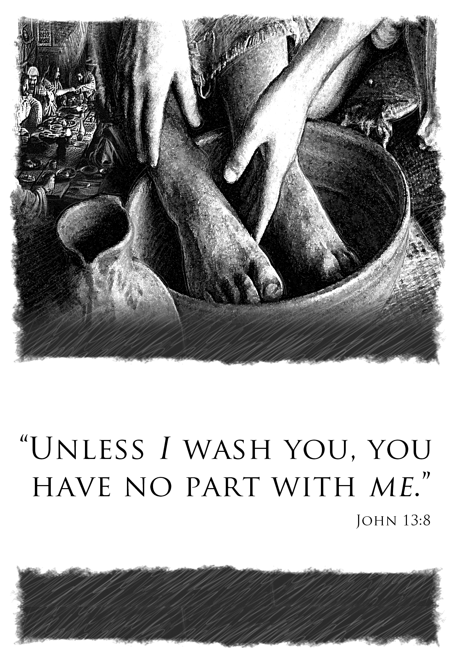

Our Celebration of the
Great Three Days continues

April 7, 2023

Good Friday

7:00 p.m. Community Service at Bethlehem Lutheran in Lanesboro
Saint John’s Passion with choral and congregational singing

April 9, 2023

Resurrection of Our Lord / Easter Day

9:00 a.m. Festival service with Holy Communion
Easter breakfast following worship

Our Celebration of the
Great Three Days continues

April 7, 2023

Good Friday

7:00 p.m. Community Service at Bethlehem Lutheran in Lanesboro
Saint John’s Passion with choral and congregational singing

April 9, 2023

Resurrection of Our Lord / Easter Day

9:00 a.m. Festival service with Holy Communion
Easter breakfast following worship

