

Pastor Kerry and Deacon Cindy announce resignations
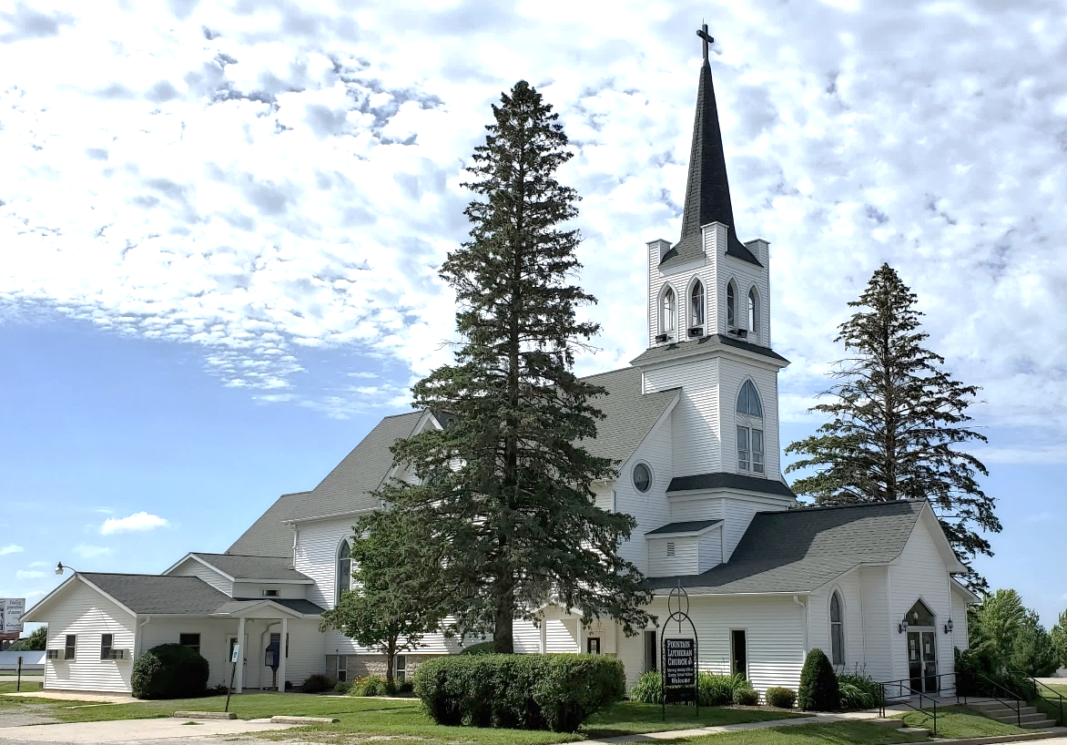
  Fountain
    - Messenger
    - August 2023

Jesus is our fountain of living water and light! Psalm 36:9

By now you should have received a letter from Pastor Kerry and Deacon Cindy announcing their intention to resign this Fall. Pastor Kerry’s last Sunday leading worship and preaching at Fountain will be October 15. This Sunday will include Affirmation of Baptism for our tenth-grade confirmand, Caroline Himli-Seelbinder, and the celebration of Holy Communion. Cindy will be leading worship and preaching at Bethlehem on that Sunday. Their calls to Bethlehem Lutheran Church and their cooperative agreement with Fountain Lutheran Church will end on October 31, Reformation Day.
What’s Next
You are strongly encouraged to
type this web address into your browser, semnsynod.org/resources-for-congregations-and-leaders/call-process. Scroll down until you see the words “Steps of the Call Process for Congregations”. Then, click on “Phase One: The Transition Process”. This document provides an outline of the Call Process and provides specific information on transitioning to the time when Pastor Kerry’s and Deacon Cindy’s calls have ended, and they are no longer our pastoral staff. You can return to this page on the synod’s website as the Call Process moves forward for additional information on what’s next.

Mailing Address:
P.O. Box 75
Fountain, MN 55935

Church E-mail Address:
flc@mediacombb.net

Church Office Phone:
507.268.4413

Pastor Kerry’s E-mail Address:
kbeversole@yahoo.com

Pastor Kerry’s Cell Phone:
507.951.3954


Parsonage Phone:
507.467.3017

Our Facebook Page
www.facebook.com/FountainLutheranChurch

Our Website
www.fountainlutheranchurch.com

Sunday, August 6

Schedule of Services for August
Tenth Sunday after Pentecost

Holy Communion

Sunday, August 13
Eleventh Sunday
after Pentecost
The Time
of the Church

Sunday, August 20
Twelfth Sunday after Pentecost

Holy Communion

Sunday, August 27
Thirteenth Sunday
after Pentecost



Chapel Services
at Care Centers
Wednesday, August 2
Chosen Valley Assisted Living and Nursing Home, Chatfield
Thursday, August 3
Good Shepherd Lutheran Home, Rushford
Thursday, August 10
Park Lane Estates Assisted Living, Preston
Thursday, August 24
Park Lane Estates Assisted Living, Preston

Altar Care & Communion

for August

Sunday, August 6
Tenth Sunday after Pentecost

Green

Sunday, August 13
Eleventh Sunday after Pentecost

Green

Sunday, August 20
Twelfth Sunday after Pentecost

Green

Sunday, August 27
Thirteenth Sunday
after Pentecost

Green

COMMUNION SCHEDULE
Sunday, August 6
In procession in front of the chancel steps,
with bread and wine.

Sunday, August 20
In procession in front of the chancel steps,
with bread and wine.

USHERS FOR August
Mike & Deb Schwarz are the greeters and ushers for August

ALTAR CARE FOR August
Deb Schwarz and Deb Schott oversee paraments, banners, and Communion preparation for August.

Our 10th Grade Confirmand this fall

Caroline Himli-Seelbinder.

Our 7th Grade Confirmands this fall

Laura Himli-Seelbinder, Corbin Reinhardt, Teagan Reinhardt, Hayden Schroeder, and
Myla Schwarz.
Those Living in Care Centers
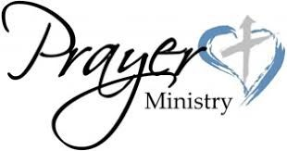
MaryAnn Hamann and Larry Hunt at Chosen Valley Care Center, Chatfield.
Duaine Bacon at Chosen Valley Assisted Living, Chatfield

Those Living with Chronic Illness and other Diseases including Cancer

David Drury and Bob Redalen.

Our Homebound Members

Mary Dohrmann and
Carol Heidke.

Those Whom You Can Name

Please contact Pastor Kerry or Deacon Cindy and let them know about your loved one or friend


Getting Ready to Affirm sessions begin, Sunday, August 13
Our lone 10th-grade confirmand, Caroline Himli-Seelbinder, will begin getting ready to affirm her baptism, that is, be confirmed, on Sunday, August 13. Getting Ready sessions will continue the following Sundays. During worship on Sunday, October 8, Caroline will present her faith projects. On Sunday, October 15, she will participate in the rite of Confirmation which is more appropriately called Affirmation of Baptism.

Summer Bible Study
This summer’s Gather Bible study is titled Salvation Now and is written by the Rev. Dr. Anna Madsen. The study focuses on John’s gospel.
The June session was “Promised Salvation Now—Jesus Brings Wellness”.
The July session was “Tangible Salvation Now—Christians Bringing Wellness”.
The third and final session is “Needed Salvation Now—A World Wanting Wellness”. In this last session, participants will explore John’s commitment to service and how we, as Christians, are compelled to follow Jesus, the bringer of salvation, into the needs of a hurting world.
Video presentations of the Bible studies can be found at www.gathermagazine.org/bible-study/, then click on “Summer 2023”.

The 12th Triennial Convention of the Women of the ELCA will be held in Phoenix AZ, September 19-21.

The Southeastern Minnesota Synodical Women’s Organization Convention will be held at First Lutheran Church in Red Wing on September 30.

Corrected Minutes of the
Special Congregational Meeting
Sunday, June 25, 2023
The Special Congregational Meeting of Fountain Lutheran Church was called to order by President Ken Hollermann following regular Church Services on 6/25/2023. Notice of this meeting had previously been provided to congregational members informing them that the purpose of the Special Meeting was to aid in making an informed decision on whether to (1) sell, or (2) keep and continue renting out the Parsonage. 21 members attended this meeting, which exceeded the quorum of 15 needed.
Ken Hollermann reported that Tim Danielson of Elcor Realty, had been contacted and he came to look at the house and did a Comparative Market Analysis on the property. Danielson’s report was very detailed and he came up with an estimated sale price of $214,900.
Ken Hollermann updated the attendees on how the last renter had ended up leaving the property due to health reasons and that she had failed to inform the Council she had moved out. Due to her not living at the property, water pipes froze causing water damage throughout the house and damage to the dishwasher in the kitchen. The stove was also damaged beyond repair. No matter what decision would be made concerning the Parsonage, repairs had to be made and the Council went ahead and made arrangements for work to be done. At this point, the sheetrocking has been completed, the waterpipes repaired, professional cleaning is being done, new appliances have been ordered, professional painting will be done on the inside of the house, and all items left in the house from the previous renter have been removed and disposed of.
Discussion was held concerning the pros and cons of selling versus renting. It was made very clear that the Church Council is not interested in being “landlords” to the Parsonage. If someone wanted to step up and take on the role of “landlord” to take care of rental applications, collecting rents, check on the property regularly, etc., we may consider this avenue. There was no one who indicated their willingness to do this.
Scott Rustad made a suggestion that the Church hold onto the house. He felt that by keeping the parsonage there could be a future flow of income which could be used as a crutch for holding on to the church building to use for funerals, weddings, etc. Scott did indicate that there was $500 in the parsonage fund when he became Treasurer and that fund has grown to $20,000 since 2018.
Dave Drury questions if we shouldn’t keep the Parsonage, also. Dave also questioned what happens to the money if sold.
Ken indicated that if the Parsonage is sold, that money will be put into a fund to draw interest.
Another asked that we wait another month or two and have another meeting to make any decision one way or the other.
After discussion, Ken asked that a Motion be made to proceed to a vote of whether to sell or rent the Parsonage. Mike Schwarz made the Motion with Tom Tienter seconding it. Motion passed.
Ballots were handed out to the 21 voting members of the congregation. Jenny Dahley and Deb Jeffers collected the ballots and counted them. Deb Jeffers announced that 18 voted in favor of selling and that 3 voted in favor of renting. Paul Gade made the Motion to accept the vote as counted and to proceed with the sale of the Parsonage with Jenny Dahley seconding it. Motion passed.
Motion to adjourn was made by Chuck Jeffers.
Respectfully submitted,
Deb Jeffers, Secretary

Who Is A “Real” American?
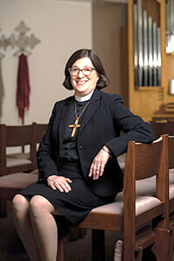
Presiding Bishop Elizabeth Eaton, ELCA

Retrieved from www.livinglutheran.org/
published June 30, 2023

My husband and I live in Skokie, Ill., a diverse community. Our neighbors to the west are an octogenarian Taiwanese Evangelical couple who regularly order meals from Kosher to Go. Our neighbors to the east are a Ukrainian and Russian multigenerational family. Our grocery stores have both kosher and halal departments. As I drive past the elementary school on my way to work, I see moms and dads in jeans along with women in saris or hijabs and men in thobes or yarmulkes. More than 90 languages are spoken in the homes of our school district. We pay our taxes, mow our (tiny) lawns, worship, raise our children and pretty much get along in our little village of Skokie.
Late one afternoon a few years ago I was finishing up yard work. I had been weeding and trimming all day. I was tired and grass stained. Just one more pile of leaves needed to be swept up. I noticed a woman walking toward me so I hurried to get the sidewalk cleared. She stopped and told me that she had seen me working all day and thought I might be too tired to prepare supper. She had made a meal for me and my husband. It was during Ramadan—the month when Muslims fast from food and water during the day and engage in prayer and acts of charity. This was her act of charity and generosity. She smiled and walked away. I was stunned.
There has been an alarming rise in hate speech and violence against religious and ethnic minorities in this country. At the same time, we’ve seen an increased polarization among us, even in our dear church. There is a movement to define what it means to be a “real American.” Some would define this as white, Christian, and native-born. When Lutheran immigrants first came to this country in the 18th and 19th centuries, they weren’t considered real Americans. They didn’t speak English or fit in with the Deist, Calvinist religious majority. They were “other” and therefore suspect. German Lutheran immigrants weren’t considered white when they settled here. Neither were Irish, Italians, or Poles. Catholics and Jews were considered an alien threat.
It’s ironic that the Puritans fled [England because of] religious persecution and that the First Amendment states “Congress shall make no law respecting an establishment of religion, or prohibiting the free expression thereof,” yet an element in our country wants to legislate that the United States is a Christian nation where Christianity should be privileged and only Christians should hold office. This is Christian Nationalism, which is neither Christian nor patriotic. There is no doubt that the Founders were Christian and that a majority of Americans identify as Christian. That is different from declaring Christianity as the established religion of the United States. And, dear church, let’s be clear, a Christian Nationalist does not define Lutherans as “Christian.”
God knows I love my country. This beautiful, fragile, yet surprisingly resilient experiment in democracy and nationhood that’s not predicated on shared ethnicity is unique among nations. My grandfather, father and uncles all served during World War I and World War II. I had the honor of placing a wreath on behalf of the ELCA at the Tomb of the Unknown Soldier in Arlington National Cemetery. I won’t have my patriotism questioned.

Continued on the next page.


Who Is A “Real” American? concluded
Christian Nationalism is a perversion of the gospel and a threat to our democracy. It’s precisely because I love my country that I warn against it.
Who is a “real American”? I say that my Muslim neighbor walking freely down the street in a hijab to offer a meal to her Christian neighbor during Ramadan is a real American. Motivated by her Muslim faith she acted as neighbor to me. She is not less American because she is Muslim. Because she is an American, she can be her authentic self and participate in building our community and country. What binds us together is not ethnicity but shared participation in our civic life springing out of our cultural heritages and working for the common good.


Learn more about what it means to be a Christian against Christian Nationalism at https://www.christiansagainstchristiannationalism.org/

Goodstock at Good Earth Village August 26-27
Join us at Good Earth Village Bible camp, rural Spring Valley, for a fun-filled weekend of music, food, and community.
SCHEDULE
Saturday, August 26
1:30 p.m. Check-In for GoodStock
Color Trail Run
2:00 p.m. GoodStock Color Trail
Run Starts
Market & Food Vendors
Family Fun Zone
3:00 p.m. Music – Becky Schlegel
4:30 p.m. Wagon rides around
Good Earth Village
5:00 p.m. Music – Six Mile Grove
7:00 p.m. Music – The Many

Sunday, August 27
9:30 a.m. Coffee and
refreshments in Log
Lodge
10:00 a.m. Outdoor worship
service at Three
Crosses

REMEMBER TO BRING YOUR LAWN CHAIRS AND BLANKETS.

PLEASE, NO PETS.
Go to goodearthvillage.org/goodstock for more information.

A LIFE CHANGING
FAITH FORMATION EVENT
OF THE ELCA

July 13-16, 2024:
MYLE & the tAble
July 16-20, 2024:
ELCA Youth Gathering &
Young Adult Gathering
New Orleans, LA

Since the last time the ELCA came together for an ELCA Youth Gathering, our young people have experienced several major life events. Still today, we are experiencing an ongoing public health crisis mixed with an economic and political crisis. However, we can rest assured that we are created to be in relationship with one another.
We are created to be brave, to show up with an open mind and heart, willing to be challenged.
We are created to be authentic, to bring our whole selves and know that we are loved by our Creator.
We are created to be free, to be transformed by the gospel.
We are created to be disruptive, to work for justice for all our siblings.

Continued on the next page.
ONLINE news, information, and opportunities in our Lutheran Church!
Fountain’s Website
www.fountainlutheranchurch.com

Fountain’s Facebook Page
www.facebook.com/FountainLutheranChurch

The Southeastern Minnesota Synod Website
www.semnsynod.org

The Southeastern Minnesota Synod Facebook Page
www.facebook.com/semnsynod

The Synod’s Weekly Newsletter RCWeekly
Sign up at www.semnsynod.org/news-and-events/e-newsletter

The Synod’s
Quarterly Magazine
River Crossings
Available exclusively online. To sign up and view previous issues go to www.semnsynod.org/news-and-events/river-crossings
The ELCA Website
www.elca.org

The ELCA Facebook Page
www.facebook.com/Lutherans

The Magazine of the ELCA Living Lutheran
www.livinglutheran.org

Lutheran Disaster Response
www.elca.org/Our-Work/Relief-and-Development/Lutheran-Disaster-Response/
www.facebook.com/ELCALDR
Lutheran World Relief
www.lwr.org
www.facebook.com/LuthWorldRelief

Lutheran Youth Organization
www.elca.org/youth

Youth Network
www.elcaymnet.org

Good Earth Village
www.goodearthvillage.org
www.facebook.com/goodearthvillage

Lutheran Campus Ministry
of Winona
www.lccwinona.com
www.facebook.com/LCCWinona

Women of the ELCA
www.womenoftheelca.org

The Magazine of the WELCA Gather
www.gathermagazine.org

Lutheran Men in Mission
www.facebook.com/LutheranMen

We are created to be disciples, to be sent out into the world to love our neighbor just as we are loved by God.
Our host city, New Orleans, has always been its true, authentic self. Our theme, “Created to Be,” highlights the arts, music and soul of this beautiful, vibrant and resilient city. New Orleans was built to host and be a city where all God’s children come together.
We hope to foster relationships and be a sanctuary for one another. We are saint and sinner simultaneously, and we need forgiveness when we aren’t or can’t be brave, authentic, free, disruptive disciples.
Go To: www.elca.church/gathering for links to a whole lot more information about the 2024 ELCA Youth Gathering in New Orleans, LA!!
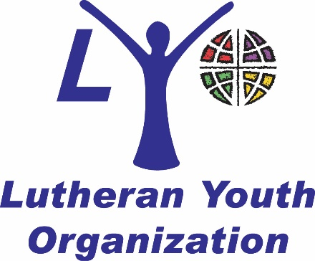



FOUNTAIN MESSENGER
Fountain Lutheran Church
P.O. Box 75
Fountain, MN 55935

ADDRESS SERVICE REQUESTED



SUNDAYS at 9:00 am
www.facebook.com/FountainLutheranChurch/
via

