Fountain Lutheran Church
Established 1904

Rev. Kerry B. Eversole, Pastor
Deacon Cindy Cordes-Eversole, Associate in Ministry

Mailing Address: P.O. Box 75, Fountain, MN 55935
Physical Address: 314 Main Street, Fountain, Minn.

Church Office Phone: 507.268.4413
E-mail Address: flc@mediacombb.net
Website: www.fountainlutheranchurch.com
Facebook Page: www.facebook.com/FountainLutheranChurch/

Parsonage Phone: 507.467.3017
Pastor Kerry’s Cell Phone: 507.951.3954

Our Global Partner Congregation: Issuna Lutheran Church, Tanzania
Fountain Lutheran Church
Fountain, Minnesota

Second Sunday of Easter

April 16, 2023


When it was evening on that day, the first day of the week, and the doors of the house where the disciples had met were locked for fear of the Jews, Jesus came and stood among them and said, “Peace be with you.” After he said this, he showed them his hands and his side.
John 20:19-20
Welcome to worship at Fountain Lutheran Church
and our continuing celebration of Easter!

COVID-19 Practices — Out of Love for God and Neighbor

1) Use hand sanitizer upon entry. Wash your hands and use hand sanitizer often while in the facility.
2) Members and visitors who are vaccinated and boosted are not required to wear a mask.
3) Members and visitors are free to wear a mask if they wish to do so.
4) Unvaccinated and not boosted members and visitors must wear a mask.
5) There are no physical distancing requirements, but you are welcome to keep a distance from others in the sanctuary as you are able.
6) All are welcome to enjoy coffee fellowship in the narthex or downstairs in the dining room following worship.

Worship Book and Hymns. This morning’s service is printed in this bulletin and can also be found with all the hymns n Evangelical Lutheran Worship (ELW), “the red book” in the pews. Hymns in ELW are identified by a large bold number in each page’s left or right margin.

Abbreviations. Throughout this worship folder, hymns are signified by the pound symbol (#), P: refers to the presiding minister or preacher, A: denotes an assisting minister, and C: and/or bold text indicates the congregation.

Mistakes do not happen in our worship service;
only unexpected events which are opportunities for joy!

An signifies that you may stand, as you are comfortably able.

Introduction to the Season and the Day. Despite all that we heard and experienced last Sunday, the Resurrection of Our Lord, it is still hard to believe. Because it is hard to believe, we will invest ourselves in the Easter mystery for fifty days. Throughout this week of weeks, these seven Sundays, we turn to John the evangelist to provide sign after sign of Jesus’s victory over death. In today’s gospel, the risen Christ appears to the disciples and offers them the gift of peace. Even amid doubts and questions, we experience the resurrection in our Sunday gathering around word and meal, and in our everyday lives. Throughout the coming Sundays of Easter, the first two readings will be from the Acts of the Apostles and the first letter of Peter. Even as the early Christians proclaimed the resurrection, we rejoice in the new birth and living hope we receive in baptism.
Gathering

The Holy Spirit calls us together as the people of God.

PRELUDE

RINGING OF THE BELL

EASTER PROCLAMATION

P: Alleluia! Christ is risen!

C: Christ is risen indeed! Alleluia!

OPENING HYMN Come, You Faithful, Raise the Strain ELW # 363

Stanzas 1, 2, 3 and 5

GREETING

P: The joy and peace of our risen Savior, the love of God, and the communion of the Holy Spirit be with you all.

C: And also with you.

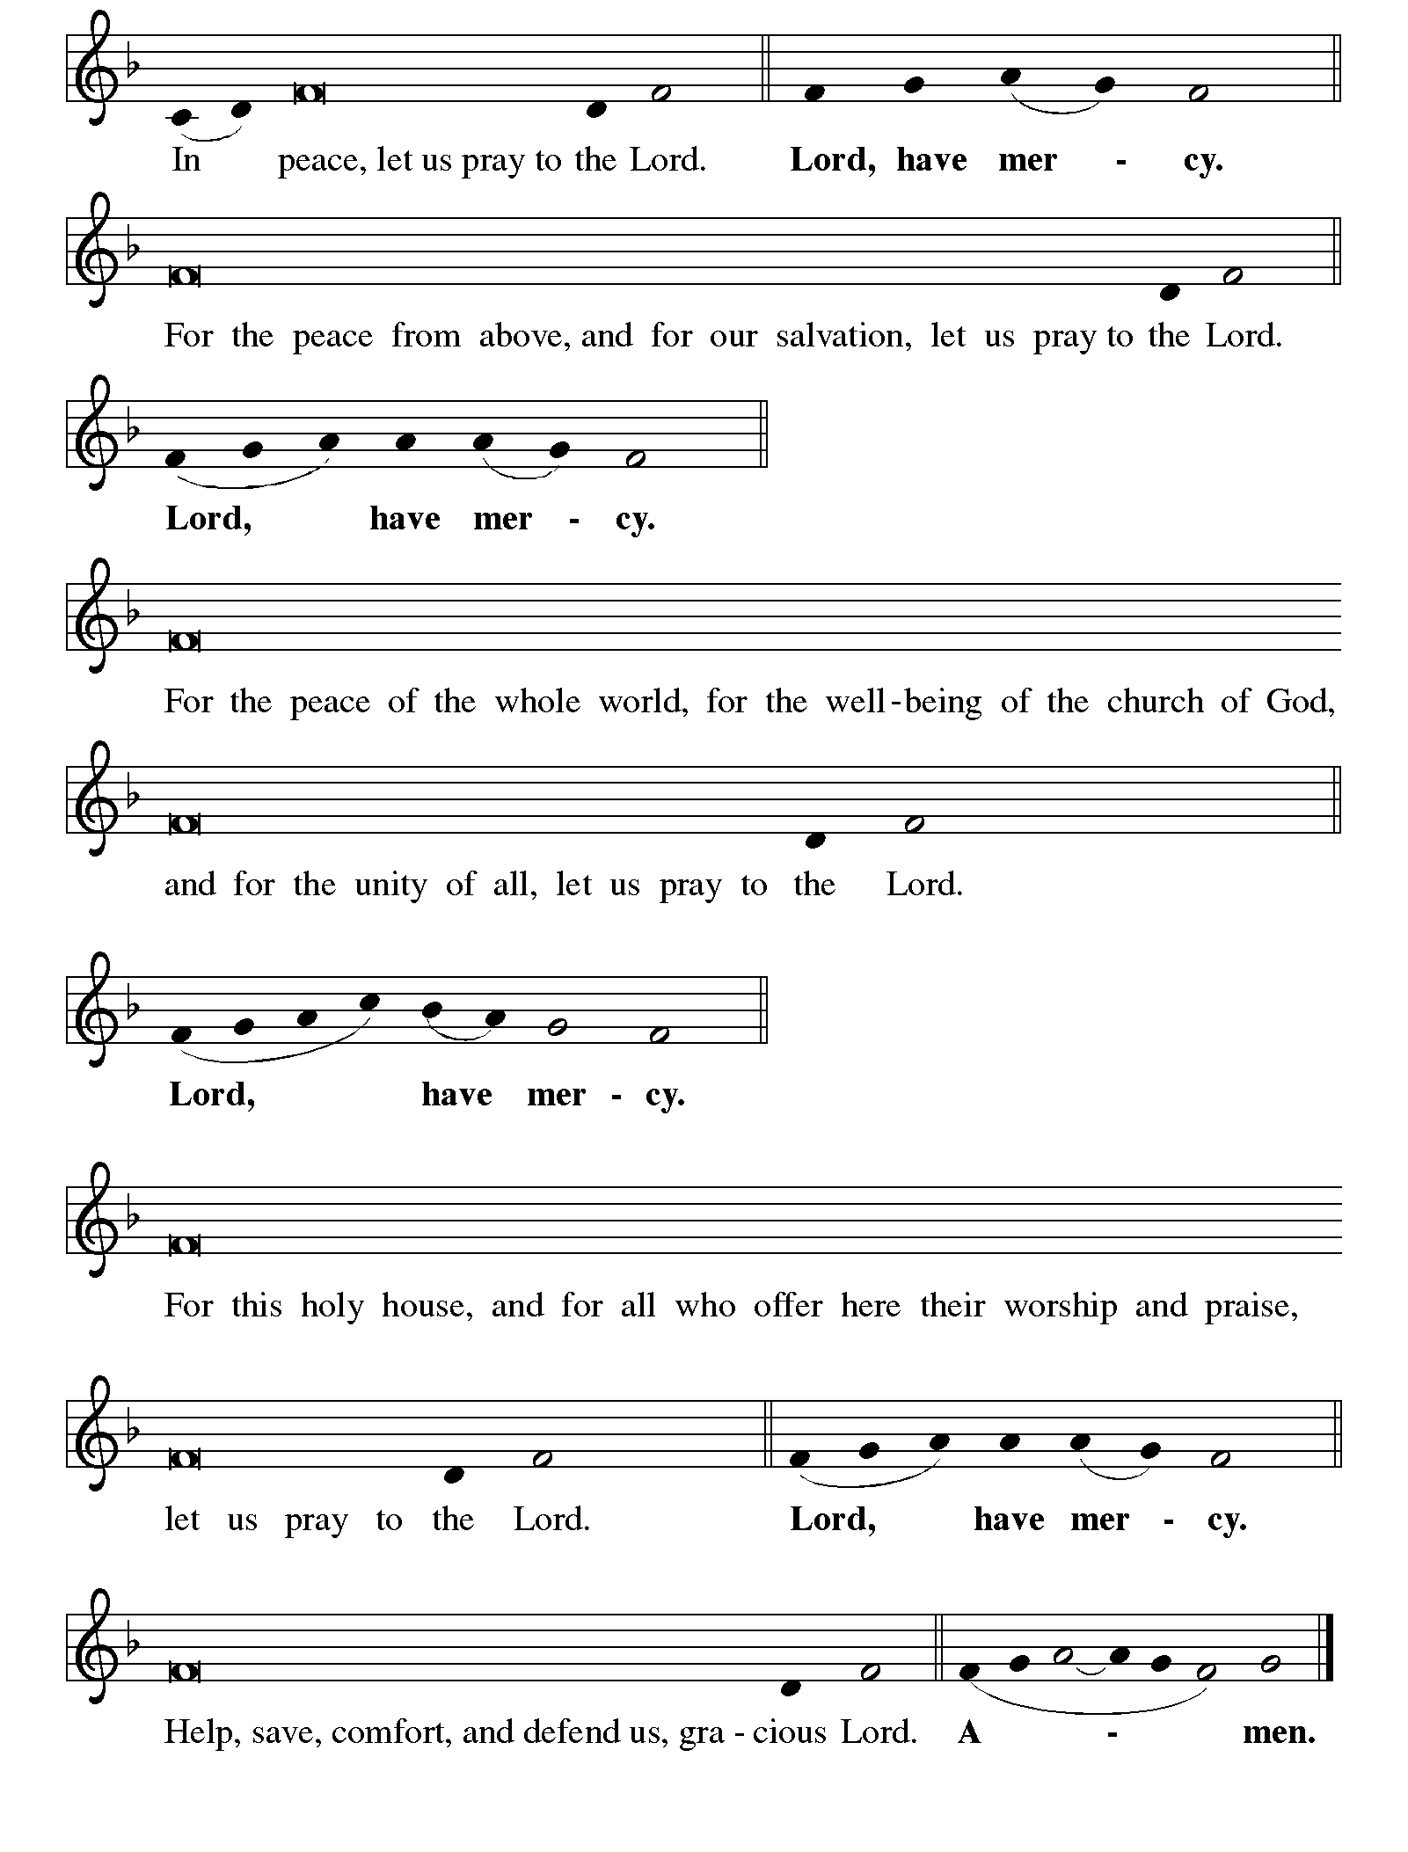KYRIE ELW p. 138

Continued on the next page

KYRIE concluded ELW pp. 138-139

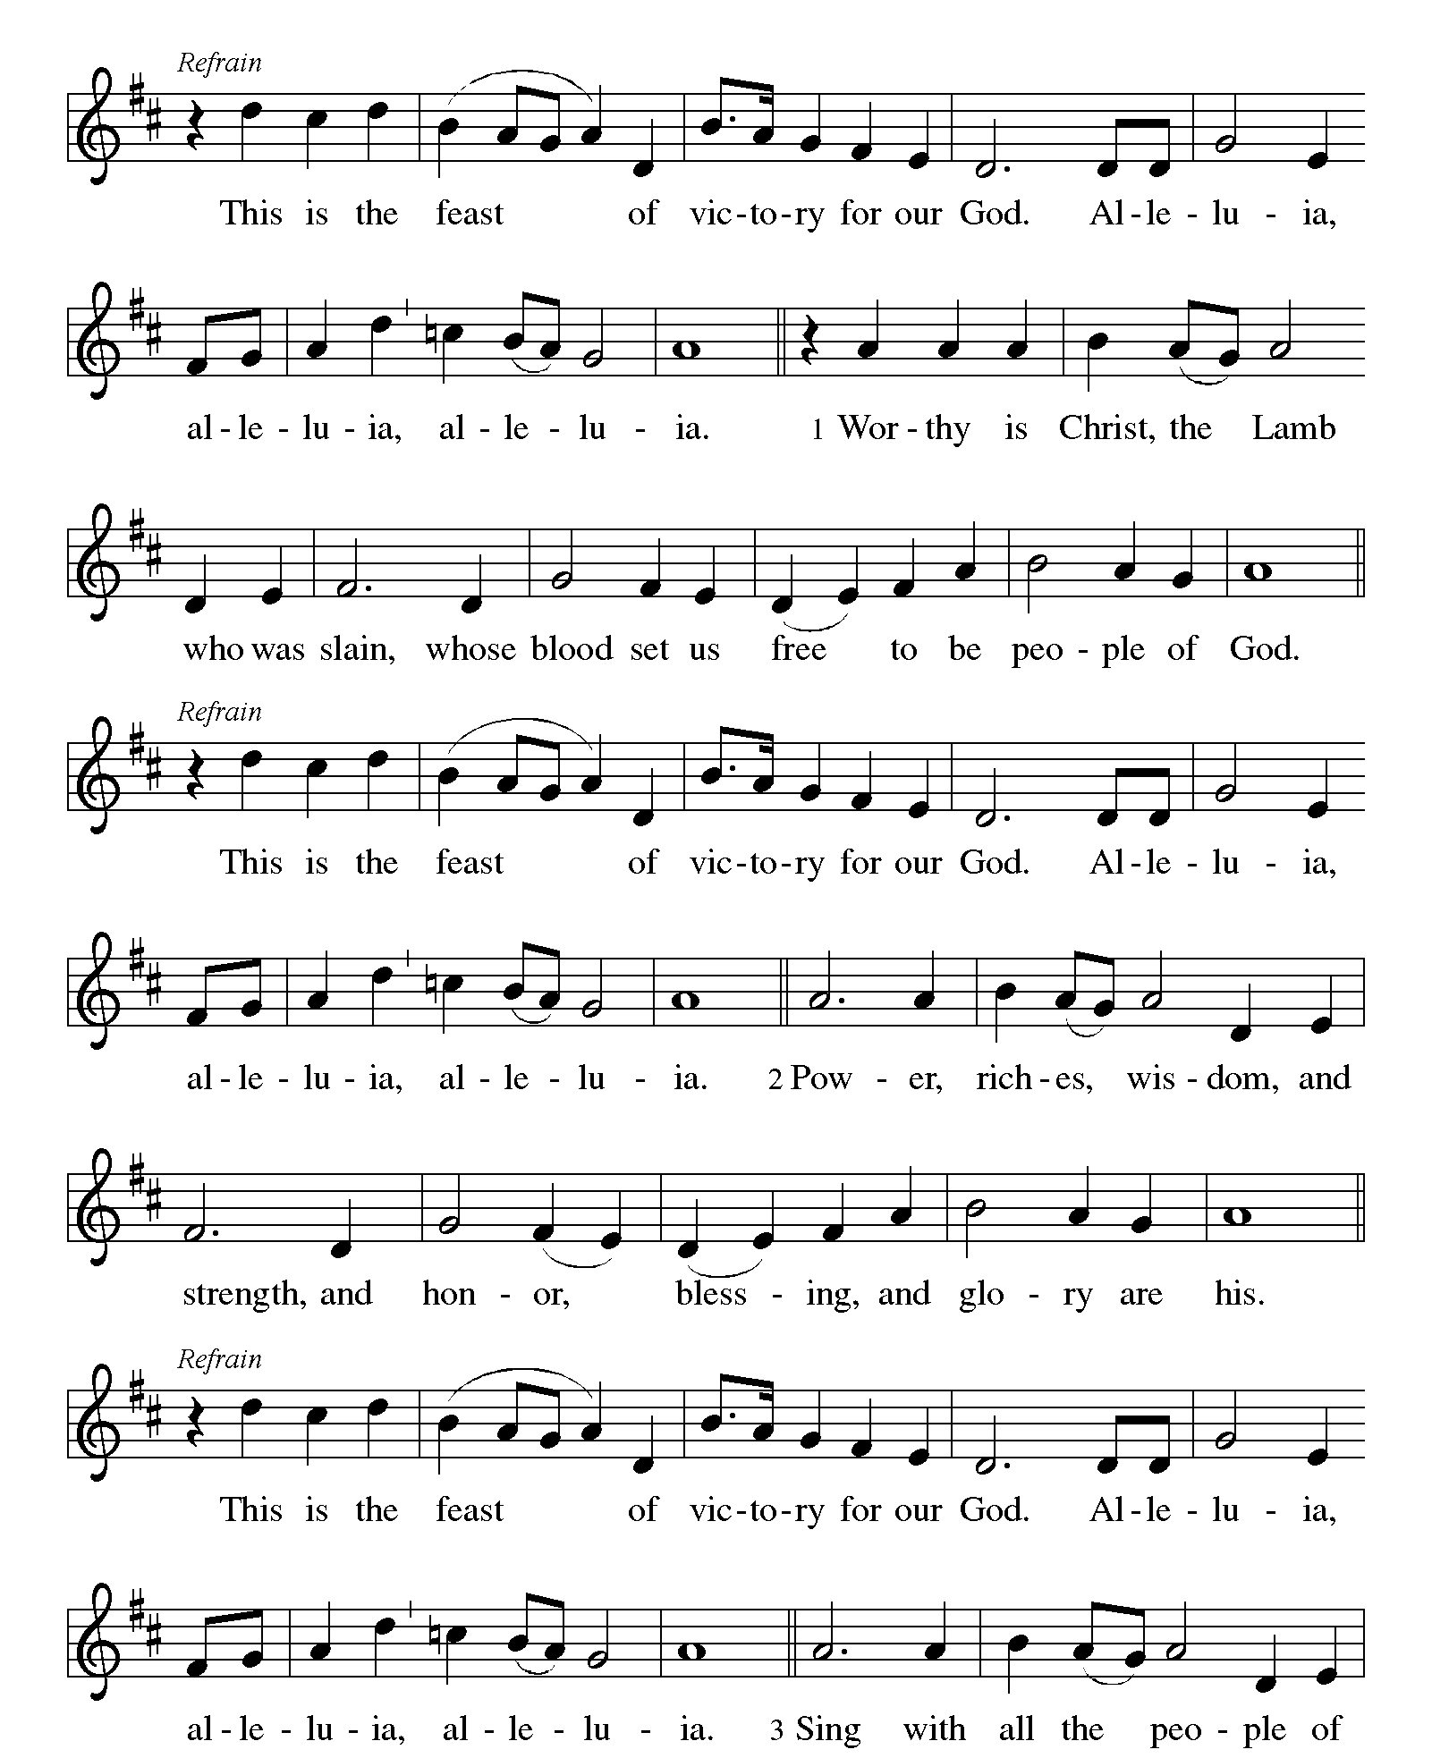CANTICLE OF PRAISE This is the Feast ELW p. 140

Continued on the next page.
CANTICLE OF PRAISE continued ELW pp. 140-141

Continued on the next page.

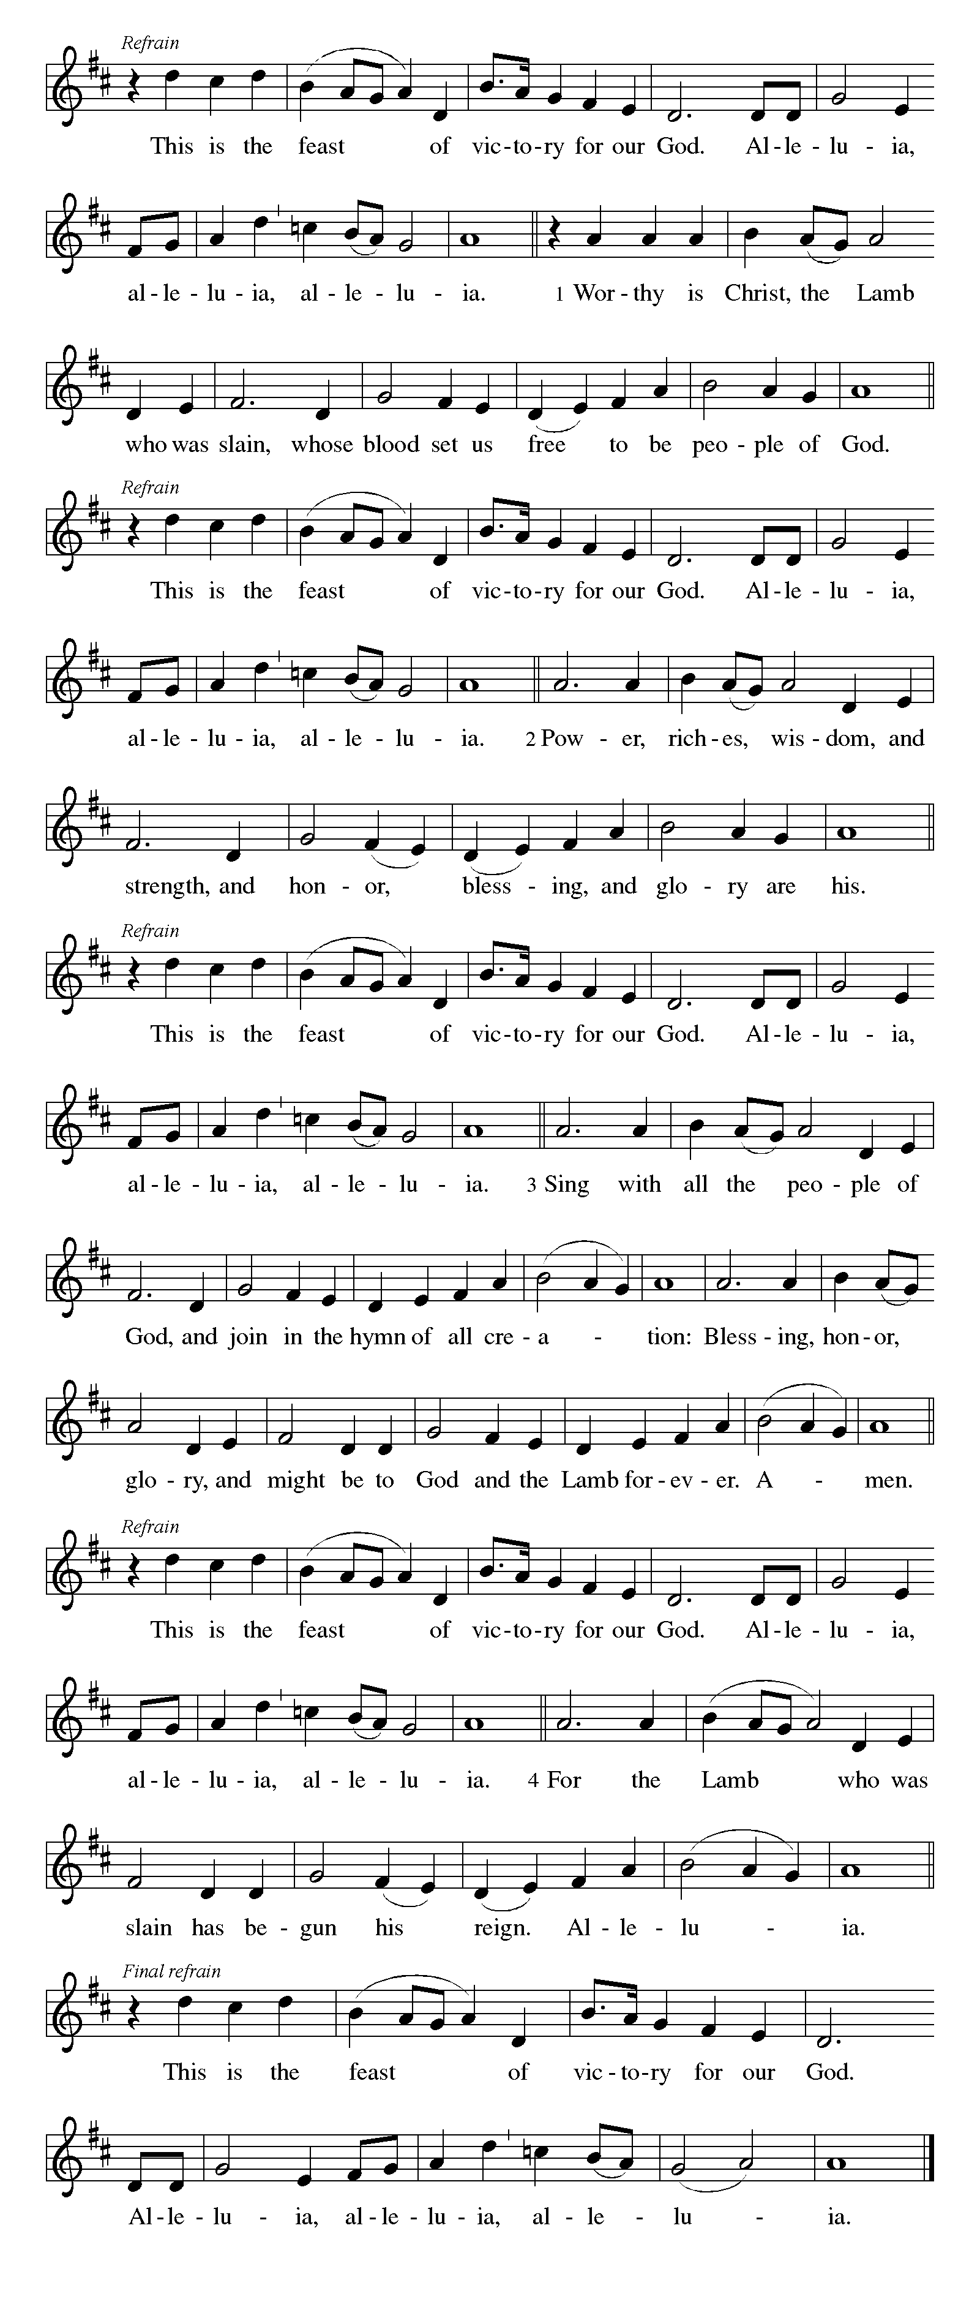CANTICLE OF PRAISE concluded ELW p. 141

PRAYER OF THE DAY

P: Let us pray together.

Almighty and eternal God,

All: the strength of those who believe and the hope of those who doubt, may we, who have not seen, have faith in you and receive the fullness of Christ’s blessing, who lives and reigns with you and the Holy Spirit, one God, now and forever. Amen.

The Good News of Easter

God speaks to us in scripture reading, preaching, and song.

FIRST READING Acts 2:14a, 22-32

After the Holy Spirit comes to the apostles on Pentecost, Peter preaches the gospel to the gathered crowd. He tells them that Jesus, who obediently went to his death according to God’s plan, was raised from the dead by God. Finally, he appeals to scripture, quoting Psalm 16:8-11, to show that Jesus is the Messiah: though crucified, the risen Jesus is now enthroned.

^{14a}Peter, standing with the eleven, raised his voice and addressed [the crowd], ²²“You that are Israelites, listen to what I have to say: Jesus of Nazareth, a man attested to you by God with deeds of power, wonders, and signs that God did through him among you, as you yourselves know—²³this man, handed over to you according to the definite plan and foreknowledge of God, you crucified and killed by the hands of those outside the law. ²⁴But God raised him up, having freed him from death, because it was impossible for him to be held in its power. ²⁵For David says concerning him,
‘I saw the Lord always before me,
for he is at my right hand so that I will not be shaken;
²⁶therefore my heart was glad, and my tongue rejoiced;
moreover my flesh will live in hope.
²⁷For you will not abandon my soul to Hades,
or let your Holy One experience corruption.
²⁸You have made known to me the ways of life;
you will make me full of gladness with your presence.’
²⁹“Fellow Israelites, I may say to you confidently of our ancestor David that he both died and was buried, and his tomb is with us to this day. ³⁰Since he was a prophet, he knew that God had sworn with an oath to him that he would put one of his descendants on his throne. ³¹Foreseeing this, David spoke of the

Continued on the next page
resurrection of the Messiah, saying,
‘He was not abandoned to Hades,
nor did his flesh experience corruption.’
³²This Jesus God raised up, and of that all of us are witnesses.”

A: Word of God, word of life.

C: Thanks be to God.

SECOND READING 1 Peter 1:3-9

This epistle was written to encourage Christians experiencing hardships and suffering because of their faith in Christ. The letter opens by blessing God for the living hope we have through Christ’s resurrection even amid difficult circumstances and surroundings.

³Blessed be the God and Father of our Lord Jesus Christ! By his great mercy he has given us a new birth into a living hope through the resurrection of Jesus Christ from the dead, ⁴and into an inheritance that is imperishable, undefiled, and unfading, kept in heaven for you, ⁵who are being protected by the power of God through faith for a salvation ready to be revealed in the last time. ⁶In this you rejoice, even if now for a little while you have had to suffer various trials, ⁷so that the genuineness of your faith—being more precious than gold that, though perishable, is tested by fire—may be found to result in praise and glory and honor when Jesus Christ is revealed. ⁸Although you have not seen him, you love him; and even though you do not see him now, you believe in him and rejoice with an indescribable and glorious joy, ⁹for you are receiving the outcome of your faith, the salvation of your souls.

A: Word of God, word of life.

C: Thanks be to God.

EASTER GOSPEL John 20:19-31

P: The holy gospel according to Saint John, the twentieth chapter.

C: Glory to you, O Lord.

The risen Jesus appears to his disciples, offering them a benediction, a commission, and the gift of the Holy Spirit. But one of their numbers is missing, and his unbelief prompts another visit from the Lord.

¹⁹When it was evening on that day, the first day of the week, and the doors of the house where the disciples had met were locked for fear of the Jews, Jesus came and stood among them and said, “Peace be with you.” ²⁰After he said

Continued on the next page
this, he showed them his hands and his side. Then the disciples rejoiced when they saw the Lord. ²¹Jesus said to them again, “Peace be with you. As the Father has sent me, so I send you.” ²²When he had said this, he breathed on them and said to them, “Receive the Holy Spirit. ²³If you forgive the sins of any, they are forgiven them; if you retain the sins of any, they are retained.”
²⁴But Thomas (who was called the Twin), one of the twelve, was not with them when Jesus came. ²⁵So the other disciples told him, “We have seen the Lord.” But he said to them, “Unless I see the mark of the nails in his hands, and put my finger in the mark of the nails and my hand in his side, I will not believe.”
²⁶A week later his disciples were again in the house, and Thomas was with them. Although the doors were shut, Jesus came and stood among them and said, “Peace be with you.” ²⁷Then he said to Thomas, “Put your finger here and see my hands. Reach out your hand and put it in my side. Do not doubt but believe.” ²⁸Thomas answered him, “My Lord and my God!” ²⁹Jesus said to him, “Have you believed because you have seen me? Blessed are those who have not seen and yet have come to believe.”
³⁰Now Jesus did many other signs in the presence of his disciples, which are not written in this book. ³¹But these are written so that you may come to believe that Jesus is the Messiah, the Son of God, and that through believing you may have life in his name.

P: The Easter gospel of our Lord.

C: Praise to you, O Christ.

SERMON

HYMN OF THE DAY We Walk by Faith ELW # 635

Stanzas 1, 2, 3 and 5

Responding to The Good News of Easter

THANKSGIVING FOR BAPTISM

All may make the sign of the cross, the sign that is marked at baptism, as the presiding minister begins.

P: Blessed be the holy Trinity, ☩ one God, by whose hand we are given new birth, by whose speaking we are given new life.

C: Amen.

Continued on the next page

P: Joined to Christ in the waters of baptism, we are welcomed, restored, and supported as citizens of the new creation. Let us give thanks for the gift of baptism.

Holy God, holy and merciful, holy and mighty, you are the river of life, you are the everlasting wellspring.

In mercy and might you have freed us from death and raised us with Jesus, the firstborn of the dead. In baptismal waters, our old life is washed away, and in them, we are born anew.

Water may be poured into the font as the presiding minister continues.

P: Glory to you for oceans and lakes, for rivers and streams. Honor to you for waters that wash us clean, quench our thirst, and nurture both crops and creatures. Praise to you for the life-giving water of baptism, the outpouring of the Spirit of the new creation.

All: Wash away our sin and all that separates us from you. Empower our witness to your resurrection. Strengthen our resolve in seeking justice for all.

P: Satisfy the world’s needs through this living water. Where drought dries the earth, bring refreshment. Where despair prevails, grant hope. Where chaos reigns, bring peace. We ask this through Christ, who with you and the Spirit reigns forever.

C: Amen.

BAPTISM HYMN We Know That Christ Is Raised ELW # 449

Stanzas 1, 2, 3 and 4

OFFERING AND MUSIC

OFFERING SONG That Easter Day with Joy Was Bright ELW # 384

Stanzas 1, 3 and 4

PRAYERS OF GOD’S PEOPLE

Each petition ends with these words and response:

P: Hear us, O God,

C: your mercy is great.

Concluding petition and response:

Continued on the next page
P: Rejoicing in the victory of Christ’s resurrection, we lift our prayers and praise to you, almighty and eternal God; through Jesus Christ, our risen Lord.

C: Amen.

LORD’S PRAYER Traditional Wording

P: Gathered into one by the Holy Spirit, let us pray as Jesus taught us.

All: Our Father, who art in heaven, hallowed be thy name, thy kingdom come, thy will be done, on earth as it is in heaven. Give us this day our daily bread; and forgive us our trespasses, as we forgive those who trespass against us; and lead us not into temptation, but deliver us from evil. For thine is the kingdom, and the power, and the glory, forever and ever. Amen.

Sending

God blesses us and sends us in mission to the world.

ANNOUNCEMENTS

BLESSING

P: The God of all, who raised ☩ Jesus from the dead,
bless you by the power of the Holy Spirit
to live in the new creation.

C: Amen.

DEPARTING HYMN Thine Is the Glory ELW # 376

Stanzas 1, 2 and 3

DISMISSAL

P: Alleluia! Christ is risen.

C: Christ is risen indeed. Alleluia!

P: Go in peace. Serve the Risen One.

C: Thanks be to God. Alleluia!

RINGING OF THE BELL

POSTLUDE

Today’s Assistants and Ministers

Greeters & Ushers ……………...………… Paul & Julie Gade and Ken & Gloria Hollermann
Organist – Pianist ……………………..…………….………..………….…… Sherry Hareldson
Presiding Minister ………………………………….…….....…………… Pastor Kerry Eversole
Altar Care ………………………………….. Paul & Julie Gade and Ken & Gloria Hollermann
Custodians ………………………….….…….………...….…..…….. Dave & Geri Ann Hanson

This Week in Our Congregation

Today, Sunday, April 16 — Second Sunday of Easter

Sunday School after the children’s message
Refreshments in the narthex or downstairs in the dining room for everyone after worship
Church Council following worship

Tuesday, April 18

Men’s breakfast at Home Sweet Home, Lanesboro 7:00 AM

Saturday, April 22

Nathan Eversole and Gabrielle Shupe wedding at Bethlehem 3:30 PM

Next Sunday, April 23 — Third Sunday of Easter

Worship with Holy Communion 9:00 AM
Sunday School after the children’s message

Prayer Requests

In Our Community. For our church members and friends living with chronic illness and other diseases, who are homebound, residing in care facilities, and hospitalized. See the newsletter for our members living in area nursing homes. And let us not forget those sick and dying of COVID-19, those entrusted with the authority of government, justice, and law enforcement, as well as our fallen and wounded soldiers and those still serving.

In Our Synod. Bishop Regina Hassanally invites the people and congregations of our Southeastern Minnesota Synod to make a commitment to pray this week for the following faith communities: North Blue Earth Lutheran Church, Bricelyn; People of Hope, Rochester; Deer Creek Valley Lutheran Church, Glenville; Kinakumi Lutheran Church, Tanzania; Nkuhi Lutheran Church, Tanzania; CELCO (Colégio de la Evangélica Luterana de Colombia) Cocuy Easces.

News and Notes

Pastor Kerry and Deacon Cindy will be on vacation from Thursday, April 20 thru Sunday, April 23 to celebrate their son Nathan’s wedding on Saturday, April 22. The Rev. Chris Miller will be our worship leader and preacher next Sunday!

Continued on the next page.
Andrew Pruett to lead a book study beginning April 24. Andrew and his family are relatively new residents of Lanesboro and new members of our sister congregation Bethlehem Lutheran. He has written a book entitled Shaped by Water which is a compilation of stories about how water has impacted his life. He will be leading a three-session study of his book beginning on Monday, April 24, at 6:30 pm, in the Bethlehem Fellowship Hall. The study will continue on May 1 and on May 8. Copies of the book are for sale. The cost is $20 for a hardcover and $15 for a paperback. Contact Andrew to buy a copy (507-993-8069).

Bethlehem Drive-thru Ham Dinner, Sunday, April 30. Our sister congregation in Lanesboro is hosting a drive-thru ham dinner on Sunday, April 30 from 11:00 am to 1:00 pm. The meal will include ham, au gratin potatoes, beans, and a dinner roll. Limited to 200 pre-sale tickets at $13 per meal. Contact Deane Benson to purchase tickets (507-208-3164).

Community Activities

Highland Prairie Lutheran Church Meatball Dinner, today! Serving from 10:30 a.m. to 1:30 p.m., at the church. The dinner includes meatballs, mashed potatoes and gravy, green beans almondine, assorted salads, our homemade lefse and buns, desserts, and beverage. The cost is $12.00 for adults, children 6-12 are $6.00, and children 5 and under are free.

North Prairie Lutheran Church Dine-In or Drive-Thru Meatball Dinner, Sunday, April 23. Serving from 11:00 a.m. to 1:00 p.m. The dinner includes meatballs, real mashed potatoes and gravy, glazed carrots, salad, rolls, bars, and beverages. All carry-outs or adults are $12.00, children under 12 $6.00, and children under 6 free. 35957 State Highway 30, rural Lanesboro.

Lanesboro Emergency Services Open House, Saturday, April 29, from 11 a.m. to 1 p.m. Free food. Prizes and give aways. Meet your local volunteers. Tours of the new building. The meal includes burgers, chips, beans and beverages. Fire & Ambulance Building, 303 Sheridan St W (MN Hwy 16 West).

Acknowledgments

Graphics, worship texts, service music, readings, and PowerPoint® Slides are from sundaysandseasons.com © 2023 Augsburg Fortress. Used by permission under Augsburg Fortress Liturgies Annual License SAS005401.

Permission to project liturgy and music content under copyright to or administered by Augsburg Fortress provided under Augsburg Fortress Liturgies Annual License SAS005401.


We gratefully acknowledge the following individuals and families who donated Easter Lilies and other flowers to decorate the church this Easter season.
We sincerely apologize for any omissions.

In loving memory of our parents
from Dave & Geri Hanson

in loving memory of our families
from Ken & Gloria Hollermann

in loving memory of our parents and in honor of our families
from Chuck & Deb Jeffers

in loving memory of Florence, Lyle & Bary Long and Myra, Allen & Donnie Rustad
from Dave & Debbie Long & family

in loving memory of Timothy Dahley
from Randy & Anne Schultz, Jennifer Dahley, JJ Dahley & Alisha Bersch

in memory of our loved ones
from Mike & Deb Schwarz

In loving memory of Marge Hunt, Lee & Carolyn Tienter, and in honor of Larry Hunt
from Tom & Julie Tienter

in loving memory of Mark Hamann
from Shari Hamann

In loving memory of Robert & Dartha Eversole and Henry & Evalee Cordes
from Kerry & Cindy Cordes-Eversole and family

We gratefully acknowledge the following individuals and families who donated Easter Lilies and other flowers to decorate the church this Easter season.
We sincerely apologize for any omissions.

In loving memory of our parents
from Dave & Geri Hanson

in loving memory of our families
from Ken & Gloria Hollermann

in loving memory of our parents and in honor of our families
from Chuck & Deb Jeffers

in loving memory of Florence, Lyle & Bary Long and Myra, Allen & Donnie Rustad
from Dave & Debbie Long & family

in loving memory of Timothy Dahley
from Randy & Anne Schultz, Jennifer Dahley, JJ Dahley & Alisha Bersch

in memory of our loved ones
from Mike & Deb Schwarz

In loving memory of Marge Hunt, Lee & Carolyn Tienter, and in honor of Larry Hunt
from Tom & Julie Tienter

in loving memory of Mark Hamann
from Shari Hamann

In loving memory of Robert & Dartha Eversole and Henry & Evalee Cordes
from Kerry & Cindy Cordes-Eversole and family

