Fountain Lutheran Church

Established 1904

Rev. Kerry B. Eversole, Pastor
Deacon Cindy Cordes-Eversole, Associate in Ministry

Mailing Address: P.O. Box 75, Fountain, MN 55935
Physical Address: 314 Main Street, Fountain, Minn.

Church Office Phone: 507.268.4413
E-mail Address: flc@mediacombb.net
Website: www.fountainlutheranchurch.com
Facebook Page: www.facebook.com/FountainLutheranChurch/

Parsonage Phone: 507.467.3017

Pastor Kerry’s Cell Phone: 507.951.3954

Our Global Partner Congregation: Issuna Lutheran Church, Tanzania
Fountain Lutheran Church
Fountain, Minnesota

Third Sunday of Easter

April 23, 2023

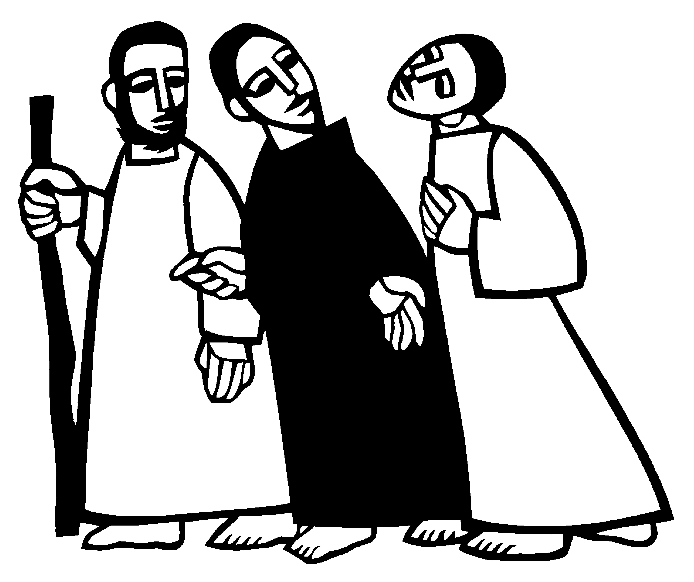
[On the first Easter, when Jesus had appeared to Mary Magdalene,] two [disciples] were going to a village called Emmaus, about seven miles from Jerusalem, and talking with each other about all these things that had happened. While they were talking and discussing, Jesus himself came near and went with them, but their eyes were kept from recognizing him.
Luke 24:13-15
Welcome to worship at Fountain Lutheran Church
and our continuing celebration of Easter!

COVID-19 Practices — Out of love for God and Neighbor

1) Use hand sanitizer upon entry. Wash your hands and use hand sanitizer often while in the facility.
2) Members and visitors who are vaccinated and boosted are not required to wear a mask.
3) Members and visitors are free to wear a mask if they wish to do so.
4) Unvaccinated and not boosted members and visitors must wear a mask.
5) There are no physical distancing requirements, but you are welcome to keep a distance from others in the sanctuary as you are able.
6) All are welcome to enjoy coffee fellowship in the narthex or downstairs in the dining room following worship.

Worship Book and Hymns. This morning’s service is printed in this bulletin and can also be found with all the hymns in Evangelical Lutheran Worship (ELW), “the red book” in the pews. Hymns in ELW are identified by a large bold number in each page’s left or right margin.

Abbreviations. Throughout this worship folder, hymns are signified by the pound symbol (#), P: refers to the presiding minister or preacher, A: denotes an assisting minister, and C: and/or bold text indicates the congregation.

Mistakes do not happen in our worship service;
only unexpected events which are opportunities for joy!

An signifies that you may stand, as you are comfortably able.

Introduction to the Season and the Day. Despite all that we heard and experienced last Sunday, the Resurrection of Our Lord, it’s still hard to believe. Because it’s hard to believe, we will invest ourselves in the Easter mystery for fifty days. Throughout this week of weeks, these seven Sundays, we turn to John and Luke to provide sign after sign of Jesus’s victory over death. Today’s gospel from Luke begins with two disciples walking to Emmaus, overcome with sadness, loss, and disappointment. They had hoped Jesus, who was crucified, would be the one to redeem Israel! Yet the risen Christ walks with them and then opens their eyes in the breaking of the bread. Each Sunday our hearts burn within us as the scriptures are proclaimed and Christ appears to us as bread is broken and wine is poured. The story of Emmaus becomes the pattern of our worship on each Lord’s Day.
Gathering

The Holy Spirit calls us together as the people of God.

PRELUDE Morning has Broken Jan Meyer

Traditional Gaelic “Bunessan” arr. by Lani Smith

RINGING OF THE BELL

EASTER PROCLAMATION

P: Alleluia! Christ is risen!

C: Christ is risen indeed! Alleluia!

OPENING HYMN Alleluia! Jesus Is Risen! ELW # 377

Stanzas 1, 2, 4 and 5

GREETING

P: The joy and peace of our risen Savior, the love of God, and the communion of the Holy Spirit be with you all.

C: And also with you.

KYRIE ELW p. 138 Spoken

P: In peace, let us pray to the Lord.

C: Lord, have mercy.

P: For the peace from above, and for our salvation, let us pray to the Lord.

C: Lord, have mercy.

P: For the peace of the whole world, for the well-being of the Church of God, and for the unity of all, let us pray to the Lord.

C: Lord, have mercy.

P: For this holy house, and for all who offer here their worship and praise, let us pray to the Lord.

C: Lord, have mercy.

P: Help, save, comfort, and defend us, gracious Lord.

C: Amen.

CANTICLE OF PRAISE This is the Feast ELW p. 140
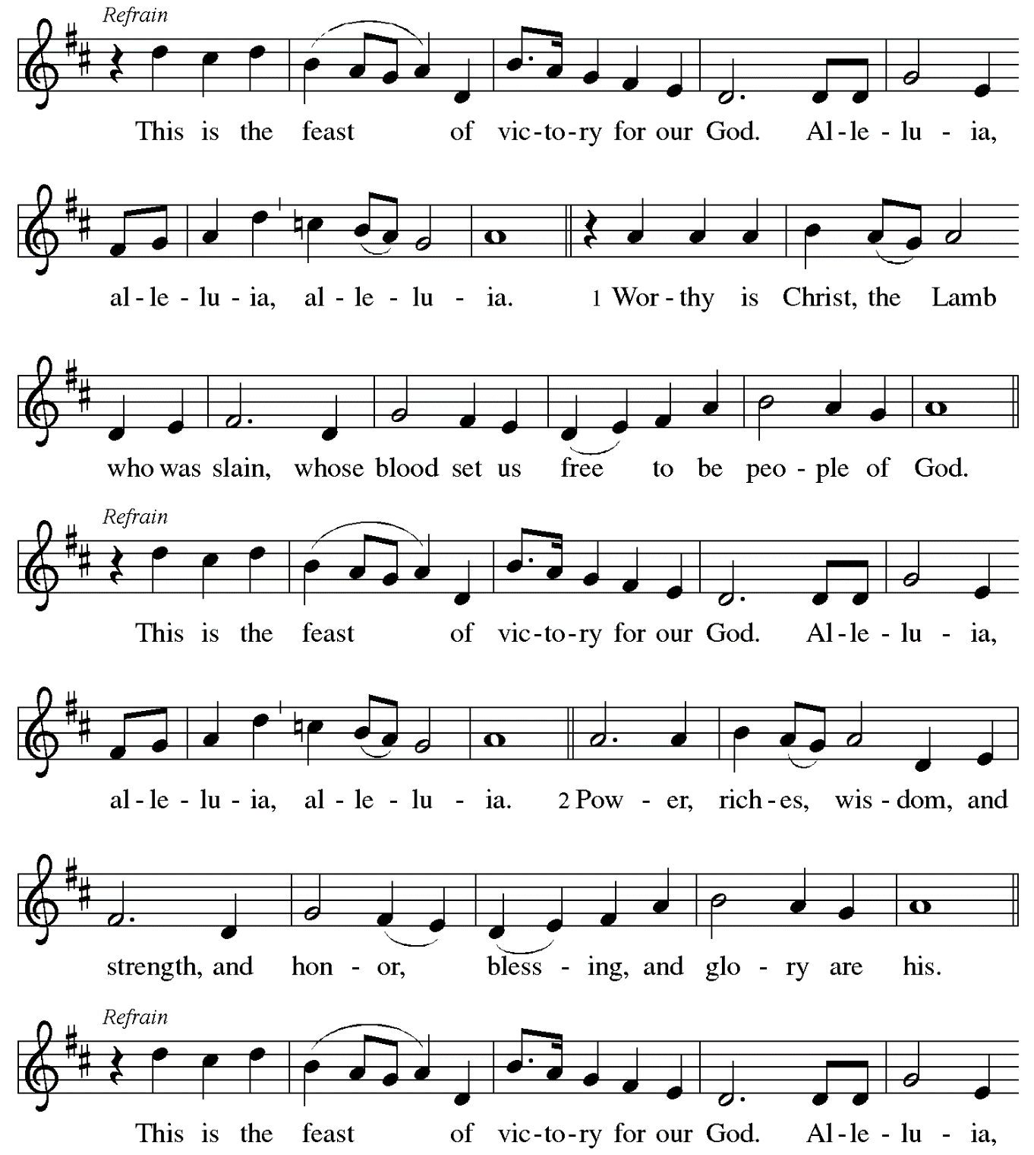

Continued on the next page.

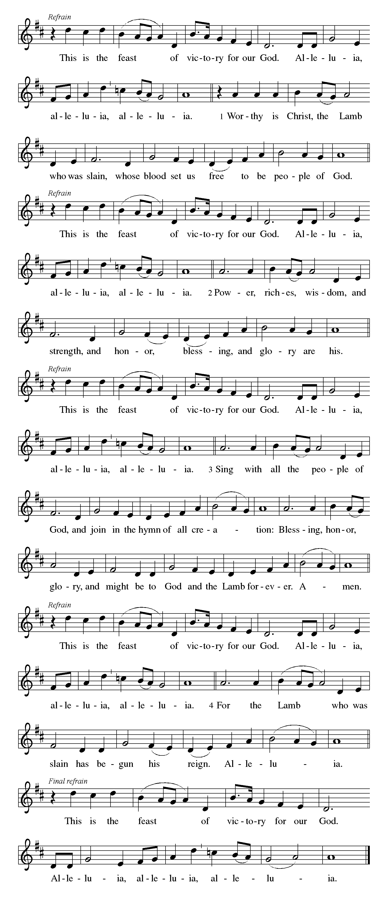
CANTICLE OF PRAISE continued ELW pp. 140-141

Continued on the next page.

CANTICLE OF PRAISE concluded ELW p. 141

PRAYER OF THE DAY

P: O God, your Son makes himself known to all his disciples in the breaking of bread. Open the eyes of our faith, that we may see him in his redeeming work, who lives and reigns with you and the Holy Spirit, one God, now and forever.

C: Amen.

The Good News of Easter

God speaks to us in scripture reading, preaching, and song.

FIRST READING Acts 2:14a, 36-41

Today’s reading is the conclusion of Peter’s sermon preached following the giving of the Holy Spirit to the apostles on the day of Pentecost. The center of his preaching is the bold declaration that God has made the crucified Jesus both Lord and Christ.

^{14a}Peter, standing with the eleven, raised his voice and addressed [the crowd], ³⁶“Therefore let the entire house of Israel know with certainty that God has made him both Lord and Messiah, this Jesus whom you crucified.”
³⁷Now when they heard this, they were cut to the heart and said to Peter and to the other apostles, “Brothers, what should we do?” ³⁸Peter said to them, “Repent, and be baptized every one of you in the name of Jesus Christ so that your sins may be forgiven; and you will receive the gift of the Holy Spirit. ³⁹For the promise is for you, for your children, and for all who are far away, everyone whom the Lord our God calls to him.” ⁴⁰And he testified with many other arguments and exhorted them, saying, “Save yourselves from this corrupt

Continued on the next page.
generation.” ⁴¹So those who welcomed his message were baptized, and that day about three thousand persons were added.

A: Word of God, word of life.

C: Thanks be to God.

SECOND READING 1 Peter 1:17-23

The imagery of exile is used to help the readers of this letter understand that they are strangers in a strange land. Christians no longer belong to this age. Through the death of Christ we belong to God, so that our focus, faith, and hope are no longer on such things as silver or gold.

¹⁷If you invoke as Father the one who judges all people impartially according to their deeds, live in reverent fear during the time of your exile. ¹⁸You know that you were ransomed from the futile ways inherited from your ancestors, not with perishable things like silver or gold, ¹⁹but with the precious blood of Christ, like that of a lamb without defect or blemish. ²⁰He was destined before the foundation of the world, but was revealed at the end of the ages for your sake. ²¹Through him you have come to trust in God, who raised him from the dead and gave him glory, so that your faith and hope are set on God.
²²Now that you have purified your souls by your obedience to the truth so that you have genuine mutual love, love one another deeply from the heart. ²³You have been born anew, not of perishable but of imperishable seed, through the living and enduring word of God.

A: Word of God, word of life.

C: Thanks be to God.

GOSPEL ACCLAMATION

“Alleluias” are from The Strife Is O’er, the Battle Done ELW # 366
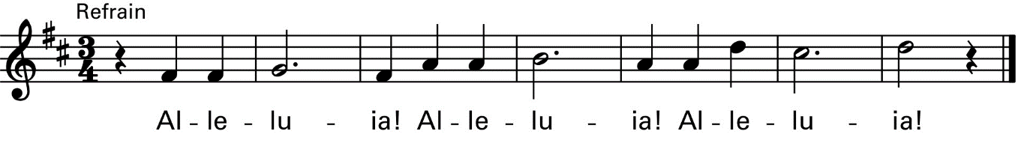

P: Our hearts burn within us while you open to us the scriptures. Luke 24:32

Continued on the next page.

GOSPEL Luke 24:13-35

Announcement of the Gospel.

P: The Holy Gospel according to Saint Luke, the twenty-fourth chapter.

C: Glory to you, O Lord.

The colorful story of Jesus’s appearance to two disciples on the road to Emmaus answers the question of how Jesus is to be recognized among us. Here, he is revealed through the scriptures and in the breaking of bread.

¹³Now on that same day [when Jesus had appeared to Mary Magdalene,] two [disciples] were going to a village called Emmaus, about seven miles from Jerusalem, ¹⁴and talking with each other about all these things that had happened. ¹⁵While they were talking and discussing, Jesus himself came near and went with them, ¹⁶but their eyes were kept from recognizing him. ¹⁷And he said to them, “What are you discussing with each other while you walk along?” They stood still, looking sad. ¹⁸Then one of them, whose name was Cleopas, answered him, “Are you the only stranger in Jerusalem who does not know the things that have taken place there in these days?” ¹⁹He asked them, “What things?” They replied, “The things about Jesus of Nazareth, who was a prophet mighty in deed and word before God and all the people, ²⁰and how our chief priests and leaders handed him over to be condemned to death and crucified him. ²¹But we had hoped that he was the one to redeem Israel. Yes, and besides all this, it is now the third day since these things took place. ²²Moreover, some women of our group astounded us. They were at the tomb early this morning, ²³and when they did not find his body there, they came back and told us that they had indeed seen a vision of angels who said that he was alive. ²⁴Some of those who were with us went to the tomb and found it just as the women had said; but they did not see him.” ²⁵Then he said to them, “Oh, how foolish you are, and how slow of heart to believe all that the prophets have declared! ²⁶Was it not necessary that the Messiah should suffer these things and then enter into his glory?” ²⁷Then beginning with Moses and all the prophets, he interpreted to them the things about himself in all the scriptures.

Continued on the next page.
²⁸As they came near the village to which they were going, he walked ahead as if he were going on. ²⁹But they urged him strongly, saying, “Stay with us, because it is almost evening and the day is now nearly over.” So he went in to stay with them. ³⁰When he was at the table with them, he took bread, blessed and broke it, and gave it to them. ³¹Then their eyes were opened, and they recognized him; and he vanished from their sight. ³²They said to each other, “Were not our hearts burning within us while he was talking to us on the road,
while he was opening the scriptures to us?” ³³That same hour they got up and returned to Jerusalem; and they found the eleven and their companions gathered together. ³⁴They were saying, “The Lord has risen indeed, and he has appeared to Simon!” ³⁵Then they told what had happened on the road, and how he had been made known to them in the breaking of the bread.

Affirmation of the Gospel.

P: The Easter Gospel of our Lord.

C: Praise to you, O Christ.

SERMON

HYMN OF THE DAY Day of Arising ELW # 374

Sung to Praise and Thanksgiving ELW # 689

PROFESSION OF FAITH Nicene Creed ELW p. 104

P: With the whole church, let us confess our faith.

All: We believe in one God, the Father, the Almighty, maker of heaven and earth, of all that is, seen and unseen.

We believe in one Lord, Jesus Christ, the only Son of God, eternally begotten of the Father, God from God, Light from Light, true God from true God, begotten, not made, of one Being with the Father; through him all things were made. For us and for our salvation he came down from heaven, was incarnate of the Holy Spirit and the virgin Mary and became truly human. For our sake he was crucified under Pontius Pilate; he suffered death and was buried. On the third day he rose again in accordance with the scriptures; he ascended into heaven and is seated at the right hand of the Father. He will come again in glory to judge the living and the dead, and his kingdom will have no end.

Continued on the next page.

We believe in the Holy Spirit, the Lord, the giver of life, who proceeds from the Father and the Son, who with the Father and the Son is worshiped and glorified, who has spoken through the prophets. We believe in one holy catholic and apostolic church. We acknowledge one baptism for the forgiveness of sins. We look for the resurrection of the dead, and the life of the world to come. Amen.

PRAYERS OF GOD’S PEOPLE

Each petition ends with these words and response:

P: Hear us, O God.

C: Your mercy is great.

Concluding petition and response:

P: Rejoicing in the victory of Christ’s resurrection, we lift our prayers and praise to you, almighty and eternal God; through Jesus Christ, our risen Lord.

C: Amen.

The Good News of Easter in the Holy Meal

God feeds us with the presence of Jesus Christ.

OFFERING AND MUSIC Let's Just Praise the Lord Jan Meyer

by William Gaither

OFFERING SONG As We Gather at Your Table ELW # 522

Stanzas 1 and 3

OFFERING PRAYER

A: Generous God,

C: in the meal we are about to receive, you offer your very self. We give thanks for these gifts of the earth. In the breaking of this bread reveal to us the Risen One. In the pouring of this wine pour us out in service to this world in need; through Christ our Lord. Amen.

GREAT THANKSGIVING

Dialogue ELW p. 144 Spoken

P: The Lord be with you.

C: And also with you.

P: Lift up your hearts.

C: We lift them to the Lord.

P: Let us give thanks to the Lord our God.

C: It is right to give our thanks and praise.

Preface

P: It is indeed right, our duty and our joy, that we should at all times and in all places give thanks and praise to you, almighty and merciful God, for the glorious resurrection of our Savior Jesus Christ, the true Paschal Lamb who gave himself to take away our sin; who in dying has destroyed death, and in rising has brought us to eternal life. And so, with Mary Magdalene and Peter and all the witnesses of the resurrection, with earth and sea and all their creatures, and with angels and archangels, cherubim and seraphim, we praise your name and join their unending hymn:

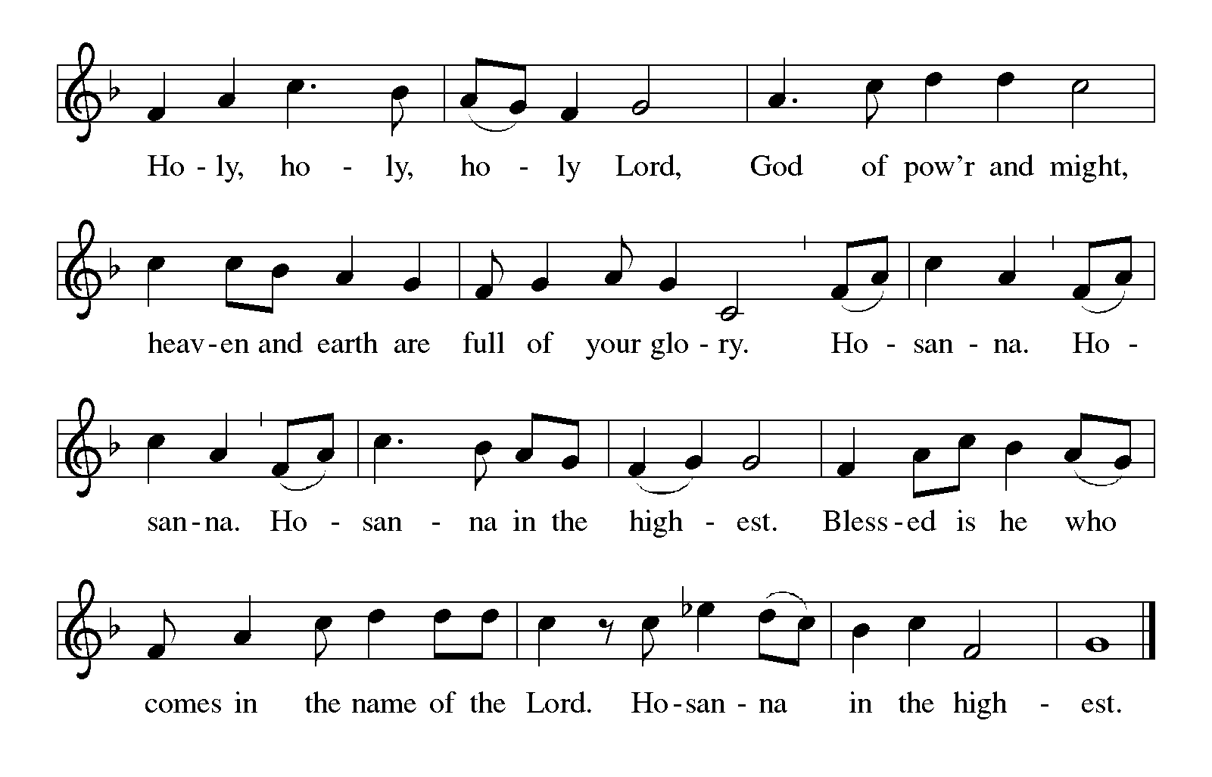
Holy, Holy, Holy (the angels’ song) ELW p. 144

Continued on the next page.

Thanksgiving at the Table ELW p. 145

P: You are indeed holy, almighty and merciful God. You are most holy, and great is the majesty of your glory.

You so loved the world that you gave your only Son, so that everyone who believes in him may not perish but have eternal life.

We give you thanks for his coming into the world to fulfill for us your holy will and to accomplish all things for our salvation.

In the night in which he was betrayed, our Lord Jesus took bread, and gave thanks; broke it, and gave it to his disciples, saying: Take and eat; this is my body, given for you. Do this for the remembrance of me.

Again, after supper, he took the cup, gave thanks, and gave it for all to drink, saying: This cup is the new covenant in my blood, shed for you and for all people for the forgiveness of sin. Do this for the remembrance of me.

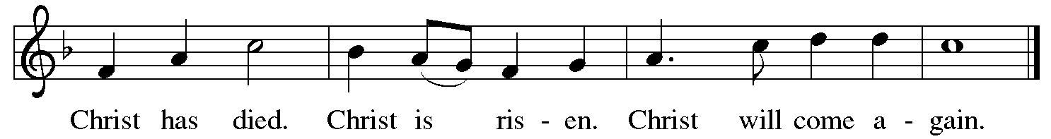
For as often as we eat of this bread and drink from this cup, we proclaim the Lord's death until he comes.

P: Remembering, therefore, his salutary command, his life-giving passion and death, his glorious resurrection and ascension, and the promise of his coming again, we give thanks to you, O Lord God Almighty, not as we ought but as we are able; we ask you mercifully to accept our praise and thanksgiving and with your Word and Holy Spirit to bless us, your servants, and these your own gifts of bread and wine, so that we and all who share in the body and blood of Christ may be filled with heavenly blessing and grace, and, receiving the forgiveness of sin, may be formed to live as your holy people and be given our inheritance with all your saints.

Continued on the next page.
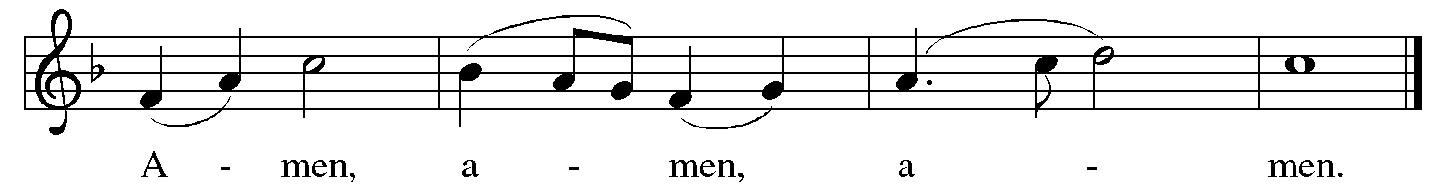
P: To you, O God, Father, Son, and Holy Spirit, be all honor and glory in your holy church, now and forever.

Lord’s Prayer Traditional Wording ELW p. 145

P: Gathered into one by the Holy Spirit, let us pray as Jesus taught us.

All: Our Father, who art in heaven, hallowed be thy name, thy kingdom come, thy will be done, on earth as it is in heaven. Give us this day our daily bread; and forgive us our trespasses, as we forgive those who trespass against us; and lead us not into temptation, but deliver us from evil. For thine is the kingdom, and the power, and the glory, forever and ever. Amen.

INVITATION TO COMMUNION

P: Come and know Christ, broken and poured out for you.

COMMUNION

What We Believe

Who May Receive. We welcome all baptized Christians to the Lord's Table. In our parish baptized children who have entered the 5th grade are instructed in this sacrament and receive their First Communion; younger children come to the altar and receive a blessing. If your baptized child has received such instruction, or if you want your baptized child to receive Communion, then he or she is welcome to partake.

Proper Preparation. In his Small Catechism, Martin Luther asks, "When is a person rightly prepared to receive this sacrament?" He answers, "Fasting and other outward preparations serve a good purpose. However, that person is well prepared and worthy who believes these words, given and shed for you for the remission of sins. But anyone who does not believe these words, or doubts them, is neither prepared nor worthy, for the words for you require simply a believing heart.”

Real Presence. We believe that the bread and wine truly are the body and blood of Christ given and shed for the forgiveness of sins.

Continued on the next page.

Distribution

Holy Communion will be served in procession with physical distancing and one side of the sanctuary at a time. The ushers will direct you when to make your way to the front of the church using the center aisle. You will receive the elements near the chancel. Please extend your hands, palms up, if you will be receiving the bread. Gluten-free wafers are also available; please ask for one. Proceed to your right or to your left to receive the wine. White grape juice is also available in the center ring of each tray for those who prefer an alcohol-free element. You may say “Amen” after receiving each element. If you will not be receiving Communion, keep your hands folded. Place your empty cup in the basket and then return to your seat by the side aisle.

Music During Distribution of Communion Jan Meyer

PRAYER AFTER COMMUNION

P: Gracious God, in you we live and move and have our being. With your word and this meal of grace, you have nourished our life together. Strengthen us to show your love and serve the world in Jesus’s name.

C: Amen.

Sending

God blesses us and sends us in mission to the world.

ANNOUNCEMENTS

BLESSING

P: The God of all, who raised ☩ Jesus from the dead,
bless you by the power of the Holy Spirit
to live in the new creation.

C: Amen.

DEPARTING HYMN Rise, O Church, like Christ Arisen ELW # 548

Stanzas 1, 2 and 4

Sung to Praise, My Soul, the God of Heaven ELW # 864

DISMISSAL

P: Alleluia! Christ is risen.

C: Christ is risen indeed. Alleluia!

P: Go in peace. Serve the Risen One.

C: Thanks be to God. Alleluia!

RINGING OF THE BELL

POSTLUDE Recessional on Laudate Dominum Jan Meyer

by Chas. H. H. Parry, arr. by E. Broughton



Peace and joy to you this Easter season!

Today’s Assistants and Ministers

Greeters & Ushers ……………...………… Paul & Julie Gade and Ken & Gloria Hollermann
Organist ……………………..….…………………………….………..………….…… Jan Meyer
Presiding Minister ……………………………………...…….....…………… Pastor Chris Miller
Altar Care & Communion Preparation ….. Paul & Julie Gade and Ken & Gloria Hollermann
Custodians ………………………….….…….………...….…..…….. Dave & Geri Ann Hanson

This Week in Our Congregation

Today, Sunday, April 23 — Third Sunday of Easter

Coffee fellowship in the narthex or downstairs in the dining room following worship

Monday, April 24

Shaped by Water book study with Andrew Pruett at Bethlehem 6:30 PM

Tuesday, April 25

Men’s breakfast at Home Sweet Home, Lanesboro 7:00 AM

Next Sunday, April 30 — Fourth Sunday of Easter

Worship 9:00 AM

News and Notes

Heartfelt thanks to our guest pastor today, the Rev. Chris Miller! Pastor Chris is our worship leader and preacher while Pastor Kerry and Deacon Cindy are on vacation celebrating their son Nathan’s wedding which took place yesterday, Saturday, April 22, at our sister congregation, Bethlehem Lutheran.

North Prairie Lutheran Church Dine-In or Drive-Thru Meatball Dinner, today! Serving from 11:00 a.m. to 1:00 p.m. The meal includes meatballs, real mashed potatoes and gravy, glazed carrots, salad, rolls, bars, and beverages. All carry-outs or adults $12.00, children under 12 $6.00, and children under 6 free. 35957 State Highway 30, rural Lanesboro.

Andrew Pruett to lead a book study beginning Monday, April 24. Andrew and his family are relatively new residents of Lanesboro and new members of our sister congregation Bethlehem Lutheran. He has written a book entitled Shaped by Water which is a compilation of stories about how water has impacted his life. He will be leading a three-session study of his book starting tomorrow, Monday, April 24, at 6:30 pm, in the Bethlehem Fellowship Hall. The study will continue on May 1 and on May 8. Copies of the book are for sale. The cost is $20 for a hardcover and $15 for a paperback. Contact Andrew to buy a copy (507-993-8069).

Continued on the other side.

Lanesboro Emergency Services Open House, Saturday, April 29, from 11 a.m. to 1 p.m. Free food. Prizes and giveaways. Meet your local volunteers. Tours of the new building. The meal includes burgers, chips, beans and beverages. Fire & Ambulance Building, 303 Sheridan St W (MN Hwy 16 West).

Bethlehem Drive-thru Ham Dinner, Sunday, April 30. Our sister congregation in Lanesboro is hosting a drive-thru ham dinner on Sunday, April 30 from 11:00 am to 1:00 pm. The meal will include ham, au gratin potatoes, beans, and a dinner roll. Limited to 200 pre-sale tickets at $13 per meal. Contact Deane Benson to purchase tickets (507-208-3164).

Prayer Requests

In Our Community. For our church members and friends living with chronic illness and other diseases, who are homebound, residing in care facilities, and hospitalized. See the newsletter for our members living in area nursing homes. And let us not forget those sick and dying of COVID-19, those entrusted with the authority of government, justice, and law enforcement, as well as our fallen and wounded soldiers and those still serving.

In Our Synod. Bishop Regina Hassanally invites the people and congregations of our Southeastern Minnesota Synod to make a commitment to pray this week for the following faith communities: Pontoppidan Lutheran Church, Ellendale; United Redeemer Lutheran Church, Zumbrota; Good Shepherd Lutheran Church, Plainview; Mazoezi Kitusha Lutheran Church, Tanzania; Shelui Lutheran Church, Tanzania; and Seniors Programming Soacha, Colombia.

Acknowledgments

Graphics, worship texts, service music, readings, and PowerPoint® Slides are from sundaysandseasons.com © 2023 Augsburg Fortress. Used by permission under Augsburg Fortress Liturgies Annual License SAS005401.

Permission to project liturgy and music content under copyright to or administered by Augsburg Fortress provided under Augsburg Fortress Liturgies Annual License SAS005401.




