Fountain Lutheran Church

Established 1904

Rev. Kerry B. Eversole, Pastor
Deacon Cindy Cordes-Eversole, Associate in Ministry

Mailing Address: P.O. Box 75, Fountain, MN 55935
Physical Address: 314 Main Street, Fountain, Minn.

Church Office Phone: 507.268.4413
E-mail Address: flc@mediacombb.net
Website: www.fountainlutheranchurch.com
Facebook Page: www.facebook.com/FountainLutheranChurch/

Parsonage Phone: 507.467.3017

Pastor Kerry’s Cell Phone: 507.951.3954

Our Global Partner Congregation: Issuna Lutheran Church, Tanzania
Fountain Lutheran Church
Fountain, Minnesota

Fourth Sunday of Easter
Good Shepherd Sunday

April 30, 2023


Jesus said, “Very truly, I tell you, I am the gate for the sheep. All who came before me are thieves and bandits; but the sheep did not listen to them. I am the gate. Whoever enters by me will be saved, and will come in and go out and find pasture.” John 10:7-9
Welcome to worship at Fountain Lutheran Church
and our continuing celebration of Easter!

COVID-19 Practices — Out of love for God and Neighbor

1) Use hand sanitizer upon entry. Wash your hands and use hand sanitizer often while in the facility.
2) Members and visitors who are vaccinated and boosted are not required to wear a mask.
3) Members and visitors are free to wear a mask if they wish to do so.
4) Unvaccinated and not boosted members and visitors must wear a mask.
5) There are no physical distancing requirements, but you are welcome to keep a distance from others in the sanctuary as you are able.
6) All are welcome to enjoy coffee fellowship in the narthex or downstairs in the dining room following worship.

Worship Book and Hymns. This morning’s service is printed in this bulletin and can also be found with all the hymns in Evangelical Lutheran Worship (ELW), “the red book” in the pews. Hymns in ELW are identified by a large bold number in each page’s left or right margin.

Abbreviations. Throughout this worship folder, hymns are signified by the pound symbol (#), P: refers to the presiding minister or preacher, A: denotes an assisting minister, and C: and/or bold text indicates the congregation.

Mistakes do not happen in our worship service;
only unexpected events which are opportunities for joy!

An signifies that you may stand, as you are comfortably able.

Introduction to the Season and the Day. Despite all that we heard and experienced on Easter Day, the Resurrection of Our Lord, it’s still hard to believe. Because it’s hard to believe, we will invest ourselves in the Easter mystery for fifty days. Throughout this week of weeks, these seven Sundays, we turn to John and Luke to provide sign after sign of Jesus’s victory over death.

Today is often called “Good Shepherd Sunday”. Jesus is called the “gate” of the sheep in today’s gospel. The risen Christ opens the way to abundant life. He anoints our heads with oil and guides us beside the still waters of our baptism. Each Sunday he spreads a feast before us amid the world’s violence and war. We go forth to be signs of the resurrection and extend God’s tender care to all creation.

Gathering

The Holy Spirit calls us together as the people of God.

MUSIC AS WE COME TOGETHER

RINGING OF THE BELL, WELCOME AND INTRODUCTION TO THE DAY

OPENING SONG Now, All the Vault of Heaven Resounds ELW # 367

Stanzas 1, 2 and 3

GREETING

P: Alleluia, Christ is risen!

C: Christ is risen indeed. Alleluia!

P: The joy and peace of the risen Savior, the love of God, and the communion of the Holy Spirit be with you all.

C: And also with you.

PRAYER OF THE DAY

P: Let us pray together.

O God our shepherd,

All: you know your sheep by name and lead us to safety through the valleys of death. Guide us by your voice, that we may walk in certainty and security to the joyous feast prepared in your house, through Jesus Christ, our Savior and Lord, who lives and reigns with you and the Holy Spirit, one God, now and forever. Amen.

The Good News of Easter in Word

God speaks to us in scripture reading, preaching, and song.

FIRST READING Acts 2:42-47

Today’s reading is a description of life in the community following Peter’s sermon on the day of Pentecost, when the Spirit was poured out on God’s people. The new community is sustained in worship and fellowship, shares what they have, and ensures that everyone has enough.

Continued on the next page.

⁴²[The baptized] devoted themselves to the apostles’ teaching and fellowship, to the breaking of bread and the prayers.
⁴³Awe came upon everyone, because many wonders and signs were being done by the apostles. ⁴⁴All who believed were together and had all things in common; ⁴⁵they would sell their possessions and goods and distribute the proceeds to all, as any had need. ⁴⁶Day by day, as they spent much time together in the temple, they broke bread at home and ate their food with glad and generous hearts, ⁴⁷praising God and having the goodwill of all the people. And day by day the Lord added to their number those who were being saved.

A: Word of God, word of life.

C: Thanks be to God.

SECOND READING 1 Peter 2:19-25

Doing the right things does not guarantee that one will not experience difficulties, hardships, rejection, or even suffering. Here Christ is presented as the model for our path of endurance and loyalty to God, particularly amid adversity.

¹⁹It is a credit to you if, being aware of God, you endure pain while suffering unjustly. ²⁰If you endure when you are beaten for doing wrong, what credit is that? But if you endure when you do right and suffer for it, you have God’s approval. ²¹For to this you have been called, because Christ also suffered for you, leaving you an example, so that you should follow in his steps.
²²“He committed no sin,
and no deceit was found in his mouth.”
²³When he was abused, he did not return abuse; when he suffered, he did not threaten; but he entrusted himself to the one who judges justly. ²⁴He himself bore our sins in his body on the cross, so that, free from sins, we might live for righteousness; by his wounds you have been healed. ²⁵For you were going astray like sheep, but now you have returned to the shepherd and guardian of your souls.

A: Word of God, word of life.

C: Thanks be to God.

GOSPEL SONG Halle, Halle, Hallelujah ELW # 172

GOSPEL John 10:1-10

Continued on the next page.

P: The Easter gospel according to Saint John, the tenth chapter.

C: Glory to you, O Lord.

Jesus uses an image familiar to the people of his day to make a point about spiritual leadership. Those who listen to Jesus are led to abundant life.

[Jesus said:] ¹“Very truly, I tell you, anyone who does not enter the sheepfold by the gate but climbs in by another way is a thief and a bandit. ²The one who enters by the gate is the shepherd of the sheep. ³The gatekeeper opens the gate for him, and the sheep hear his voice. He calls his own sheep by name and leads them out. ⁴When he has brought out all his own, he goes ahead of them, and the sheep follow him because they know his voice. ⁵They will not follow a stranger, but they will run from him because they do not know the voice of strangers.” ⁶Jesus used this figure of speech with them, but they did not understand what he was saying to them.
⁷So again Jesus said to them, “Very truly, I tell you, I am the gate for the sheep. ⁸All who came before me are thieves and bandits; but the sheep did not listen to them. ⁹I am the gate. Whoever enters by me will be saved, and will come in and go out and find pasture. ¹⁰The thief comes only to steal and kill and destroy. I came that they may have life, and have it abundantly.”

P: The Easter gospel of our Lord.

C: Praise to you, O Christ.

SERMON

SONG OF THE DAY The King of Love My Shepherd Is ELW # 502

Responding to the Good News of Easter

THANKSGIVING FOR BAPTISM

All may make the sign of the cross, the sign that is marked at baptism, as the presiding minister begins.

P: Blessed be the holy Trinity, ☩ one God, by whose hand we are given new birth, by whose speaking we are given new life.

C: Amen.

P: Joined to Christ in the waters of baptism, we are welcomed, restored, and supported as citizens of the new creation.

Continued on the next page.
P Let us give thanks for the gift of baptism.

Holy God, holy and merciful, holy and mighty, you are the river of life, you are the everlasting wellspring.

In mercy and might you have freed us from death and raised us with Jesus, the firstborn of the dead. In baptismal waters, our old life is washed away, and in them, we are born anew.

Water may be poured into the font as the presiding minister continues.

P: Glory to you for oceans and lakes, for rivers and streams. Honor to you for waters that wash us clean, quench our thirst, and nurture both crops and creatures. Praise to you for the life-giving water of baptism, the outpouring of the Spirit of the new creation.

All: Wash away our sin and all that separates us from you. Empower our witness to your resurrection. Strengthen our resolve in seeking justice for all.

P: Satisfy the world’s needs through this living water. Where drought dries the earth, bring refreshment. Where despair prevails, grant hope. Where chaos reigns, bring peace. We ask this through Christ, who with you and the Spirit reigns forever.

C: Amen.

BAPTISM SONG Baptized and Set Free ELW # 453

OFFERING AND MUSIC

OFFERING SONG Have No Fear, Little Flock ELW # 764

PRAYERS OF GOD’S PEOPLE

SONG AFTER THE PRAYERS Hear Our Prayer ELW # 178

LORD'S PRAYER Traditional Wording

P: Gathered into one by the Holy Spirit, let us pray as Jesus taught us.

All: Our Father, who art in heaven, hallowed be thy name, thy kingdom come, thy will be done, on earth as it is in heaven. Give us this day our daily bread; and forgive us our trespasses, as we forgive those who trespass against us; and lead us not into temptation, but deliver us from evil. For thine is the kingdom, and the power, and the glory, forever and ever. Amen.
Sending

God blesses us and sends us in mission to the world.

ANNOUNCEMENTS

BLESSING

P: The God of all, who raised ☩ Jesus from the dead,
bless you by the power of the Holy Spirit
to live in the new creation.

C: Amen.

SENDING SONG Savior, like a Shepherd Lead Us ELW # 789

DISMISSAL

P: Alleluia, Christ is risen!

C: Christ is risen indeed. Alleluia!

P: Go in peace. Serve the Risen One.

C: Thanks be to God. Alleluia!

DEPARTING MUSIC

Peace and joy to you this Easter season!

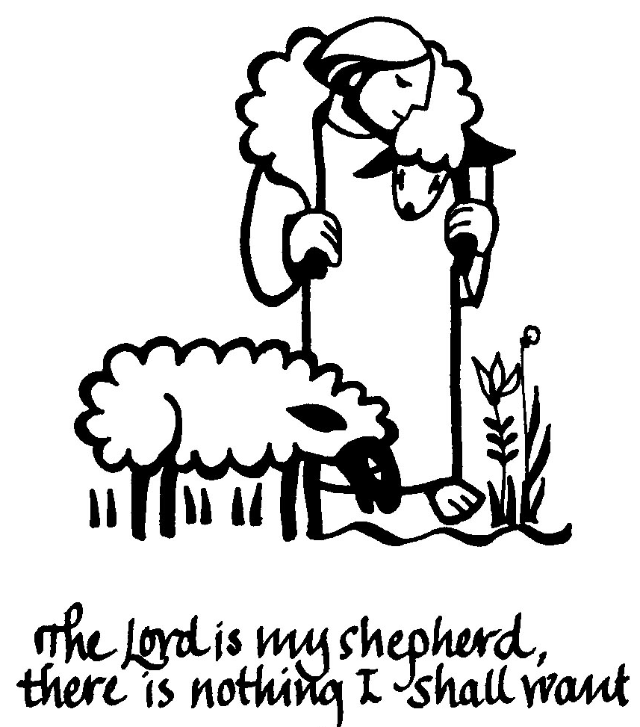

Today’s Assistants and Ministers

Greeters & Ushers ……………...………… Paul & Julie Gade and Ken & Gloria Hollermann
Organist-Pianist ……………………..………………………..………….…… Sherry Hareldson
Presiding Minister ………………….…...…….....…………… Deacon Cindy Cordes-Eversole
Altar Care ………………………………….. Paul & Julie Gade and Ken & Gloria Hollermann
Custodians ………………………….….…….………...….…..…….. Dave & Geri Ann Hanson

This Week in Our Congregation

Today, Sunday, April 30 — Fourth Sunday of Easter

Coffee fellowship in the narthex or downstairs in the dining room following worship
Bethlehem Lutheran’s Drive-Thru Ham Dinner 11:00 AM to 1:00 PM

Monday, May 1

Shaped by Water book study with Andrew Pruett at Bethlehem Lutheran 6:30 PM

Tuesday, May 2

Men’s breakfast at Home Sweet Home, Lanesboro 7:00 AM

Wednesday, May 3

Deacon Cindy at Chosen Valley Care Center, Chatfield, for Chapel 12:30 & 1:30 PM

Thursday, May 4

Pastor Kerry at Good Shepherd Lutheran Home, Rushford, for chapel 1:30 PM

Next Sunday, May 7 — Fifth Sunday of Easter

Worship with Holy Communion 9:00 AM

News and Notes

Bethlehem Drive-thru Ham Dinner today! Our sister congregation in Lanesboro is hosting a drive-thru ham dinner today from 11:00 am to 1:00 pm. The meal includes ham, au gratin potatoes, beans, and a dinner roll. You needed to have purchased a pre-sale ticket. No meal purchases today.

Andrew Pruett book study continues next month. Andrew and his family are relatively new residents of Lanesboro and new members of our sister congregation Bethlehem Lutheran. He has written a book entitled Shaped by Water which is a compilation of stories about how water has impacted his life. The three-session study of his book will continue Monday, May 1, and Monday, May 8. Copies of the book are for sale. The cost is $20 for a hardcover and $15 for a paperback. Contact Andrew to buy a copy (507-993-8069).

Continued on the next page.

Prayer Requests

In Our Community. For our church members and friends living with chronic illness and other diseases, who are homebound, residing in care facilities, and hospitalized. See the newsletter for our members living in area nursing homes. And let us not forget those sick and dying of COVID-19, those entrusted with the authority of government, justice, and law enforcement, as well as our fallen and wounded soldiers and those still serving.

In Our Synod. Bishop Regina Hassanally invites the people and congregations of our Southeastern Minnesota Synod to make a commitment to pray this week for the following faith communities: Zion Lutheran Church, Lake Crystal; Our Savior’s Lutheran Church, Faribault; Moland Lutheran Church, Kenyon; Nuer Sudanese Worshipping Community in Owatonna; Kisonga Lutheran Church, Tanzania; Light and Life Ministry, Colombia.

Acknowledgments

Graphics, worship texts, service music, readings, and PowerPoint® Slides are from sundaysandseasons.com © 2023 Augsburg Fortress. Used by permission under Augsburg Fortress Liturgies Annual License SAS005401.

Permission to project liturgy and music content under copyright to or administered by Augsburg Fortress provided under Augsburg Fortress Liturgies Annual License SAS005401.






