Fountain Lutheran Church
Established 1904

Rev. Kerry B. Eversole, Pastor
Deacon Cindy Cordes-Eversole, Associate in Ministry

Mailing Address: P.O. Box 75, Fountain, MN 55935
Physical Address: 314 Main Street, Fountain, Minn.

Church Office Phone: 507.268.4413
E-mail Address: flc@mediacombb.net
Website: www.fountainlutheranchurch.com
Facebook Page: www.facebook.com/FountainLutheranChurch/

Parsonage Phone: 507.467.3017
Pastor Kerry’s Cell Phone: 507.951.3954

Our Global Partner Congregation: Issuna Lutheran Church, Tanzania
Fountain Lutheran Church
Fountain, Minnesota

Fifth Sunday of Easter

May 7, 2023

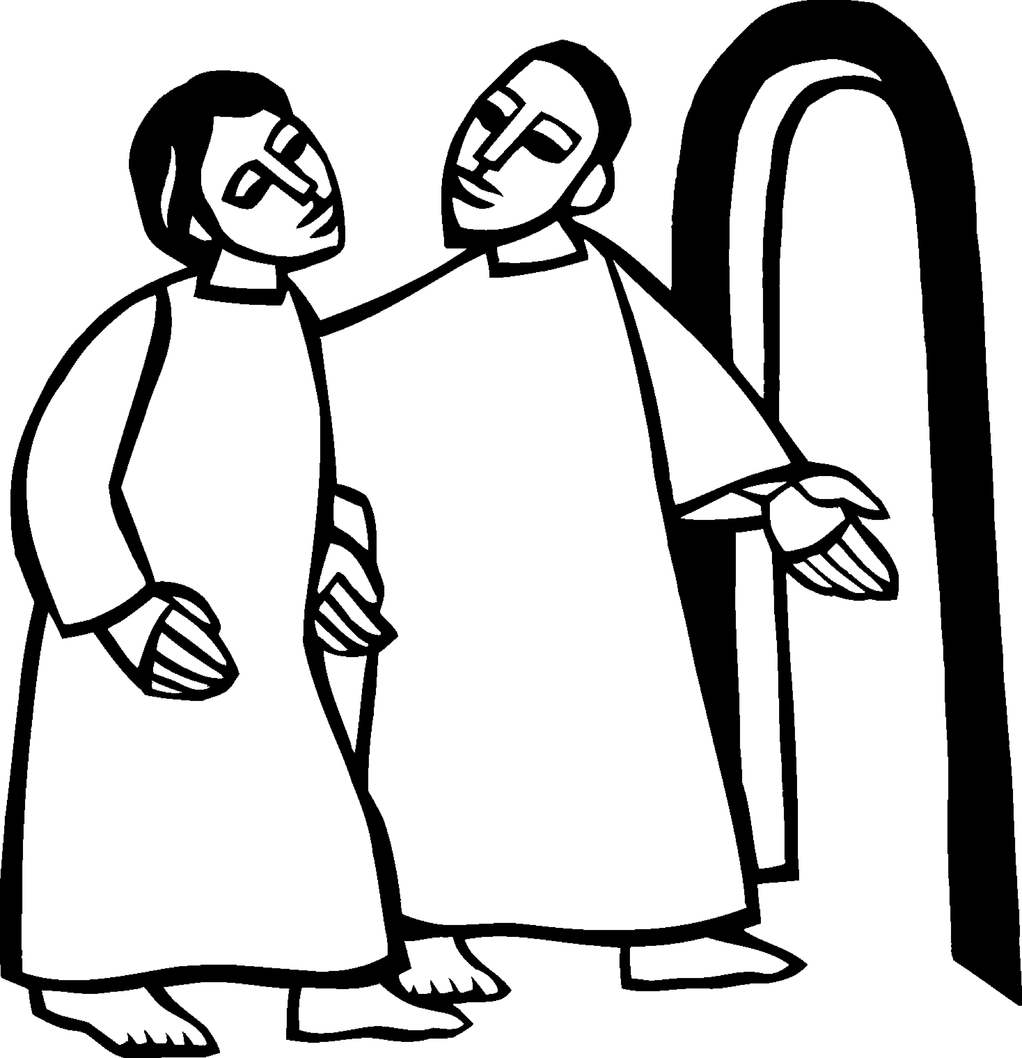
[Jesus said to the disciples,] “Do not let your hearts be troubled. Believe in God, believe also in me. In my Father’s house there are many dwelling places. If it were not so, would I have told you that I go to prepare a place for you?” [Jesus said to Thomas,] “I am the way, and the truth, and the life. No one comes to the Father except through me.” John 14:1-2, 6
Welcome to worship at Fountain Lutheran Church
and our continuing celebration of Easter!

COVID-19 Practices — Out of Love for God and Neighbor

1) Use hand sanitizer upon entry. Wash your hands and use hand sanitizer often while in the facility.
2) Members and visitors who are vaccinated and boosted are not required to wear a mask.
3) Members and visitors are free to wear a mask if they wish to do so.
4) Unvaccinated and not boosted members and visitors must wear a mask.
5) There are no physical distancing requirements, but you are welcome to keep a distance from others in the sanctuary as you are able.
6) All are welcome to enjoy coffee fellowship in the narthex or downstairs in the dining room following worship.

Worship Book and Hymns. This morning’s service is printed in this bulletin and can also be found with all the hymns in Evangelical Lutheran Worship (ELW), “the red book” in the pews. Hymns in ELW are identified by a large bold number in each page’s left or right margin.

Abbreviations. Throughout this worship folder, hymns are signified by the pound symbol (#), P: refers to the presiding minister or preacher, A: denotes an assisting minister, and C: and/or bold text indicates the congregation.

Mistakes do not happen in our worship service;
only unexpected events which are opportunities for joy!

An signifies that you may stand, as you are comfortably able.

Introduction to the Season and the Day. Despite all that we heard and experienced on Easter Day, the Resurrection of Our Lord, it’s still hard to believe. Because it’s hard to believe, we will invest ourselves in the Easter mystery for fifty days. Throughout this week of weeks, these seven Sundays, we turn to John and Luke to provide sign after sign of Jesus’s victory over death.

Today’s gospel includes Jesus’s promise that he goes to prepare a place for his followers in his Father’s house. Our baptism commissions us to share Jesus’s mission in the world. As 1 Peter reminds us, we are a holy people, called to proclaim the one who called us out of darkness into light. In words and deeds, we witness the risen Christ—our way, our truth, our life.
Gathering

The Holy Spirit calls us together as the people of God.

PRELUDE

RINGING OF THE BELL

OPENING HYMN Hallelujah! Jesus Lives! ELW # 380

Stanzas 1, 2, 3 and 4

GREETING

P: Alleluia! Christ is risen!

C: Christ is risen indeed! Alleluia!

P: The joy and peace of our risen Savior, the love of God, and the communion of the Holy Spirit be with you all.

C: And also with you.

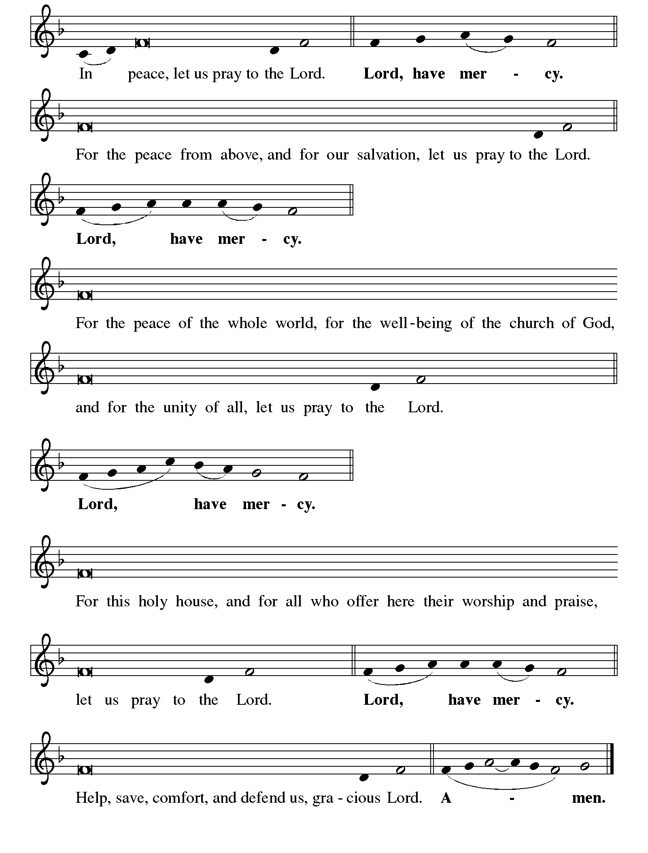KYRIE ELW p. 138

Continued on the next page

KYRIE concluded ELW pp. 138-139

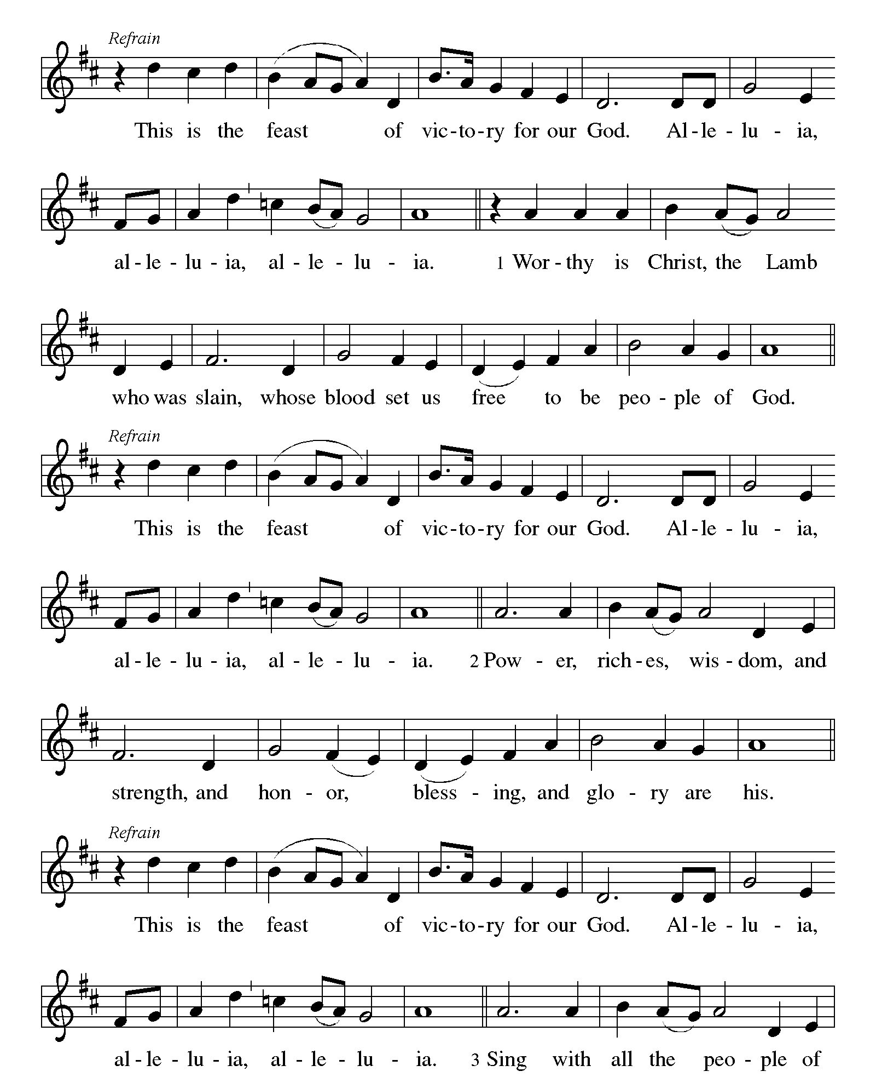CANTICLE OF PRAISE This is the Feast ELW p. 140

Continued on the next page.
CANTICLE OF PRAISE continued ELW pp. 140-141

Continued on the next page.

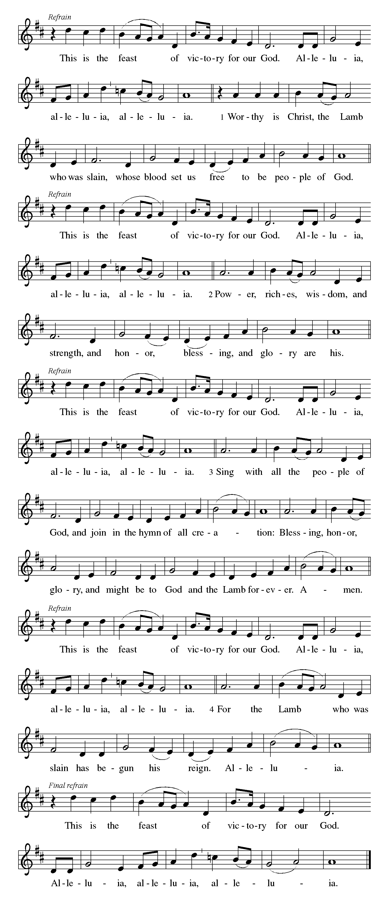CANTICLE OF PRAISE concluded ELW p. 141

PRAYER OF THE DAY

P: Almighty God, your Son Jesus Christ is the way, the truth, and the life. Give us grace to love one another, to follow in the way of his commandments, and to share his risen life with all the world, for he lives and reigns with you and the Holy Spirit, one God, now and forever.

C: Amen.

The Good News of Easter

God speaks to us in scripture reading, preaching, and song.

FIRST READING Acts 7:55-60

Stephen was one of the seven men chosen by the apostles to serve tables so that the apostles could be free to serve the word (Acts 6:1-6). Stephen does more than distribute food, however. For his preaching of God’s word, he becomes the first martyr of the faith.

⁵⁵Filled with the Holy Spirit, [Stephen] gazed into heaven and saw the glory of God and Jesus standing at the right hand of God. ⁵⁶“Look,” he said, “I see the heavens opened and the Son of Man standing at the right hand of God!” ⁵⁷But they covered their ears, and with a loud shout all rushed together against him. ⁵⁸Then they dragged him out of the city and began to stone him; and the witnesses laid their coats at the feet of a young man named Saul. ⁵⁹While they were stoning Stephen, he prayed, “Lord Jesus, receive my spirit.” ⁶⁰Then he knelt down and cried out in a loud voice, “Lord, do not hold this sin against them.” When he had said this, he died.

A: Word of God, word of life.

C: Thanks be to God.

SECOND READING 1 Peter 2:2-10

Christ is the cornerstone of God’s saving work and the foundation of our lives. We are God’s chosen, holy people who continuously celebrate and declare the mercy of God we experience through Jesus Christ.

²Like newborn infants, long for the pure, spiritual milk, so that by it you may grow into salvation—³if indeed you have tasted that the Lord is good.
⁴Come to him, a living stone, though rejected by mortals yet chosen and precious in God’s sight, and ⁵like living stones, let yourselves be built into a

Continued on the next page.
spiritual house, to be a holy priesthood, to offer spiritual sacrifices acceptable to God through Jesus Christ. ⁶For it stands in scripture:
“See, I am laying in Zion a stone,
a cornerstone chosen and precious;
and whoever believes in him will not be put to shame.”
⁷To you then who believe, he is precious; but for those who do not believe,
“The stone that the builders rejected
has become the very head of the corner,”
⁸and
“A stone that makes them stumble,
and a rock that makes them fall.”
They stumble because they disobey the word, as they were destined to do.
⁹But you are a chosen race, a royal priesthood, a holy nation, God’s own people, in order that you may proclaim the mighty acts of him who called you out of darkness into his marvelous light.
¹⁰Once you were not a people,
but now you are God’s people;
once you had not received mercy,
but now you have received mercy.

A: Word of God, word of life.

C: Thanks be to God.

GOSPEL ACCLAMATION

“Alleluias” are from The Strife Is O’er, the Battle Done ELW # 366

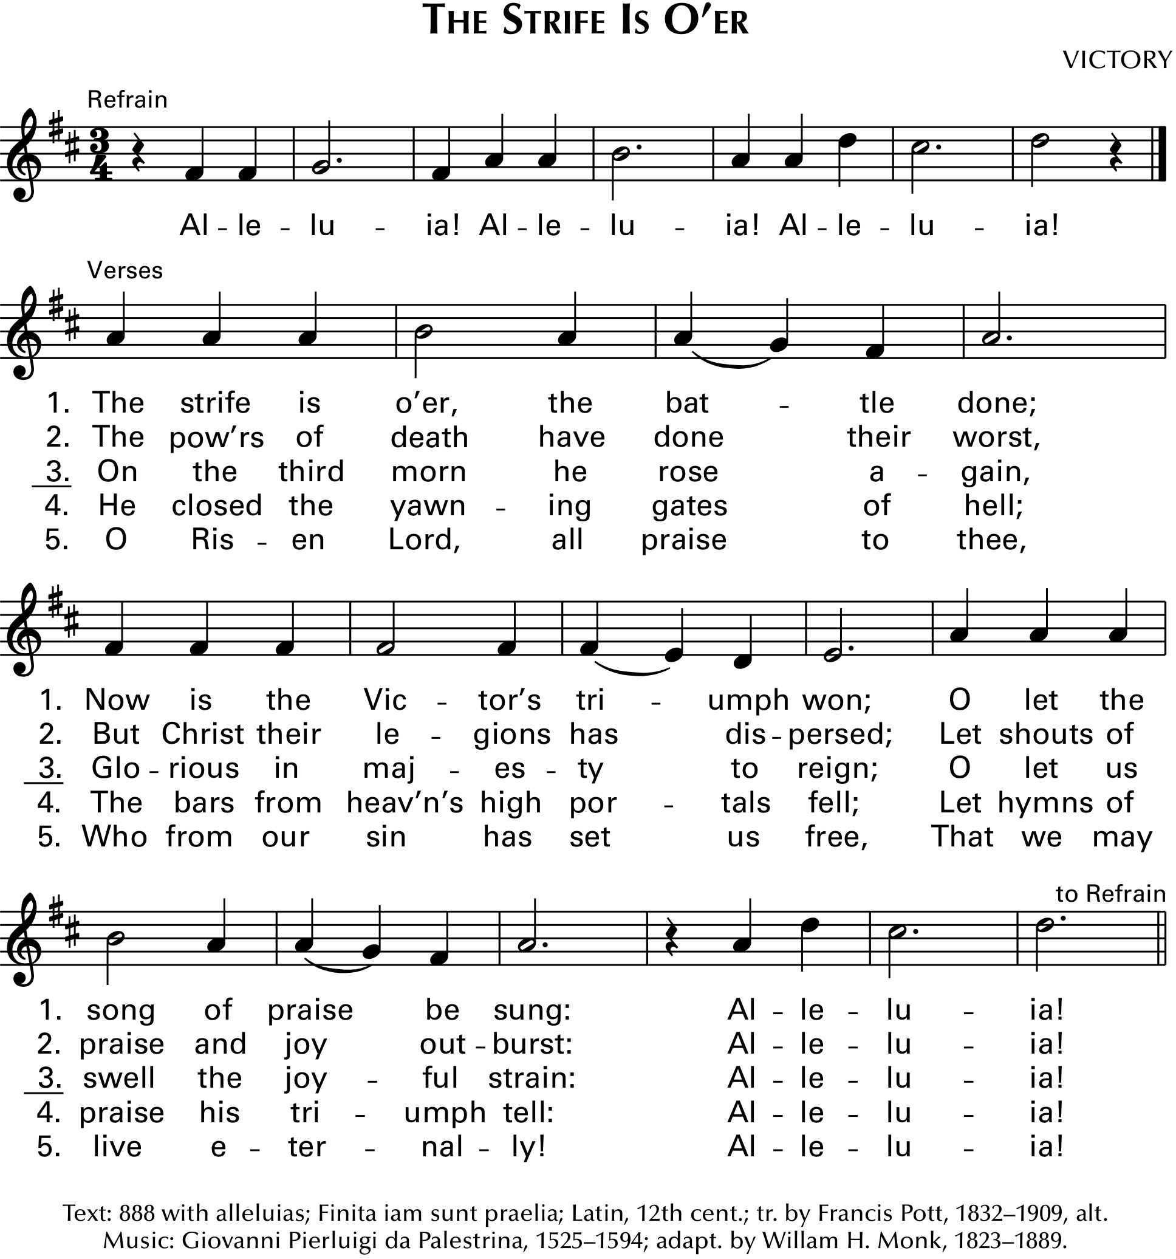

P: I am the way, the truth, and the life. No one comes to the Father except through me. John 14:6

GOSPEL John 14:1-14

Announcement of the Gospel.

P: The Holy Gospel according to Saint John, the fourteenth chapter.

C: Glory to you, O Lord.

On the night that he is to be arrested, Jesus shares final words with his disciples. As the one through whom God is known, he promises to go before them and act on their behalf.

[Jesus said to the disciples:] ¹“Do not let your hearts be troubled. Believe in God, believe also in me. ²In my Father’s house there are many dwelling places. If it were not so, would I have told you that I go to prepare a place for you? ³And if I go and prepare a place for you, I will come again and will take you to myself, so that where I am, there you may be also. ⁴And you know the way to the place where I am going.” ⁵Thomas said to him, “Lord, we do not know where you are going. How can we know the way?” ⁶Jesus said to him, “I am the way, and the truth, and the life. No one comes to the Father except through me. ⁷If you know me, you will know my Father also. From now on you do know him and have seen him.”
⁸Philip said to him, “Lord, show us the Father, and we will be satisfied.” ⁹Jesus said to him, “Have I been with you all this time, Philip, and you still do not know me? Whoever has seen me has seen the Father. How can you say, ‘Show us the Father’? ¹⁰Do you not believe that I am in the Father and the Father is in me? The words that I say to you I do not speak on my own; but the Father who dwells in me does his works. ¹¹Believe me that I am in the Father and the Father is in me; but if you do not, then believe me because of the works themselves. ¹²Very truly, I tell you, the one who believes in me will also do the works that I do and, in fact, will do greater works than these, because I am going to the Father. ¹³I will do whatever you ask in my name, so that the Father may be glorified in the Son. ¹⁴If in my name you ask me for anything, I will do it.”

Affirmation of the Gospel.

P: The Easter Gospel of our Lord.

C: Praise to you, O Christ.

SERMON

HYMN OF THE DAY Christ is Alive! Let Christians Sing ELW # 389

Stanzas 1, 2, 4 and 5

PROFESSION OF FAITH Nicene Creed ELW p. 104

P: With the whole church, let us confess our faith.

All: We believe in one God, the Father, the Almighty, maker of heaven and earth, of all that is, seen and unseen.

We believe in one Lord, Jesus Christ, the only Son of God, eternally begotten of the Father, God from God, Light from Light, true God from true God, begotten, not made, of one Being with the Father; through him all things were made. For us and for our salvation he came down from heaven, was incarnate of the Holy Spirit and the virgin Mary and became truly human. For our sake he was crucified under Pontius Pilate; he suffered death and was buried. On the third day he rose again in accordance with the scriptures; he ascended into heaven and is seated at the right hand of the Father. He will come again in glory to judge the living and the dead, and his kingdom will have no end.

We believe in the Holy Spirit, the Lord, the giver of life, who proceeds from the Father and the Son, who with the Father and the Son is worshiped and glorified, who has spoken through the prophets. We believe in one holy catholic and apostolic church. We acknowledge one baptism for the forgiveness of sins. We look for the resurrection of the dead, and the life of the world to come. Amen.

PRAYERS OF GOD’S PEOPLE

Each petition ends with these words and response:

P: Hear us, O God.

C: Your mercy is great.

Concluding petition and response:

P: Rejoicing in the victory of Christ’s resurrection, we lift our prayers and praise to you, almighty and eternal God; through Jesus Christ, our risen Lord.

C: Amen.

The Good News of Easter in the Holy Meal

God feeds us with the presence of Jesus Christ.

OFFERING AND MUSIC

OFFERING SONG Come, My Way, My Truth, My Life ELW # 816

Stanzas 1, 2 and 3

OFFERING PRAYER

P: Generous God,

C: in the meal we are about to receive, you offer your very self. We give thanks for these gifts of the earth. In the breaking of this bread reveal to us the Risen One. In the pouring of this wine pour us out in service to this world in need; through Christ our Lord. Amen.

GREAT THANKSGIVING

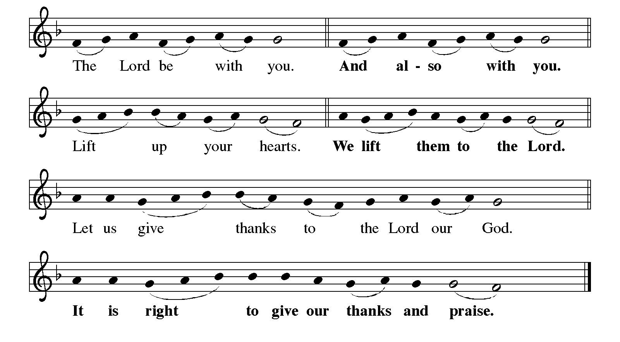Dialogue ELW p. 144

Preface

P: It is indeed right, our duty and our joy, that we should at all times and in all places give thanks and praise to you, almighty and merciful God, for the glorious resurrection of our Savior Jesus Christ, the true Paschal Lamb who gave himself to take away our sin; who in dying has destroyed death, and in rising has brought us to eternal life. And so, with Mary Magdalene and Peter and all the witnesses of the resurrection, with earth and sea and all their creatures, and with angels and archangels, cherubim and seraphim, we praise your name and join their unending hymn:

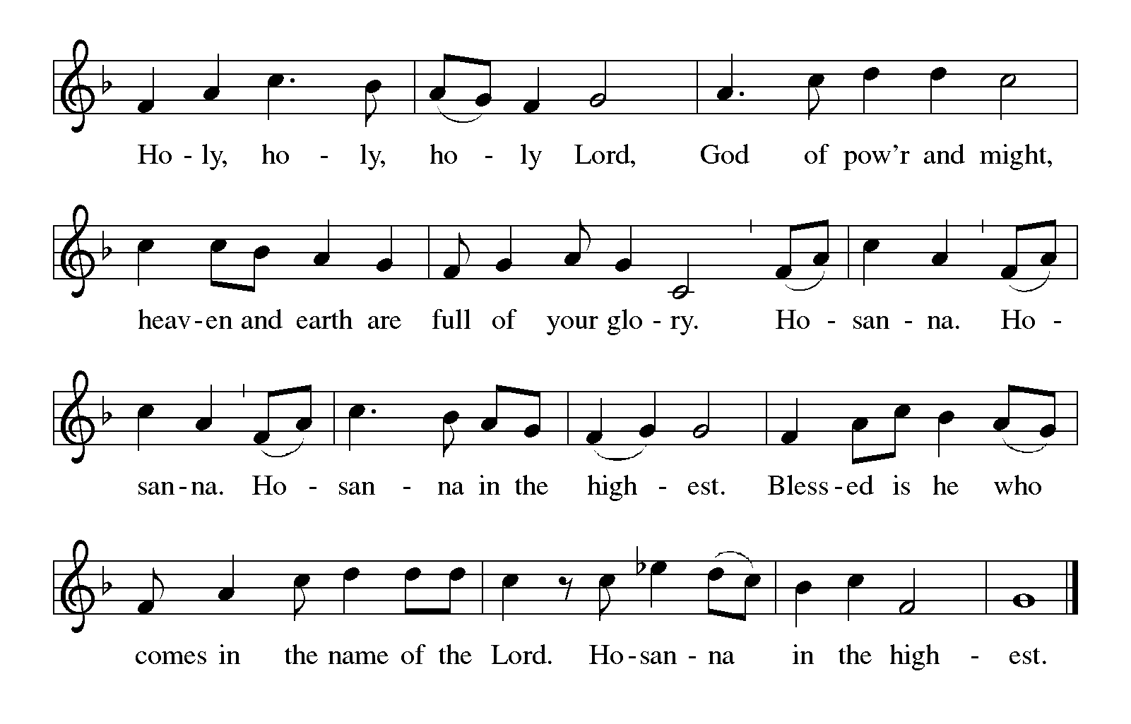Holy, Holy, Holy (the angels’ song) ELW p. 144

Thanksgiving at the Table ELW p. 145

P: You are indeed holy, almighty and merciful God. You are most holy, and great is the majesty of your glory.

Continued on the next page.

P: You so loved the world that you gave your only Son, so that everyone who believes in him may not perish but have eternal life.

We give you thanks for his coming into the world to fulfill for us your holy will and to accomplish all things for our salvation.

In the night in which he was betrayed, our Lord Jesus took bread, and gave thanks; broke it, and gave it to his disciples, saying: Take and eat; this is my body, given for you. Do this for the remembrance of me.

Again, after supper, he took the cup, gave thanks, and gave it for all to drink, saying: This cup is the new covenant in my blood, shed for you and for all people for the forgiveness of sin. Do this for the remembrance of me.

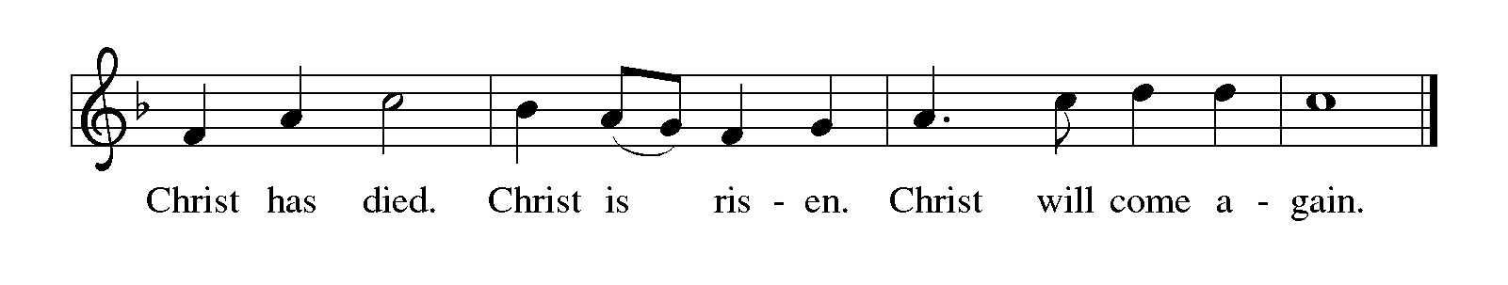For as often as we eat of this bread and drink from this cup, we proclaim the Lord's death until he comes.

P: Remembering, therefore, his salutary command, his life-giving passion and death, his glorious resurrection and ascension, and the promise of his coming again, we give thanks to you, O Lord God Almighty, not as we ought but as we are able; we ask you mercifully to accept our praise and thanksgiving and with your Word and Holy Spirit to bless us, your servants, and these your own gifts of bread and wine, so that we and all who share in the body and blood of Christ may be filled with heavenly blessing and grace, and, receiving the forgiveness of sin, may be formed to live as your holy people and be given our inheritance with all your saints.

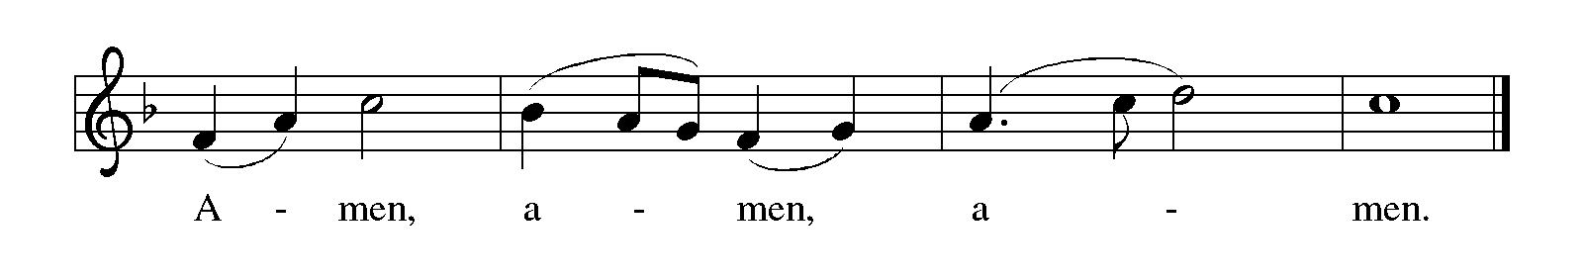To you, O God, Father, Son, and Holy Spirit, be all honor and glory in your holy church, now and forever.

Lord’s Prayer Traditional Wording ELW p. 145

P: Gathered into one by the Holy Spirit, let us pray as Jesus taught us.

All: Our Father, who art in heaven, hallowed be thy name, thy kingdom come, thy will be done, on earth as it is in heaven. Give us this day our daily bread; and forgive us our trespasses, as we forgive those who trespass against us; and lead us not into temptation, but deliver us from evil. For thine is the kingdom, and the power, and the glory, forever and ever. Amen.

INVITATION TO COMMUNION

P: Come and know Christ, broken and poured out for you.

COMMUNION

What We Believe

Who May Receive. We welcome all baptized Christians to the Lord's Table. In our parish baptized children who have entered the 5th grade are instructed in this sacrament and receive their First Communion; younger children come to the altar and receive a blessing. If your baptized child has received such instruction, or if you want your baptized child to receive Communion, then he or she is welcome to partake.

Proper Preparation. In his Small Catechism, Martin Luther asks, "When is a person rightly prepared to receive this sacrament?" He answers, "Fasting and other outward preparations serve a good purpose. However, that person is well prepared and worthy who believes these words, given and shed for you for the remission of sins. But anyone who does not believe these words, or doubts them, is neither prepared nor worthy, for the words for you require simply a believing heart.”

Real Presence. We believe that the bread and wine truly are the body and blood of Christ given and shed for the forgiveness of sins.

Distribution

Holy Communion will be served in procession with physical distancing and one side of the sanctuary at a time. The ushers will direct you when to make your way to the front of the church using the center aisle. You will receive the elements near the chancel. Please extend your hands, palms up, if you will be receiving the bread. Gluten-free wafers are also available; please ask for one. Proceed to your right or to your left to receive the wine. White grape juice is also available in the center ring of each tray for those who prefer an alcohol-free element. You may say “Amen” after receiving each element. If you will not be receiving Communion, keep your ands folded. Place your empty cup in the basket and then return to your seat by the side aisle.
Music During Distribution of Communion Sherry Hareldson

PRAYER AFTER COMMUNION

P: Gracious God, in you we live and move and have our being. With your word and this meal of grace, you have nourished our life together. Strengthen us to show your love and serve the world in Jesus’s name.

C: Amen.

Sending

God blesses us and sends us in mission to the world.

ANNOUNCEMENTS

BLESSING

P: The God of all, who raised ☩ Jesus from the dead,
bless you by the power of the Holy Spirit
to live in the new creation.

C: Amen.

DEPARTING HYMN The Church’s One Foundation ELW # 654

Stanzas 1, 2, 4 and 5

DISMISSAL

P: Alleluia! Christ is risen.

C: Christ is risen indeed. Alleluia!

P: Go in peace. Serve the Risen One.

C: Thanks be to God. Alleluia!

RINGING OF THE BELL

POSTLUDE

Today’s Assistants and Ministers

Greeters & Ushers …………………………….....………… Gary Miller and Steve Sutherland
Organist-Pianist ……………………..………………………..………….…… Sherry Hareldson
Presiding Minister ………………………….….…...…….....…………… Pastor Kerry Eversole
Altar Care …………………………………….…………….. Mona Himli and Steve Sutherland
Custodians ………………………….….…….………...….…..…….. Dave & Geri Ann Hanson

This Week in Our Congregation

Today, Sunday, May 7 — Fifth Sunday of Easter

Coffee fellowship in the narthex or downstairs in the dining room following worship

Monday, May 8

Shaped by Water book study with Andrew Pruett at Bethlehem Lutheran 6:30 PM

Tuesday, May 9

Men’s breakfast at Home Sweet Home, Lanesboro 7:00 AM
Root River Conference Monthly gathering in Spring Grove 9:00 AM – 1:00 PM

Wednesday, May 10

Pastor Kerry and Deacon Cindy at Bethlehem Church Council 6:30 PM

Thursday, May 11

Deacon Cindy at Park Lane Estates, Preston for chapel 9:30 AM

Next Sunday, May 14 — Sixth Sunday of Easter — Mother’s Day

Worship with Blessing of Mothers 9:00 AM
Church Council meeting after worship

News and Notes

Andrew Pruett book study concludes tomorrow. Andrew has written a book entitled Shaped by Water which is a compilation of stories about how water has impacted his life. The three-session study of his book concludes tomorrow Monday, May 8 at 6:30 p.m. Copies of the book are still for sale. The cost is $20 for a hardcover and $15 for a paperback. Contact Andrew to buy a copy (507-993-8069).

Prayer Requests

In Our Community. For our church members and friends living with chronic illness and other diseases, who are homebound, residing in care facilities, and hospitalized. See the newsletter for our members living in area nursing homes. And let us not forget those sick and dying of COVID-19, those entrusted with the authority of government, justice, and law enforcement, as well as our fallen and wounded soldiers and those still serving.

Continued on the next page.
Prayer Requests

In Our Synod. Bishop Regina Hassanally invites the people and congregations of our Southeastern Minnesota Synod to make a commitment to pray this week for the following faith communities: Bricelyn Lutheran Church, Bricelyn; Our Savior’s Lutheran Church, Rochester; St. Paul Kyengege Lutheran Church, Tanzania; Wembere Lutheran Church, Tanzania; and The True Vine Ministry, Colombia.

Acknowledgments

Graphics, worship texts, service music, readings, and PowerPoint® Slides are from sundaysandseasons.com © 2023 Augsburg Fortress. Used by permission under Augsburg Fortress Liturgies Annual License SAS005401.

Permission to project liturgy and music content under copyright to or administered by Augsburg Fortress provided under Augsburg Fortress Liturgies Annual License SAS005401.

