Bethlehem Lutheran Church
Established 1874

Rev. Kerry B. Eversole, Pastor
Deacon Cindy Cordes-Eversole, Associate in Ministry

Mailing Address: P.O. Box 314, Lanesboro, MN 55949-0314
Physical Address: 200 Kenilworth Ave S, Lanesboro, Minn.

Telephone: 507.467.3344
E-mail Address: bethlehem@acegroup.cc
Website: www.staronthehill.com
Facebook Page: www.facebook.com/BethlehemLutheranLanesboro

Office Hours: Tuesday, Wednesday, Thursday 10 a.m. to 3 p.m.
Parsonage Phone: 507.467.3017
Pastor Kerry’s Cell Phone: 507.951.3954

Bethlehem Lutheran Church
Lanesboro, Minnesota

Sixth Sunday of Easter
Mother’s Day

May 14, 2023


[Jesus said to his disciples and today says to us,] “I will not leave you orphaned; I am coming to you. In a little while the world will no longer see me, but you will see me; because I live, you also will live. On that day you will know that I am in my Father, and you in me, and I in you.”
John 14:18-20
Welcome to worship at Bethlehem Lutheran Church
and our continuing celebration of Easter!

COVID-19 Practices — Out of Love for God and Neighbor

1) Use hand sanitizer upon entry. Wash your hands and use hand sanitizer often while in the facility.
2) Members and visitors who are vaccinated and boosted are not required to wear a mask.
3) Members and visitors are free to wear a mask if they wish to do so.
4) Unvaccinated and not boosted members and visitors must wear a mask.
5) There are no physical distancing requirements, but you are welcome to keep a distance from others in the sanctuary as much as you are able.
6) All are welcome to enjoy coffee fellowship in the dining room following worship.

Worship Book and Hymns. This morning’s service is printed in this bulletin but can also be found with all the hymns in Evangelical Lutheran Worship (ELW), “the red book” in the pew bookracks, and on the pews. Hymns in ELW are indicated by a large bold number in each page’s left or right margin.

Abbreviations. Hymns are signified throughout this worship folder by the pound symbol (#). P: refers to the presiding minister or preacher, A: denotes an assisting minister, and C: and/or bold text indicates the congregation.

Offering. Later in our service, we will be receiving an offering. The offering is an opportunity to worship God with our money. We know that the money you give to Bethlehem Lutheran Church represents your lives — your time, talents, and hard work. We recognize that and we appreciate your generosity. Your support not only helps all of us to fulfill God’s call on our lives, but it also makes an impact, and we thank you! Lastly, our visitors are not expected to give. After all, you are our guests! We’re glad you’re here and we want you to feel welcome!

Mistakes do not happen in our worship service;
only unexpected events which are opportunities for joy!

An signifies that you may stand as you are comfortably able.

Introduction to the Season. We are in the midst of a fifty-day celebration of the Easter mystery, often referred to as the “week of weeks”. We turn to John and Luke during these seven Sundays to provide sign after sign of Jesus’s victory over death.

Continued on the next page.
Introduction to the Day. On this sixth Sunday of Easter, we hear that Jesus does not abandon his followers. Through the Holy Spirit, Jesus comes to abide with his disciples of every generation. As Pentecost draws near, we are reminded that the risen Christ dwells in us as the Spirit of truth. We receive this Spirit in baptism and pray that in our gathering around word and sacrament the Spirit will transform us to be the body of the risen Christ in the world.

Gathering

The Holy Spirit calls us together as the people of God.

PRELUDE

RINGING OF THE BELL, WELCOME, AND INTRODUCTION TO THE DAY

THANKSGIVING FOR BAPTISM

All may make the sign of the cross, the sign that is marked at baptism, as the presiding minister begins.

P: Blessed be the holy Trinity, ☩ one God, by whose hand we are given new birth, by whose speaking we are given new life.

C: Amen.

P: Joined to Christ in the waters of baptism, we are welcomed, restored, and supported as citizens of the new creation.

Let us give thanks for the gift of baptism.

Holy God, holy and merciful, holy and mighty, you are the river of life, you are the everlasting wellspring. In mercy and might you have freed us from death and raised us with Jesus, the firstborn of the dead.

In baptismal waters, our old life is washed away, and in them, we are born anew.

Water may be poured into the font as the presiding minister continues.

P: Glory to you for oceans and lakes, for rivers and streams. Honor to you for waters that wash us clean, quench our thirst, and nurture both crops and creatures. Praise to you for the life-giving water of baptism, the outpouring of the Spirit of the new creation.

All: Wash away our sin and all that separates us from you.
Empower our witness to your resurrection.
Strengthen our resolve in seeking justice for all.

Continued on the next page.
P: Satisfy the world’s need through this living water.
Where drought dries the earth, bring refreshment.
Where despair prevails, grant hope.
Where chaos reigns, bring peace.
We ask this through Christ, who with you and the Spirit reigns forever.

C: Amen.

OPENING HYMN Rise, O Sun of Righteousness ELW # 657

Stanzas 1, 2, 3, 4 and 5

GREETING

P: Alleluia! Christ is risen!

C: Christ is risen indeed! Alleluia!

P: The joy and peace of our risen Savior, the love of God, and the communion of the Holy Spirit be with you all.

C: And also with you.

PRAYER OF THE DAY

P: Let us pray together.

Almighty and ever-living God,

All: you hold together all things in heaven and on earth. In your great mercy receive the prayers of all your children, and give to all the world the Spirit of your truth and peace, through Jesus Christ, our Savior and Lord, who lives and reigns with you and the Holy Spirit, one God, now and forever. Amen.

The Good News of Easter

God speaks to us in scripture reading, preaching, and song.

FIRST READING Acts 17:22-31

In Athens, Paul faces the challenge of proclaiming the gospel to Greeks who know nothing of either Jewish or Christian tradition. He proclaims that the “unknown god” whom they worship is the true Lord of heaven and earth who will judge the world with justice through Jesus, whom God has raised from the dead.

Continued on the next page.

²²Paul stood in front of the Areopagus and said, “Athenians, I see how extremely religious you are in every way. ²³For as I went through the city and looked carefully at the objects of your worship, I found among them an altar with the inscription, ‘To an unknown god.’ What therefore you worship as unknown, this I proclaim to you. ²⁴The God who made the world and everything in it, he who is Lord of heaven and earth, does not live in shrines made by human hands, ²⁵nor is he served by human hands, as though he needed anything, since he himself gives to all mortals life and breath and all things. ²⁶From one ancestor he made all nations to inhabit the whole earth, and he allotted the times of their existence and the boundaries of the places where they would live, ²⁷so that they would search for God and perhaps grope for him and find him—though indeed he is not far from each one of us. ²⁸For ‘In him we live and move and have our being’; as even some of your own poets have said,
‘For we too are his offspring.’
²⁹Since we are God’s offspring, we ought not to think that the deity is like gold, or silver, or stone, an image formed by the art and imagination of mortals. ³⁰While God has overlooked the times of human ignorance, now he commands all people everywhere to repent, ³¹because he has fixed a day on which he will have the world judged in righteousness by a man whom he has appointed, and of this he has given assurance to all by raising him from the dead.”

A: Word of God, word of life.

C: Thanks be to God.

SECOND READING 1 Peter 3:13-22

The author of 1 Peter encourages Christians to remain faithful even in the face of defamation and persecution. In baptism we are made clean to act in accordance with what is right.

¹³Who will harm you if you are eager to do what is good? ¹⁴But even if you do suffer for doing what is right, you are blessed. Do not fear what they fear, and do not be intimidated, ¹⁵but in your hearts sanctify Christ as Lord. Always be ready to make your defense to anyone who demands from you an accounting for the hope that is in you; ¹⁶yet do it with gentleness and reverence. Keep your conscience clear, so that, when you are maligned, those who abuse you for your good conduct in Christ may be put to shame. ¹⁷For it is better to suffer for doing good, if suffering should be God’s will, than to suffer for doing evil. ¹⁸For Christ also suffered for sins once for all, the righteous for the unrighteous, in order to bring you to God. He was put to death in the flesh, but made alive in

Continued on the next page.
the spirit, ¹⁹in which also he went and made a proclamation to the spirits in prison, ²⁰who in former times did not obey, when God waited patiently in the days of Noah, during the building of the ark, in which a few, that is, eight persons, were saved through water. ²¹And baptism, which this prefigured, now saves you—not as a removal of dirt from the body, but as an appeal to God for a good conscience, through the resurrection of Jesus Christ, ²²who has gone into heaven and is at the right hand of God, with angels, authorities, and powers made subject to him.

A: Word of God, word of life.

C: Thanks be to God.

GOSPEL ACCLAMATION We Know That Christ is Raised ELW # 449

Stanzas 1, 2 and 3

GOSPEL John 14:15-21

P: Announcement of the Gospel.

C: Glory to you, O Lord.

In final words to his disciples on the night of his arrest, Jesus encourages obedience to his commandments and speaks of the Spirit, who will be with them forever.

[Jesus said to the disciples:] ¹⁵“If you love me, you will keep my commandments. ¹⁶And I will ask the Father, and he will give you another Advocate, to be with you forever. ¹⁷This is the Spirit of truth, whom the world cannot receive, because it neither sees him nor knows him. You know him, because he abides with you, and he will be in you.
¹⁸“I will not leave you orphaned; I am coming to you. ¹⁹In a little while the world will no longer see me, but you will see me; because I live, you also will live. ²⁰On that day you will know that I am in my Father, and you in me, and I in you. ²¹They who have my commandments and keep them are those who love me; and those who love me will be loved by my Father, and I will love them and reveal myself to them.”

P: Affirmation of the Gospel.

C: Praise to you, O Christ.

SERMON

HYMN OF THE DAY Because He Lives

printed at the end of the bulletin.

Responding to the Good News of Easter

BLESSING OF MOTHERS

ANTHEM Gift of Love Bethlehem Choir

OFFERING

OFFERING SONG Love Divine, All Loves Excelling ELW # 631

Stanzas 1, 2 and 3

PRAYERS OF GOD’S PEOPLE

Each petition ends with these words and response:

P: Hear us, O God.

C: Your mercy is great.

Concluding petition and response:

P: Rejoicing in the victory of Christ’s resurrection, we lift our prayers and praise to you, almighty and eternal God; through Jesus Christ, our risen Lord.

C: Amen.

LORD’S PRAYER Traditional Wording

P: Gathered into one by the Holy Spirit, let us pray as Jesus taught us.

All: Our Father, who art in heaven, hallowed be thy name, thy kingdom come, thy will be done, on earth as it is in heaven. Give us this day our daily bread; and forgive us our trespasses, as we forgive those who trespass against us; and lead us not into temptation, but deliver us from evil. For thine is the kingdom, and the power, and the glory, forever and ever. Amen.

Sending

God blesses us and sends us in mission to the world.

ANNOUNCEMENTS

BLESSING

P: The God of all, who raised ☩ Jesus from the dead,
bless you by the power of the Holy Spirit
to live in the new creation.

C: Amen.

DEPARTING HYMN Now Thank We All Our God ELW # 840

DISMISSAL

P: Alleluia! Christ is risen.

C: Christ is risen indeed. Alleluia!

P: Go in peace. Serve the Risen One.

C: Thanks be to God. Alleluia!

RINGING OF THE BELL

POSTLUDE

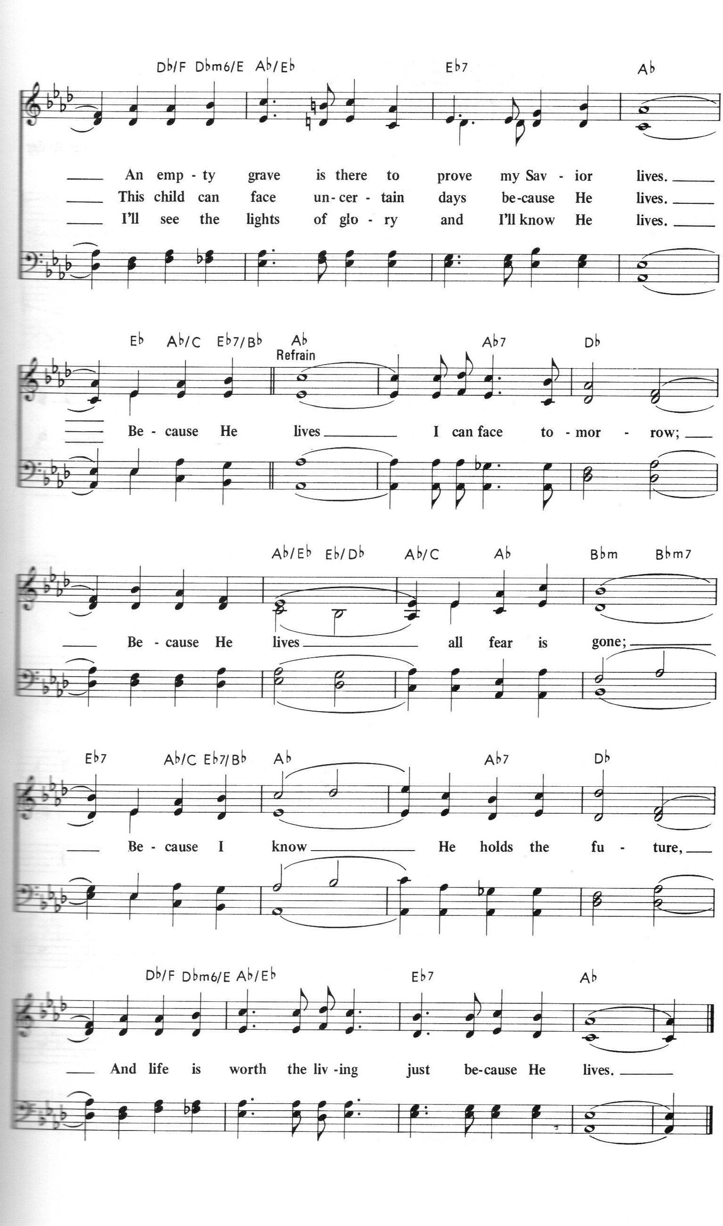God Sent His Son/Because He Lives
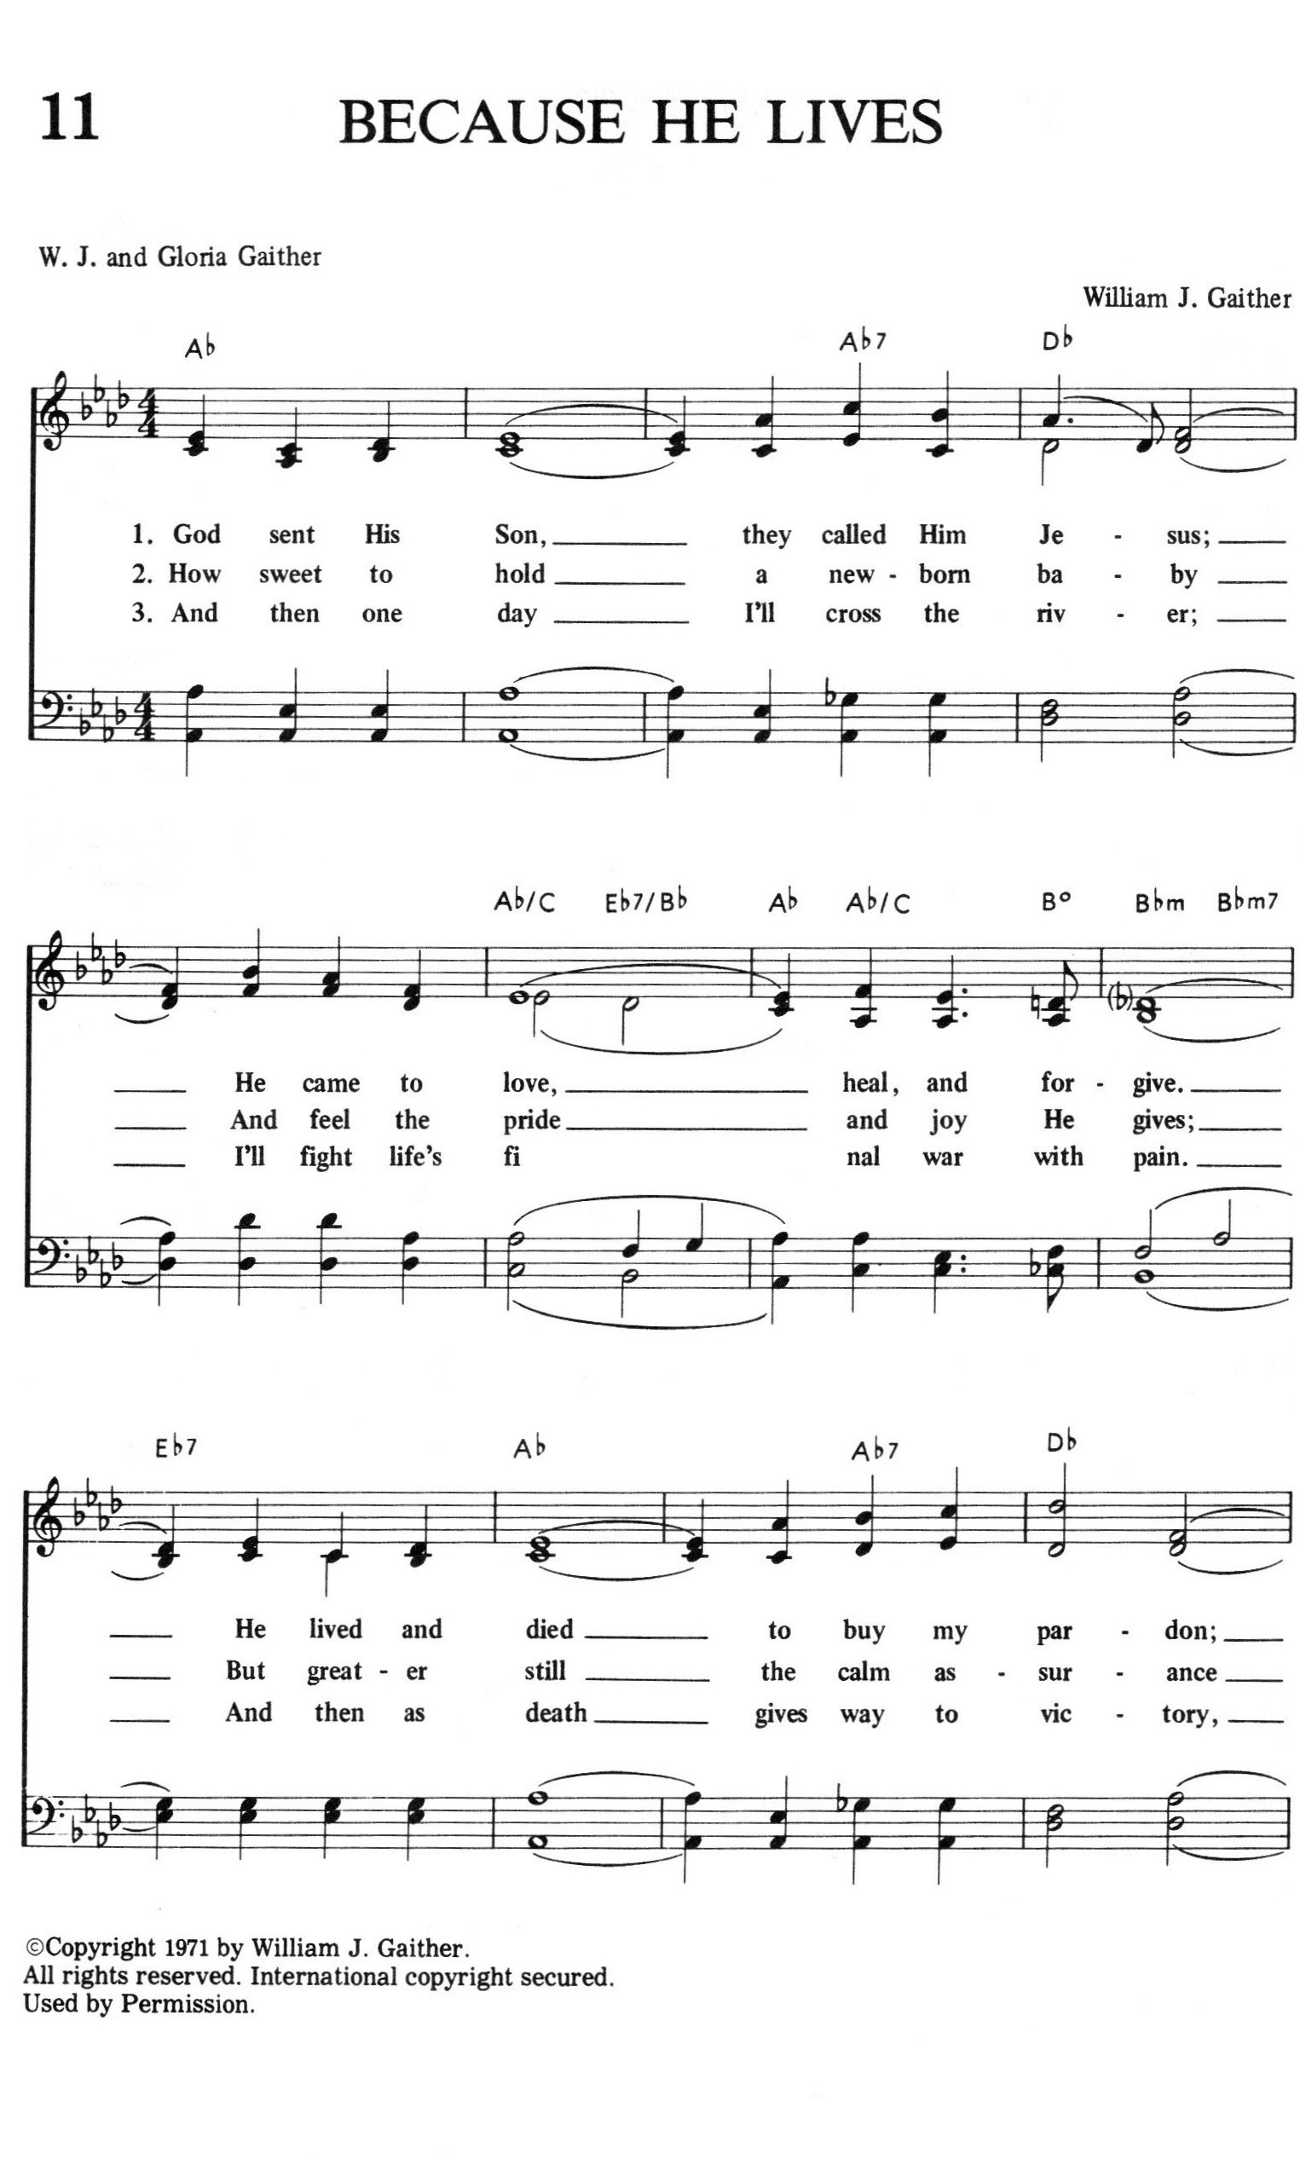

Continued on the next page.
Today’s Assistants and Ministers

Greeters & Ushers ………………....…..….…… Lester & Dianne Dunn and Curt & Jean Hall
Organist-Pianist …………………………………………....……….……………..…… Sue Holst
Presiding Minister …………………...................…………… Deacon Cindy Cordes-Eversole
Reader …………………………………….………………...........…….……………. Phill Rogers
Altar Care ….................................................... Lester & Dianne Dunn and Curt & Jean Hall
Refreshments ….....................................…….. Lester & Dianne Dunn and Curt & Jean Hall
Custodian …………………………………………………………..…………….. Deane Benson

Presence Last Week and April Presents

Attendance Last Sunday, May 7 = 59

Average Sunday Worship Attendance for April = 70
April Contributions: General Fund = $13,404 Designated Giving = $175
Jan-Apr Income = $49,492 Jan-Apr Expenses = $57,458 Deficit = $7,966

This Week in Our Congregation

Today, Sunday, May 14 — Sixth Sunday of Easter — Mother’s Day

Refreshments in the Fellowship Hall for everyone following worship
7th - & 8th-grade Confirmation session 10:15 AM

Monday, May 15 — June Newsletter articles due

Tuesday, May 16

Men’s breakfast at Home Sweet Home, Lanesboro 7:00 AM

Thursday, May 18 — Ascension Day

Next Sunday, May 21 — Seventh Sunday of Easter — Senior Recognition

Worship with Holy Baptism 9:00 AM
7th - & 8th-grade Confirmation session 10:15 AM
Baccalaureate for the LHS Class of 2023 at Bethlehem 7:00 PM

News and Notes

A huge and heartfelt thank you goes out to Hollie Clarke for meeting with and helping to form the faith of our kindergarten through sixth-grade students throughout the 2022-2023 Sunday school year that concluded on Sunday, April 30. God bless you!

Senior Recognition is next Sunday, May 21. Worship will include a time of blessing and prayers for our nine high school graduates. Refreshments will be served in their honor following worship.

Lanesboro High School Baccalaureate next Sunday, May 21, at 7:00 pm, at Bethlehem Lutheran Church. Everyone is welcome.

Continued on the next page.
Pastor Kerry and Deacon Cindy will be on vacation Sunday, June 4 for their daughter Sarah’s graduation from LHS. Pastor Kay Wold will be the guest preacher and worship leader.

Prayer Requests

In Our Community. For our church members and friends living with chronic illness and other diseases, who are homebound, residing in care facilities, and hospitalized. See the newsletter for our members living in area nursing homes. And let us not forget those sick and dying of COVID-19, those entrusted with the authority of government, justice, and law enforcement, as well as our fallen and wounded soldiers and those still serving.

In Our Synod. Bishop Regina Hassanally invites the people and congregations of our Southeastern Minnesota Synod to make a commitment to pray this week for the following faith communities: Mansfield Lutheran Church, Alden; Trinity Lutheran Church, Owatonna; St. Olaf College Student Congregation, Northfield; Tyeme Lutheran Church, Tanzania; Amani Lutheran Church, Tanzania; and Preventative Mental Health Ministry, Colombia.

Acknowledgments

Graphics, worship texts, service music, readings, and commemorations are from sundaysandseasons.com © 2023 Augsburg Fortress. Used by permission under Augsburg Fortress Liturgies Annual License SAS103296.

Permission to project, live stream, or podcast liturgy and music content under copyright to or administered by Augsburg Fortress provided under Augsburg Fortress Liturgies Annual License SAS103296.

Permission to Podcast / Stream provided by One License, Inc., under License # A-735588. An additional fee was paid. www.onelicense.net.

Permission to print and podcast / stream provided by Christian Copyright Licensing International, under CCLI License # 11459672. Because He Lives by Gloria Gaither and William J. Gaither, © 1971 Hanna Street Music (Admin. by Gaither Copyright Management). CCLI Song # 16880. An additional fee was paid. www.ccli.com.



