Fountain Lutheran Church

Established 1904

Rev. Kerry B. Eversole, Pastor
Deacon Cindy Cordes-Eversole, Associate in Ministry

Mailing Address: P.O. Box 75, Fountain, MN 55935
Physical Address: 314 Main Street, Fountain, Minn.

Church Office Phone: 507.268.4413
E-mail Address: flc@mediacombb.net
Website: www.fountainlutheranchurch.com
Facebook Page: www.facebook.com/FountainLutheranChurch/

Parsonage Phone: 507.467.3017

Pastor Kerry’s Cell Phone: 507.951.3954

Our Global Partner Congregation: Issuna Lutheran Church, Tanzania
Fountain Lutheran Church
Fountain, Minnesota

Twelfth Sunday after Pentecost

August 20, 2023

A Canaanite woman from the region of Tyre and Sidon came out and started shouting, “Have mercy on me, Lord, Son of David; my daughter is tormented by a demon.” And she came and knelt before [Jesus], saying, “Lord, help me.” He answered, “It is not fair to take the children’s food and throw it to the dogs.” She said, “Yes, Lord, yet even the dogs eat the crumbs that fall from their masters’ table.” Then Jesus answered her, “Woman, great is your faith! Let it be done for you as you wish.” And her daughter was healed instantly. Matthew 15:21-28
Welcome to worship at Fountain Lutheran
and our celebration of the Season after Pentecost,
the Time of the Church!

Jesus is our fountain of Living Water and Light! Psalm 36:9

COVID-19 Practices — Out of Love for God and Neighbor

1) Use hand sanitizer upon entry. Wash your hands and use hand sanitizer often while in the facility.
2) Members and visitors who are vaccinated and boosted are not required to wear a mask.
3) Members and visitors are free to wear a mask if they wish to do so.
4) Unvaccinated and not boosted members and visitors must wear a mask.
5) There are no physical distancing requirements, but you are welcome to keep a distance from others in the sanctuary as much as you are able.
6) All are welcome to enjoy coffee fellowship in the dining room following worship.

Worship Book and Hymns. This morning’s service is printed in the bulletin. All the hymns can be found in Evangelical Lutheran Worship (ELW), “the red book” in the pews. Hymns in ELW are indicated by a large bold number in the left or right margin of each page.

Abbreviations. Throughout this worship folder, hymns are signified by the pound symbol (#), P: refers to the presiding minister or preacher, A: denotes an assisting minister, and C: and/or bold text indicates the congregation.

Offering. Later in our service, we will be receiving an offering. The offering is an opportunity to worship God with our money. We know that the money you give to Bethlehem Lutheran Church represents your lives — your time, talents, and hard work. We recognize that and we appreciate your generosity. Your support not only helps all of us to fulfill God’s call on our lives, but it also makes an impact, and we thank you! Lastly, our visitors are not expected to give. After all, you are our guests! We’re glad you’re here and we want you to feel welcome!

Mistakes do not happen in our worship service;
only unexpected events which are opportunities for joy!

An signifies that you may stand as you are comfortably able.

Introduction to the Day. In Isaiah, we hear that God’s house shall be a house of prayer for all people and that God will gather the outcasts of Israel. The Canaanite woman in today’s gospel is a Gentile, an outsider, who is unflinching in her request that Jesus heal her daughter. As Jesus commends her bold faith, how might our church extend its mission to those on the margins of society? In our gathering around word and meal, we receive strength to be signs of comfort, healing, and justice for those in need.

Gathering

The Holy Spirit calls us together as the people of God.

PRELUDE My Faith Looks Up to Thee Jan Meyer

by Lowell Mason

RINGING OF THE BELL, WELCOME, AND INTRODUCTION TO THE DAY

OPENING HYMN All Are Welcome ELW # 641

Stanzas 1, 2, 3 and 5

GREETING ELW p. 203

P: The grace of our Lord Jesus Christ, the love of God, and the communion of the Holy Spirit be with you all.

C: And also with you.

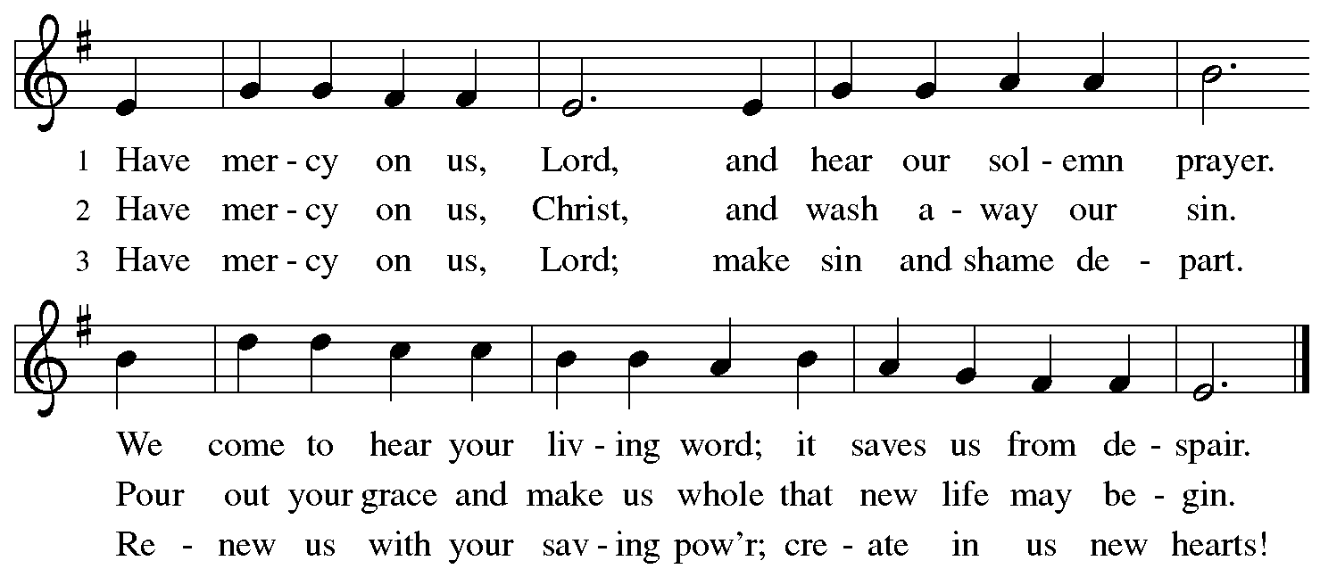
KYRIE ELW p. 203

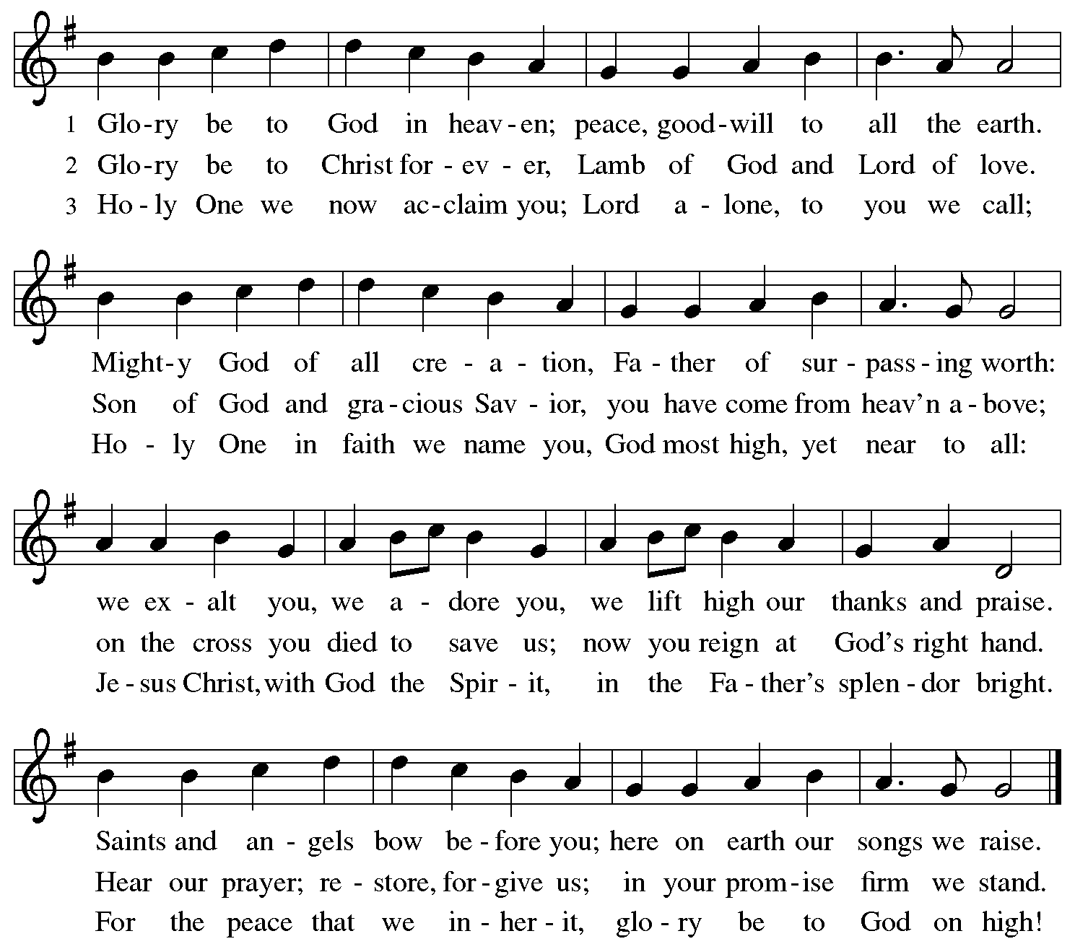
CANTICLE OF PRAISE Glory Be to God ELW p. 204

PRAYER OF THE DAY

P: God of all peoples, your arms reach out to embrace all those who call upon you. Teach us as disciples of your Son to love the world with compassion and constancy, that your name may be known throughout the earth, through Jesus Christ, our Savior and Lord.

C: Amen.

Word

God speaks to us in scripture reading, preaching, and song.

FIRST READING Isaiah 56:1, 6-8

The prophet calls upon Israel to do justice in view of God’s imminent intervention to save. Righteousness and obedience define who belongs to the Israelite community—not race, nationality, or any other category.

¹Thus says the Lord:
Maintain justice, and do what is right,
for soon my salvation will come,
and my deliverance be revealed.
⁶And the foreigners who join themselves to the Lord,
to minister to him, to love the name of the Lord,
and to be his servants,
all who keep the sabbath, and do not profane it,
and hold fast my covenant—
⁷these I will bring to my holy mountain,
and make them joyful in my house of prayer;
their burnt offerings and their sacrifices
will be accepted on my altar;
for my house shall be called a house of prayer
for all peoples.
⁸Thus says the Lord God,
who gathers the outcasts of Israel,
I will gather others to them
besides those already gathered.

A: The Word of the Lord.

C: Thanks be to God.

PSALM 67

May God be merciful to us and bless us; may the light of God’s face shine upon us.

Let your way be known upon earth, your saving health among all nations.

³Let the peoples praise you, O God; let all the peoples praise you.

Let the nations be glad and sing for joy, for you judge the peoples with equity and guide all the nations on earth.

Continued on the next page.
Let the peoples praise you, O God; let all the peoples praise you.

The earth has brought forth its increase; God, our own God, has blessed us.

May God give us blessing,

and may all the ends of the earth stand in awe.

GOSPEL ACCLAMATION ELW p. 205

GOSPEL Matthew 15:21-28

P: Announcement of the Gospel.

C: Glory to you, O Lord.

After John the Baptist is murdered, Jesus desires a time of solitude. Still, his compassion for others will not allow him to dismiss those who need him, and he is moved to perform one of his greatest miracles.

²¹Jesus left that place and went away to the district of Tyre and Sidon. ²²Just then a Canaanite woman from that region came out and started shouting, “Have mercy on me, Lord, Son of David; my daughter is tormented by a demon.” ²³But he did not answer her at all. And his disciples came and urged him, saying, “Send her away, for she keeps shouting after us.” ²⁴He answered,

Continued on the next page.
“I was sent only to the lost sheep of the house of Israel.” ²⁵But she came and knelt before him, saying, “Lord, help me.” ²⁶He answered, “It is not fair to take the children’s food and throw it to the dogs.” ²⁷She said, “Yes, Lord, yet even
the dogs eat the crumbs that fall from their masters’ table.” ²⁸Then Jesus answered her, “Woman, great is your faith! Let it be done for you as you wish.” And her daughter was healed instantly.

P: Affirmation of the Gospel.

C: Praise to you, O Christ.

SERMON

HYMN OF THE DAY There’s a Wideness in God’s Mercy ELW # 588

PRAYERS OF INTERCESSION

Each petition ends with these words and response:

P: Hear us, O God.

C: Your mercy is great.

Concluding petition and response:

P: Into your hands, O God, we commend all for whom we pray, in the name of the one who reconciled all creation to himself, Jesus Christ our Savior.

C: Amen.

Meal

God feeds us with the presence of Jesus Christ.

OFFERING AND MUSIC My Faith Has Found a Resting Place Jan Meyer

old Norwegian melody

OFFERING SONG As the Grains of Wheat ELW # 465

OFFERING PRAYER

P: God of field and forest, sea and sky, you are the giver of all good things. Sustain us with these gifts of your creation, and multiply your graciousness in us, that the world may be fed with your love, through Jesus Christ, our Savior and Lord.

C: Amen.

Dialogue ELW p. 206

P: The Lord be with you.

C: And also with you.

P: Lift up your hearts.

C: We lift them to the Lord.

P: Let us give thanks to the Lord our God.

C: It is right to give our thanks and praise.

PREFACE

P: It is indeed right, our duty and our joy, that we should at all times and in all places give thanks and praise to you, almighty and merciful God, through our Savior Jesus Christ; who on this day overcame death and the grave, and by his glorious resurrection opened to us the way of everlasting life. And so, with all the choirs of angels, with the church on earth and the hosts of heaven, we praise your name and join their unending hymn:

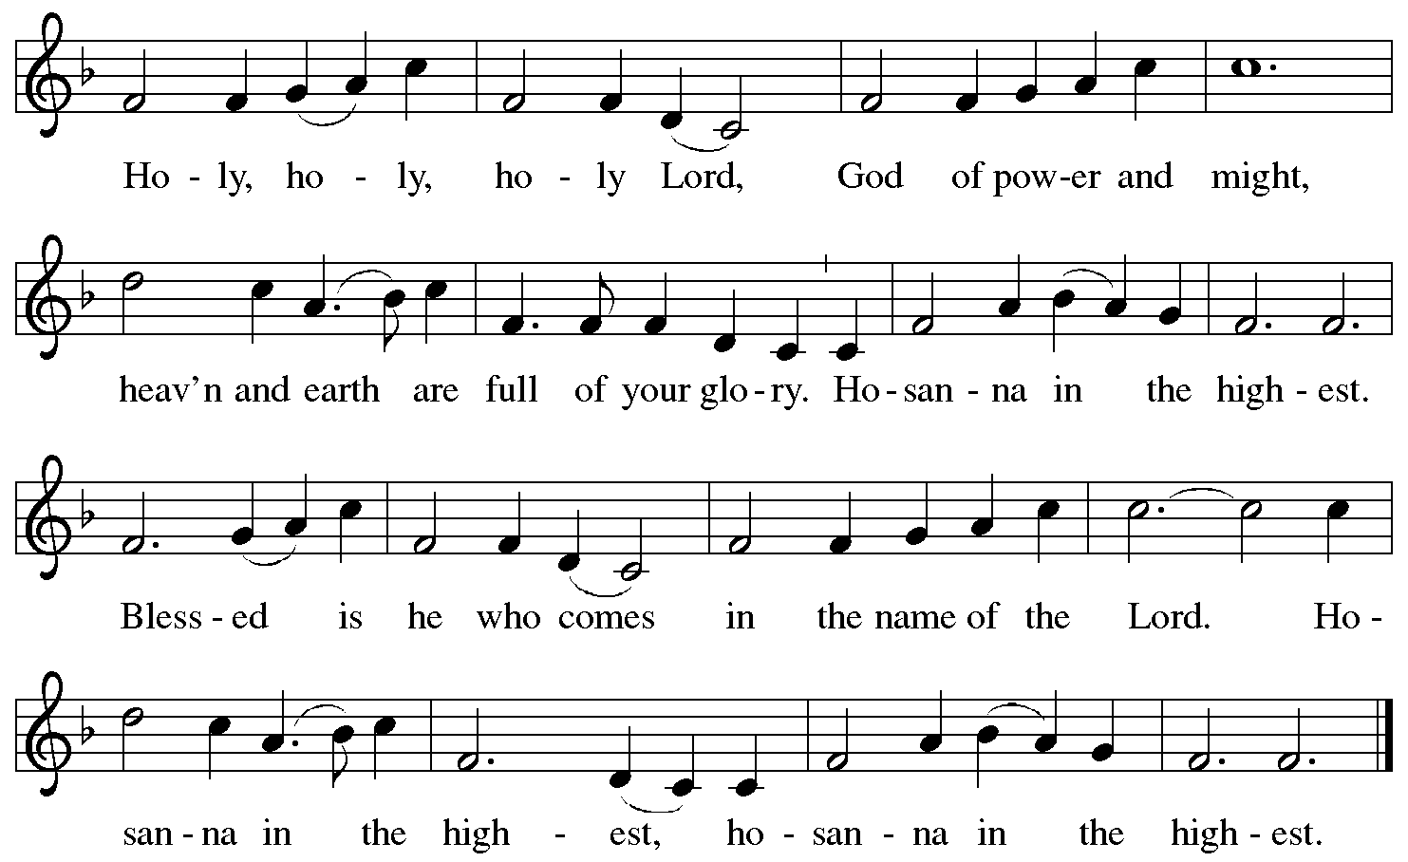
HOLY, HOLY, HOLY (the angels’ song) ELW p. 207

THANKSGIVING AT THE TABLE

P: Holy, mighty, and merciful Lord, heaven and earth are full of your glory. In great love you sent to us Jesus, your Son, who reached out to heal the sick and suffering, who preached good news to the poor, and who, on the cross, opened his arms to all.

In the night in which he was betrayed, our Lord Jesus took bread, and gave thanks; broke it, and gave it to his disciples, saying: Take and eat; this is my body, given for you. Do this for the remembrance of me.

Again, after supper, he took the cup, gave thanks, and gave it for all to drink, saying: This cup is the new covenant in my blood, shed for you and for all people for the forgiveness of sin. Do this for the remembrance of me.

Remembering, therefore, his death, resurrection, and ascension,
we await his coming in glory.

Pour out upon us the Spirit of your love, O Lord, and unite the wills of all who share this heavenly food, the body and blood of Jesus Christ, our Lord; to whom, with you and the Holy Spirit, be all honor and glory, now and forever.

C: Amen.

LORD'S PRAYER Traditional Wording ELW p. 208

P: Gathered into one by the Holy Spirit, let us pray as Jesus taught us.

All: Our Father, who art in heaven, hallowed be thy name, thy kingdom come, thy will be done, on earth as it is in heaven. Give us this day our daily bread; and forgive us our trespasses, as we forgive those who trespass against us; and lead us not into temptation, but deliver us from evil. For thine is the kingdom, and the power, and the glory, forever and ever. Amen.

INVITATION TO COMMUNION

P: All people are called to Christ’s table. Come, eat what is good.

COMMUNION

What We Believe

Who May Receive. We welcome all baptized Christians to the Lord's Table. In our parish baptized children who have entered the 5th grade are instructed in this sacrament and receive their First Communion; younger children come to the altar and receive a blessing. If your baptized child has received such instruction, or if you want your baptized child to receive Communion, then he or she is welcome to partake.

Proper Preparation. In his Small Catechism, Martin Luther asks, "When is a person rightly prepared to receive this sacrament?" He answers, "Fasting and other outward preparations serve a good purpose. However, that person is well prepared and worthy who believes these words, given and shed for you for the remission of sins. But anyone who does not believe these words, or doubts them, is neither prepared nor worthy, for the words for you require simply a believing heart.”

Real Presence. We believe that the bread and wine truly are the body and blood of Christ given and shed for the forgiveness of sins.

Distribution

Holy Communion will be served in procession, one side of the sanctuary at a time; please keep some distance from the person in front of you. The ushers will direct you when to make your way to the front of the church using the center aisle. You will receive the elements near the chancel. Please extend your hands, palms up, if you will be receiving the bread. Gluten-free wafers are also available; please ask for one. Proceed to your right or to your left depending on which side of the sanctuary you are seated on to receive the wine. White grape juice is also available in the center ring of each tray for those who prefer an alcohol-free element. You may say “Amen” after receiving each element. If you will not be receiving Communion, keep your hands folded for a blessing. Place your empty cup in the basket and then return to your seat by the side aisle.

Music During Distribution of Communion Jan Meyer

PRAYER AFTER COMMUNION

P: We thank you, generous God, for the refreshment we have received at your banquet table. Send us now to spread your generosity into all the world, through the one who is our dearest treasure, Jesus Christ, our Savior and Lord.

C: Amen.

Sending

God blesses us and sends us in mission to the world.

ANNOUNCEMENTS

BENEDICTION

P: The God who calls across the cosmos and speaks in the smallest seed ☩ bless, keep, and sustain you now and to the end of the age.

C: Amen.

DEPARTING HYMN Rise, Shine, You People! ELW # 665

Stanzas 1, 2 and 3

DISMISSAL

P: Go in peace. Share the harvest.

C: Thanks be to God.

POSTLUDE We are God's People Jan Meyer

mel. Johannes Brahms, arr. by Fred Bock



Today’s Assistants and Ministers

Greeters & Ushers …………………………………….….…....………… Mike & Deb Schwarz
Organist ……….…..…………………............................….…….…..………….…… Jan Meyer
Presiding Minister …………………….....…... ....…………… Pastor Kerry Eversole
Altar Care & Communion Preparation ……………………….. Deb Schwarz and Deb Schott
Custodians ………………………….….…….………...….…..…….. Dave & Geri Ann Hanson

This Week in Our Congregation

Today, August 20 — Twelfth Sunday after Pentecost

Coffee fellowship in the narthex or downstairs in the dining room following worship
Getting Ready to Affirm Session 10:15 PM

Monday, August 21

Pastor Kerry and Deacon Cindy at Bethlehem for Kathie Rogers funeral
Visitation 1:00 PM, Service 2:00 PM

Tuesday, August 22

Men’s breakfast at Home Sweet Home in Lanesboro 7:00 AM

Wednesday, August 23

Pastor Kerry at Bethlehem WELCA Bible study 9:00 AM
Pastor Kerry at Getting Ready to Affirm Session at Bethlehem 7:00 PM

Thursday, August 24

Pastor Kerry at Park Lane Estates, Preston, for Bible study/chapel 9:30 AM

Next Sunday, August 27 — Thirteenth Sunday after Pentecost

Worship 9:00 AM

Prayer Requests

In Our Community. For our church members and friends living with chronic illness and other diseases, who are homebound, residing in care facilities, and hospitalized. See the newsletter for our members living in area nursing homes. And let us not forget those sick and dying of COVID-19, those entrusted with the authority of government, justice, and law enforcement, as well as our fallen and wounded soldiers and those still serving.

In Our Synod. Bishop Regina Hassanally invites the people and congregations of our Southeastern Minnesota Synod to make a commitment to pray this week for the following faith communities: Dale Lutheran Church, Kenyon; Jackson Lake Lutheran Church, Amboy; Aurora Lutheran Church, Owatonna; Trondhjem Lutheran Church, Hayward; Mitume Ghata Lutheran Church, Tanzania; and Kinyangiri Lutheran Church, Tanzania.

Continued on the next page.

News and Notes

Make summertime giving a breeze with recurring gifts! Many of you support our congregation with your time, talents, and financial contributions throughout the year. But since many of you travel or spend time visiting family and friends during the summer, it can be hard to keep up with your giving. That’s why we encourage you to set up recurring gifts.
It takes just moments to do. Visit our website at https://fountainlutheranchurch.com/ and find our online giving in the blue text box titled “Click here to contribute to Fountain Lutheran!” Thank you for your continued support of our ministry and mission!

2023 Southeastern Minnesota Women of the ELCA Convention, Saturday, September 30 at First Lutheran Church, Red Wing. Registration $25. Registration deadline: September 15. Contact Kathy Bolin 507.292.0277, bolin1948@gmail.com, or Sharon Northouse 507.471.4796, borniniowa@gmail.com.

Community Activities

Community Christian Cantata this fall. Julie Kiehne from our sister congregation, Bethlehem Lutheran, is coordinating a Christian Cantata called “He Lived the Good Life.” It’s the story of Jesus’ life with a 70s vibe! This is not a traditional SATB-type cantata. Songs are 2-part, unison, with repetitive choruses that can be intergenerational with young voices too. All singers and all levels are welcome! This promises to be a fun time celebrating our community and sharing the Advent story! Please come and join the community choir! Rehearsals will be Wednesdays from 5:30 to 6:30 pm, October 4 thru November 8 at Bethlehem Lutheran Church, Lanesboro. Full run-through Wednesday, November 15, from 5:00 to 6:30 pm at the Sons of Norway Hall. Performances will be Saturday, November 18 at 7:00 pm at Bethlehem Lutheran and Sunday, November 19, at 2:00 pm at the Sons of Norway Hall. Reply to julie.kiehne@gmail.com if you would like to join the community choir or play an instrument. We have commitments from instrumentalists including piano, flute(s), drums, and percussion. I’m still looking for an electric guitarist and/or bass player. I have print music and audio mp3 files which I can share any time between now and when rehearsals start. Questions? Contact Julie Kiehne at 507-272-4581.

Mark your calendar! Saturday, December 2, from 9:00 am to 2:00 pm,Craft & Bake Sale at Christ Lutheran Church, Preston. Featuring the Gnome Café with treats, coffee, cider, and hot chocolate. Free samples of rommegrot. Shop local for Norwegian baked goods, breads, cookies, candies, and rolls! Find unique woodworking, gults, toys, gift baskets, jewelry, greeting card, artwork and more. Procees will help CLC missions such as RIP Medical Debt, Preston Food Shelf, and Growing Hope Globally.


Acknowledgments

Graphics, worship texts, service music, readings, and PowerPoint® Slides are from sundaysandseasons.com © 2023 Augsburg Fortress. Used by permission under Augsburg Fortress Liturgies Annual License SAS005401.

Permission to project liturgy and music content under copyright to or administered by Augsburg Fortress provided under Augsburg Fortress Liturgies Annual License SAS005401.



