Fountain Lutheran Church

Established 1904

Rev. Kerry B. Eversole, Pastor
Deacon Cindy Cordes-Eversole, Associate in Ministry

Mailing Address: P.O. Box 75, Fountain, MN 55935
Physical Address: 314 Main Street, Fountain, Minn.

Church Office Phone: 507.268.4413
E-mail Address: flc@mediacombb.net
Website: www.fountainlutheranchurch.com
Facebook Page: www.facebook.com/FountainLutheranChurch/

Parsonage Phone: 507.467.3017

Pastor Kerry’s Cell Phone: 507.951.3954

Our Global Partner Congregation: Issuna Lutheran Church, Tanzania
Fountain Lutheran Church
Fountain, Minnesota

Thirteenth Sunday after Pentecost

August 27, 2023



Jesus asked his disciples, “Who do you say that I am?” Simon Peter answered, “You are the Messiah, the Son of the living God.” And Jesus answered him, “Blessed are you, Simon son of Jonah! For flesh and blood has not revealed this to you, but my Father in heaven. And I tell you, you are Peter, and on this rock I will build my church, and the gates of Hades will not prevail against it. I will give you the keys of the kingdom of heaven, and whatever you bind on earth will be bound in heaven, and whatever you loose on earth will be loosed in heaven.”
Matthew 16:16-20
Welcome to worship at Fountain Lutheran
and our celebration of the Season after Pentecost,
the Time of the Church!

Jesus is our fountain of Living Water and Light! Psalm 36:9

COVID-19 Practices — Out of Love for God and Neighbor

1) Use hand sanitizer upon entry. Wash your hands and use hand sanitizer often while in the facility.
2) Members and visitors who are vaccinated and boosted are not required to wear a mask.
3) Members and visitors are free to wear a mask if they wish to do so.
4) Unvaccinated and not boosted members and visitors must wear a mask.
5) There are no physical distancing requirements, but you are welcome to keep a distance from others in the sanctuary as much as you are able.
6) All are welcome to enjoy coffee fellowship in the dining room following worship.

Worship Book and Hymns. This morning’s service is printed in the bulletin. All the hymns can be found in Evangelical Lutheran Worship (ELW), “the red book” in the pews. Hymns in ELW are indicated by a large bold number in the left or right margin of each page.

Abbreviations. Throughout this worship folder, hymns are signified by the pound symbol (#), P: refers to the presiding minister or preacher, A: denotes an assisting minister, and C: and/or bold text indicates the congregation.

Offering. Later in our service, we will be receiving an offering. The offering is an opportunity to worship God with our money. We know that the money you give to Bethlehem Lutheran Church represents your lives — your time, talents, and hard work. We recognize that and we appreciate your generosity. Your support not only helps all of us to fulfill God’s call on our lives, but it also makes an impact, and we thank you! Lastly, our visitors are not expected to give. After all, you are our guests! We’re glad you’re here and we want you to feel welcome!

Mistakes do not happen in our worship service;
only unexpected events which are opportunities for joy!

An signifies that you may stand as you are comfortably able.

Introduction to the Day. In Isaiah the people are advised to look to their spiritual ancestors as the rock from which they were hewn. Paul urges us to not be conformed to this world but to offer our bodies as a living sacrifice, using our individual gifts to build up the body of Christ.

Continued on the next page.
Jesus declares that the church will be built on the rock of Peter’s bold confession of faith. God’s word of reconciliation and God’s mercy are keys to the church’s mission which are offered daily through our words and deeds.

Gathering

The Holy Spirit calls us together as the people of God.

PRELUDE Built on The Rock Jan Meyer

by Lindeman-Christian Teilman

RINGING OF THE BELL, WELCOME, AND INTRODUCTION TO THE DAY

OPENING SONG The Church’s One Foundation ELW # 654

Stanzas 1, 2, 4 and 5

CONFESSION AND FORGIVENESS

All may make the sign of the cross, the sign that is marked at baptism, as the presiding minister begins.

P: Blessed be the holy Trinity, ☩ one God, who forgives all our sins, whose mercy endures forever.

C: Amen.

P: Almighty God, to whom all hearts are open, all desires known, and from whom no secrets are hid: cleanse the thoughts of our hearts by the inspiration of your Holy Spirit, that we may perfectly love you and worthily magnify your holy name, through Jesus Christ our Lord.

C: Amen.

P: Let us confess our sins in the presence of God and of one another.

Silence is kept for reflection.

P: Most merciful God,

All: we confess that we are captive to sin and cannot free ourselves. We have sinned against you in thought, word, and deed, by what we have done and by what we have left undone. We have not loved you with our whole heart; we have not loved our neighbors as ourselves. For the sake of your Son, Jesus Christ, have mercy on us. Forgive us, renew us, and lead us, so that we may delight in your will and walk in your ways, to the glory of your holy name. Amen.

Continued on the next page.
P: God, who is rich in mercy, loved us even when we were dead in sin, and made us alive together with Christ. By grace you have been saved. In the name of ☩ Jesus Christ, your sins are forgiven. Almighty God strengthen you with power through the Holy Spirit, that Christ may live in your hearts through faith.

C: Thanks be to God.

SONG OF PRAISE O Savior, Precious Savior ELW # 820

Stanzas 1, 2 and 3

GREETING

P: The grace of our Lord Jesus Christ, the love of God, and the communion of the Holy Spirit be with you all.

C: And also with you.

PRAYER OF THE DAY

P: Let us pray together. O God,

All: with all your faithful followers of every age, we praise you, the rock of our life. Be our strong foundation and form us into the body of your Son, that we may gladly minister to all the world, through Jesus Christ, our Savior and Lord. Amen.

Word

God speaks to us in scripture reading, preaching, and song.

SCRIPTURE SONG Holy Wisdom, Holy Word

Printed at the end of the bulletin.

FIRST READING Isaiah 51:1-6

Just as God had called Abraham and Sarah and given them many descendants, so now God offers comfort to Zion. God’s deliverance will come soon and will never end.

¹Listen to me, you that pursue righteousness, you that seek the Lord. Look to the rock from which you were hewn, and to the quarry from which you were dug.
²Look to Abraham your father and to Sarah who bore you; for he was but one when I called him, but I blessed him and made him many.

Continued on the next page.
³For the Lord will comfort Zion; he will comfort all her waste places, and will make her wilderness like Eden, her desert like the garden of the Lord; joy and gladness will be found in her, thanksgiving and the voice of song.
⁴Listen to me, my people, and give heed to me, my nation; for a teaching will go out from me, and my justice for a light to the peoples.
⁵I will bring near my deliverance swiftly, my salvation has gone out and my arms will rule the peoples; the coastlands wait for me, and for my arm they hope.
⁶Lift up your eyes to the heavens, and look at the earth beneath; for the heavens will vanish like smoke, the earth will wear out like a garment, and those who live on it will die like gnats; but my salvation will be forever, and my deliverance will never be ended.

A: The word of the Lord.

C: Thanks be to God.

SECOND READING Romans 12:1-8

In response to God’s merciful activity, we are to worship by living holistic, God-pleasing lives. Our values and viewpoints are not molded by the time in which we live but are transformed by the Spirit’s renewing work. God’s grace empowers different forms of service among Christians, but all forms of ministry function to build up the body of Christ.

¹I appeal to you therefore, brothers and sisters, by the mercies of God, to present your bodies as a living sacrifice, holy and acceptable to God, which is your spiritual worship. ²Do not be conformed to this world, but be transformed by the renewing of your minds, so that you may discern what is the will of God—what is good and acceptable and perfect.
³For by the grace given to me I say to everyone among you not to think of yourself more highly than you ought to think, but to think with sober judgment, each according to the measure of faith that God has assigned. ⁴For as in one body we have many members, and not all the members have the same function, ⁵so we, who are many, are one body in Christ, and individually we are members one of another. ⁶We have gifts that differ according to the grace given to us: prophecy, in proportion to faith; ⁷ministry, in ministering; the teacher, in teaching; ⁸the exhorter, in exhortation; the giver, in generosity; the leader, in diligence; the compassionate, in cheerfulness.

A: The word of the Lord.

C: Thanks be to God.

GOSPEL Matthew 16:13-20

P: Announcement of the Gospel.

C: Glory to you, O Lord.

At a climactic point in Jesus’s ministry, God reveals to Peter that Jesus is “the Messiah, the Son of the living God”, and Jesus responds with the promise of a church that will overcome the very gates of Hades.

¹³Now when Jesus came into the district of Caesarea Philippi, he asked his disciples, “Who do people say that the Son of Man is?” ¹⁴And they said, “Some say John the Baptist, but others Elijah, and still others Jeremiah or one of the prophets.” ¹⁵He said to them, “But who do you say that I am?” ¹⁶Simon Peter answered, “You are the Messiah, the Son of the living God.” ¹⁷And Jesus answered him, “Blessed are you, Simon son of Jonah! For flesh and blood has not revealed this to you, but my Father in heaven. ¹⁸And I tell you, you are Peter, and on this rock I will build my church, and the gates of Hades will not prevail against it. ¹⁹I will give you the keys of the kingdom of heaven, and whatever you bind on earth will be bound in heaven, and whatever you loose on earth will be loosed in heaven.” ²⁰Then he sternly ordered the disciples not to tell anyone that he was the Messiah.

P: Affirmation of the Gospel.

C: Praise to you, O Christ.

SERMON

SONG OF THE DAY My Hope is Built on Nothing Less ELW # 597

Responding

We act on God’s word.

OFFERING AND MUSIC Blest Be the Tie that Binds Jan Meyer

by Johann G Naegeli, arr by Lowell Mason

OFFERING SONG Seek Ye First TOSB # 187

PRAYERS OF GOD’S PEOPLE

After the last prayer, all sing ELW # 752

Lord, Listen to Your Children Praying

LORD’S PRAYER Traditional Wording

P: As children of God, let us be bold to pray as Jesus himself taught us.

All: Our Father, who art in heaven, hallowed be thy name, thy kingdom come, thy will be done, on earth as it is in heaven. Give us this day our daily bread; and forgive us our trespasses, as we forgive those who trespass against us; and lead us not into temptation, but deliver us from evil. For thine is the kingdom, and the power, and the glory, forever and ever. Amen.

Sending

God blesses us and sends us in mission to the world.

ANNOUNCEMENTS

BLESSING

P: The Lord bless you and keep you.
The Lord’s face shine on you with grace and mercy.
The Lord look upon you with favor and ☩ give you peace.

C: Amen.

DEPARTING SONG We All Are One in Mission ELW # 576

DISMISSAL

P: Go in peace. Share the good news.

C: Thanks be to God.

POSTLUDE The Call of the Trumpets Jan Meyer

by Henry Purcell, arr by Franklin Ritter

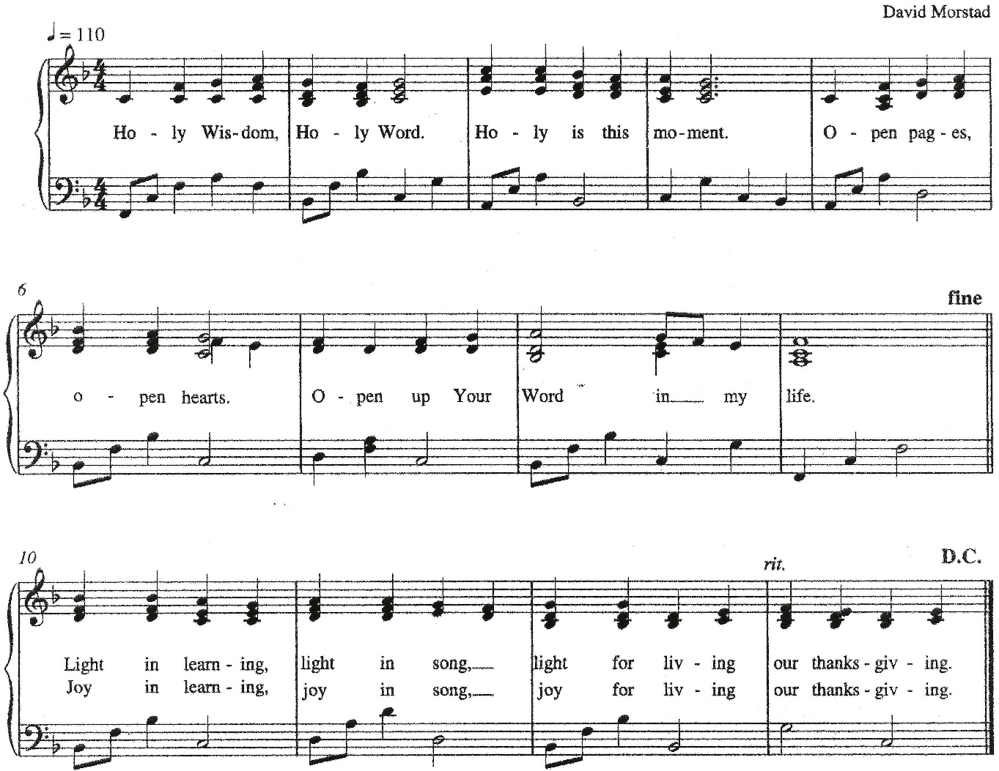
Holy Wisdom, Holy Word

Text and Music: David Morstad, My Word! The Bible for Every One 2009-2010 Christian Education Planning Guide developed by ELCA Christian Education of the Evangelical Outreach and Congregational Mission unit. Copyright © 2009 Evangelical Lutheran Church in America. All rights reserved. Permission is granted to photocopy this resource provided copies are for local use only and each copy carries all copyright acknowledgments.



Today’s Assistants and Ministers

Greeters & Ushers …………………………………….….…....………… Mike & Deb Schwarz
Organist ……….…..…………………............................….…….…..………….…… Jan Meyer
Presiding Minister …………………….....….......…………… Deacon Cindy Cordes-Eversole
Altar Care …………………………………………….………….. Deb Schwarz and Deb Schott
Custodians ………………………….….…….………...….…..…….. Dave & Geri Ann Hanson

This Week in Our Congregation

Today, August 27 — Thirteenth Sunday after Pentecost

Coffee fellowship in the narthex or downstairs in the dining room following worship
Getting Ready to Affirm Session 10:15 AM

Tuesday, August 29

Men’s breakfast at Home Sweet Home in Lanesboro 7:00 AM

Wednesday, August 30

Pastor Kerry at Getting Ready to Affirm Session at Bethlehem 7:00 PM

Thursday, August 31

Pastor Kerry at Good Shepherd Lutheran Home, Rushford, for chapel 1:30 AM

Next Sunday, September 3 — Fourteenth Sunday after Pentecost

Worship with Holy Communion 9:00 AM

Prayer Requests

In Our Community. For our church members and friends living with chronic illness and other diseases, who are homebound, residing in care facilities, and hospitalized. See the newsletter for our members living in area nursing homes. And let us not forget those sick and dying of COVID-19, those entrusted with the authority of government, justice, and law enforcement, as well as our fallen and wounded soldiers and those still serving.

In Our Synod. Bishop Regina Hassanally invites the people and congregations of our Southeastern Minnesota Synod to make a commitment to pray this week for the following faith communities: United Lutheran Church, Walters; Vang Lutheran Church, Dennison; Cross of Christ Lutheran Church, Houston; Sayuni Mipilo Lutheran Church, Tanzania; Iguguno Lutheran Church, Tanzania; and Jikmir Lutheran Parish, South Sudan.

News and Notes

Make summertime giving a breeze with recurring gifts! Many of you support our congregation with your time, talents, and financial contributions throughout the year. But since many of you travel or spend time visiting family and friends during the summer, it can be hard to keep up with your giving. That’s why we encourage you to set up recurring gifts.

Continued on the next page.

It takes just moments to do. Visit our website at https://fountainlutheranchurch.com/ and find our online giving in the blue text box titled “Click here to contribute to Fountain Lutheran!” Thank you for your continued support of our ministry and mission!

2023 Southeastern Minnesota Women of the ELCA Convention, Saturday, September 30 at First Lutheran Church, Red Wing. Registration $25. Registration deadline: September 15. Contact Kathy Bolin 507.292.0277, bolin1948@gmail.com, or Sharon Northouse 507.471.4796, borniniowa@gmail.com.

Community Activities

Community Christian Cantata this fall. Julie Kiehne from our sister congregation, Bethlehem Lutheran, is coordinating a Christian Cantata called “He Lived the Good Life.” It’s the story of Jesus’ life with a 70s vibe! This is not a traditional SATB-type cantata. Songs are 2-part, unison, with repetitive choruses that can be intergenerational with young voices too. All singers and all levels are welcome! This promises to be a fun time celebrating our community and sharing the Advent story! Please come and join the community choir! Rehearsals will be Wednesdays from 5:30 to 6:30 pm, October 4 thru November 8 at Bethlehem Lutheran Church, Lanesboro. Full run-through Wednesday, November 15, from 5:00 to 6:30 pm at the Sons of Norway Hall. Performances will be Saturday, November 18 at 7:00 pm at Bethlehem Lutheran and Sunday, November 19, at 2:00 pm at the Sons of Norway Hall. Reply to julie.kiehne@gmail.com if you would like to join the community choir or play an instrument. We have commitments from instrumentalists including piano, flute(s), drums, and percussion. I’m still looking for an electric guitarist and/or bass player. I have print music and audio mp3 files which I can share any time between now and when rehearsals start. Questions? Contact Julie Kiehne at 507-272-4581.

Mark your calendar! Saturday, December 2, from 9:00 am to 2:00 pm, Craft & Bake Sale at Christ Lutheran Church, Preston. Featuring the Gnome Café with treats, coffee, cider, and hot chocolate. Free samples of rommegrot. Shop local for Norwegian baked goods, breads, cookies, candies, and rolls! Find unique woodworking, gults, toys, gift baskets, jewelry, greeting card, artwork and more. Procees will help CLC missions such as RIP Medical Debt, Preston Food Shelf, and Growing Hope Globally.

Acknowledgments

Graphics, worship texts, service music, readings, and PowerPoint® Slides are from sundaysandseasons.com © 2023 Augsburg Fortress. Used by permission under Augsburg Fortress Liturgies Annual License SAS005401.

Permission to project liturgy and music content under copyright to or administered by Augsburg Fortress provided under Augsburg Fortress Liturgies Annual License SAS005401.

