Fountain Lutheran Church
Established 1904

Rev. Kerry B. Eversole, Pastor
Deacon Cindy Cordes-Eversole, Associate in Ministry

Mailing Address: P.O. Box 75, Fountain, MN 55935
Physical Address: 314 Main Street, Fountain, Minn.

Church Office Phone: 507.268.4413
E-mail Address: flc@mediacombb.net
Website: www.fountainlutheranchurch.com
Facebook Page: www.facebook.com/FountainLutheranChurch/

Parsonage Phone: 507.467.3017
Pastor Kerry’s Cell Phone: 507.951.3954

Our Global Partner Congregation: Issuna Lutheran Church, Tanzania
Fountain Lutheran Church
Fountain, Minnesota

Fourteenth Sunday after Pentecost

September 3, 2023



Jesus told his disciples, “If any want to become my followers, let them deny themselves and take up their cross and follow me. For those who want to save their life will lose it, and those who lose their life for my sake will find it. For what will it profit them if they gain the whole world but forfeit their life? Or what will they give in return for their life?
Matthew 16:24-26
Welcome to worship at Fountain Lutheran
and our celebration of the Season after Pentecost,
the Time of the Church!

Jesus is our fountain of Living Water and Light! Psalm 36:9

COVID-19 Practices — Out of Love for God and Neighbor

1) Use hand sanitizer upon entry. Wash your hands and use hand sanitizer often while in the facility.
2) Members and visitors who are vaccinated and boosted are not required to wear a mask.
3) Members and visitors are free to wear a mask if they wish to do so.
4) Unvaccinated and not boosted members and visitors must wear a mask.
5) There are no physical distancing requirements, but you are welcome to keep a distance from others in the sanctuary as much as you are able.
6) All are welcome to enjoy coffee fellowship in the narthex or downstairs in the dining room following worship.

Worship Book and Hymns. This morning’s service is printed in the bulletin. All the hymns can be found in Evangelical Lutheran Worship (ELW), “the red book” in the pews. Hymns in ELW are indicated by a large bold number in the left or right margin of each page.

Abbreviations. Throughout this worship folder, hymns are signified by the pound symbol (#), P: refers to the presiding minister or preacher, A: denotes an assisting minister, and C: and/or bold text indicates the congregation.

Offering. Later in our service, we will be receiving an offering. The offering is an opportunity to worship God with our money. We know that the money you give to Bethlehem Lutheran Church represents your lives — your time, talents, and hard work. We recognize that and we appreciate your generosity. Your support not only helps all of us to fulfill God’s call on our lives, but it also makes an impact, and we thank you! Lastly, our visitors are not expected to give. After all, you are our guests! We’re glad you’re here and we want you to feel welcome!

Mistakes do not happen in our worship service;
only unexpected events which are opportunities for joy!

An signifies that you may stand as you are comfortably able.

Introduction to the Day. In today’s first reading, the prophet Jeremiah speaks of the incurable wound of his suffering yet finds in God’s words the delight of his heart. When Peter doesn’t grasp Jesus’s words about suffering, Jesus tells the disciples they will find their lives in losing them. Such sacrificial love is described by Paul when he urges us to associate with the lowly and not repay evil with evil. In worship we gather as a community that we might offer ourselves for the sake of our suffering world.

Gathering

The Holy Spirit calls us together as the people of God.

PRELUDE

RINGING OF THE BELL, WELCOME, AND INTRODUCTION TO THE DAY

OPENING HYMN For the Beauty of the Earth ELW # 879

Stanzas 1, 2, 4 and 5

GREETING ELW p. 203

P: The grace of our Lord Jesus Christ, the love of God, and the communion of the Holy Spirit be with you all.

C: And also with you.

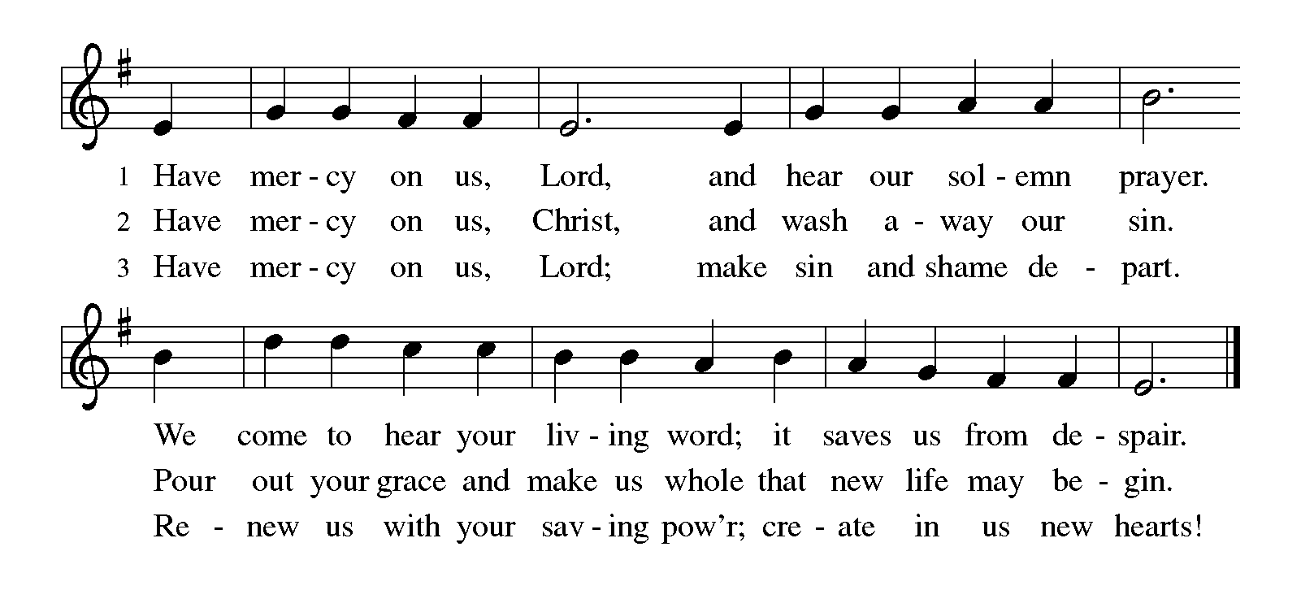KYRIE ELW p. 203

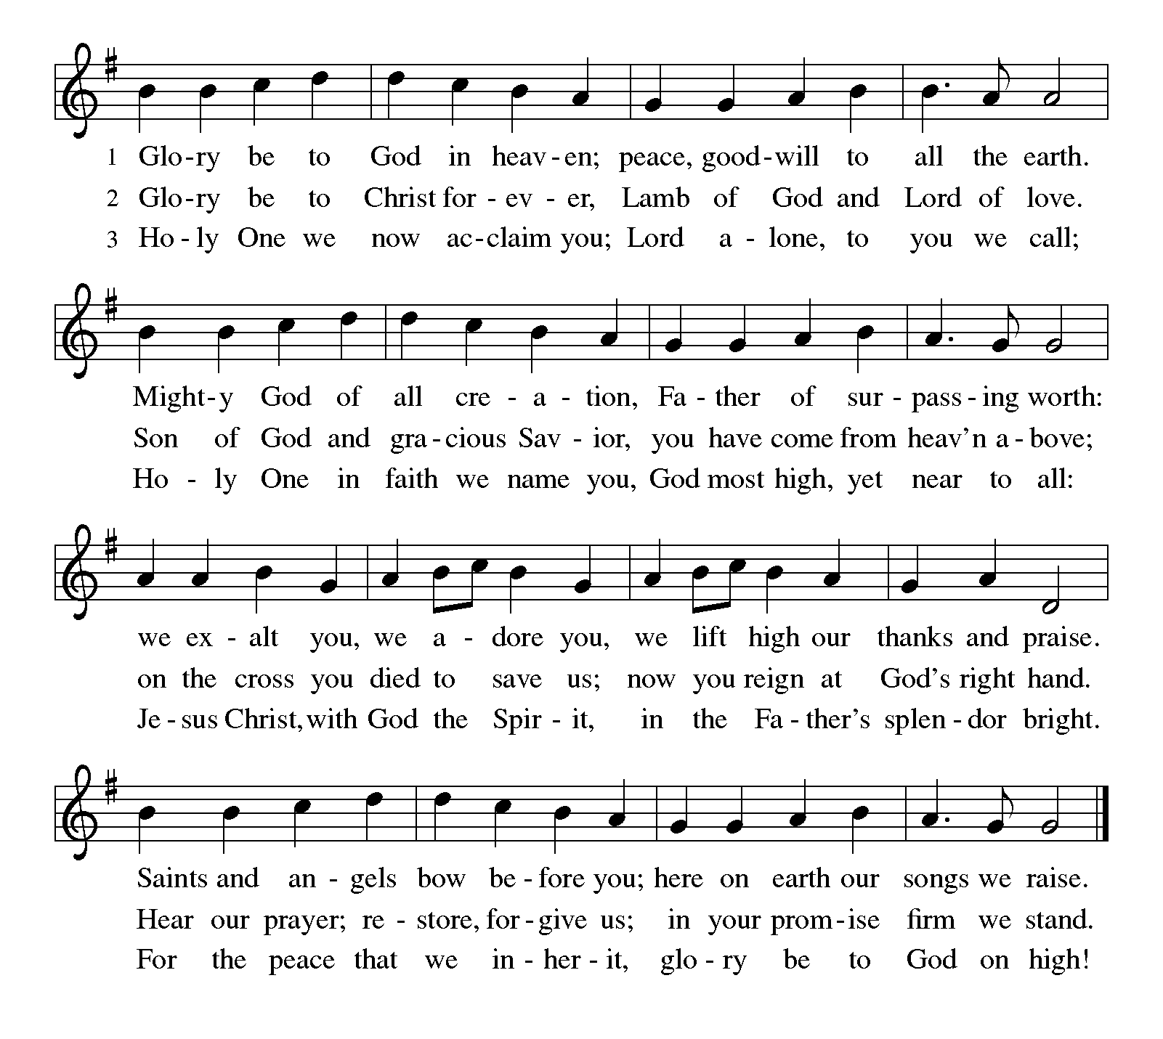CANTICLE OF PRAISE Glory Be to God ELW p. 204

PRAYER OF THE DAY

P: O God, we thank you for your Son, who chose the path of suffering for the sake of the world. Humble us by his example, point us to the path of obedience, and give us strength to follow your commands, through Jesus Christ, our Savior and Lord.

C: Amen.

Word

God speaks to us in scripture reading, preaching, and song.

FIRST READING Jeremiah 15:15-21

Jeremiah’s delight in the word of the Lord is contradicted by the heaviness of God’s hand upon him and God’s seeming unfaithfulness. God’s tough love to Jeremiah says that if he repents, he will be allowed to continue in his strenuous ministry. Jeremiah is strengthened by the simple words, “I am with you.”

¹⁵O Lord, you know; remember me and visit me, and bring down retribution for me on my persecutors. In your forbearance do not take me away; know that on your account I suffer insult.
¹⁶Your words were found, and I ate them, and your words became to me a joy and the delight of my heart; for I am called by your name, O Lord, God of hosts.
¹⁷I did not sit in the company of merrymakers, nor did I rejoice; under the weight of your hand I sat alone, for you had filled me with indignation.
¹⁸Why is my pain unceasing, my wound incurable, refusing to be healed? Truly, you are to me like a deceitful brook, like waters that fail.
¹⁹Therefore thus says the Lord: If you turn back, I will take you back, and you shall stand before me. If you utter what is precious, and not what is worthless, you shall serve as my mouth. It is they who will turn to you, not you who will turn to them.
²⁰And I will make you to this people a fortified wall of bronze; they will fight against you, but they shall not prevail over you, for I am with you to save you and deliver you, says the Lord.
²¹I will deliver you out of the hand of the wicked, and redeem you from the grasp of the ruthless.

A: The word of the Lord.

C: Thanks be to God.

SECOND READING Romans 12:9-21

Paul presents benchmarks for faithful relationships with Christians and non-Christians: Love is the unflagging standard of our behavior. When we encounter evil, we do not resort to its tactics but seek to overcome it with good. While Christians cannot control the actions and attitudes of others, we seek to live at peace with all people.

Continued on the next page.

⁹Let love be genuine; hate what is evil, hold fast to what is good; ¹⁰love one another with mutual affection; outdo one another in showing honor. ¹¹Do not lag in zeal, be ardent in spirit, serve the Lord. ¹²Rejoice in hope, be patient in suffering, persevere in prayer. ¹³Contribute to the needs of the saints; extend hospitality to strangers.
¹⁴Bless those who persecute you; bless and do not curse them. ¹⁵Rejoice with those who rejoice, weep with those who weep. ¹⁶Live in harmony with one another; do not be haughty, but associate with the lowly; do not claim to be wiser than you are. ¹⁷Do not repay anyone evil for evil, but take thought for what is noble in the sight of all. ¹⁸If it is possible, so far as it depends on you, live peaceably with all. ¹⁹Beloved, never avenge yourselves, but leave room for the wrath of God; for it is written, “Vengeance is mine, I will repay, says the Lord.” ²⁰No, “if your enemies are hungry, feed them; if they are thirsty, give them something to drink; for by doing this you will heap burning coals on their heads.” ²¹Do not be overcome by evil, but overcome evil with good.

A: The word of the Lord.

C: Thanks be to God.

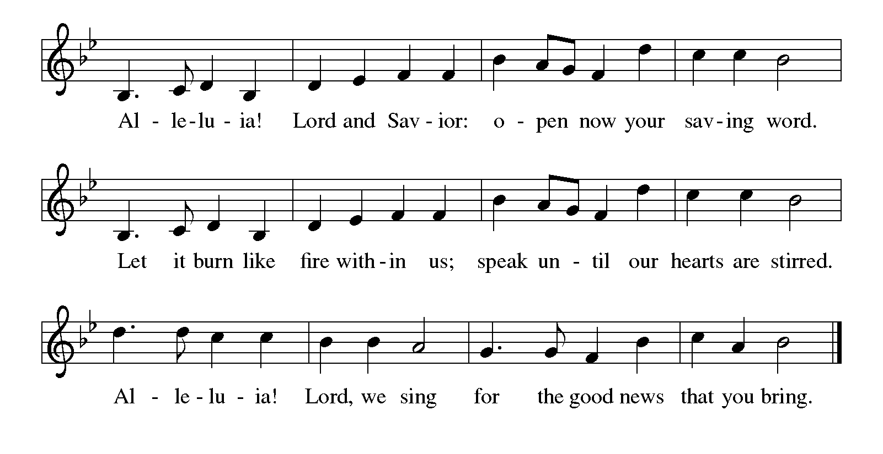GOSPEL ACCLAMATION Alleluia ELW p. 205

GOSPEL Matthew 16:21-28

P: Announcement of the Gospel.

C: Glory to you, O Lord.

After Peter confesses that Jesus is “the Messiah, the Son of the living God” (16:16), Jesus reveals the ultimate purpose of his ministry. These words prove hard to accept, even for a disciple whom Jesus has called a “rock”.

²¹From that time on, [after Peter confessed that Jesus was the Messiah,] Jesus began to show his disciples that he must go to Jerusalem and undergo great suffering at the hands of the elders and chief priests and scribes, and be killed, and on the third day be raised. ²²And Peter took him aside and began to rebuke him, saying, “God forbid it, Lord! This must never happen to you.” ²³But he turned and said to Peter, “Get behind me, Satan! You are a stumbling block to me; for you are setting your mind not on divine things but on human things.”
²⁴Then Jesus told his disciples, “If any want to become my followers, let them deny themselves and take up their cross and follow me. ²⁵For those who want to save their life will lose it, and those who lose their life for my sake will find it. ²⁶For what will it profit them if they gain the whole world but forfeit their life? Or what will they give in return for their life?
²⁷“For the Son of Man is to come with his angels in the glory of his Father, and then he will repay everyone for what has been done. ²⁸Truly I tell you, there are some standing here who will not taste death before they see the Son of Man coming in his kingdom.”

P: Affirmation of the Gospel.

C: Praise to you, O Christ.

SERMON

HYMN OF THE DAY Will You Come and Follow Me ELW # 798

Stanzas 1, 2, 3 and 4

PRAYERS OF INTERCESSION

Each petition ends with these words and response:

P: Merciful God,

C: receive our prayer.

Continued on the next page.

Concluding petition and response:

P: Remember us according to your steadfast love as we offer these and the prayers of our hearts, trusting in your compassion made known through Jesus Christ.

C: Amen.

Meal

God feeds us with the presence of Jesus Christ.

OFFERING AND MUSIC

OFFERING SONG Son of God, Eternal Savior ELW # 655

Stanzas 1, 2 and 3

OFFERING PRAYER

P: God of power, God of plenty, all things belong to you. We bring your gifts to the table, that all might be fed. Form us into the body of your Beloved, Jesus Christ, our Savior.

C: Amen.

Dialogue ELW p. 206

P: The Lord be with you.

C: And also with you.

P: Lift up your hearts.

C: We lift them to the Lord.

P: Let us give thanks to the Lord our God.

C: It is right to give our thanks and praise.

PREFACE

P: It is indeed right, our duty and our joy, that we should at all times and in all places give thanks and praise to you, almighty and merciful God, through our Savior Jesus Christ; who on this day overcame death and the grave, and by his glorious resurrection opened to us the way of everlasting life. And so, with all the choirs of angels, with the church on earth and the hosts of heaven, we praise your name and join their unending hymn:

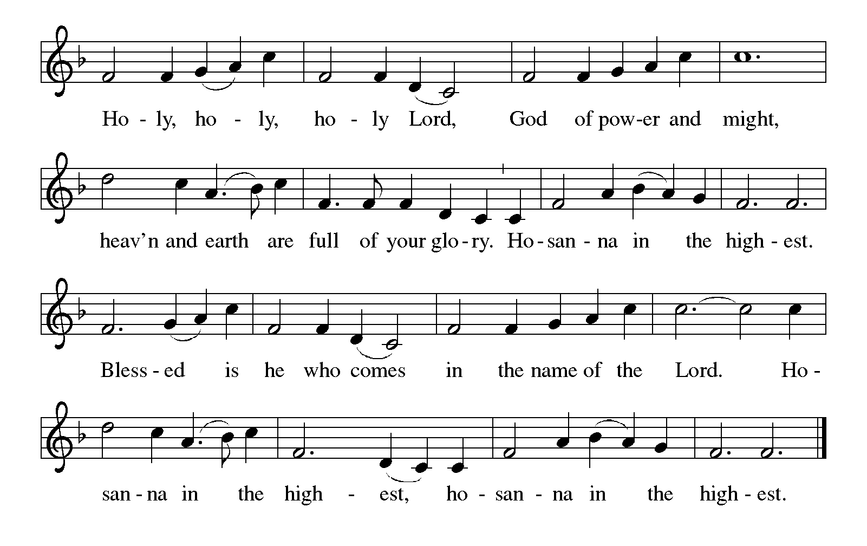HOLY, HOLY, HOLY (the angels’ song) ELW p. 207

THANKSGIVING AT THE TABLE

P: Holy, mighty, and merciful Lord, heaven and earth are full of your glory. In great love you sent to us Jesus, your Son, who reached out to heal the sick and suffering, who preached good news to the poor, and who, on the cross, opened his arms to all.

In the night in which he was betrayed, our Lord Jesus took bread, and gave thanks; broke it, and gave it to his disciples, saying: Take and eat; this is my body, given for you. Do this for the remembrance of me.

Again, after supper, he took the cup, gave thanks, and gave it for all to drink, saying: This cup is the new covenant in my blood, shed for you and for all people for the forgiveness of sin. Do this for the remembrance of me.

Remembering, therefore, his death, resurrection, and ascension,
we await his coming in glory.

Continued on the next page.

P: Pour out upon us the Spirit of your love, O Lord, and unite the wills of all who share this heavenly food, the body and blood of Jesus Christ, our Lord; to whom, with you and the Holy Spirit, be all honor and glory, now and forever.

C: Amen.

LORD'S PRAYER Traditional Wording ELW p. 208

P: Gathered into one by the Holy Spirit, let us pray as Jesus taught us.

All: Our Father, who art in heaven, hallowed be thy name, thy kingdom come, thy will be done, on earth as it is in heaven. Give us this day our daily bread; and forgive us our trespasses, as we forgive those who trespass against us; and lead us not into temptation, but deliver us from evil. For thine is the kingdom, and the power, and the glory, forever and ever. Amen.

INVITATION TO COMMUNION

P: Jesus invites you to this table. Come, eat and live.

COMMUNION

What We Believe

Who May Receive. We welcome all baptized Christians to the Lord's Table. In our parish baptized children who have entered the 5th grade are instructed in this sacrament and receive their First Communion; younger children come to the altar and receive a blessing. If your baptized child has received such instruction, or if you want your baptized child to receive Communion, then he or she is welcome to partake.

Proper Preparation. In his Small Catechism, Martin Luther asks, "When is a person rightly prepared to receive this sacrament?" He answers, "Fasting and other outward preparations serve a good purpose. However, that person is well prepared and worthy who believes these words, given and shed for you for the remission of sins. But anyone who does not believe these words, or doubts them, is neither prepared nor worthy, for the words for you require simply a believing heart.”

Real Presence. We believe that the bread and wine truly are the body and blood of Christ given and shed for the forgiveness of sins.

Distribution

Holy Communion will be served in procession, one side of the sanctuary at a time; please keep some distance from the person in front of you. The ushers will direct

Continued on the next page.
you when to make your way to the front of the church using the center aisle. You will receive the elements near the chancel. Please extend your hands, palms up, if you will be receiving the bread. Gluten-free wafers are also available; please ask for one. Proceed to your right or to your left depending on which side of the sanctuary you are seated on to receive the wine. White grape juice is also available in the center ring of each tray for those who prefer an alcohol-free element. You may say “Amen” after receiving each element. If you will not be receiving Communion, keep your hands folded for a blessing. Place your empty cup in the basket and then return to your seat by the side aisle.

Music During Distribution of Communion Sherry Hareldson

PRAYER AFTER COMMUNION

P: Blessed be your name, O God, for we have feasted on your Word, Christ Jesus, the joy and delight of our hearts. Strengthened by this food, send us to gather the world to your banquet, where none are left out and all are satisfied. In Jesus’s name we pray.

C: Amen.

Sending

God blesses us and sends us in mission to the world.

ANNOUNCEMENTS

BENEDICTION

P: The God of glory, ☩ Jesus Christ, name above all names, and the Spirit who lives in you, bless you now and forever.

C: Amen.

DEPARTING HYMN Bind Us Together TOSB # 14

DISMISSAL

P: Go in peace. God is at work in you.

C: Thanks be to God.

POSTLUDE

Today’s Assistants and Ministers

Greeters & Ushers ………………………………………….…....………… Tom & Julie Tienter
Organist -Pianist ……….…..……………….......….…….…..………….…… Sherry Hareldson
Presiding Minister …………………….....….......................…………… Pastor Kerry Eversole
Altar Care & Communion Preparation ………………….…….………….. Tom & Julie Tienter
Custodians ………………………….….…….………...….…..…….. Dave & Geri Ann Hanson

This Week in Our Congregation

Today, September 3 — Fourteenth Sunday after Pentecost

Coffee fellowship in the narthex or downstairs in the dining room following worship
NO Getting Ready to Affirm Session today

Tuesday, September 5

Men’s breakfast at Home Sweet Home in Lanesboro 7:00 AM

Wednesday, September 6

Pastor Kerry at Getting Ready to Affirm Session at Bethlehem 7:00 PM

Next Sunday, September 10 — Fifteenth Sunday after Pentecost

Worship 9:00 AM
Getting Ready to Affirm Session 10:15 AM
7th- & 8th Grade Confirmation session 10:15 AM
Church Council meeting after worship

News and Notes

Make summertime giving a breeze with recurring gifts! Many of you support our congregation with your time, talents, and financial contributions throughout the year. But since many of you travel or spend time visiting family and friends during the summer, it can be hard to keep up with your giving. That’s why we encourage you to set up recurring gifts.
It takes just moments to do. Visit our website at https://fountainlutheranchurch.com/ and find our online giving in the blue text box titled “Click here to contribute to Fountain Lutheran!” Thank you for your continued support of our ministry and mission!

2023 Southeastern Minnesota Women of the ELCA Convention, Saturday, September 30 at First Lutheran Church, Red Wing. Registration $25. Registration deadline: September 15. Contact Kathy Bolin 507.292.0277, bolin1948@gmail.com, or Sharon Northouse 507.471.4796, borniniowa@gmail.com.

Community Activities

Community Christian Cantata this fall. Julie Kiehne from our sister congregation, Bethlehem Lutheran, is coordinating a Christian Cantata called “He Lived the Good Life.” It’s the story of Jesus’ life with a 70s vibe! This is not a traditional SATB-type cantata. Songs are 2-part, unison, with repetitive choruses that can be intergenerational with young

Continued on the back side.
voices too. All singers and all levels are welcome! This promises to be a fun time celebrating our community and sharing the Advent story! Please come and join the community choir! Rehearsals will be Wednesdays from 5:30 to 6:30 pm, October 4 thru November 8 at Bethlehem Lutheran Church, Lanesboro. Full run-through Wednesday, November 15, from 5:00 to 6:30 pm at the Sons of Norway Hall. Performances will be Saturday, November 18 at 7:00 pm at Bethlehem Lutheran and Sunday, November 19, at 2:00 pm at the Sons of Norway Hall. Reply to julie.kiehne@gmail.com if you would like to join the community choir or play an instrument. We have commitments from instrumentalists including piano, flute(s), drums, and percussion. I’m still looking for an electric guitarist and/or bass player. I have print music and audio mp3 files which I can share any time between now and when rehearsals start. Questions? Contact Julie Kiehne at 507-272-4581.

Mark your calendar! Saturday, December 2, from 9:00 am to 2:00 pm, Craft & Bake Sale at Christ Lutheran Church, Preston. Featuring the Gnome Café with treats, coffee, cider, and hot chocolate. Free samples of rommegrot. Shop local for Norwegian baked goods, breads, cookies, candies, and rolls! Find unique woodworking, quilts, toys, gift baskets, jewelry, greeting cards, artwork, and more. Proceeds will help CLC missions such as RIP Medical Debt, Preston Food Shelf, and Growing Hope Globally.

Prayer Requests

In Our Community. For our church members and friends living with chronic illness and other diseases, who are homebound, residing in care facilities, and hospitalized. See the newsletter for our members living in area nursing homes. And let us not forget those sick and dying of COVID-19, those entrusted with the authority of government, justice, and law enforcement, as well as our fallen and wounded soldiers and those still serving.

In Our Synod. Bishop Regina Hassanally invites the people and congregations of our Southeastern Minnesota Synod to make a commitment to pray this week for the following faith communities: Red Oak Grove Lutheran Church, Austin; Whalan Lutheran Church, Lanesboro; Epiphany Lutheran Church, Eagle Lake; Nuru Itaja Lutheran Church, Tanzania; Iambi Lutheran Church, Tanzania; Banytic Lutheran Parish, South Sudan; and Mission of San Juan, Bucaramanga, Colombia.

Acknowledgments

Graphics, worship texts, service music, readings, and PowerPoint® Slides are from sundaysandseasons.com © 2023 Augsburg Fortress. Used by permission under Augsburg Fortress Liturgies Annual License SAS005401.

Permission to project liturgy and music content under copyright to or administered by Augsburg Fortress provided under Augsburg Fortress Liturgies Annual License SAS005401.

