Fountain Lutheran Church

Established 1904

Rev. Kerry B. Eversole, Pastor
Deacon Cindy Cordes-Eversole, Associate in Ministry

Mailing Address: P.O. Box 75, Fountain, MN 55935
Physical Address: 314 Main Street, Fountain, Minn.

Church Office Phone: 507.268.4413
E-mail Address: flc@mediacombb.net
Website: www.fountainlutheranchurch.com
Facebook Page: www.facebook.com/FountainLutheranChurch/

Parsonage Phone: 507.467.3017

Pastor Kerry’s Cell Phone: 507.951.3954

Our Global Partner Congregation: Issuna Lutheran Church, Tanzania
Fountain Lutheran Church
Fountain, Minnesota

Third Sunday after Pentecost
Father’s Day

June 18, 2023

When [Jesus] saw the crowds, he had compassion for them, because they were harassed and helpless, like sheep without a shepherd. Then he said to his disciples, “The harvest is plentiful, but the laborers are few; therefore ask the Lord of the harvest to send out laborers into his harvest.”
Matthew 9:36-38
Welcome to worship at Fountain Lutheran
and our celebration of the Time of the Church.
Jesus is our fountain of Living Water and Light! Psalm 36:9

COVID-19 Practices — Out of love for God and Neighbor

1) Use hand sanitizer upon entry. Wash your hands and use hand sanitizer often while in the facility.
2) Members and visitors who are vaccinated and boosted are not required to wear a mask.
3) Members and visitors are free to wear a mask if they wish to do so.
4) Unvaccinated and not boosted members and visitors must wear a mask.
5) There are no physical distancing requirements, but you are welcome to keep a distance from others in the sanctuary as you are able.
6) All are welcome to enjoy coffee fellowship in the narthex or dining room downstairs following worship.

Worship Book and Hymns. This morning’s service is printed in the bulletin. All the hymns can be found in Evangelical Lutheran Worship (ELW), “the red book” in the pews. Hymns in ELW are indicated by a large bold number in the left or right margin of each page.

Abbreviations. Throughout this worship folder, hymns are signified by the pound symbol (#), P: refers to the presiding minister or preacher, A: denotes an assisting minister, and C: and/or bold text indicates the congregation.

Offering. Later in our service, we will be receiving an offering. The offering is an opportunity to worship God with our money. We know that the money you give to Fountain Lutheran Church represents your lives — your time, talents, and hard work. We recognize that and we appreciate your generosity. Your support not only helps all of us to fulfill God’s call on our lives, but it also makes an impact, and we thank you! Lastly, our visitors are not expected to give. After all, you are our guests! We’re glad you’re here and we want you to feel welcome!

Mistakes do not happen in our worship service;
only unexpected events which are opportunities for joy!

An signifies that you may stand as you are comfortably able.

Introduction to the Day. Moses tells the Israelites that they are called to be a priestly kingdom and a holy people. Jesus sends out the disciples as laborers into the harvest. In baptism we too are anointed for ministry, sharing God’s compassion with our needy world. From the Lord’s table, we go forth to proclaim the good news, to heal the sick, and to share our bread with the hungry.
Gathering

The Holy Spirit calls us together as the people of God.

PRELUDE

RINGING OF THE BELL, WELCOME AND INTRODUCTION TO THE DAY

CALL TO WORSHIP Psalm 100 Spoken Responsively

Make a joyful noise to the Lord, all the earth.

Serve the Lord with gladness; come into his presence with singing.

Know that the Lord is God.

It is he who made us, and we are his; we are his people and the sheep of his pasture.

Enter his gates with thanksgiving and his courts with praise.

Give thanks to him; bless his name.

For the Lord is good; his steadfast love endures forever

and his faithfulness to all generations.

OPENING HYMN Open Now Thy Gates of Beauty ELW # 533

Stanzas 1, 2, 3, 4 and 5

GREETING ELW p. 203

P: The grace of our Lord Jesus Christ, the love of God, and the communion of the Holy Spirit be with you all.

C: And also with you.

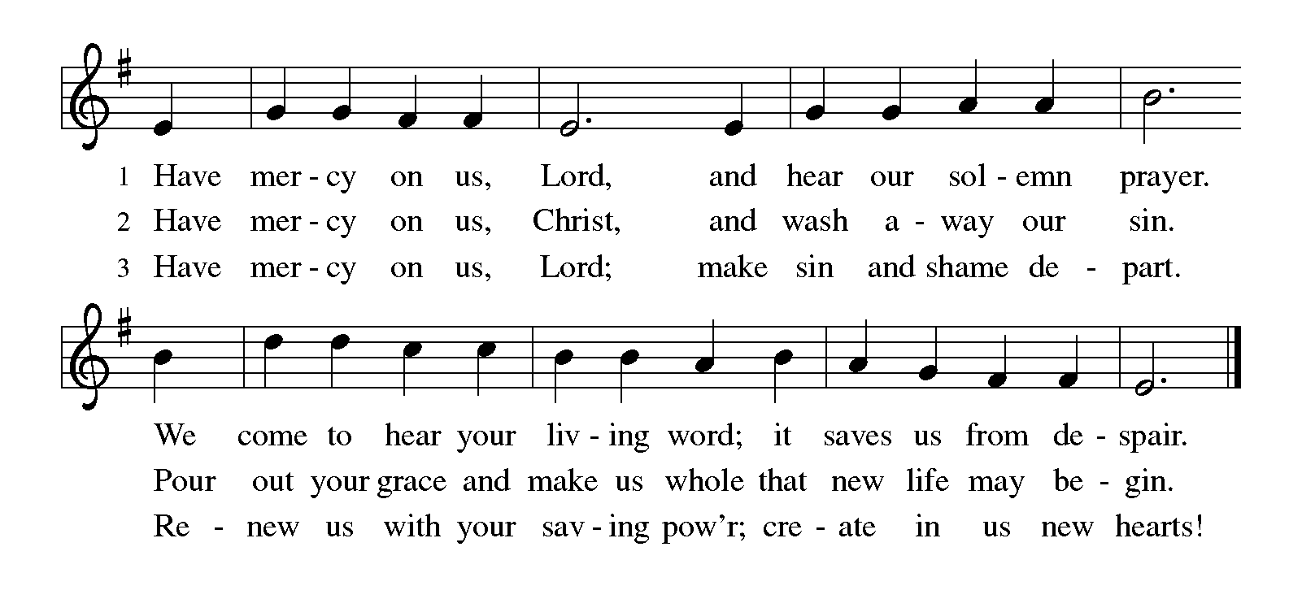
KYRIE ELW p. 203

Continued on the next page.

Return to the previous page.

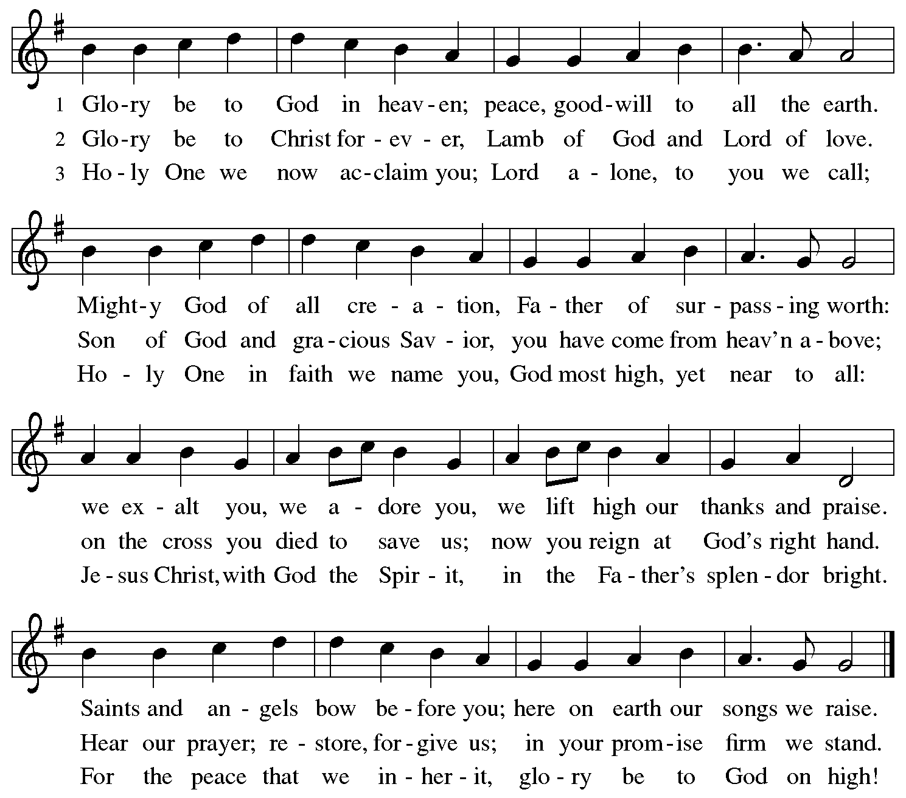
CANTICLE OF PRAISE Glory Be to God ELW p. 204

PRAYER OF THE DAY

P: God of compassion, you have opened the way for us and brought us to yourself. Pour your love into our hearts, that, overflowing with joy, we may freely share the blessings of your realm and faithfully proclaim the good news of your Son, Jesus Christ, our Savior and Lord.

C Amen.

Word

God speaks to us in scripture reading, preaching, and song.

FIRST READING Exodus 19:2-8a

At Sinai God assured Israel, “You shall be my treasured possession” and commissioned them to serve as mediating priests for the nations. The people commit themselves completely to God’s will.

²[The Israelites] had journeyed from Rephidim, entered the wilderness of Sinai, and camped in the wilderness; Israel camped there in front of the mountain. ³Then Moses went up to God; the Lord called to him from the mountain, saying, “Thus you shall say to the house of Jacob, and tell the Israelites: ⁴You have seen what I did to the Egyptians, and how I bore you on eagles’ wings and brought you to myself. ⁵Now therefore, if you obey my voice and keep my covenant, you shall be my treasured possession out of all the peoples. Indeed, the whole earth is mine, ⁶but you shall be for me a priestly kingdom and a holy nation. These are the words that you shall speak to the Israelites.”
⁷So Moses came, summoned the elders of the people, and set before them all these words that the Lord had commanded him. ^{8a}The people all answered as one: “Everything that the Lord has spoken we will do.”

A: The word of the Lord.

C: Thanks be to God.

GOSPEL ACCLAMATION Alleluia ELW p. 205

Printed on the next page.

GOSPEL Matthew 9:35—10:8

P: Announcement of the Gospel.

C: Glory to you, O Lord.

The mission of Jesus’s followers is to continue the mission of Jesus himself. Here, he instructs his first disciples as to how they might proclaim the gospel through their words and deeds.

³⁵Jesus went about all the cities and villages, teaching in their synagogues, and proclaiming the good news of the kingdom, and curing every disease and every sickness. ³⁶When he saw the crowds, he had compassion for them, because they were harassed and helpless, like sheep without a shepherd. ³⁷Then he said to his disciples, “The harvest is plentiful, but the laborers are few; ³⁸therefore ask the Lord of the harvest to send out laborers into his harvest.”
^{10:1}Then Jesus summoned his twelve disciples and gave them authority over unclean spirits, to cast them out, and to cure every disease and every sickness. ²These are the names of the twelve apostles: first, Simon, also known as Peter, and his brother Andrew; James son of Zebedee, and his brother John; ³Philip and Bartholomew; Thomas and Matthew the tax collector; James son of Alphaeus, and Thaddaeus; ⁴Simon the Cananaean, and Judas Iscariot, the one who betrayed him.
⁵These twelve Jesus sent out with the following instructions: “Go nowhere

Continued on the next page.
among the Gentiles, and enter no town of the Samaritans, ⁶but go rather to the lost sheep of the house of Israel. ⁷As you go, proclaim the good news, ‘The kingdom of heaven has come near.’ ⁸Cure the sick, raise the dead, cleanse the lepers, cast out demons. You received without payment; give without payment.

P: Affirmation of the Gospel.

C: Praise to you, O Christ.

SERMON

HYMN OF THE DAY We All Are One in Mission ELW # 576

Stanzas 1, 2 and 3

BLESSING OF FATHERS

A HYMN FOR FATHERS For the Beauty of the Earth ELW # 879

Stanzas 1, 4 and 5

PRAYERS OF INTERCESSION

Each prayer ends with these words and response:

P: God, in your mercy,

C: hear our prayer.

Concluding prayer and response:

P: Receive our prayers and answer us, O God, in the name of Jesus Christ.

C: Amen.

Meal

God feeds us with the presence of Jesus Christ.

OFFERING AND MUSIC

OFFERING SONG Lord, Speak to Us that We May Speak ELW # 676

Stanzas 1, 2, 3 and 4

OFFERING PRAYER

Printed on the next page.

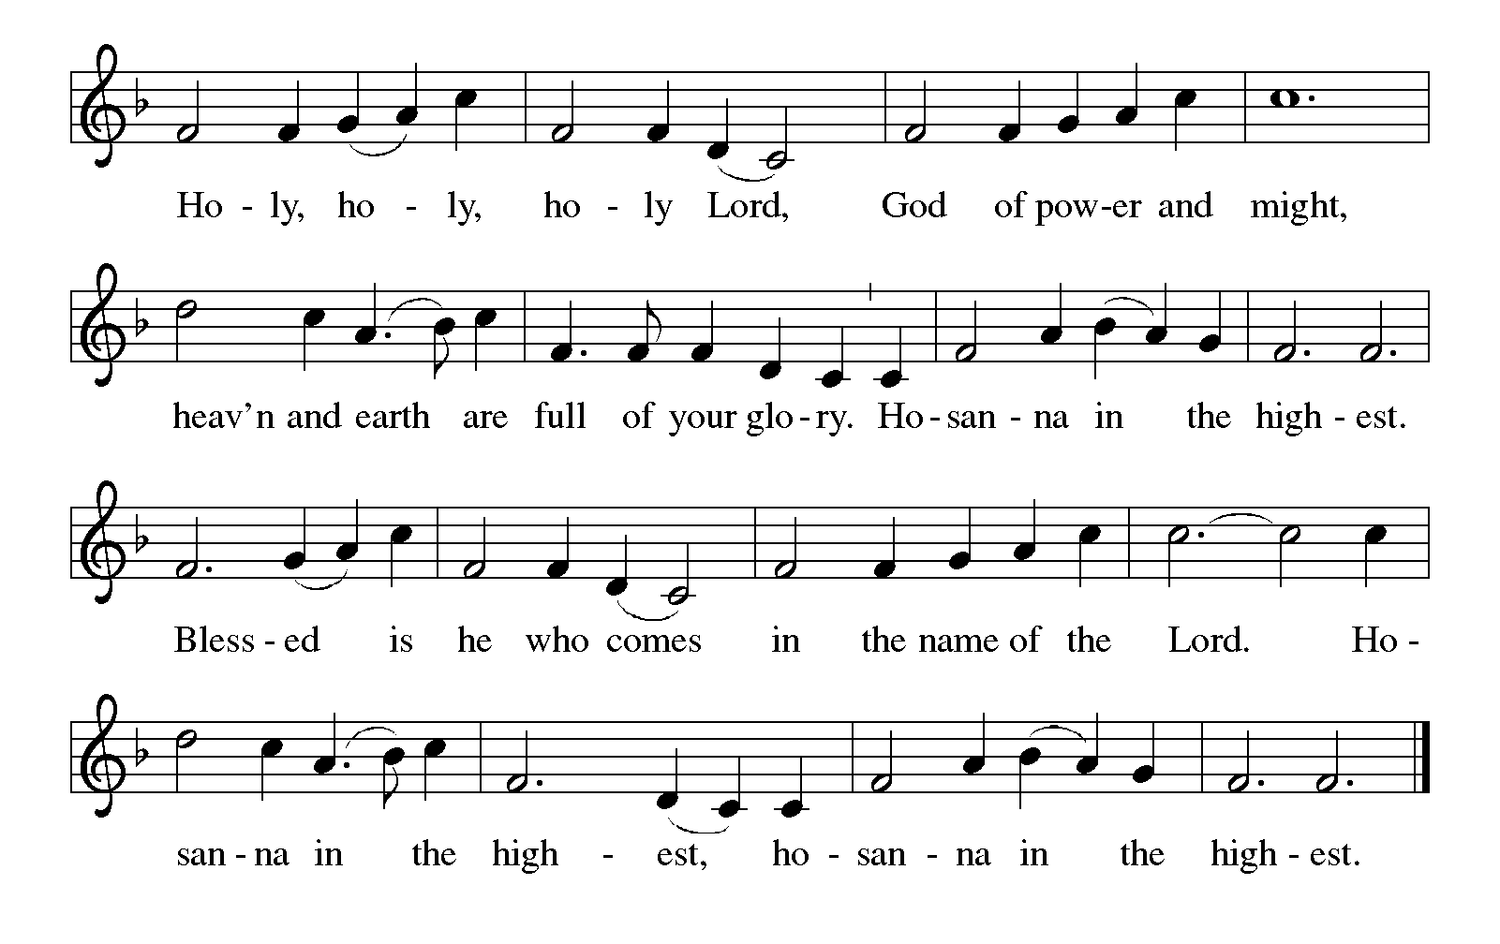
P: God of field and forest, sea and sky, you are the giver of all good things. Sustain us with these gifts of your creation, and multiply your graciousness in us, that the world may be fed with your love, through Jesus Christ, our Savior and Lord.

C: Amen.

GREAT THANKSGIVING

Dialogue ELW p. 206

P: The Lord be with you.

C: And also with you.

P: Lift up your hearts.

C: We lift them to the Lord.

P: Let us give thanks to the Lord our God.

C: It is right to give our thanks and praise.

Preface

P: It is indeed right, our duty and our joy, that we should at all times and in all places give thanks and praise to you, almighty and merciful God, through our Savior Jesus Christ; who on this day overcame death and the grave, and by his glorious resurrection opened to us the way of everlasting life. And so, with all the choirs of angels, with the church on earth and the hosts of heaven, we praise your name and join their unending hymn:

Holy, Holy, Holy (the angels’ song) ELW p. 207

Continued on the next page.

Thanksgiving at The Table

P: Holy, mighty, and merciful Lord, heaven and earth are full of your glory. In great love you sent to us Jesus, your Son, who reached out to heal the sick and suffering, who preached good news to the poor, and who, on the cross, opened his arms to all.

In the night in which he was betrayed, our Lord Jesus took bread, and gave thanks; broke it, and gave it to his disciples, saying: Take and eat; this is my body, given for you. Do this for the remembrance of me.

Again, after supper, he took the cup, gave thanks, and gave it for all to drink, saying: This cup is the new covenant in my blood, shed for you and for all people for the forgiveness of sin. Do this for the remembrance of me.

Remembering, therefore, his death, resurrection, and ascension,
we await his coming in glory.

Pour out upon us the Spirit of your love, O Lord,
and unite the wills of all who share this heavenly food,
the body and blood of Jesus Christ, our Lord;
to whom, with you and the Holy Spirit,
be all honor and glory, now and forever.

C: Amen.

Lord’s Prayer ELW p. 208 Traditional Wording

P: Gathered into one by the Holy Spirit, let us pray as Jesus taught us.

Continued on the next page.

All: Our Father, who art in heaven, hallowed be thy name, thy kingdom come, thy will be done, on earth as it is in heaven. Give us this day our daily bread; and forgive us our trespasses, as we forgive those who trespass against us; and lead us not into temptation, but deliver us from evil. For thine is the kingdom, and the power, and the glory, forever and ever. Amen.

Invitation to Communion

P: All people are called to Christ’s table. Come, eat what is good.

COMMUNION

What We Believe

Who May Receive. We welcome all baptized Christians to the Lord's Table. In our parish baptized children who have entered the 5th grade are instructed in this sacrament and receive their First Communion; younger children come to the altar and receive a blessing. If your baptized child has received such instruction, or if you want your baptized child to receive Communion, then he or she is welcome to partake.

Proper Preparation. In his Small Catechism, Martin Luther asks, “When is a person rightly prepared to receive this sacrament?” He answers, “Fasting and other outward preparations serve a good purpose. However, that person is well prepared and worthy who believes these words, given and shed for you for the remission of sins. But anyone who does not believe these words, or doubts them, is neither prepared nor worthy, for the words for you require simply a believing heart.”

Real Presence. We believe that the bread and wine truly are the body and blood of Christ given and shed for the forgiveness of sins.

Distribution

Holy Communion will be served in procession on one side of the sanctuary at a time. Keep some distance from the person in front of you. The ushers will direct you when to make your way to the front of the church using the center aisle. You will receive the elements near the chancel. Please extend your hands, palms up, if you will be receiving the bread. Gluten-free wafers are also available; please ask for one. Proceed to your right or to your left to receive the wine. White grape juice is also available in the center ring of each tray for those who prefer an alcohol-free element. You may say “Amen” after receiving each element. If you will not be receiving Communion, keep your hands folded. Place your empty cup in the basket and then return to your seat by the side aisle.

Music During Distribution of Communion Sherry Hareldson

PRAYER AFTER COMMUNION

P: We thank you, generous God, for the refreshment we have received at your banquet table. Send us now to spread your generosity into all the world, through the one who is our dearest treasure, Jesus Christ, our Savior and Lord.

C: Amen.

Sending

God blesses us and sends us in mission to the world.

ANNOUNCEMENTS

BLESSING

P: The God who calls across the cosmos and speaks in the smallest seed ☩ bless, keep, and sustain you now and to the end of the age.

C: Amen.

DEPARTING HYMN I Love to Tell the Story ELW # 661

Stanzas 1, 2 and 3

DISMISSAL

P: Go in peace. Share the harvest.

C: Thanks be to God.

POSTLUDE

Commemoration

Saturday, June 17

Emanuel Nine, martyrs, died 2015

On June 17, 2015, Clementa C. Pinckney, Cynthia Marie Graham Hurd, Susie Jackson, Ethel Lee Lance, DePayne Middleton-Doctor, Tywanza Sanders, Daniel Lee Simmons, Sharonda Coleman-Singleton, and Myra Thompson were murdered by a self-professed white supremacist while they were gathered for Bible study and prayer at the Emanuel African Methodist Episcopal Church (often referred to as Mother Emanuel) in Charleston, South Carolina. Pastors Pinckney and Simmons were both graduates of the Lutheran Theological Southern Seminary. A resolution to commemorate June 17 as a day of repentance for the martyrdom of the Emanuel Nine was adopted by the Churchwide Assembly of the Evangelical Lutheran Church in America on August 8, 2019. Congregations of the ELCA are encouraged to reaffirm their commitment to repenting of the sins of racism and white supremacy which continue to plague this church, to venerate the martyrdom of the Emanuel Nine, and to mark this day of penitence with study and prayer.

Today’s Assistants and Ministers

Greeters & Ushers …………………………….….……….....………… Jason & Mary Schwarz
Organist/Pianist ……………………..……………...…….…..………….…… Sherry Hareldson
Presiding Minister ……………………...….….....…………… Deacon Cindy Cordes-Eversole
Altar Care & Communion Preparation ……...…………….. Sharon Miller and Mary Schwarz
Custodians ………………………….….…….………...….…..…….. Dave & Geri Ann Hanson

This Week in Our Congregation

Today, June 18 — Third Sunday after Pentecost — Father’s Day

Coffee fellowship in the narthex or downstairs in the dining room following worship

Tuesday, June 20

Men’s breakfast at Home Sweet Home in Lanesboro 7:00 AM

Thursday, June 22

Pastor Kerry at Park Lane Estates, Preston, for Bible study/chapel 9:30 AM
Deacon Cindy at Good Shepherd Lutheran Home, Rushford, for chapel 1:30 PM

Next Sunday, June 25 — Fourth Sunday after Pentecost

Worship 9:00 AM
Special Congregational Meeting 10:15 AM

Continued on the other side.

News and Notes

Notice of Special Congregational Meeting. In accordance with the constitution and bylaws of Fountain Lutheran Church of Fountain, Minnesota, official notice is hereby given of a special meeting of the congregation next Sunday, June 25, 2023, immediately following the 9:00 a.m. worship service. The sole purpose of this meeting is to talk about the Parsonage and to make an informed decision on whether Fountain Lutheran Church continues to rent the house out or sell the property. The Council will present information on the condition and repairs recently made to the parsonage. Please plan to attend worship on Sunday, June 25, and this special congregational meeting. According to our constitution, at least 15 people need to be in attendance to conduct this meeting.

Make summertime giving a breeze with recurring gifts! Many of you support our congregation with your time, talents, and financial contributions throughout the year. But since many of you travel or spend time visiting family and friends during the summer, it can be hard to keep up with weekly gifts. That’s why we encourage you to set up regular, recurring donations. It takes just moments to set up. Visit our website at https://fountainlutheranchurch.com/ and find our online giving in the blue text box titled “Click here to contribute to Fountain Lutheran!” Thank you for your continued support of our ministry and mission! Scan the QR Code to the right to visit our online giving page.

Prayer Requests

In Our Community. For our church members and friends living with chronic illness and other diseases, who are homebound, residing in care facilities, and hospitalized. See the newsletter for our members living in area nursing homes. And let us not forget those sick and dying of COVID-19, those entrusted with the authority of government, justice, and law enforcement, as well as our fallen and wounded soldiers and those still serving.

In Our Synod. Bishop Regina Hassanally invites the people and congregations of our Southeastern Minnesota Synod to make a commitment to pray this week for the following faith communities: Arendahl Lutheran Church, Peterson; Mount Olive Lutheran Church, Rochester; Our Savior’s Lutheran Church, Owatonna; Urughu Lutheran Church, Tanzania; Nduguti Lutheran Church, Tanzania; Ecovida and Food Security Ministry, Colombia; and Comuna Trece, Colombia.

Acknowledgments

Graphics, worship texts, service music, readings, and PowerPoint® Slides are from sundaysandseasons.com © 2023 Augsburg Fortress. Used by permission under Augsburg Fortress Liturgies Annual License SAS005401.

Permission to project liturgy and music content under copyright to or administered by Augsburg Fortress provided under Augsburg Fortress Liturgies Annual License SAS005401.

