Fountain Lutheran Church

Established 1904

Rev. Kerry B. Eversole, Pastor
Deacon Cindy Cordes-Eversole, Associate in Ministry

Mailing Address: P.O. Box 75, Fountain, MN 55935
Physical Address: 314 Main Street, Fountain, Minn.

Church Office Phone: 507.268.4413
E-mail Address: flc@mediacombb.net
Website: www.fountainlutheranchurch.com
Facebook Page: www.facebook.com/FountainLutheranChurch/

Parsonage Phone: 507.467.3017

Pastor Kerry’s Cell Phone: 507.951.3954

Our Global Partner Congregation: Issuna Lutheran Church, Tanzania
Fountain Lutheran Church
Fountain, Minnesota

Ninth Sunday after Pentecost

July 30, 2023

[Jesus] put before [the crowds] another parable: “The kingdom of heaven is like a mustard seed that someone took and sowed in his field; it is the smallest of all the seeds, but when it has grown it is the greatest of shrubs and becomes a tree, so that the birds of the air come and make nests in its branches.” Matthew 13:31-32
Welcome to worship at Fountain Lutheran
and our celebration of the Season after Pentecost,
the Time of the Church!

Jesus is our fountain of Living Water and Light! Psalm 36:9

COVID-19 Practices — Out of Love for God and Neighbor

1) Use hand sanitizer upon entry. Wash your hands and use hand sanitizer often while in the facility.
2) Members and visitors who are vaccinated and boosted are not required to wear a mask.
3) Members and visitors are free to wear a mask if they wish to do so.
4) Unvaccinated and not boosted members and visitors must wear a mask.
5) There are no physical distancing requirements, but you are welcome to keep a distance from others in the sanctuary as much as you are able.
6) All are welcome to enjoy coffee fellowship in the dining room following worship.

Worship Book and Hymns. This morning’s service is printed in the bulletin. All the hymns can be found in Evangelical Lutheran Worship (ELW), “the red book” in the pews. Hymns in ELW are indicated by a large bold number in the left or right margin of each page.

Abbreviations. Throughout this worship folder, hymns are signified by the pound symbol (#), P: refers to the presiding minister or preacher, A: denotes an assisting minister, and C: and/or bold text indicates the congregation.

Offering. Later in our service, we will be receiving an offering. The offering is an opportunity to worship God with our money. We know that the money you give to Bethlehem Lutheran Church represents your lives — your time, talents, and hard work. We recognize that and we appreciate your generosity. Your support not only helps all of us to fulfill God’s call on our lives, but it also makes an impact, and we thank you! Lastly, our visitors are not expected to give. After all, you are our guests! We’re glad you’re here and we want you to feel welcome!

Mistakes do not happen in our worship service;
only unexpected events which are opportunities for joy!

An signifies that you may stand as you are comfortably able.

Introduction to the Day. As Solomon prays for wisdom, we seek to more deeply know the treasures of faith. In today’s gospel Jesus offers everyday images that reveal to us the reign of God: a tree that becomes a sheltering home, yeast that penetrates and expands, a treasured pearl, a net that gains a great catch. Even as we seek the riches of God’s reign, the great surprise is that God’s grace finds us first!
Gathering

The Holy Spirit calls us together as the people of God.

MUSIC AS WE COME TOGETHER Trusting Jesus Jan Meyer
melody by I. Sankey, arr. by Mary McDonald

RINGING OF THE BELL, WELCOME AND INTRODUCTION TO THE DAY

OPENING SONG Gather Us In ELW # 532

CONFESSION AND FORGIVENESS ELW pp. 211-212

All may make the sign of the cross, the sign that is marked at baptism, as the presiding minister begins.

P: Blessed be the holy Trinity, ☩ one God, who forgives all our sins, whose mercy endures forever.

C: Amen.

P: Almighty God, to whom all hearts are open, all desires known, and from whom no secrets are hid: cleanse the thoughts of our hearts by the inspiration of your Holy Spirit, that we may perfectly love you and worthily magnify your holy name, through Jesus Christ our Lord.

C: Amen.

P: Let us confess our sin in the presence of God and of one another.

Silence is kept for reflection.

P: Most merciful God,

All: we confess that we are captive to sin and cannot free ourselves. We have sinned against you in thought, word, and deed, by what we have done and by what we have left undone. We have not loved you with our whole heart; we have not loved our neighbors as ourselves. For the sake of your Son, Jesus Christ, have mercy on us. Forgive us, renew us, and lead us, so that we may delight in your will and walk in your ways, to the glory of your holy name. Amen.

P: God, who is rich in mercy, loved us even when we were dead in sin, and made us alive together with Christ. By grace you have been saved. In the name of ☩ Jesus Christ, your sins are forgiven. Almighty God strengthen you with power through the Holy Spirit, that Christ may live in your hearts through faith.

C: Thanks be to God.
SONG OF PRAISE God of Grace and God of Glory ELW # 705

Stanzas 1, 3 and 4

GREETING

P: The grace of our Lord Jesus Christ, the love of God, and the communion of the Holy Spirit be with you all.

C: And also with you.

PRAYER OF THE DAY

P: Let us pray together. Beloved and sovereign God,

All: through the death and resurrection of your Son you bring us into your kingdom of justice and mercy. By your Spirit, give us your wisdom, that we may treasure the life that comes from Jesus Christ, our Savior and Lord. Amen.

Word

God speaks to us in scripture reading, preaching, and song.

SCRIPTURE SONG Holy Wisdom, Holy Word

Printed at the end of the bulletin.

FIRST READING 1 Kings 3:5-12

Because Solomon did not ask for long life, riches, or the defeat of his enemies, God gave him what he asked for: wisdom to govern the people well.

⁵At Gibeon the Lord appeared to Solomon in a dream by night; and God said, “Ask what I should give you.” ⁶And Solomon said, “You have shown great and steadfast love to your servant my father David, because he walked before you in faithfulness, in righteousness, and in uprightness of heart toward you; and you have kept for him this great and steadfast love, and have given him a son to sit on his throne today. ⁷And now, O Lord my God, you have made your servant king in place of my father David, although I am only a little child; I do not know how to go out or come in. ⁸And your servant is in the midst of the people whom you have chosen, a great people, so numerous they cannot be numbered or counted. ⁹Give your servant therefore an understanding mind to govern your people, able to discern between good and evil; for who can govern this your great people?”

Continued on the next page.
¹⁰It pleased the Lord that Solomon had asked this. ¹¹God said to him, “Because you have asked this, and have not asked for yourself long life or riches, or for the life of your enemies, but have asked for yourself understanding to discern what is right, ¹²I now do according to your word. Indeed I give you a wise and discerning mind; no one like you has been before you and no one like you shall arise after you.”

A: The word of the Lord.

C: Thanks be to God.

SECOND READING Romans 8:26-39

These words celebrate the depth of God’s actions for us. Through Christ’s death for us and the activity of the Spirit praying for us, we are fused to God’s love poured out in Jesus Christ. Nothing, not even death itself, is able to separate us from such incredible divine love.

²⁶The Spirit helps us in our weakness; for we do not know how to pray as we ought, but that very Spirit intercedes with sighs too deep for words. ²⁷And God, who searches the heart, knows what is the mind of the Spirit, because the Spirit intercedes for the saints according to the will of God.
²⁸We know that all things work together for good for those who love God, who are called according to his purpose. ²⁹For those whom he foreknew he also predestined to be conformed to the image of his Son, in order that he might be the firstborn within a large family. ³⁰And those whom he predestined he also called; and those whom he called he also justified; and those whom he justified he also glorified.
³¹What then are we to say about these things? If God is for us, who is against us? ³²He who did not withhold his own Son, but gave him up for all of us, will he not with him also give us everything else? ³³Who will bring any charge against God’s elect? It is God who justifies. ³⁴Who is to condemn? It is Christ Jesus, who died, yes, who was raised, who is at the right hand of God, who indeed intercedes for us. ³⁵Who will separate us from the love of Christ? Will hardship, or distress, or persecution, or famine, or nakedness, or peril, or sword? ³⁶As it is written,
“For your sake we are being killed all day long;
we are accounted as sheep to be slaughtered.”
³⁷No, in all these things we are more than conquerors through him who loved us. ³⁸For I am convinced that neither death, nor life, nor angels, nor rulers, nor things present, nor things to come, nor powers, ³⁹nor height, nor depth, nor

Continued on the next page.
anything else in all creation, will be able to separate us from the love of God in Christ Jesus our Lord.

A: The word of the Lord.

C: Thanks be to God.

GOSPEL Matthew 13:31-33, 44-52

P: Announcement of the Gospel.

C: Glory to you, O Lord.

Throughout Matthew’s gospel, Jesus and his disciples proclaim the good news that “the kingdom of heaven is near!” Here, Jesus offers several brief parables that explore the implications of this announcement for people’s lives.

³¹[Jesus] put before [the crowds] another parable: “The kingdom of heaven is like a mustard seed that someone took and sowed in his field;³²it is the smallest of all the seeds, but when it has grown it is the greatest of shrubs and becomes a tree, so that the birds of the air come and make nests in its branches.”
³³He told them another parable: “The kingdom of heaven is like yeast that a woman took and mixed in with three measures of flour until all of it was leavened.”
⁴⁴“The kingdom of heaven is like treasure hidden in a field, which someone found and hid; then in his joy he goes and sells all that he has and buys that field.
⁴⁵“Again, the kingdom of heaven is like a merchant in search of fine pearls; ⁴⁶on finding one pearl of great value, he went and sold all that he had and bought it.
⁴⁷“Again, the kingdom of heaven is like a net that was thrown into the sea and caught fish of every kind; ⁴⁸when it was full, they drew it ashore, sat down, and put the good into baskets but threw out the bad. ⁴⁹So it will be at the end of the age. The angels will come out and separate the evil from the righteous ⁵⁰and throw them into the furnace of fire, where there will be weeping and gnashing of teeth.
⁵¹“Have you understood all this?” They answered, “Yes.” ⁵²And he said to them, “Therefore every scribe who has been trained for the kingdom of heaven is like the master of a household who brings out of his treasure what is new and what is old.”

P: Affirmation of the Gospel.

C: Praise to you, O Christ.

GOSPEL SONG Jesus, Priceless Treasure ELW # 775

Sung to LBW # 458

SERMON

SONG OF THE DAY Seek Ye First TOSB # 187

PRAYERS OF GOD’S PEOPLE

After the last prayer, all sing Hear Our Prayer ELW # 178

Thanksgiving

We give thanks for God’s word.

OFFERING AND MUSIC Jesus Priceless Treasure Jan Meyer
by Ludvig M. Lindeman

SONG OF THANKSGIVING Praise and Thanksgiving ELW # 689

THANKSGIVING FOR THE WORD ELW p. 220

P: O God of justice and love, we give thanks to you that you illumine our way through life with the words of your Son. Give us the light we need, awaken us to the needs of others, and at the end bring all the world to your feast; through Jesus Christ, our Savior and Lord, to whom, with you and the Holy Spirit, be honor and glory forever.

C: Amen.

LORD’S PRAYER Traditional Wording ELW p. 221

P: As children of God, let us be bold to pray as Jesus himself taught us.

All: Our Father, who art in heaven, hallowed be thy name, thy kingdom come, thy will be done, on earth as it is in heaven. Give us this day our daily bread; and forgive us our trespasses, as we forgive those who trespass against us; and lead us not into temptation, but deliver us from evil. For thine is the kingdom, and the power, and the glory, forever and ever. Amen.

Sending

God blesses us and sends us in mission to the world.

ANNOUNCEMENTS

BLESSING ELW p. 221

P: The God of steadfastness and encouragement grant you to live in harmony with one another, in accordance with Christ Jesus.

C: Amen.

P: The God of hope fill you with all joy and peace in believing, so that you may abound in hope by the power of the Holy Spirit.

C: Amen.

P: The God of all grace ☩ bless you now and forever.

C: Amen.

DEPARTING SONG Be Thou My Vision ELW # 793

DISMISSAL ELW p. 222

P: Go in peace. Share the good news.

C: Thanks be to God.

SENDING MUSIC Will You Come and Follow Me Jan Meyer
melody Kelvingrove, Scottish traditional hymn

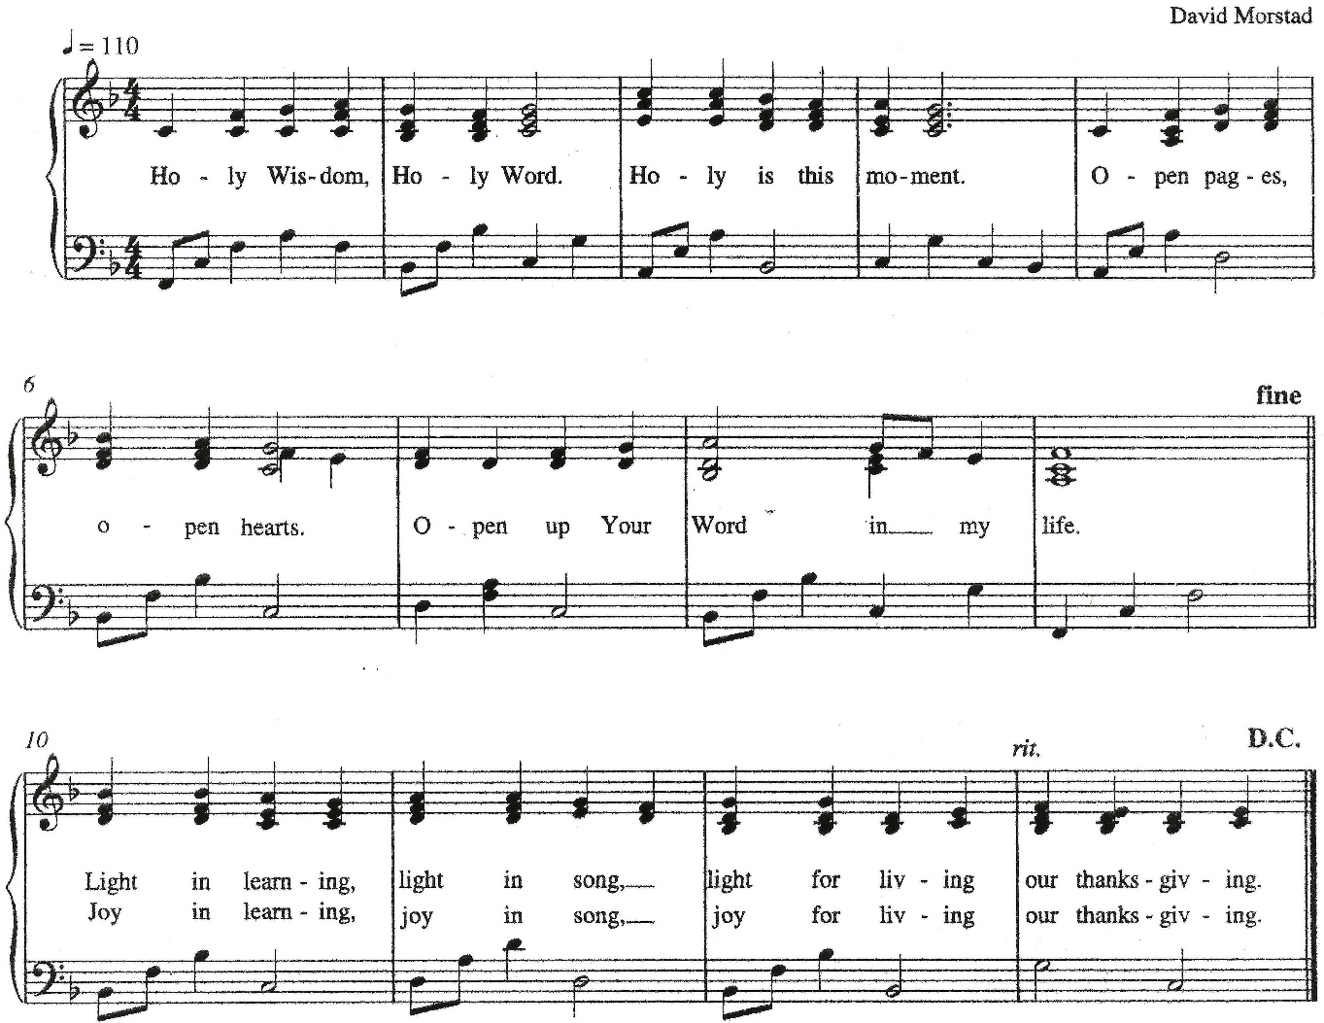
Holy Wisdom, Holy Word

Holy Wisdom, Holy Word Text and Music: David Morstad, My Word! The Bible for EveryOne 2009-2010 Christian Education Planning Guide developed by ELCA Christian Education of the Evangelical Outreach and Congregational Mission unit. Copyright © 2009 Evangelical Lutheran Church in America. All rights reserved. Permission is granted to photocopy this resource provided copies are for local use only and each copy carries all copyright acknowledgments.

Today’s Assistants and Ministers

Greeters & Ushers …………………………………….….….……….....………… Mike Tangen
Organist ……….…..…………………............................….…….…..………….…… Jan Meyer
Presiding Minister …………………….....….......................…………… Pastor Kerry Eversole
Altar Care ……...…………………………………………….. Shari Hamaan and Joyce Priebe
Custodians ………………………….….…….………...….…..…….. Dave & Geri Ann Hanson

This Week in Our Congregation

Today, July 30 — Ninth Sunday after Pentecost

Coffee fellowship in the narthex or downstairs in the dining room following worship

Tuesday, August 1

Men’s breakfast at Home Sweet Home in Lanesboro 7:00 AM

Wednesday, August 2

Pastor Kerry at Chosen Valley Care Center, Chatfield, for chapel 12:30 & 1:30 PM

Thursday, August 3

Deacon Cindy at Good Shepherd Lutheran Home, Rushford, for chapel 1:30 PM

Next Sunday, August 6 — Tenth Sunday after Pentecost

Worship with Holy Communion 9:00 AM

Prayer Requests

In Our Community. For our church members and friends living with chronic illness and other diseases, who are homebound, residing in care facilities, and hospitalized. See the newsletter for our members living in area nursing homes. And let us not forget those sick and dying of COVID-19, those entrusted with the authority of government, justice, and law enforcement, as well as our fallen and wounded soldiers and those still serving.

In Our Synod. Bishop Regina Hassanally invites the people and congregations of our Southeastern Minnesota Synod to make a commitment to pray this week for the following faith communities: First Lutheran Church, Blooming Prairie: Solor Lutheran Church, Webster: Redeemer Lutheran Church, Alden: Ngimu Lutheran Church, Tanzania: Igengu Lutheran Church, Tanzania: and CELCO (Colégio de la Evangélica Luterana de Colombia) Paz de Ariporo.

News and Notes

Make summertime giving a breeze with recurring gifts! Many of you support our congregation with your time, talents, and financial contributions throughout the year. But since many of you travel or spend time visiting family and friends during the summer, it can be hard to keep up with weekly gifts. That’s why we encourage you to set up regular, recurring donations. It takes just moments to set up.

Continued on the next page.
Summertime giving a breeze continued. Visit our website at https://fountainlutheranchurch.com/ and find our online giving in the blue text box titled “Click here to contribute to Fountain Lutheran!” Thank you for your continued support of our ministry and mission!

Acknowledgments

Graphics, worship texts, service music, readings, and PowerPoint® Slides are from sundaysandseasons.com © 2023 Augsburg Fortress. Used by permission under Augsburg Fortress Liturgies Annual License SAS005401.

Permission to project liturgy and music content under copyright to or administered by Augsburg Fortress provided under Augsburg Fortress Liturgies Annual License SAS005401.



Strikepoint will perform at Bethlehem Lutheran Church
Tuesday, August 1, at 7:00 p.m.

There is no admission charge
a donation of $18 per person is suggested
Bethlehem will receive 20% of the offering

Refreshments will be served following the concert

Strikepoint is a church-based community / professional handbell ensemble from Duluth. They have performed throughout the U.S. and Canada, as well as in England, Scotland, Wales, Sweden, Japan, and Hong Kong. Strikepoint is at the forefront of handbell technique innovation (have you seen us dip bells in water to bend the sound?). They are known for their accessible music, with concert selections ranging from Bach to Lady Gaga.

Strikepoint has requested that we provide supper for the eleven members of their ensemble before the concert and housing for Tuesday night. Please contact the church office to take part in the potluck supper and/or to host overnight guest(s).

Calling all percussionists! Strikepoint has asked us to solicit 6-8 local percussionists to accompany them on their final piece, Africa by Toto. The parts are simple and repetitive but need to be strong. There will be one rehearsal 90 minutes before the concert on August 1. They will bring the instruments and music. Contact the Bethlehem church office, 467-3344.

How can eleven people play more than 150 bells?!

Strikepoint will perform at Bethlehem Lutheran Church
Tuesday, August 1, at 7:00 p.m.

There is no admission charge
a donation of $18 per person is suggested
Bethlehem will receive 20% of the offering

Refreshments will be served following the concert

Strikepoint is a church-based community / professional handbell ensemble from Duluth. They have performed throughout the U.S. and Canada, as well as in England, Scotland, Wales, Sweden, Japan, and Hong Kong. Strikepoint is at the forefront of handbell technique innovation (have you seen us dip bells in water to bend the sound?). They are known for their accessible music, with concert selections ranging from Bach to Lady Gaga.

Strikepoint has requested that we provide supper for the eleven members of their ensemble before the concert and housing for Tuesday night. Please contact the church office to take part in the potluck supper and/or to host overnight guest(s).

Calling all percussionists! Strikepoint has asked us to solicit 6-8 local percussionists to accompany them on their final piece, Africa by Toto. The parts are simple and repetitive but need to be strong. There will be one rehearsal 90 minutes before the concert on August 1. They will bring the instruments and music. Contact the Bethlehem church office, 467-3344.

How can eleven people play more than 150 bells?!

